**GUVI ZEN CLASS DB MODEL**

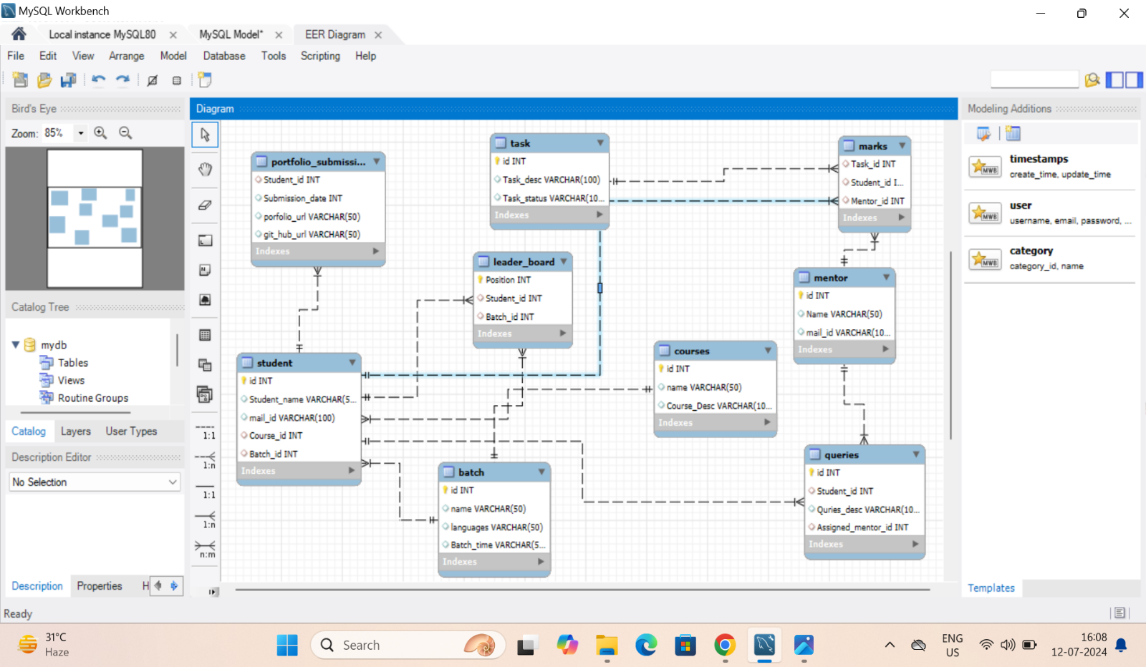

**QURIES;**

create table Task (id int primary key, Task_desc varchar(100), Task_status varchar(100));

create table Mentor (id int primary key, Name varchar(50), mail_id varchar(100));

create table Batch (id int primary key, name varchar(50), languages varchar(50), Batch_time varchar(50));

create table Courses (id int primary key, name varchar(50), Course_Desc varchar (100));

create table Student (id int primary key, Student_name varchar(50), mail_id varchar(100), Course_id int,

Batch_id int, foreign key (Course_id) references Courses (id), foreign key (Batch_id) references Batch (id));

create table Queries (id int primary key, Student_id int, Quries_desc varchar (100), Assigned_mentor_id int,

foreign key (Student_id) references Student (id),foreign key (Assigned_mentor_id) references Mentor(id));

create table Leader_Board (Position int primary key, Student_id int, Batch_id int,

foreign key (Student_id) references Student (id), foreign key (Batch_id) references Batch(id));

create table Marks(Task_id int, Student_id int, Mentor_id int ,

foreign key (Task_id) references Task(id),

foreign key (Student_id) references Student(id),

foreign key (Mentor_id) references Mentor(id));

create table Portfolio_Submission (Student_id int, Submission_date int,

porfolio_url varchar(50), git_hub_url varchar (50),

foreign key (Student_id) references Student(id));