**TASK QURIES**

1.Find all the information about each products

**db.products.find();**

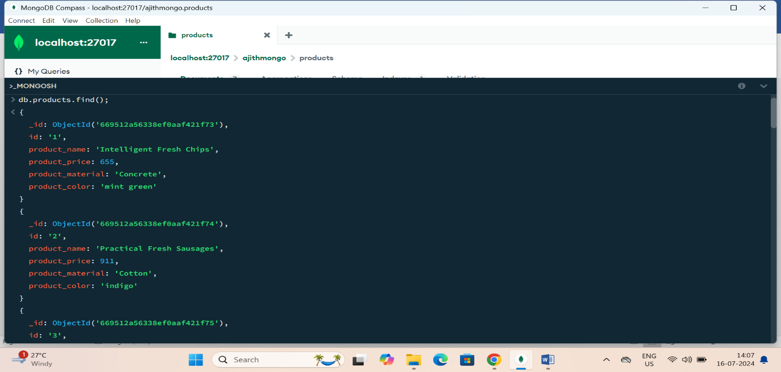

2. Find the product price which are between 400 to 800

**db.products.find({product_price:{$gte:400,$lte:800}});**

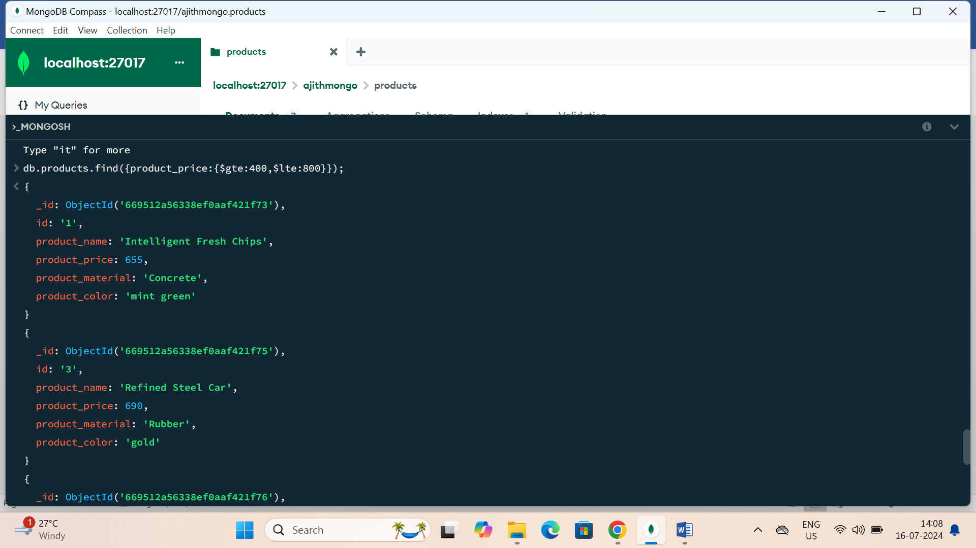

3. Find the product price which are not between 400 to 600

**db.products.find({product_price:{$not:{$gte:400,$lte:600}}});**

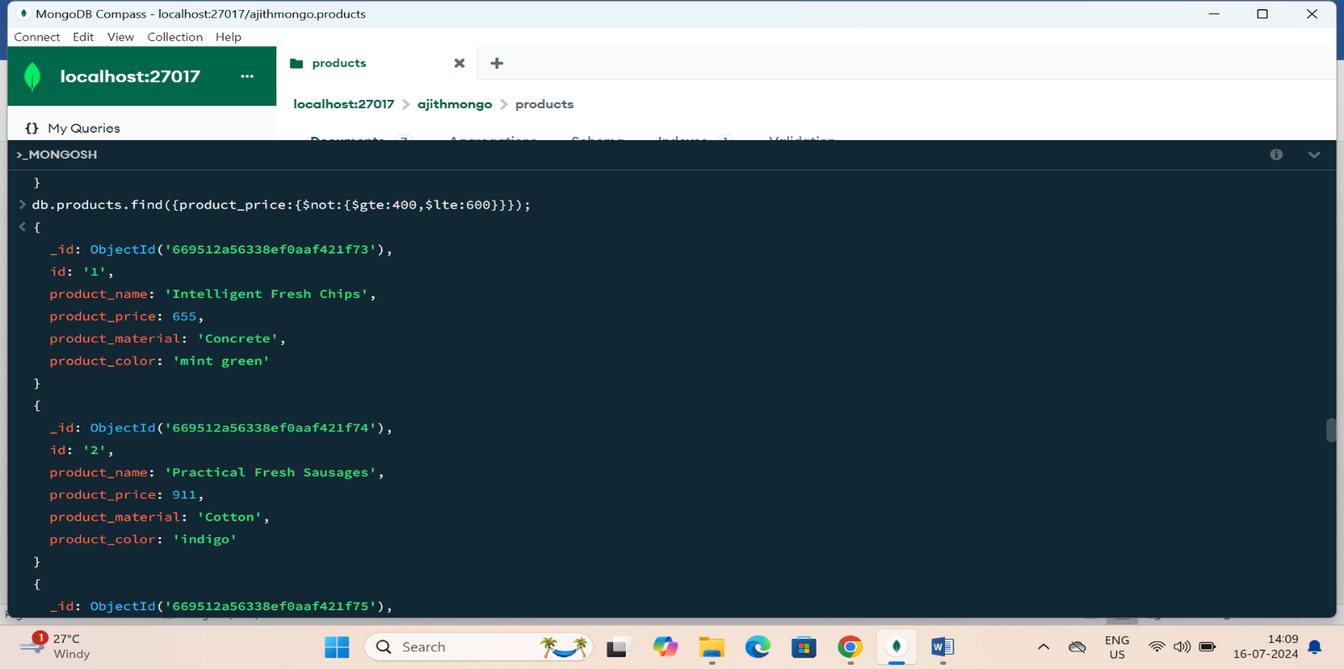

4. List the four product which are greater than 500 in price

**db.products.find({product_price:{$gt:500}}).sort().limit(4);**

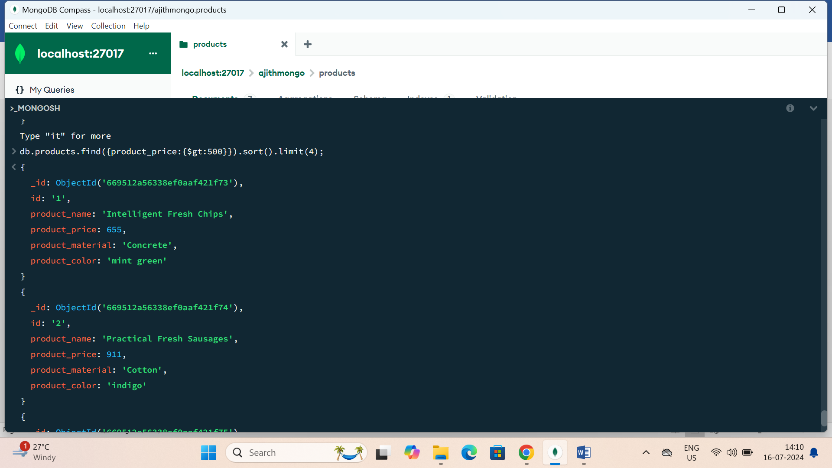

5. Find the product name and product material of each products

**db.products.find({},{product_name:1,product_material:1});**

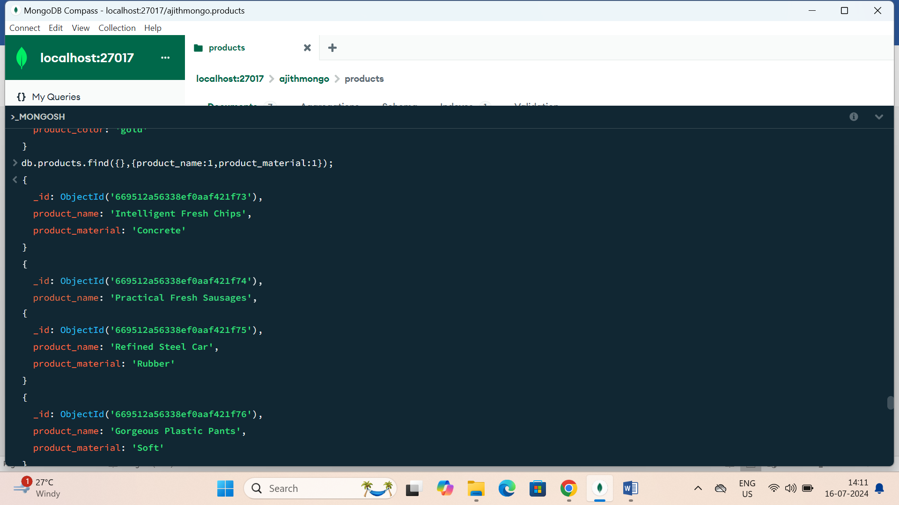

6. Find the product with a row id of 10

**db.products.findOne({id:'10'});**

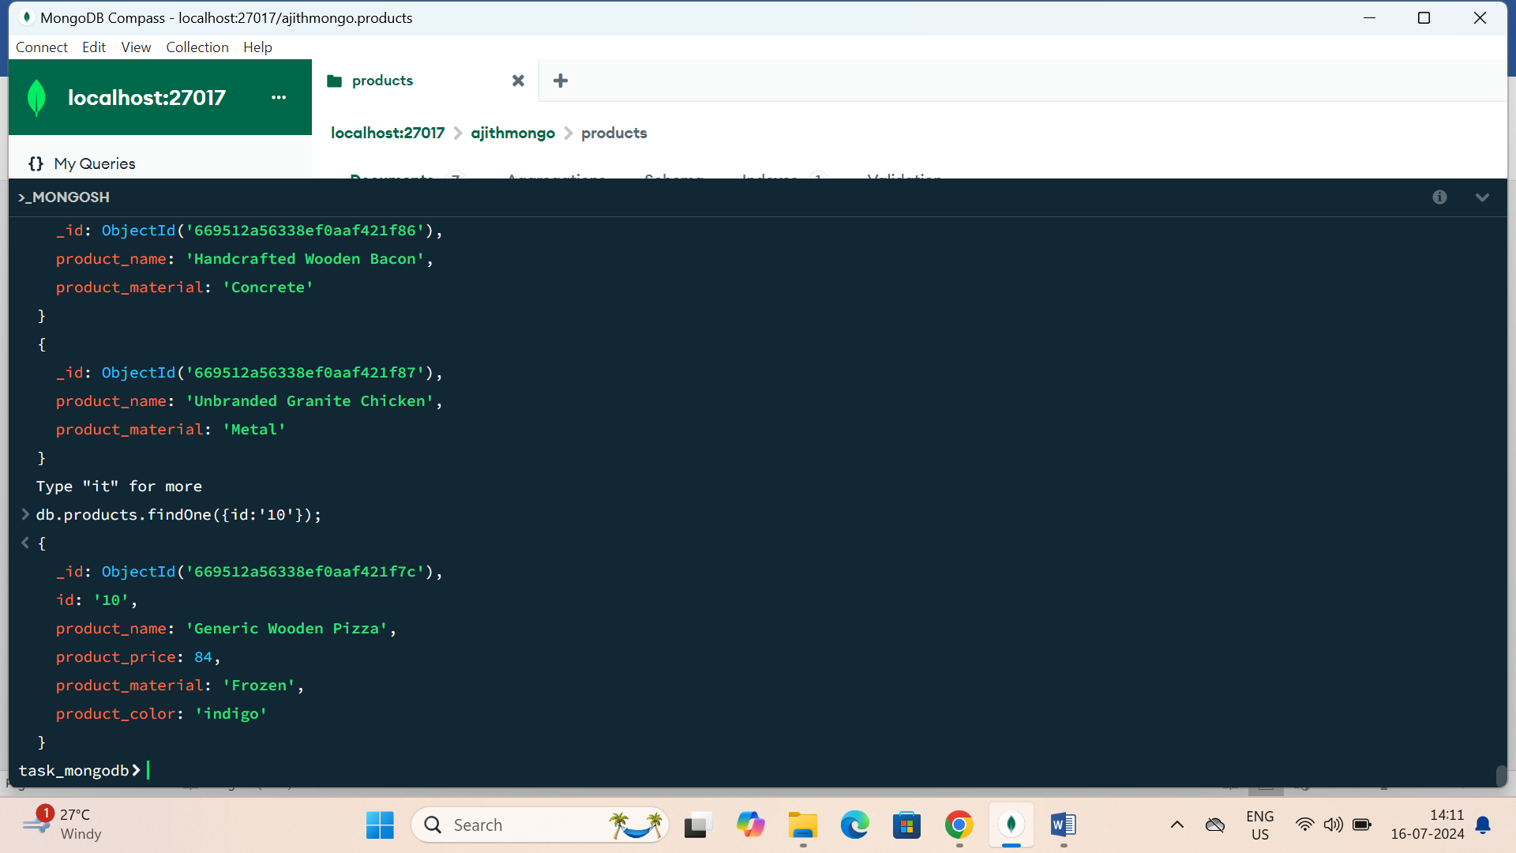

7. Find only the product name and product material

**db.products.find({},{_id:0,product_name:1,product_material:1});**

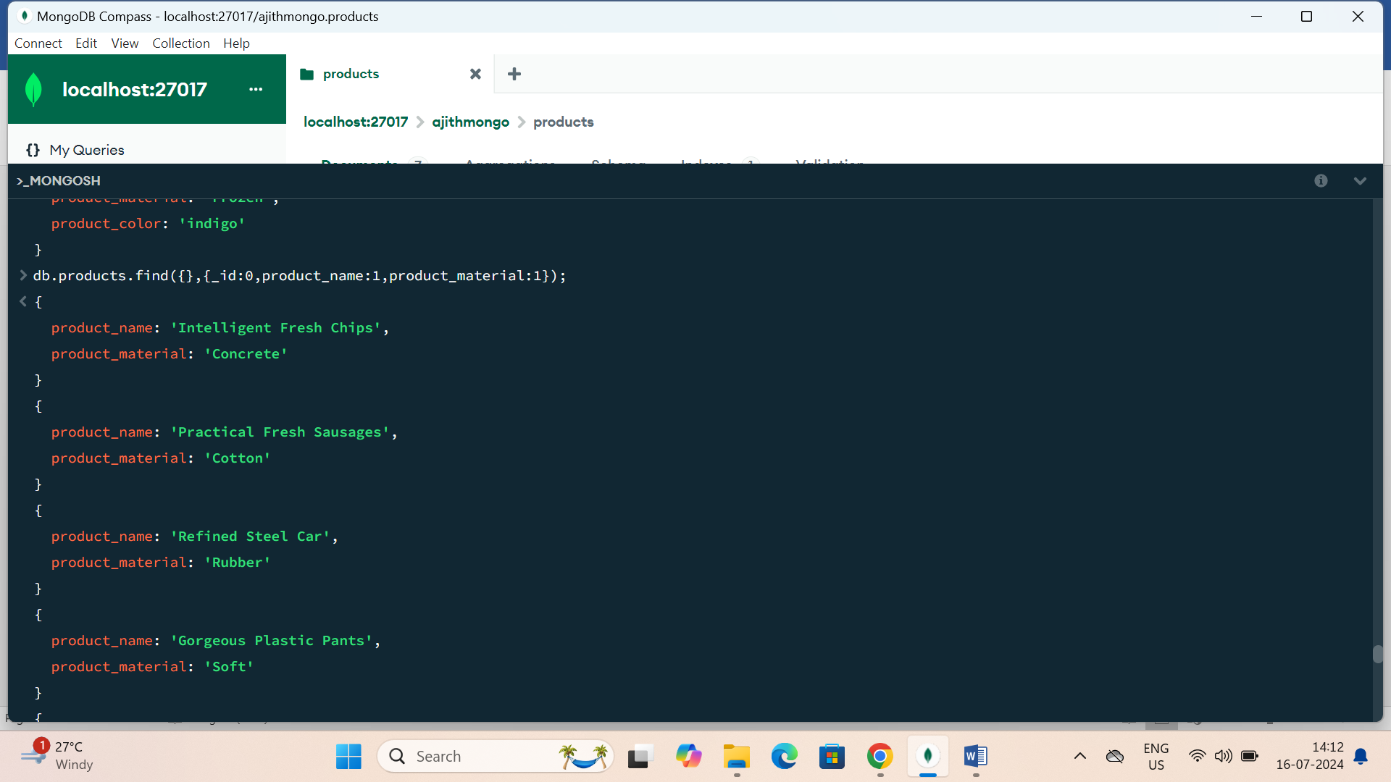

8. Find all products which contain the value of soft in product material

**db.products.find({product_material: /soft/i});**

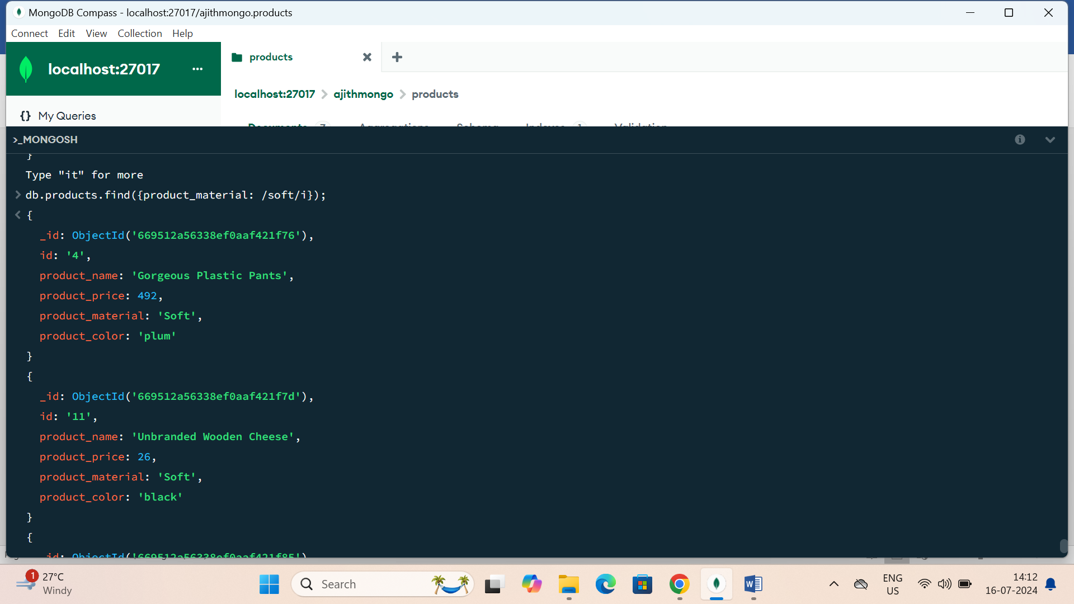

9. Find products which contain product colour indigo and product price 492.00

**db.products.find({$and:[{product_color:{$eq:'indigo'}},{product_price:{$eq:492}}]});**

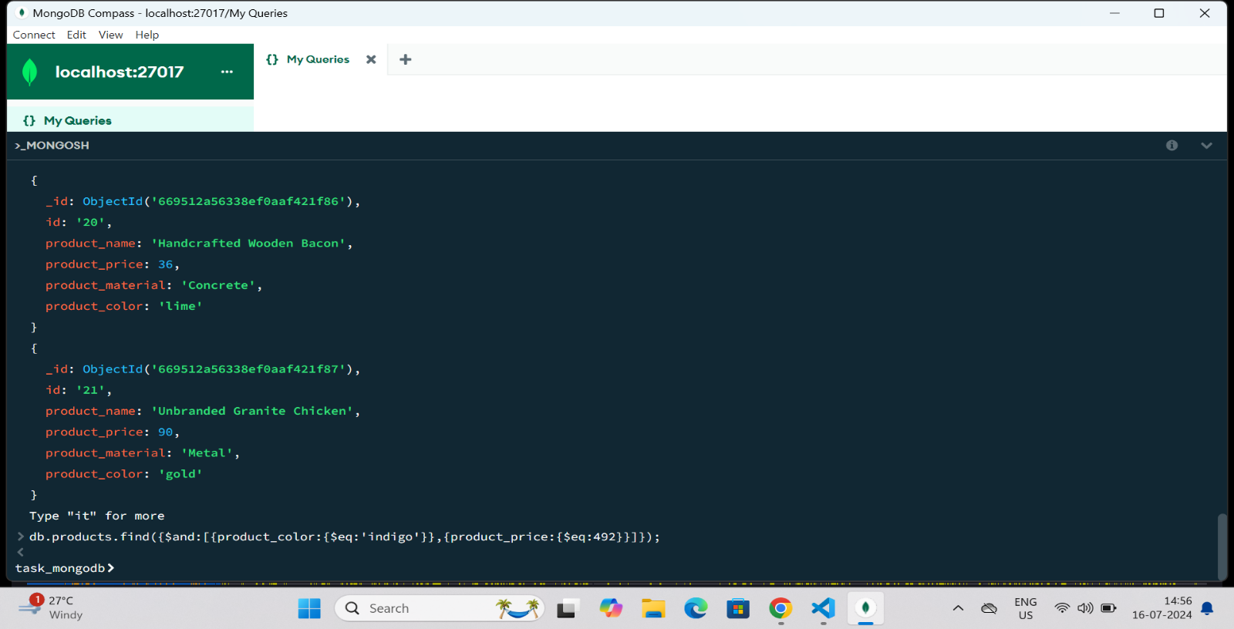

10. Delete the products which product price value are same

**db.products.deleteMany({product_price:{$eq:28}});**

