**Alvin L. Yanson**  
Casiana, Eroreco, Brgy. Mandalagan, Bacolod City  
09163195904 | yansonalvin29@gmail.com | www.creativealvin.cf

August 6, 2019

Rankignite Digital Marketing

Room 201, San Jose Building, Bacolod City

Dear Rankignite Digital Marketing Hiring Manager,

I am writing to express my interest for the position of Digital Marketing Assistant in your company. Having recently obtained my Bachelor’s Degree in Information Systems in the University of Negros Occidental–Recoletos. As a fresh graduate, I wish to bring my knowledge, skills and commitment to excellence to your company.

I am flexible and open to accomplish digital media skills such as designing and implementing digital media strategies that generate new clients and revenue streams for businesses. I would like to bring my collective experience and success to the digital marketing assistant position you are currently advertising, specifically contributing the following to Rankignite Digital Marketing:

* Proficiency in developing and maintaining websites using WordPress.
* Expertise in Web Programming (HTML, JavaScript, PHP, MySQL, Codeigniter, AngularJS).
* Photo and Video Editing

In all previous experience, I excelled at coordinating with business owner, senior programmer, and city health personnel to develop digital platforms that meets their needs and satisfaction. Below are my portfolio which presents my works. As your digital marketing assistant position requires knowledge similar to mine, I believe I would serve Rankignite Digital Marketing well in this role.

I am hoping for your favorable feedback with this application. I can be reached anytime via email at [yansonalvin29@gmail.com](mailto:yansonalvin29@gmail.com) or my mobile number 09163195904 at your most available time. I look forward to hearing back from you. Thank you for your time and God bless!

Sincerely,

Alvin L. Yanson

**V3 Pestmasters Website**

(I was the web developer of the V3 Pestmasters Bacolod. I made this website using WordPress.)

**UNOR Map Locator**

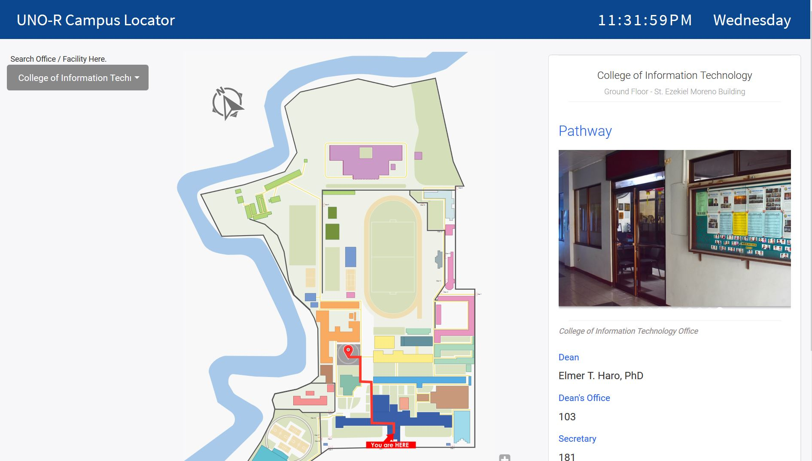

(I successfully developed this map locator in UNOR. This is currently installed in the three kiosk of the university. I developed this during my OJT Internship at the MIS Office UNOR. This task was given to me by the Senior Programmer of MIS UNOR.)

**UNOR 360 Map**

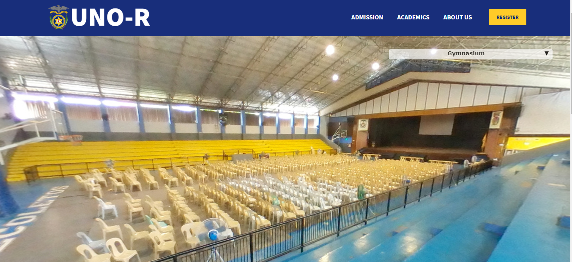

(I help developed this 360 map of UNOR during my OJT Internship at the MIS Office UNOR. This was my last task during my OJT Internship and I finished it for almost 2 weeks.)

**Bacolod City Health TB DOTS Center Patient Management Information System**

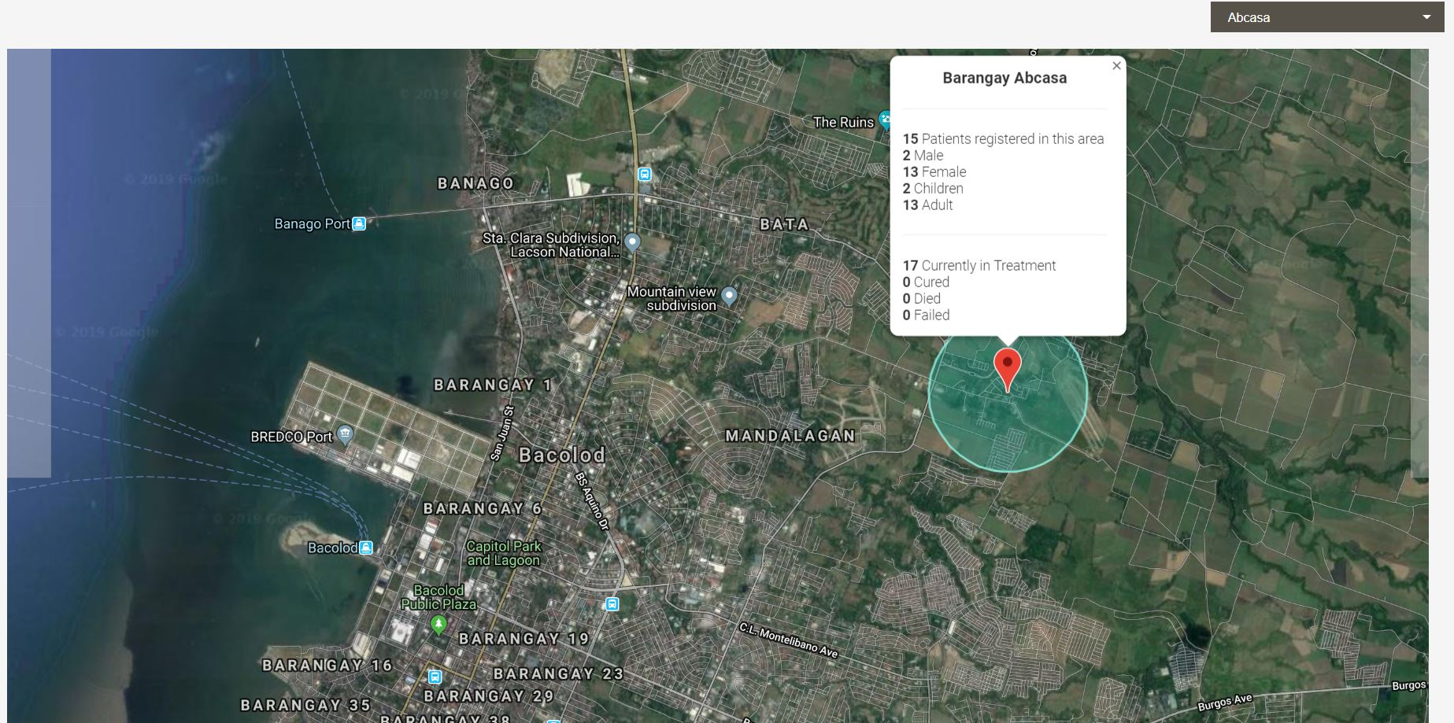

(This is my thesis during my senior years in UNOR-IT. This was awarded as Best Thesis 2018. However, this was not implemented at Bacolod City Health TB DOTS because of the budget problem of the said department.)