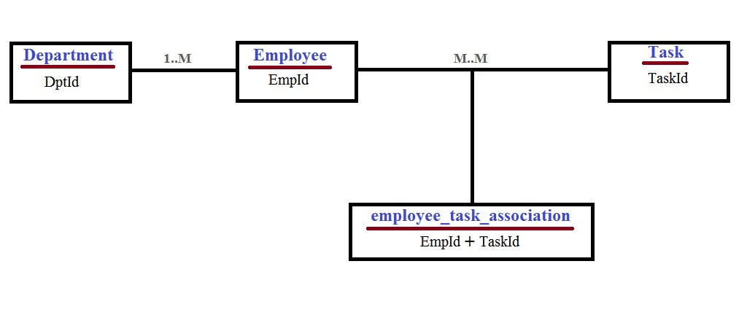

* Department table :
* Create : <http://localhost:8080/dpts>

Sample JSON Data:-

{

"dptName" : "Administration"

}

* Read : http://localhost:8080/dpts/{id}
* Update : http://localhost:8080/dpts/{id}
* Delete : [http://localhost:8080/dpts/{id}](http://localhost:8080/dpts/%7bid%7d)
* Employee table :
* Create : [http://localhost:8080/employees/{dptId}/employee](http://localhost:8080/employees/%7bdptId%7d/employee) (Department wise)

Sample JSON Data:-

{

"firstName": "Manoj",

"lastName": "Singh",

"email": "manoj@gmail.com",

"mobileNo": "9889888147",

"address": "Ahmedabad"

}

* Read : http://localhost:8080/employees
* Update : http://localhost:8080/employees/{empId}
* Delete : http://localhost:8080/employees/{empId}
* Task table :
* Create : <http://localhost:8080/tasks>

Sample JSON Data :-

{

"taskName" : "Auditing"

}

* Read : http://localhost:8080/tasks
* Update : http://localhost:8080/tasks/{taskid}
* Delete : [http://localhost:8080/tasks/{taskid}](http://localhost:8080/tasks/%7btaskid%7d)
* One To Many Mapping (Department -> Employee)
* [http://localhost:8080/employees/{dptId}/employee](http://localhost:8080/employees/%7bdptId%7d/employee)

((POST) Employee get registered with dpt_id as a foreign key)

* [http://localhost:8080/employees/{dptId}/employee](http://localhost:8080/employees/%7bdptId%7d/employee)

((GET) Get all employees belonged to specific department)

* [http://localhost:8080/employees/{dptId}/employee](http://localhost:8080/employees/%7bdptId%7d/employee)

((DELETE) Delete all employees for specific department)

* Many To Many ( Employee -> Task)
* [http://localhost:8080/tasks/{taskid}/employees](http://localhost:8080/tasks/%7btaskid%7d/employees)

((GET) Get employee for specific task)

* [http://localhost:8080/employees/{empId}/task](http://localhost:8080/employees/%7bempId%7d/task)

((PUT) Attach task with employee)

Sample JSON Data :-

[

{

"taskId": 1,

"taskName": "Auditing"

},

{

"taskId": 2,

"taskName": “Managing"

}

]

* [http://localhost:8080/employees/{empId}/tasks](http://localhost:8080/employees/%7bempId%7d/tasks)

((GET) Get list of tasks assigned to specific employee)