**Adarsh Bajpai**

**Aims to be able to find an exciting and challenging entry level position in the Information and Technology industry alongside a company who will continuously motivate and drive me to do my best and improve on my skills and abilities in order to be able to assist the company in achieving its company mission and goals.**

**CONTACT**

**ACADEMIC BACKGROUND**

**SKILLS**

**INTERNSHIPS**

**EXPERTISE**

**INTERESTS**

**A/713, MEA Apartment, Noida, Uttar Pradesh.**

**+91 8932964300**

**adarshbajpayee@gmail.com**

**2018 -**

**2014 -**

**2017**

**2012**

**MASTERAL DEGREE (M.C.A)**

**IMS Noida, Noida, Uttar Pradesh**

**BACHELOR DEGREE (B.C.A)**

**Shri Ramswaroop Memorial University, Lucknow.**

**12th Standard**

**J.K.S Inter College of Commerce, Jamshedpur**

**2019**

**MCN Solutions Pvt. Ltd.**

* **Java and Android**

**Attentive Listening and Effective  
Oral Communication Skills**

**Great at Problem Solving**

**Ability to Quickly Create and  
Apply Ideas and Solutions**

**Good Leadership Skills**

**Critical Thinker**

**Master of Computer Application**

**Basic C and C++, JAVA, Operating Systems (Windows 7, 8, 10), Office Suits, Communications and Collaboration Tools,**

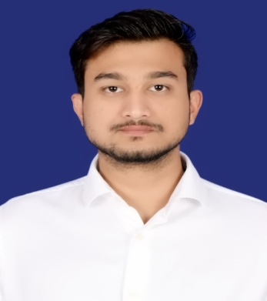

**Name- Adarsh Bajpai**

**Date of Birth: July 8, 1994  
Age: 25**

**Gender: Male  
Birth Place: Jamshedpur, India.**