**Satendra Singh**

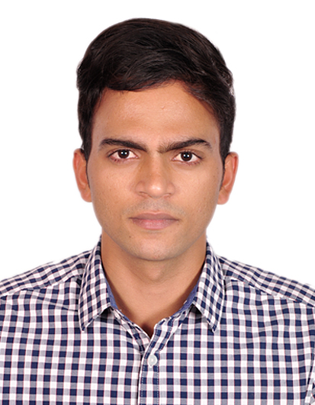

**Tel: +917011970089**

**Tel: +919717512897**

[**callsatendra@gmail.com**](mailto:callsatendra@gmail.com)

**CAREER OBJECTIVE**

Being an intellective, enthusiast, engaged and self-motivated individual, I believe in connectedness amongst a team, society and the world. I aspire to get involved in an organization that is willing to train and pose me with challenges that can help me maximize my skills and abilities to with efficacy.

**PROFESSIONAL SUMMARY**

* Worked as an Intern in Pavaki
* School Captain and House Captain
* Adaptive to learning new technical developments
* Supportive and passionate as a team member
* Understanding of professional ethics and protocols
* Decent communication skills – personal & professional

**TECHNICAL EXPERTISE**

**Languages**: C, C++, Java, Python, PHP, HTML, CSS, JS   
**DBMS Packages**: Oracle (SQL & PL/SQL), MS-Access   
**Scripting Languages**: Java Script, JQUERY  
**Platforms**: Linux, Windows 98, 2000, XP, Windows7.0, Windows8   
**Web Designing**: HTML, XML, CSS, DHTML   
**Other Tools**: Microsoft Office, Dreamweaver, Adobe Photoshop

**EDUCATIONAL QUALIFICATION:**

|  |  |  |  |  |
| --- | --- | --- | --- | --- |
| **QUALIFICATION** | **YEAR** | **NAME OF INSTITUTE** | **UNIVERSITY / BOARD** | **% OF MARKS** |
| MCA | 2020 | Institute Of Management Studies, Noida (UP) | AKTU | 60 |
| BCA | 2018 | Institute Of Management Studies, Noida (UP) | CCSU | 60 |
| Class XII | 2015 | Children Public Senior Secondary School, Fatehpur (UP) | CBSE | 61.4 |
| Class X | 2013 | Children Public Senior Secondary School, Fatehpur (UP) | CBSE | 91.2 |

**ACADEMIC PROJECTS**

Designed college website using Word Press and awarded by first prize  
Designed Website for college library (HTML, CSS, JavaScript)

**EXTRA-CURRICULAR ACTIVITIES**

Participated in various sports events.  
Participated in Annual Sports Day at school.  
Participated in various cultural events in School and Colleges.

**ACCOLADES**

Medals in various Quiz, Sports and Dance Competitions.  
Secured Highest Point in Inter House Competition.

**PERSONAL PROFILE**

Name – Satendra Singh  
Father’s Name - Bachchh Raj Singh  
Sex – Male

DOB- 07/08/ 1998  
Marital Status – Unmarried  
Languages Known – English, Hindi  
Nationality - Indian  
Hobbies – Blogging, Tec buzz, Solving technical problems, Surfing, Playing Cricket  
Present Address – I-304, GOLF CITY-PLOT 8, SECTOR 75, NOIDA-201303

**REFERENCES (If any)**

NameDesignation  
Phone:   
E-mail:

**Declaration:**

I hereby declare that the above-mentioned information is correct up to my knowledge.