Keypad-Synchronized Multi-Digit 7-Segment Display Using Arduino Nano
This project uses an Arduino Nano to read keypad inputs and display the corresponding value in real time on a 7-segment display..
Este documento foi desenvolvido por Andrei Inoue Hirata está protegido por direitos autorais, sendo vedada sua reprodução sem autorização prévia do autor.

Components and supplies
- 1 Arduino Nano Matter
- 1 Button Keypad 4x4 module
- 1 Resistor 220 ohmios
- 1 7 Segment Display-Common Anode
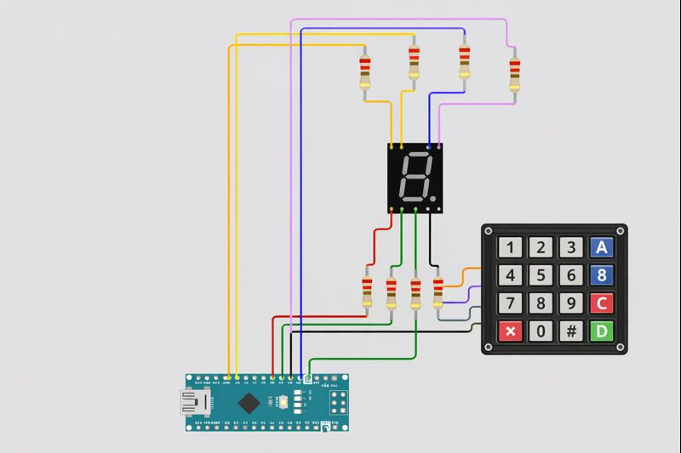

Project description
This project demonstrates how to interface a 4×4 matrix keypad with an Arduino Nano to control a 7-segment display. Each key pressed on the keypad is processed by the Arduino and displayed in real time on the 7-segment display, creating a simple and responsive human–machine interface.

The project focuses on understanding digital input scanning, keypad matrix decoding, and output control of a 7-segment display using current-limiting resistors. It serves as a foundation for applications such as access systems, counters, menu selection interfaces, and basic embedded user input systems.
- The 4×4 keypad is connected to the Arduino Nano using row and column pins.
- The Arduino continuously scans the keypad matrix to detect which key is pressed.
- When a key is detected, the Arduino maps the key value to its corresponding 7-segment pattern.
- The 7-segment display is driven directly from the Arduino’s digital pins through resistors to protect the LEDs.
- Each keypad press is synchronized with the display, ensuring that the selected number or character appears instantly on the 7-segment display. Experimente: Atualize o Sumário.
Code
#include <Keypad.h>

/* ===== Keypad setup ===== */
const byte ROWS = 4;
const byte COLS = 4;

char keys[ROWS][COLS] = {
{'1','2','3','A'},
{'4','5','6','B'},
{'7','8','9','C'},
{'*','0','#','D'}
};

byte rowPins[ROWS] = {9, 8, 7, 6}; // Connect to keypad ROW pins
byte colPins[COLS] = {5, 4, 3, 2}; // Connect to keypad COL pins

Keypad keypad = Keypad(makeKeymap(keys), rowPins, colPins, ROWS, COLS);

/* ===== 7-segment pins (a–g) ===== */
int segA = 10;
int segB = 11;
int segC = 12;
int segD = A0;
int segE = A1;
int segF = A2;
int segG = A3;

/* ===== Segment patterns for numbers 0–9 ===== */
/* Common Cathode (HIGH = ON) */
byte digits[10][7] = {
{1,1,1,1,1,1,0}, // 0
{0,1,1,0,0,0,0}, // 1
{1,1,0,1,1,0,1}, // 2
{1,1,1,1,0,0,1}, // 3
{0,1,1,0,0,1,1}, // 4
{1,0,1,1,0,1,1}, // 5
{1,0,1,1,1,1,1}, // 6
{1,1,1,0,0,0,0}, // 7
{1,1,1,1,1,1,1}, // 8
{1,1,1,1,0,1,1} // 9
};

int segmentPins[7] = {segA, segB, segC, segD, segE, segF, segG};

void setup() {
for (int i = 0; i < 7; i++) {
pinMode(segmentPins[i], OUTPUT);
digitalWrite(segmentPins[i], LOW);
}
}

void loop() {
char key = keypad.getKey();

if (key >= '0' && key <= '9') {
displayDigit(key - '0');
}
}

/* ===== Display function ===== */
void displayDigit(int num) {
for (int i = 0; i < 7; i++) {
digitalWrite(segmentPins[i], digits[num][i]);
}
}

