# Typing Test Application

A Java Swing-based Typing Test Application developed as part of academic learning in Java and Object-Oriented Programming.

## Project Overview

This application helps users practice typing speed and accuracy by displaying a text passage that must be typed within a specified time limit.

The system tracks user performance and provides results based on the typing test.

## Features

* 60-second typing timer
* Random text passages
* User typing area
* Start test functionality
* Submit answers
* Generate new typing passages
* Display typing results
* Simple graphical user interface

## Technologies Used

* Java
* Java Swing
* Object-Oriented Programming

## Application Interface

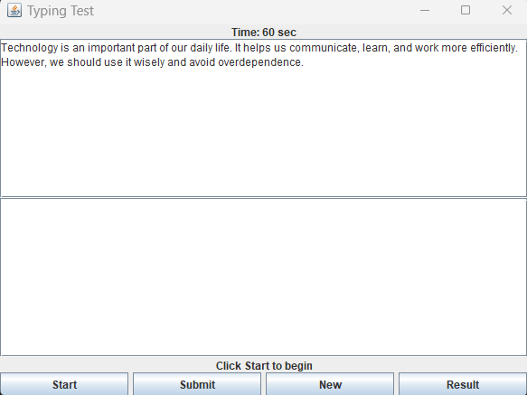

## Learning Outcomes

This project helped in understanding:

* Java Swing GUI Development
* Event Handling
* Object-Oriented Programming Concepts
* User Interface Design
* Timer Implementation

## Future Improvements

* Words Per Minute (WPM) calculation
* Accuracy percentage tracking
* Difficulty levels
* Performance history
* Database integration

## Author

Gitanjali Jain

Computer Engineering Student

