So when you get an idea and want to turn it into a website, there are a few questions you should answer before anything else:

* What exactly do I want to accomplish?
* How will a website help me reach my goals?
* What needs to be done, and in what order, to reach my goals?

**Deeper dive**

 You must sit down and structure your ideas to get a clear view of what path you must take to make your ideas a reality.

To do this, answer at least the following questions.

Q1. What exactly do I want to accomplish

List all the goals you want to reach. Once you have such a list, you need to prioritize. Doing this simple exercise—writing goals and sorting them—will help you out when you have decisions to make.

Q2. How could a website bring me to my goals?

Since our goal is what matters most, we should spend our energy on leveraging existing tools rather than starting from scratch.

Q3 What needs to be done, and in what order, to reach my goals?

 As a side note, your goals are not necessarily set in stone. They evolve over time even in the course of the project, especially if you run across unexpected obstacles or just change your mind.

# How does the Internet work?

Each computer on a network is connected to a special tiny computer called a router. This router has only one job: like a signaler at a railway station, it makes sure that a message sent from a given computer arrives at the right destination computer. To send a message to computer B, computer A must send the message to the router, which in turn forwards the message to computer B and makes sure the message is not delivered to computer C.

**The Internet is an infrastructure, whereas the Web is a service built on top of the infrastructure.**

It is worth noting there are several other services built on top of the Internet, such as email and [IRC](https://developer.mozilla.org/en-US/docs/Glossary/IRC).

## Clients and servers

Computers connected to the web are called **clients**and **servers**. A simplified diagram of how they interact might look like this:

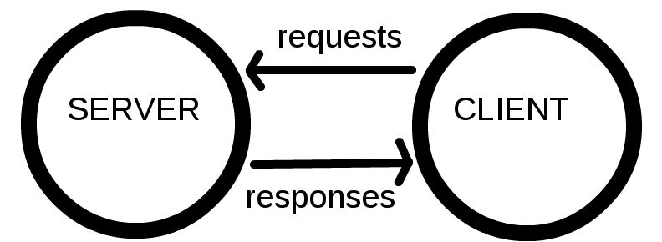

* Clients are the typical web user's internet-connected devices

Servers are computers that store webpages, sites, or apps. When a client device wants to access a webpage, a copy of the webpage is downloaded from the server onto the client machine to be displayed in the user's web browser.

**Note:**Browsers can also display other documents such as [PDF](https://developer.mozilla.org/en-US/docs/Glossary/PDF) files or images, but the term **web page** specifically refers to HTML documents. Otherwise, we only use the term **document**.

# **HTTP — an Application-Level Protocol**

HTTP is an application-level protocol on top of [TCP/IP](https://en.wikipedia.org/wiki/TCP/IP_model), a communication protocol.