Asad Manzoor

BSCS7B

214405

**MOODLE**

*Introduction*:

Moodle is a free open source software learning management system which helps user create dynamic course. The users can create their own courses, make graded quizzes, message (both private and public) etc. Also due to the open source nature of the Moodle, has hundreds of plugins available for free. From a recent survey over 70,000 Universities rely on Moodle for their learning management system.

Exploring from a user’s perspective:

Moodle provides a simple interface where the user can sign in as a teacher or a student, providing different functionality for either of the cases. After logging in Moodle provides us with a three-column interface. Navigation of courses and classes to the most left, the courses in the middle and forums etc. to the most left. Moodle always creates a forum for each course which can be used by teachers or students for discussion purposes.

Editing a course adding new information Is also quite simple as shown in the picture.

Moodle has a convenient editing mode which can be used to make changes to the course. The user can add courses change their positionings, their look and feel and their subtitles etc. The user can also create and customize their own profiles on Moodle.

The user can also add their own lectures and links and even videos as simple as a drag and drop from their pc. Also, Moodle opens a new page for each f the video file which keeps the interface clean.

Moodle also has quite a bit of customization so the users can make theirs look according to their choice.

Exploring from a data base developer’s perspective:

To add a database to our learning management system, the user logs in as admin, simply turn on the editing mode, choose to add a database, select database and add the description etc. The user can also choose to select, total entries, allowing editing, viewing other’s entries etc.

The user can also specify requirements such as text only entry, not blank, pic only with of a specific size or dimension, add geographic location etc.

All these restrictions and requirements added by the admin are translated to SQL queries and are execute in the connected database. Hence creating different tables and entries for all the data added. A generic view of such a database in from of a diagram is shown in the picture below.

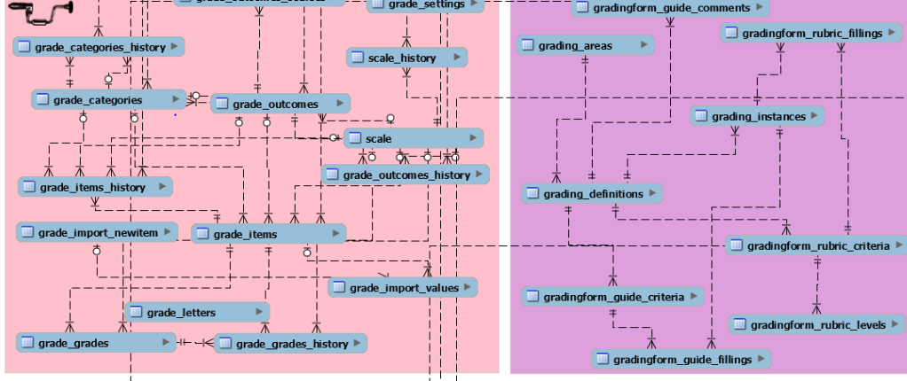

Exploring as a coder:

The Moodle framework is written in php and can be run through a local php server. As a programmer there is little to no need to write your own code. All the functions are well defined, and the interface is simple and interactive. A snippet of underlying php code is attached for reference.

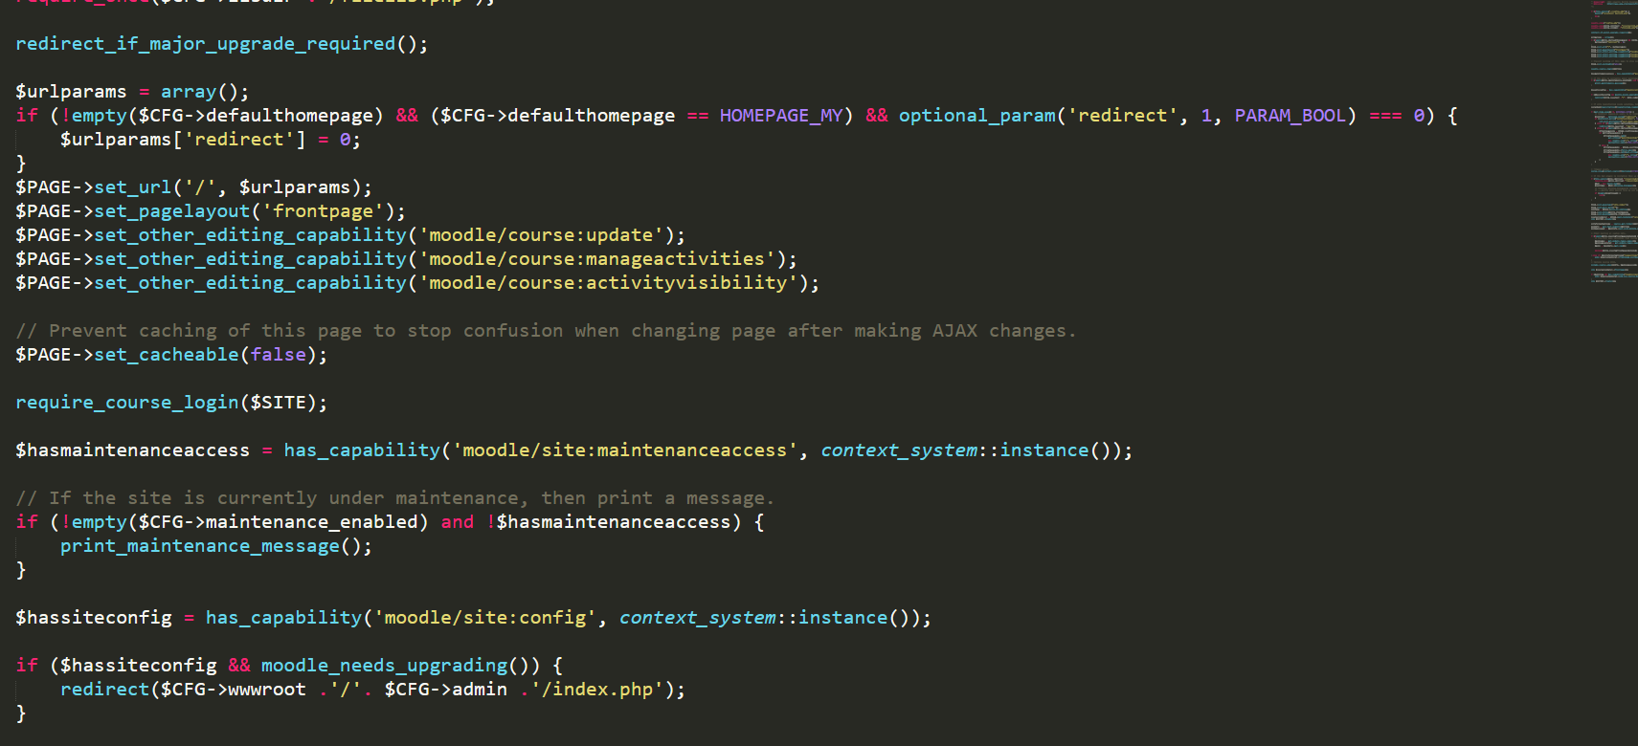

The user can also install and add from hundreds of plugins available online. To install a plugin for Moodle simply visit moodle.org, go to downloads section, choose your plugin.

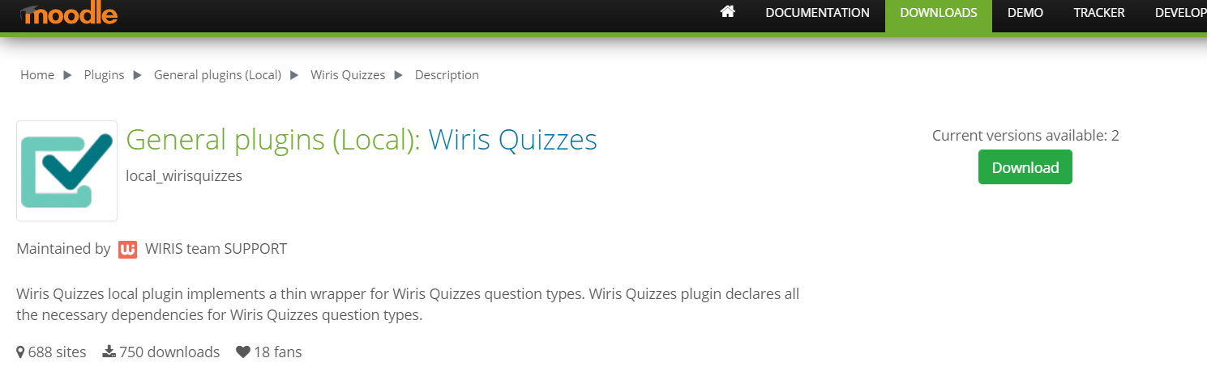

Download the zip file, select the file and install as shown below.

