Asad Manzoor

BSCS7B

214405

_____________________________________________________________________________________

TASK 1

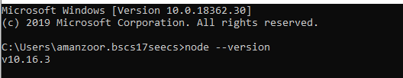

TASK 2

var http = require('http');

http.createServer(function (req, res) {

res.writeHead(200, {'Content-Type': 'text/plain'});

res.end('Hello World\n');

}).listen(1337, "127.0.0.1");

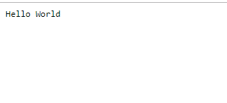

TASK 3

var date = function(){

return Date();

}

module.exports.date;

TASK 4:

var date = require('./myfirstmodule.js');

console.log(date.myDateTime());



TASK 5:

var http = require('http');

http.createServer(function (req, res) {

res.writeHead(200, {'Content-Type': 'text/plain'});

res.end('Hello World\n');

}).listen(1337, "127.0.0.1");



TASK 6:

var http = require('http');

http.createServer(function (req, res) {

res.writeHead(200, {'Content-Type': 'text/html'});

res.end('<h1>Hello World</h1>');

}).listen(1337, "127.0.0.1");

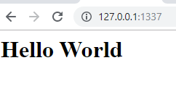

TASK 7

var http = require('http');

var fs = require('fs');

http.createServer(function (req, res) {

fs.readFile('web.html', function(err, data){

res.writeHead(200, {'Content-Type': 'text/html'});

res.end(data);

})

}).listen(1338);

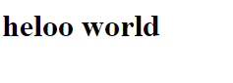

TASK 8

A:

var fs = require('fs');

fs.OPENFile('C:/Users/amanzoor.bscs17seecs/file.txt', 'Hello content!', function (err) {

  if (err) throw err;

  console.log('Saved!');});

B:

var fs = require('fs');

fs.Appendfile('C:/Users/amanzoor.bscs17seecs/file.txt', 'Hello content!', function (err) {

  if (err) throw err;

  console.log('Saved!');});

C:

var fs = require('fs');

fs.writefile('C:/Users/amanzoor.bscs17seecs/file.txt', 'Hello content!', function (err) {

  if (err) throw err;

  console.log('Saved!');});



TASK 9:

var fs = require('fs');

fs.appendFile('C:/Users/amanzoor.bscs17seecs/file.txt', 'Hello content!', function (err) {

  if (err) throw err;

  console.log('Saved!');});



TASK 10:

var fs = require('fs');

fs.writeFile('C:/Users/amanzoor.bscs17seecs/file.txt', 'This is new', function (err) {

  if (err) throw err;

  console.log('new!');});



TASK 11:

var fs = require('fs');

fs.unlink('C:/Users/amanzoor.bscs17seecs/file.txt', function (err) {

  if (err) throw err;

  console.log('deleted!');});



TASK 12:

var fs = require('fs');fs.rename('mynewfile3.txt','newname', function (err) {

  if (err) throw err;

  console.log('renamed!');});

