**Asad Manzoor**

**BSCS7B**

**214405**

**_____________________________________________**

**Task 1:**

var mysql = require('mysql')

var con = mysql.createConnection({

host: "localhost",

user: "root",

password: "seecs@123"});

con.connect(function(err){

if(err) throw err;

console.log("Connected");

});

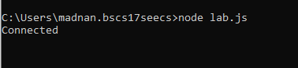

**Task 2:**

var mysql = require('mysql')

var con = mysql.createConnection({

host: "localhost",

user: "root",

password: "seecs@123",

database: "db"});

con.connect(function(err){

if(err) throw err;

console.log("Connected");

var sql = 'select name from customers';

con.query(sql,function(err,result){

if(err) throw err;

console.log(result)

});

});

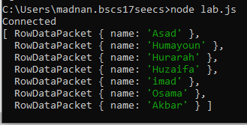

**Task 3:**

var mysql = require('mysql')

var con = mysql.createConnection({

host: "localhost",

user: "root",

password: "seecs@123"});

con.connect(function(err){

if(err) throw err;

console.log("Connected");

var sql = 'create database db';

con.query(sql,function(err,result){

if(err) throw err;

console.log("Query Executed Successfully!");

});

});

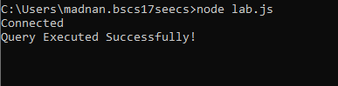

**Task 4:**

var mysql = require('mysql')

var con = mysql.createConnection({

host: "localhost",

user: "root",

password: "seecs@123",

database: "db"});

con.connect(function(err){

if(err) throw err;

console.log("Connected");

var sql = 'create table customers(name varchar(100), address varchar(250))';

con.query(sql,function(err,result){

if(err) throw err;

console.log("Query Executed Successfully!");

});

});

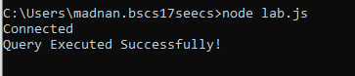

**Task 5:**

var mysql = require('mysql')

var con = mysql.createConnection({

host: "localhost",

user: "root",

password: "seecs@123",

database: "db"});

con.connect(function(err){

if(err) throw err;

console.log("Connected");

var sql = 'Alter table customers add column id int auto_increment Primary Key';

con.query(sql,function(err,result){

if(err) throw err;

console.log("Query Executed Successfully");

});

});



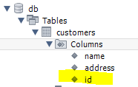

**Task 6:**

var mysql = require('mysql')

var con = mysql.createConnection({

host: "localhost",

user: "root",

password: "seecs@123",

database: "db"});

con.connect(function(err){

if(err) throw err;

console.log("Connected");

var sql = 'insert into customers(name,address) values("Razi","House No.10,Street No.111, G-11/1")';

con.query(sql,function(err,result){

if(err) throw err;

console.log("Query Executed Successfully");

});

});

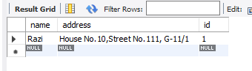

**Task 7:**

var mysql = require('mysql')

var con = mysql.createConnection({

host: "localhost",

user: "root",

password: "seecs@123",

database: "db"});

con.connect(function(err){

if(err) throw err;

console.log("Connected");

var sql = 'insert into customers(name,address) values("Asad","Attar Hostel"),("Humayoun","Razi Hostel"),("Hurarah","Razi Hostel")';

con.query(sql,function(err,result){

if(err) throw err;

console.log("Query Executed Successfully")

console.log("Number Of Rows Inserted:"+result.affectedRows);

});

});

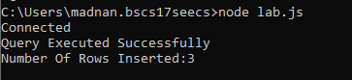

**Task 8:**

var mysql = require('mysql')

var con = mysql.createConnection({

host: "localhost",

user: "root",

password: "seecs@123",

database: "db"});

con.connect(function(err){

if(err) throw err;

console.log("Connected");

var sql = 'Select * from customers';

con.query(sql,function(err,result){

if(err) throw err;

console.log("Query Executed Successfully")

console.log(result);

});

});

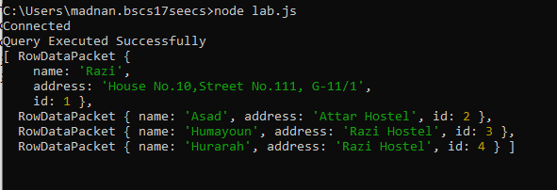

**Task 9:**

var mysql = require('mysql')

var con = mysql.createConnection({

host: "localhost",

user: "root",

password: "seecs@123",

database: "db"});

con.connect(function(err){

if(err) throw err;

console.log("Connected");

var sql = 'Select name,address from customers';

con.query(sql,function(err,result){

if(err) throw err;

console.log("Query Executed Successfully")

console.log(result);

});

});

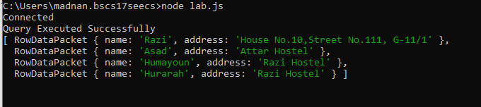

**Task 10:**

var mysql = require('mysql')

var con = mysql.createConnection({

host: "localhost",

user: "root",

password: "seecs@123",

database: "db"});

con.connect(function(err){

if(err) throw err;

console.log("Connected");

var sql = 'Select * from customers';

con.query(sql,function(err,result,fields){

if(err) throw err;

console.log("Query Executed Successfully")

console.log(fields);

});

});

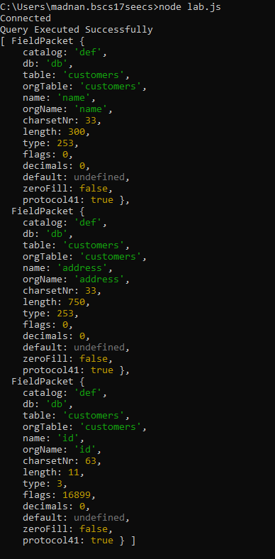

**Task 11:**

var mysql = require('mysql')

var con = mysql.createConnection({

host: "localhost",

user: "root",

password: "seecs@123",

database: "db"});

con.connect(function(err){

if(err) throw err;

console.log("Connected");

var sql = 'Select * from customers where address="Attar Hostel"';

con.query(sql,function(err,result){

if(err) throw err;

console.log("Query Executed Successfully")

console.log(result);

});

});

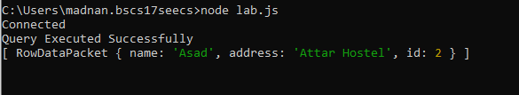

**Task 12:**

var mysql = require('mysql')

var con = mysql.createConnection({

host: "localhost",

user: "root",

password: "seecs@123",

database: "db"});

con.connect(function(err){

if(err) throw err;

console.log("Connected");

var sql = 'Select * from customers where address Like "H%"';

con.query(sql,function(err,result){

if(err) throw err;

console.log("Query Executed Successfully")

console.log(result);

});

});

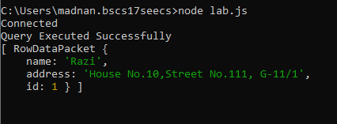

**Task 13:**

var mysql = require('mysql')

var con = mysql.createConnection({

host: "localhost",

user: "root",

password: "seecs@123",

database: "db"});

con.connect(function(err){

if(err) throw err;

console.log("Connected");

var sql = 'Select * from customers order by name';

con.query(sql,function(err,result){

if(err) throw err;

console.log("Query Executed Successfully")

console.log(result);

});

});

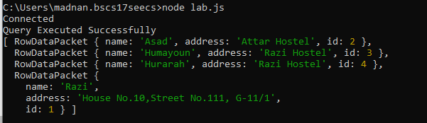

**Task 14:**

var mysql = require('mysql')

var con = mysql.createConnection({

host: "localhost",

user: "root",

password: "seecs@123",

database: "db"});

con.connect(function(err){

if(err) throw err;

console.log("Connected");

var sql = 'Delete from customers where address="Attar Hostel"';

con.query(sql,function(err,result){

if(err) throw err;

console.log("Query Executed Successfully")

console.log("Number of Rows Affected: "+result.affectedRows);

});

});

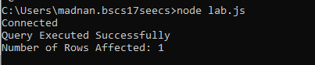

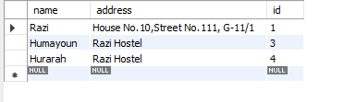

**Task 15:**

var mysql = require('mysql')

var con = mysql.createConnection({

host: "localhost",

user: "root",

password: "seecs@123",

database: "db"});

con.connect(function(err){

if(err) throw err;

console.log("Connected");

var sql = 'Drop table customers';

con.query(sql,function(err,result){

if(err) throw err;

console.log("Query Executed Successfully");

});

});

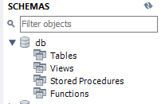

**Task 16:**

var mysql = require('mysql')

var con = mysql.createConnection({

host: "localhost",

user: "root",

password: "seecs@123",

database: "db"});

con.connect(function(err){

if(err) throw err;

console.log("Connected");

var sql = 'update customers set address = "Ghazali Hostel" where address="Attar Hostel"';

con.query(sql,function(err,result){

if(err) throw err;

console.log("Query Executed Successfully")

});

});

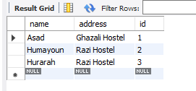

**Task 17:**

var mysql = require('mysql')

var con = mysql.createConnection({

host: "localhost",

user: "root",

password: "seecs@123",

database: "db"});

con.connect(function(err){

if(err) throw err;

console.log("Connected");

var sql = 'Select * from customers limit 5';

con.query(sql,function(err,result){

if(err) throw err;

console.log(result)

});

});

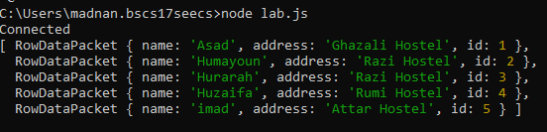

var mysql = require('mysql')

var con = mysql.createConnection({

host: "localhost",

user: "root",

password: "seecs@123",

database: "db"});

con.connect(function(err){

if(err) throw err;

console.log("Connected");

var sql = 'Select * from customers limit 2,5';

con.query(sql,function(err,result){

if(err) throw err;

console.log(result)

});

});

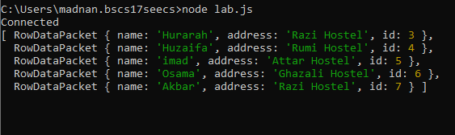

**Task 18:**

var mysql = require('mysql')

var con = mysql.createConnection({

host: "localhost",

user: "root",

password: "seecs@123",

database: "db"});

con.connect(function(err){

if(err) throw err;

console.log("Connected");

var sql = 'select customers.name,humans.age from customers join humans on customers.name = humans.name';

con.query(sql,function(err,result){

if(err) throw err;

console.log(result)

});

});

