Asad Manzoor

BSCS-7B

214405

TASK 1:

A:

 import React from 'react';

class Welcome extends React.Component {

constructor(){

super()

this.state={message:"welcome"}

}

  render(){

  return( <h1>{this.state.message}</h1>

  )

}

}

export default Welcome;

B:

 import React from 'react';

class Welcome extends React.Component {

  constructor(){

    super()

    this.state={message:"welcome visitor"}

    }

    changeMessage(){

    this.setState({

    message: "Thank you for subscribing"

    })

    }

      render(){

      return (

    <div>

    <h1>{this.state.message}</h1>

    <button onClick={()=>this.changeMessage()}>Subscribe</button>

    </div>

      )

    }

  }

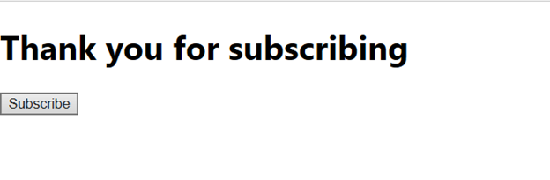

TASK 2:

import React from 'react';  
  
class clock extends React.Component{  
  constructor(props){  
    super(props);  
    this.state = {  
      mins: 0,  
      secs: 0  
    }  
    this.setTimer = this.setTimer.bind(this)  
    this.clock = this.clock.bind(this)  
    this.changeTime = this.changeTime.bind(this)  
  }  
  setTimer(event){  
    this.setState({  
      mins: event.target.value  
    })  
  }  
  
  clock(){  
    if(this.state.mins >=1){  
    this.setState({secs: 59, mins: this.state.mins-1 });  
    this.intervalID = setInterval(()=>this.changeTime() ,1000);}  
  }  
  
  changeTime(){  
    if(this.state.mins ===0 && this.state.secs===0)  
    {  
      clearInterval(this.intervalID);  
    }  
    else if(this.state.secs === 0 ) {  
      this.setState({  
        secs: 59,  
        mins: this.state.mins-1 })  
    }  
    else this.setState({secs: this.state.secs-1 })  
  }  
  
  render(){  
    return (  
    <div style={{padding: 20}}>  
      <input type="number" onChange={this.setTimer}/><div></div>  
      <div><h1>{this.state.mins}:{this.state.secs}</h1></div>  
      <button onClick={this.clock}>Start</button>  
    </div>  
    )  
  }  
}  
export default clock;

