

|  |  |  |  |  |
| --- | --- | --- | --- | --- |
| Experiment No. 1l |  |  |  |  |
| Program to demonstrate Mani manipulation using Pandas | data | frame | creation | and |
| Date of Performance:25/03/2024 |  |  |  |  |
| Date of Submission:08/04/2024 |  |  |  |  |

Experiment No. 11

Title: Program to demonstrate data frame creation and Manipulation using Pandas Aim: To study and implement data frame creation and Manipulation using Pandas

Objective: To introduce Pandas package for python

Theory:

Pandas is an open-source library that is built on top of NumPy library. It is a Python package that offers various data structures and operations for manipulating numerical data and time series. It is mainly popular for importing and analyzing data much easier. Pandas is fast and it has high-performance & productivity for users.

Installation of Pandas

If you have Python and PIP already installed on a system, then installation of Pandas is very easy.

Install it using this command:

|  |
| --- |
| C:\Users\Your Name>pip install pandas |

If this command fails, then use a python distribution that already has Pandas installed like, Anaconda, Spyder etc.

Import Pandas

Once Pandas is installed, import it in your applications by adding the import keyword:

import pandas

Now Pandas is imported and ready to use.

Example Code:

import pandas mydataset 'Fruit': ["Orange", "apple", "mango"],

'passings': [8 , 3 , 2]

myvar = pandas.DataFrame(mydataset) print(myvar)

OUTPUT:

# Fruit passings

8 Orange

1. apple 3
2. man go 2

Pandas as pd

Pandas is usually imported under the pd alias.

alias: In Python alias are an alternate name for referring to the same thing.

Create an alias with the as keyword while importing:

import pandas as pd

Now the Pandas package can be referred to as pd instead of pandas.

Example

import pandas as pd

mydataset

'Fruit': ["Orange", "apple", "mango"]'

'passings': [8 , 3 , 2]

myvar — pd.DataFrame(mydataset) print(myvar)

Checking Pandas Version

The version string is stored under version attribute.

Example

import pandas as pd print(pd. version_)

Output:

2.0. 3

What is a Series?

A Pandas Series is like a column in a table.

It is a one-dimensional array holding data of any type.

Example

Create a simple Pandas Series from a list:

import pandas as pd



myvar — pd.Series(a) print(myvar)

1

1. 7
2. 2 dtype: int64

Labels

If nothing else is specified, the values are labeled with their index number. First value has index 0, second value has index I etc.

This label can be used to access a specified value.

Example

Return the first value of the Series:

print(myvar[()])

# print(myvarCQ])

1

Create Labels

With the index argument, you can name your own labels.

Example

Create your own labels:

import pandas as pd



myvar pd.Series(a, index = ["a", "b", 'c ]) print(myvar)

 7 b 5 c 8

dtype•. int64

When you have created labels, you can access an item by referring to the label.

Example

Return the value of "y":

print(myvar["y"])

Key/Value Objects as Series

You can also use a key/value object, like a dictionary, when creating a Series.

Example

Create a simple Pandas Series from a dictionary:

import pandas as pd calories = {"dayl 420, "day2": 380, "day3": 390} myvar = pd. Series(calories) print(myvar)

dayl 428 day2 day3 dtype.• int64

To select only some of the items in the dictionary, use the index argument and specify only the items you want to include in the Series.

Example

Create a Series using only data from "dayl " and "day2":

import pandas as pd calories = {"dayl 420, "day2": 380, "day3": 390} myvar = pd.Series(calories, index = ["dayl ", "day2"]) print(myvar)

dayl 428 day2 388 dtype: int64

DataFrames

Data sets in Pandas are usually multi-dimensional tables, called DataFrames.

Series is like a column, a DataFrame is the whole table.

Example

Create a DataFrame from two Series:

import pandas as pd

data — {

"calories": [420, 380, 390],

"duration": [50, 40, 45]

myvar — pd.DataFrame(data) print(myvar)

# calories duration 8 428

1. 388 48
2. 45

Read CSV Files

A simple way to store big data sets is to use CSV files (comma separated files).

CSV files contains plain text and is a well know format that can be read by everyone including Pandas.

In our examples we will be using a CSV file called 'data.csv'.

Example

Load the CSV into a DataFrame:

import pandas as pd

df pd.read_csv('data.csv')

print(df.to_string())

Example:

Print the DataFrame without the to_string() method:

import pandas as pd df pd.read_csv('data.csv') print(df)

max rows

The number of rows returned is defined in Pandas option settings.

You can check your system's maximum rows with the pd.options.display.max rows statement.

Example

Check the number of maximum returned rows:

import pandas as pd

print(pd.options.display.max rows)

import pandas as pd

# print(pd.options.display.max rows)

68

Example

Increase the maximum number of rows to display the entire DataFrame:

import pandas as pd

pd.options.display.max rows = 9999

df — pd.read_csv('data.csv')

print(df)

Code:

mport pandas as pd df pd.read_csv('data.csv') print("Original DataFrame:") print(df) print() dfl'Average'] — dfl['quizl-marks', 'quiz2-marks', 'quiz3-marks']].mean(axis=1) df = df.sort_values(by='total', ascending=False) print("Manipulated DataFrame:") print(df)

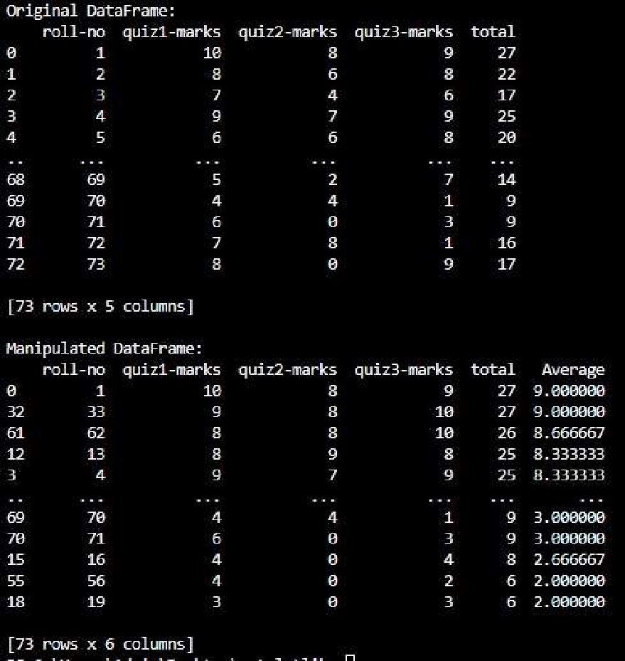

**Conclusion:** we have successfully studied and implemented various data frame creation and manipulation techniques using the Pandas library in Python. We have learned how to create data frames using different methods such as from a dictionary, structured/unstructured data, and CSV files. We have also explored various data manipulation techniques like filtering, sorting, reshaping, merging, and joining data frames. Additionally, we have gained knowledge on how to clean and prepare data for analysis by handling missing values, renaming columns, and changing data types.