|  |
| --- |
| Experiment No. 13 |
| Program to demonstrate CRUD (create, read, update and delete) operations on database (SQLite/ MySQL) using python |
| Date of Performance: 08/04/2024 |
| Date of Submission: 15/04/2024 |

**Experiment No. 13**

**Title:** Program to demonstrate CRUD (create, read, update and delete) operations on database (SQLite/ MySQL) using python

**Aim:** To study and implement CRUD (create, read, update and delete) operations on database (SQLite/ MySQL) using python

**Objective:** To introduce database connectivity with python

**Theory:**

In general CRUD means performing Create, Retrieve, Update and Delete operations on a table in a database. Let’s discuss what actually CRUD means,

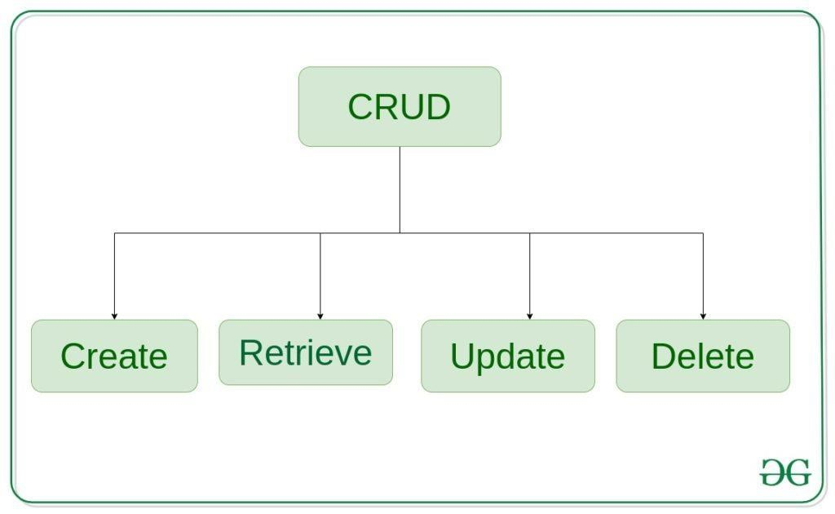

**Create** – create or add new entries in a table in the database.

**Retrieve** – read, retrieve, search, or view existing entries as a list(List View) or retrieve a

particular entry in detail (Detail View)

**Update** – update or edit existing entries in a table in the database

**Delete** – delete, deactivate, or remove existing entries in a table in the database

**Code:**

import sqlite3

conn = sqlite3.connect('data.db') cursor = conn.cursor()

cursor.execute('''CREATE TABLE IF NOT EXISTS employees

(id INTEGER PRIMARY KEY, name TEXT, age INTEGER, position TEXT)''')

cursor.execute("INSERT INTO employees (name, age, position) VALUES ('Jidnyasa', 20,

'Manager')")

cursor.execute("INSERT INTO employees (name, age, position) VALUES ('Jyoti', 20,

'Developer')")

cursor.execute("INSERT INTO employees (name, age, position) VALUES ('Ankul', 20,

'Analyst')")

cursor.execute("INSERT INTO employees (name, age, position) VALUES ('Vedant', 19, 'Engineer')")

conn.commit()

print("Records in the employees table:") cursor.execute("SELECT * FROM employees") rows = cursor.fetchall() for row in rows: print(row)

cursor.execute("UPDATE employees SET age = 18 WHERE name = 'Jidnyasa'") conn.commit()

print("\nAfter updating Jidnyasa's age:") cursor.execute("SELECT * FROM employees") rows = cursor.fetchall() for row in rows: print(row)

cursor.execute("DELETE FROM employees WHERE name = 'Jyoti'") conn.commit()

print("\nAfter deleting Jyoti's record:") cursor.execute("SELECT * FROM employees") rows = cursor.fetchall() for row in rows:

print(row)

conn.close()

**Output:**

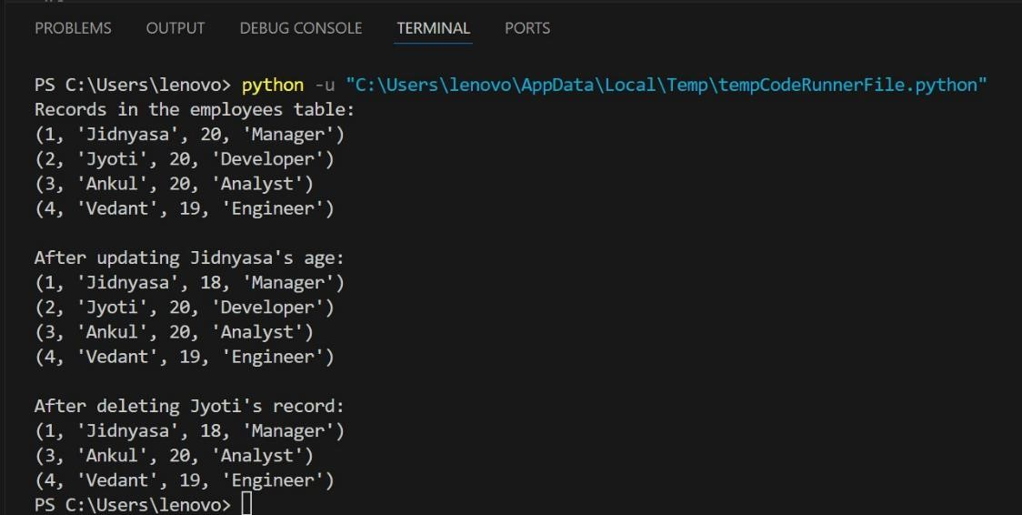

**Conclusion:**

The code establishes a SQLite database connection, creates a table named "employees" if it doesn't exist already, inserts four records into the table, and then performs two operations: updating the age of one employee to 18 and deleting the record of another employee. After each operation, the code fetches and prints all records in the "employees" table to demonstrate the changes made. In conclusion, the code effectively demonstrates basic CRUD (Create, Read, Update, Delete) operations on a SQLite database table without mentioning specific employee names.