|  |
| --- |
| Experiment No. 8 |
| Creating GUI with python containing widgets such as labels, textbox, radio, checkboxes and custom dialog boxes |
| Date of Performance:18/03/2024 |
| Date of Submission:25/03/2024 |

**Experiment No. 7**

**Title:** Creating GUI with python containing widgets such as labels, textbox, radio, checkboxes and custom dialog boxes

**Aim:** To study and create GUI with python containing widgets such as labels, textbox, radio, checkboxes and custom dialog boxes

**Objective:** To introduce GUI, TKinter in python

# Theory:

Python offers multiple options for developing GUI (Graphical User Interface). Out of all the GUI methods, tkinter is the most commonly used method. It is a standard Python interface to the Tk GUI toolkit shipped with Python. Python with tkinter is the fastest and easiest way to create the GUI applications. Creating a GUI using tkinter is an easy task.

To create a tkinter app:

Importing the module – tkinter Create the main window (container)

Add any number of widgets to the main window Apply the event Trigger on the widgets.

Importing tkinter is same as importing any other module in the Python code. Note that the name of the module in Python 2.x is ‘Tkinter’ and in Python 3.x it is ‘tkinter’.

# Code:

import tkinter as tk

from tkinter import messagebox def submit():

name = name_entry.get() email = email_entry.get() course = course_entry.get()

semester = semester_entry.get()

messagebox.showinfo(" Submitted" , f"Name: {name} \nEmail:

{email}\nCourse:{course}\nSemester: {semester} ") def clear():

name_entry.delete(0, tk.END) email_entry.delete(0, tk.END) course_entry.delete(0, tk.END) semester_entry. delete(0, tk.END)

root = tk.Tk()

root.title("Student Registration Form") name_label = tk.Label(root, text="Name:")

name_label.grid(row=0, column=0, padx=10, pady=5, sticky="e") email_label = tk.Label(root, text="Email:") email_label.grid(row=1, column=0, padx=10, pady=5, sticky="e") course_label = tk.Label(root, text="Course:") course_label.grid(row=2, column=0, padx=10, pady=5, sticky="e") semester_label = tk.Label(root, text="Semester:")

semester_label.grid(row=3, column=0, padx=10, pady=5, sticky="e") name_entry = tk.Entry(root)

name_entry.grid(row=0, column=1, padx=10, pady=5) email_entry = tk.Entry(root)

email_entry.grid(row=1, column=1, padx=10, pady=5) course_entry = tk.Entry(root)

course_entry.grid(row=2, column=1, padx=10, pady=5) semester_entry = tk.Entry(root) semester_entry.grid(row=3, column=1, padx=10, pady=5)

submit_button = tk.Button(root, text="Submit", command=submit) submit_button.grid(row=4, column=0, columnspan=2, pady=10) clear_button = tk.Button(root, text="Clear", command=clear) clear_button.grid(row=5, column=0, columnspan=2, pady=10) root.mainloop()

# Output:

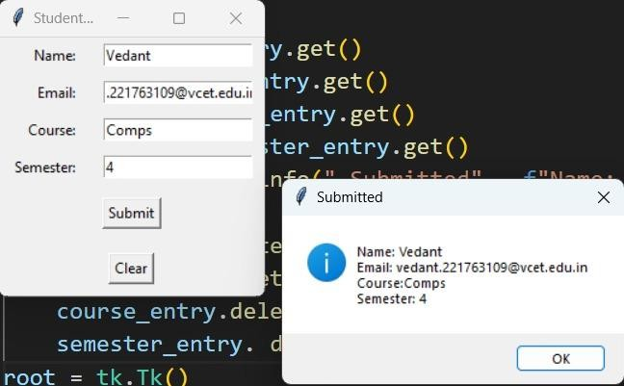

**Conclusion:**

Tkinter is a powerful and easy-to-use library for creating graphical user interfaces (GUIs) in Python. It comes bundled with Python, so there's no need for additional installations, making it convenient for beginners and professionals alike.