Comparative Evaluation of Backup Tools
Criteria | Restic | Duplicati | UrBackup
Recovery Time | 6–7 sec | ~15 sec | ~20–25 sec
Recovery Rate | 100% | 100% | 100%
Data Integrity | 100% | 100% | 100%
Usability | Medium | Easy | Easy
Scalability | Medium | Medium | High
Figure: Backup Tools Comparison Infographic
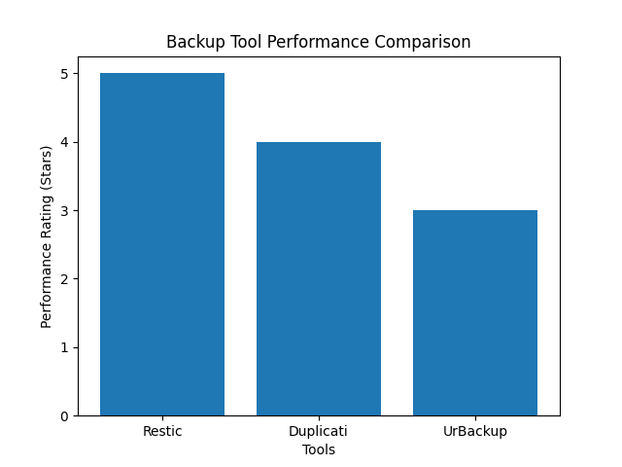
Comparative Evaluation of Backup Tools
Criteria | Restic | Duplicati | UrBackup
Type | Command-line backup tool | GUI-based backup tool | Client-server backup system
Architecture | Local / repository-based | Local / cloud-based | Centralized server-based
Recovery Time (RTO) | 6–7 sec (Fastest) | ~15 sec (Moderate) | ~20–25 sec (Slowest)
Recovery Rate | 100% | 100% | 100%
Data Integrity | 100% (Hash Match) | 100% (Hash Match) | 100% (Hash Match)
Data Loss (RPO) | 0% | 0% | 0%
Encryption Impact Recovery | Fully recovered | Fully recovered | Fully recovered
Backup Size Efficiency | High (Compressed) | Medium | Lower (larger storage)
Performance Efficiency | ⭐⭐⭐⭐⭐ | ⭐⭐⭐⭐ | ⭐⭐⭐
Ease of Use | Moderate (CLI required) | Very Easy (GUI) | Easy
Scalability | Medium | Medium | High (multi-client)
Reliability | ⭐⭐⭐⭐⭐ | ⭐⭐⭐⭐ | ⭐⭐⭐⭐
Best Use Case | Fast recovery systems | Small businesses / beginners | Enterprise / network backups

Table Analysis
The comparison highlights that while all three tools successfully achieved full data recovery with zero data loss, their performance differs significantly in terms of efficiency and usability.
Restic stands out as the most efficient tool due to its fastest recovery time and optimized storage usage. Duplicati provides the best user experience through its graphical interface, making it suitable for less technical users. UrBackup, although slower, offers strong scalability and centralized backup management, making it ideal for enterprise environments.
Overall, the results suggest that the choice of backup tool should depend on organizational needs, balancing recovery speed, usability, and system architecture.

