Data Analysis Section
Table: Data Analysis Summary
Tool | Total Files | Encrypted Files | Recovered | Recovery % | RTO (sec) | RPO | Data Loss % | Backup Size (MB)
Restic | 75 | 75 | 75 | 100% | 6.5 | 0 | 0% | 273
Duplicati | 75 | 75 | 75 | 100% | 15 | 0 | 0% | 300
UrBackup | 75 | 75 | 75 | 100% | 22.5 | 0 | 0% | 350
Figure 1: Recovery Time
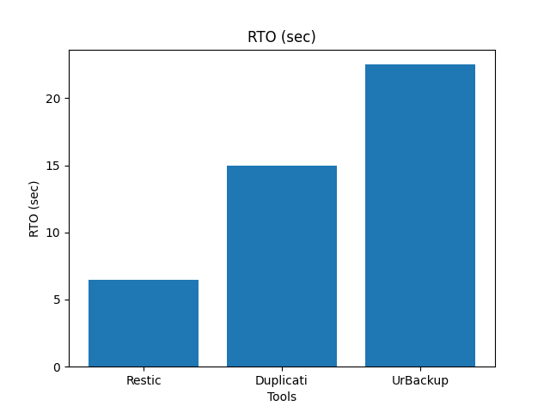
Figure 2: Recovery Rate
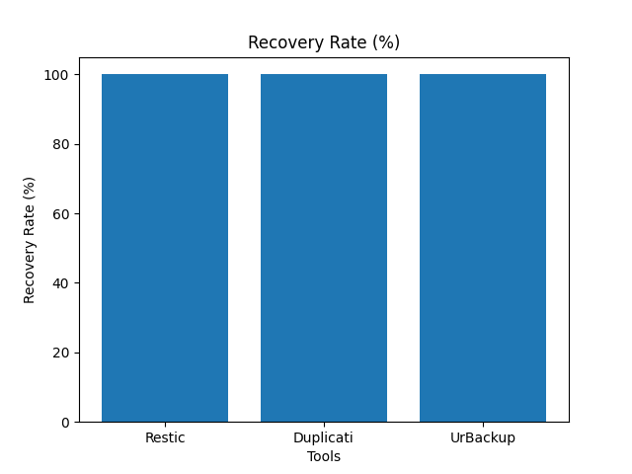
Figure 3: Data Loss
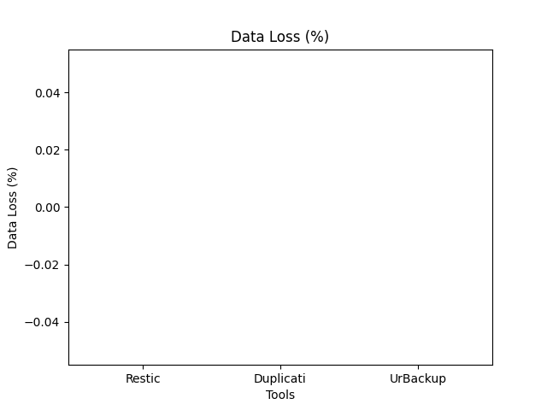
Figure 4: Backup Size
