Backup Data Analysis Graphs
Figure 1: Recovery Time Comparison
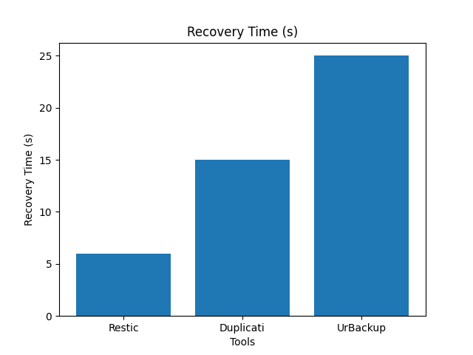
Figure 2: Recovery Rate Comparison
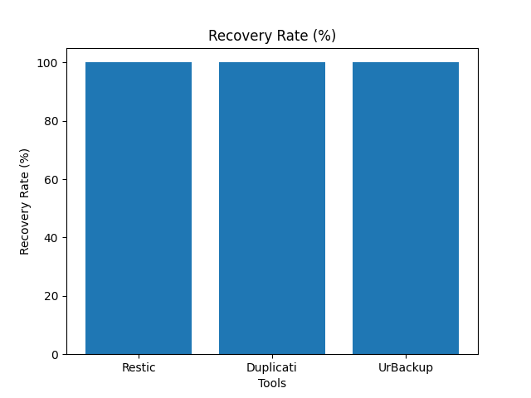
Figure 3: Data Integrity Comparison
