Encryption Impact Analysis
Metric | Description | Formula
Files Encrypted | Number of affected files | Count .locked files
Encryption Rate (%) | % of files affected | (Encrypted / Total) × 100
Time to Encrypt | How fast ransomware spreads | End – Start time
Size Change (%) | File size difference after encryption | ((Encrypted Size - Original Size) / Original Size) × 100
Accessibility Loss | Can files be opened? | Yes/No
System Impact | CPU / system slowdown | Observed

Figure: Encryption Impact (Before vs After Attack)
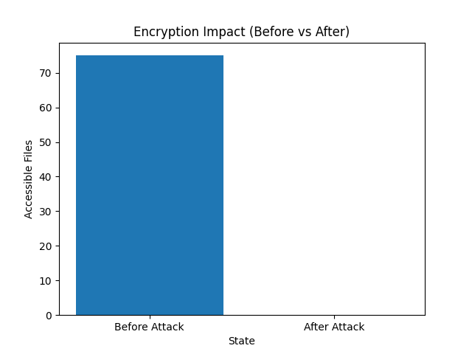
The graph shows that all files became inaccessible after the ransomware attack, demonstrating a 100% loss of accessibility.

Encryption Impact Analysis
The ransomware simulation resulted in the encryption of all 75 files within the dataset, producing an encryption rate of 100%. All files were renamed with a .locked extension, rendering them inaccessible to users.
This demonstrates the severe impact of ransomware attacks, where complete loss of data accessibility can occur within a short period. The system experienced full operational disruption, as none of the files could be opened or used after encryption.
The findings highlight the critical importance of implementing reliable backup solutions, as encryption alone can effectively halt business operations. Without backup systems, such an attack would result in total data loss.
This analysis reinforces the need for proactive cybersecurity measures, including regular backups, monitoring, and rapid recovery strategies.

