Better Joystick For DFGUI (v 0.1)

This package contains ready-to-use high performance mobile joystick for Daikon Forge GUI and a demo scene showing joystick usage example.

- Better performance comparing to Daikon Forge Joystick as Physics.Raycast is not used to detect touch.
- No additional draw calls provided joystick uses the same atlas as the rest of your DFGUI controls.
- Full multitouch support – add as many joysticks as you like.

Inspired by Daikon Forge Touch Joystick and Mobile CNJoystick.

Installation

This package requires Daikon Forge GUI Library. Please first import Daikon Forge GUI package and then import this package. It may not work properly otherwise.

Take a look at the contents of the “Better Joystick For DFGUI” folder:

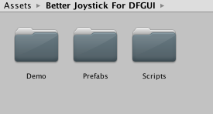

- Demo folder contains demo scene
- Prefabs folder contains joystick prefab
- Scripts folder contains source for joystick script

To use joystick, first create UI Root using Daikon Forge UI Wizard (GameObject – Daikon Forge – UI Wizard menu).

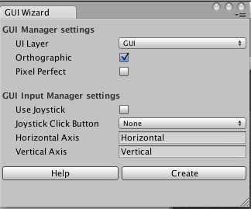
Select “Touch Joystick Atlas” as Default Atlas.

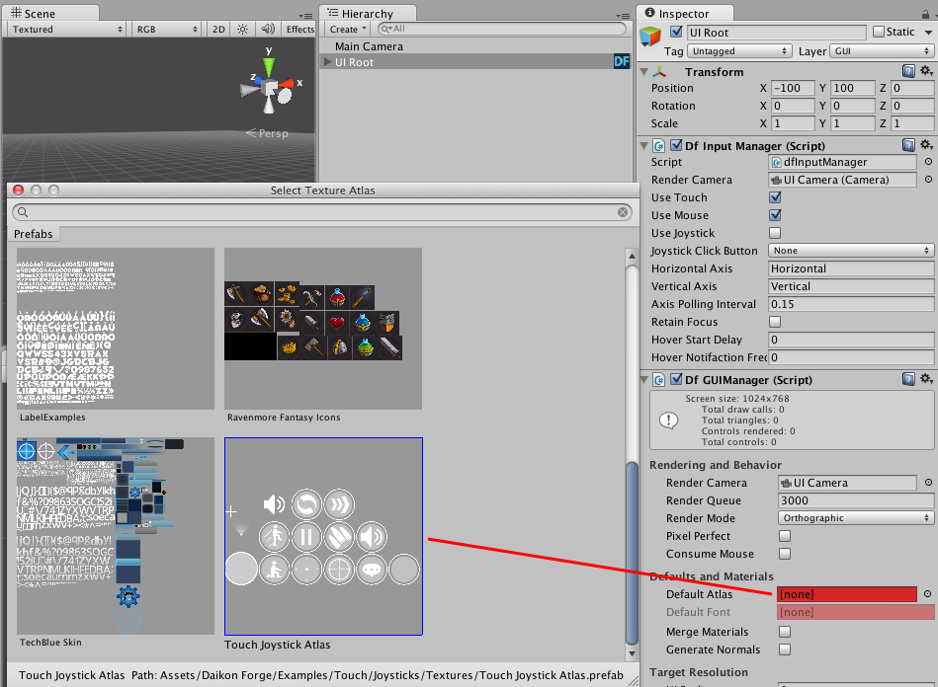
Now drag Joystick prefab onto UI Root. Joystick consists of parent panel (Joystick) and two sprites (Thumb and Thumb Area). Joystick panel has green border around it. Only taps that occur inside the panel will be used for control.

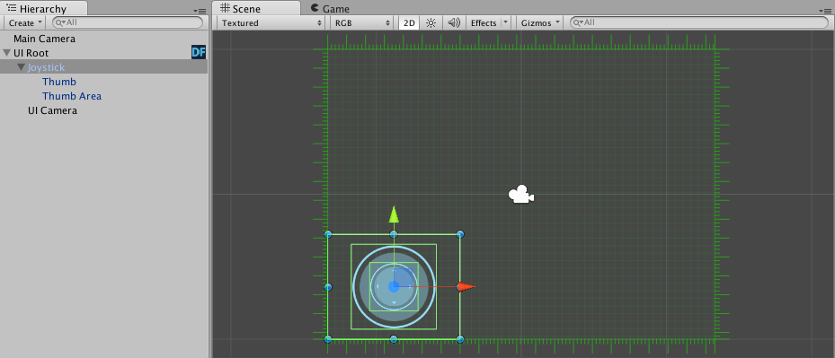

You can drag Joystick panel around the screen. For example, move it to the bottom right corner.

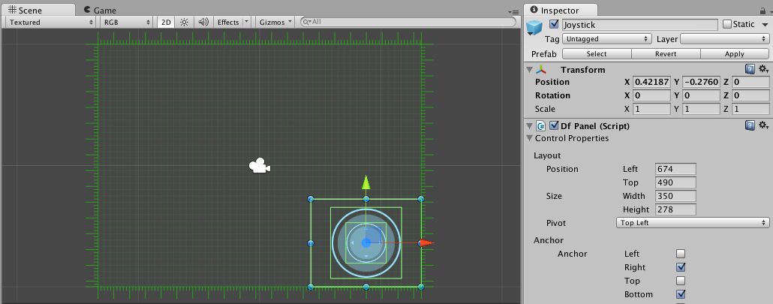

Properties:

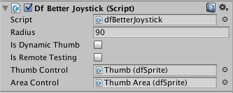

- Radius – How far the thumb can be moved from the center of the area.
- Is Dynamic Thumb – When checked, area control will snap to the tap or click position.
- Is Remote Testing – Check this when you are using Unity Remote app for testing. Otherwise, it must be unchecked.

Try running your scene in the editor. You should be able to tweak the joystick with your mouse.

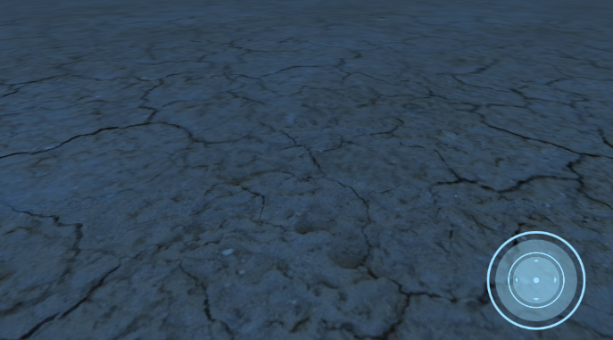
Let's get to character controls.

First make a Plane for your character to run on if there's none yet. Then drag Player prefab to the scene view and place it somewhere above the surface of the floor. Note that it already contains Camera Relative Setup script and Character Controller components. If you are going to make your custom character move, just drop Camera Relative Setup script on its game object and it will automatically add a Character Controller to it.

Now drag your joystick to the Joystick slot in the CameraRelativeSetup component.

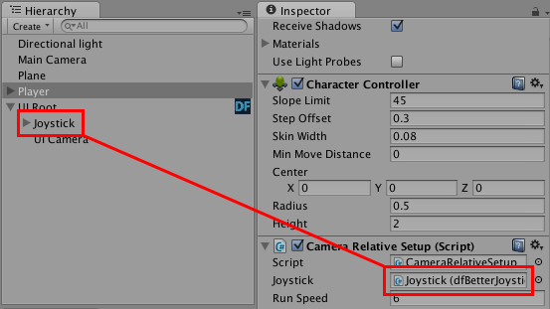
That's it, your character is already controllable. Yet your camera is not following it. Drag CameraFollow script to your camera and link your Player to its Target Object property.

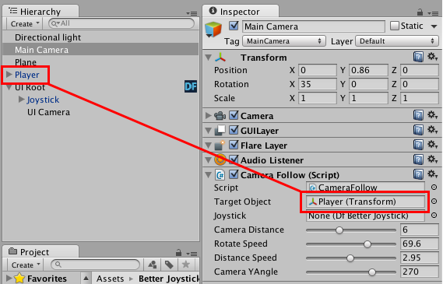

Camera Follow script has a joystick property. It's not a mandatory but if you link a joystick to it, you'll be able to control the camera.

Try running your scene, you should be able to control your character. You can also create a second joystick and control your camera with it.

Events

Better Joystick has the following public events:

- JoystickMovedEvent is called each frame if player is currently tweaking the joystick. It has a Vector3 parameter which represents relative position of the joystick. X and Y components are between 0 and 1. 0 is center and 1 is full radius. Z component is always 0.

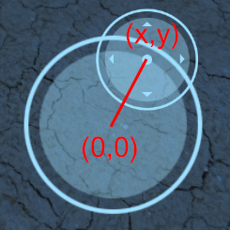

- FingerLiftedEvent is called once when user removes finger from the joystick. Useful for stopping your character.

- FingerTouchedEvent is called once when player begins tweaking the joystick. Useful when you need to know when user starts interaction.

