**Great Outdoors**

**Azure Tasks Document**

**Team A**

**Publish an ASP.NET MVC Web application in Azure**

**Step 1:**

Details entered:

Resource Group: Team A

Name: Great Outdoors

Publish: Code

Runtime Stack: .NET Core

Operating System: Linux

Region: Central US

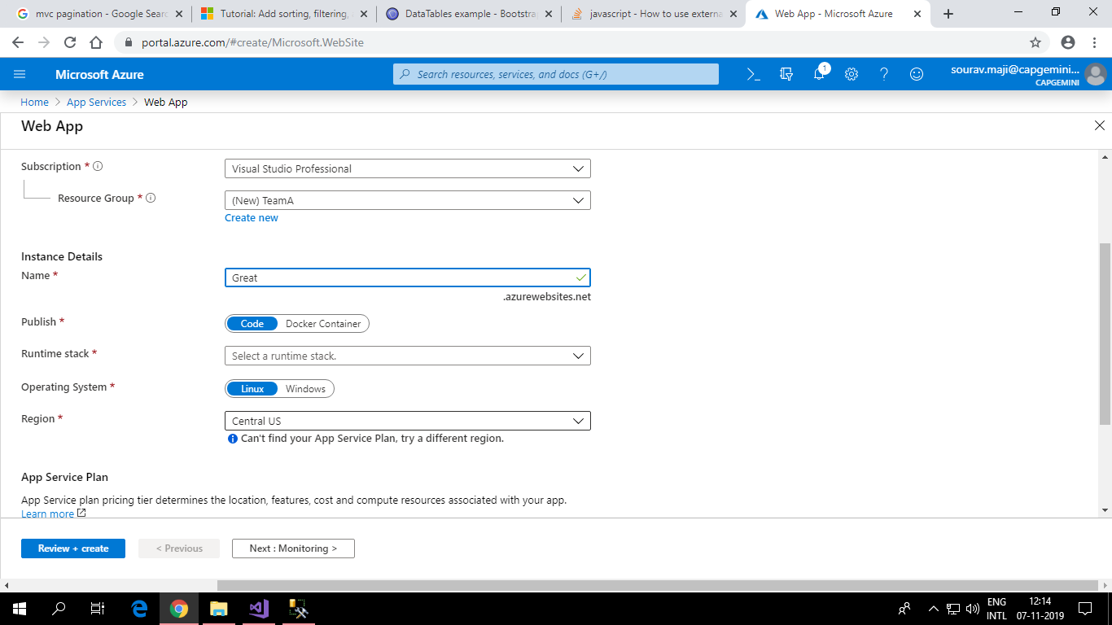

**Step 2:**

Setting the connection string to connect to the Database in Azure.

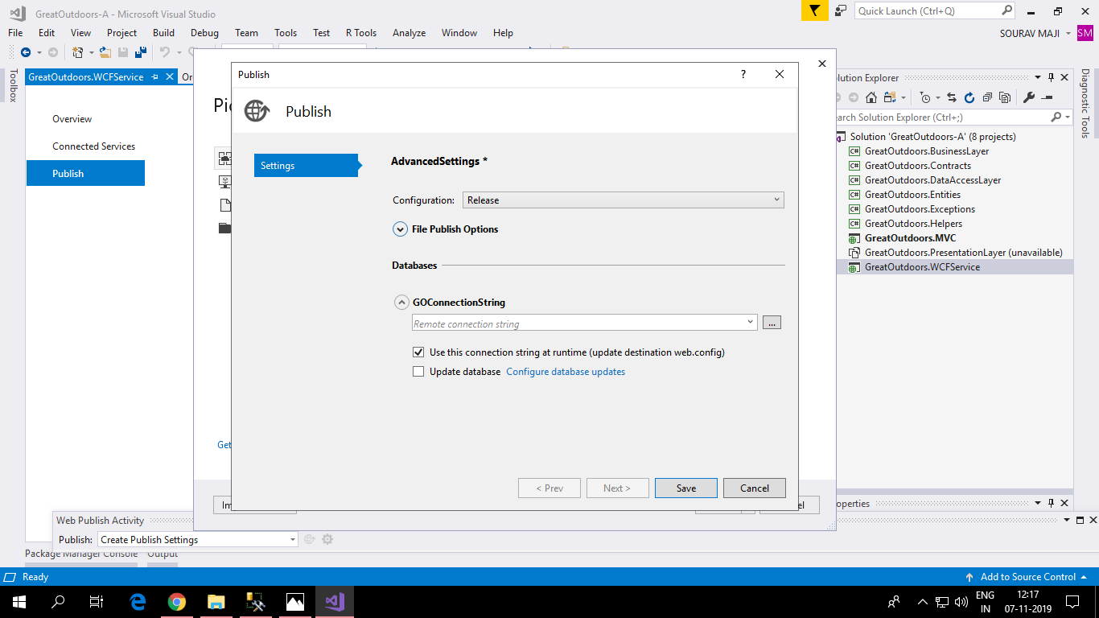

**Step 3:**

Allow precompile site to be updatable.

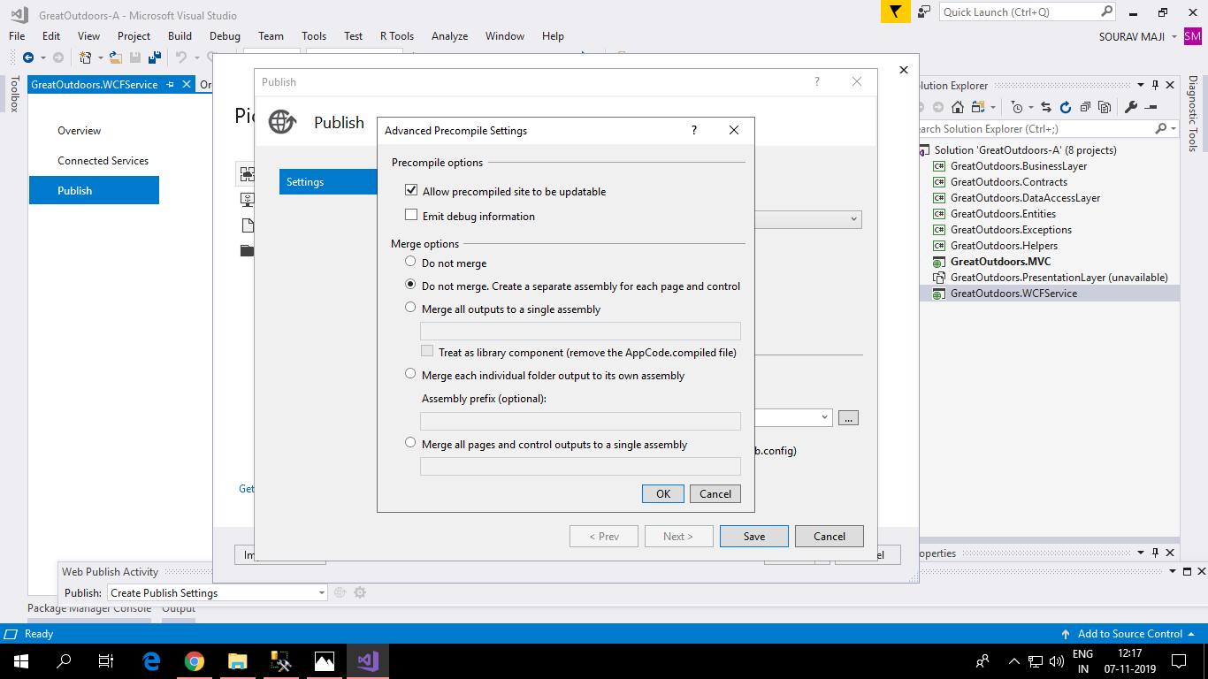

**Step 4:**

Select the Web App previously created.

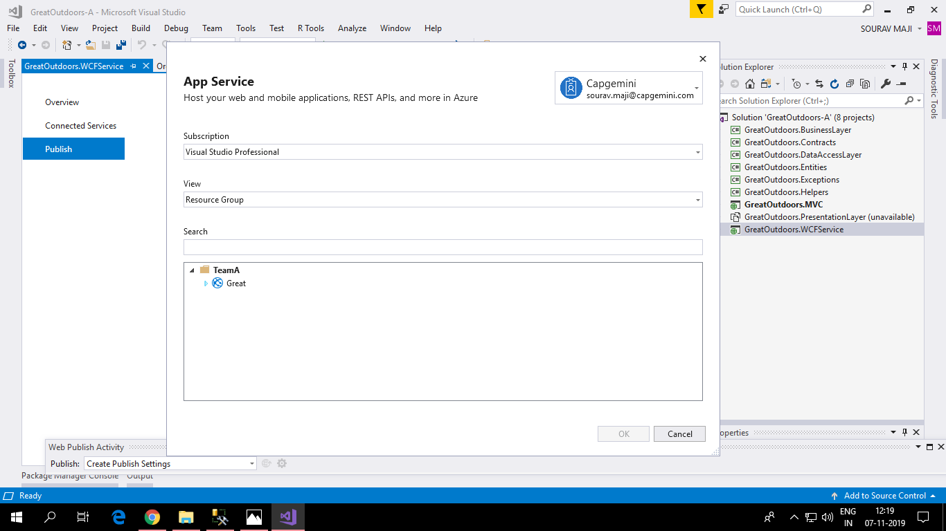

**Step 5:**

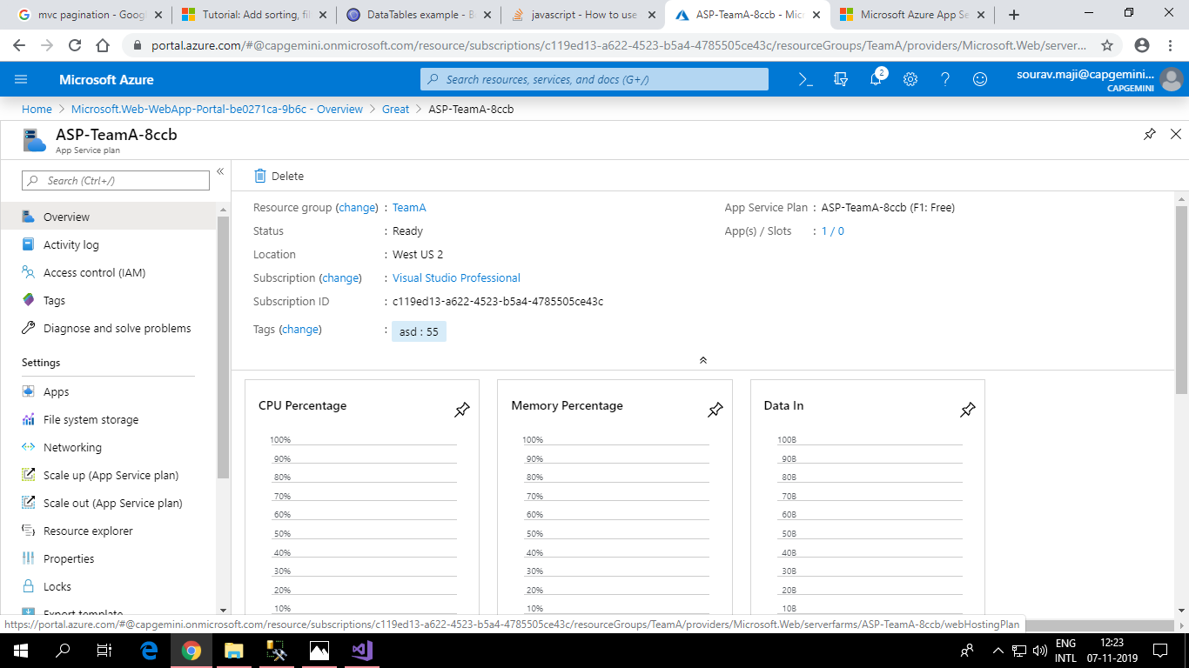

**Creating and Deploying a Function app in Azure**

**Step 1:**

Details to be entered:

Resource Group: Use existing resource 13thAugustPTImmersive

App Name: GreatOutdoors

Publish: Code

Runtime Stack: .NET Core

Region: West US 2

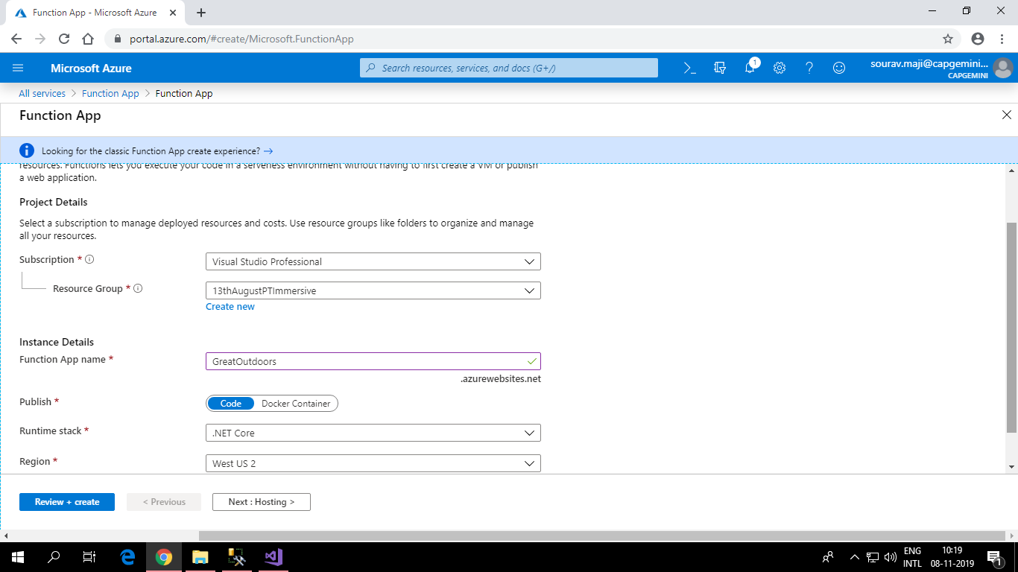

**Step 2:**

Creating new storage account.

OS: Windows

Plan: Consumption

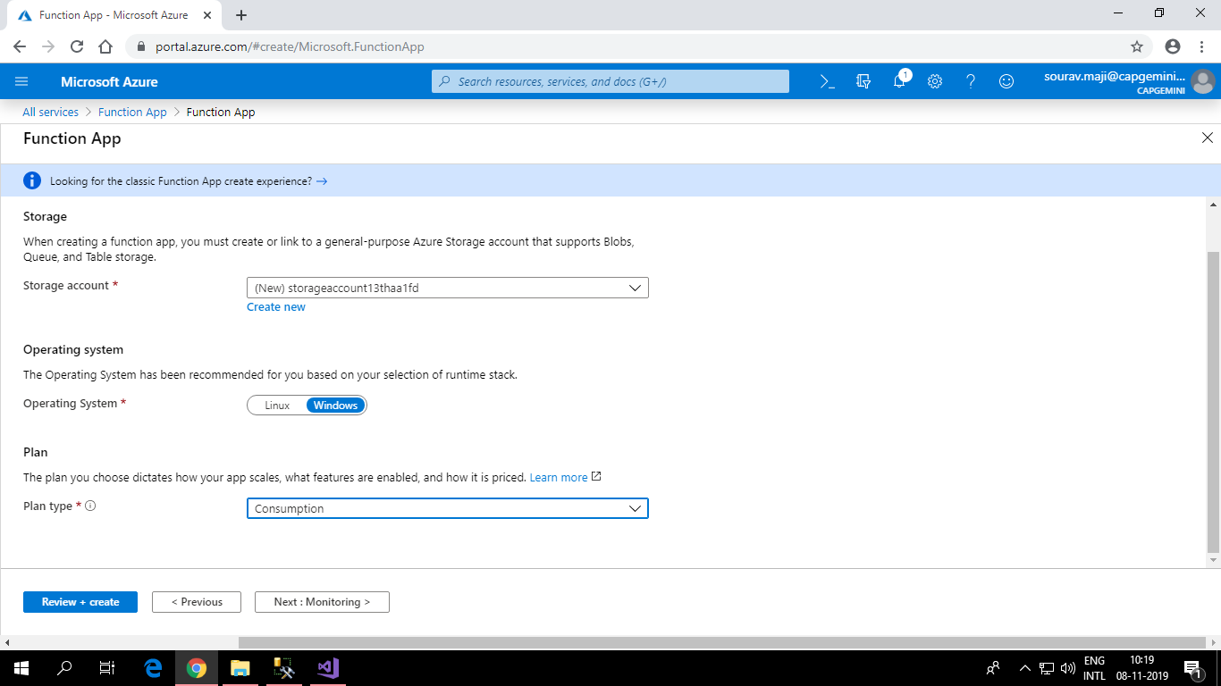

**Step 3:**

Enabling Application Insights

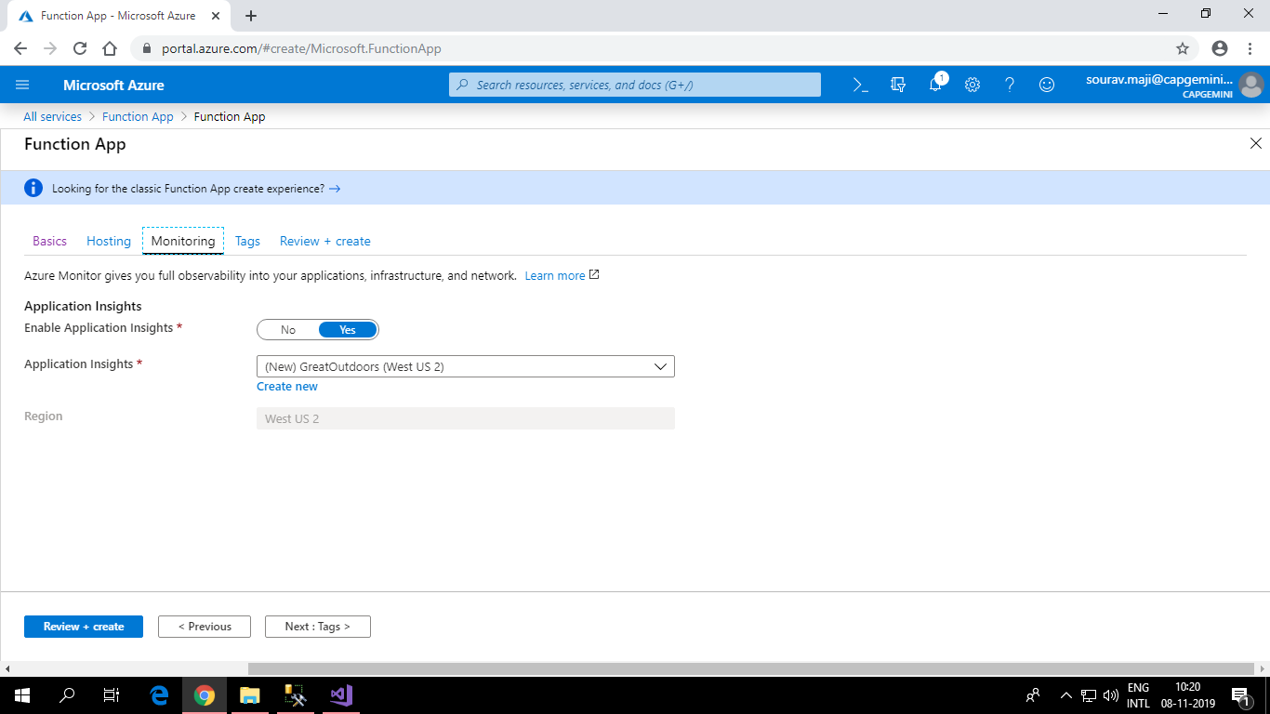

**Step 4:**

Adding tag to group the resources.

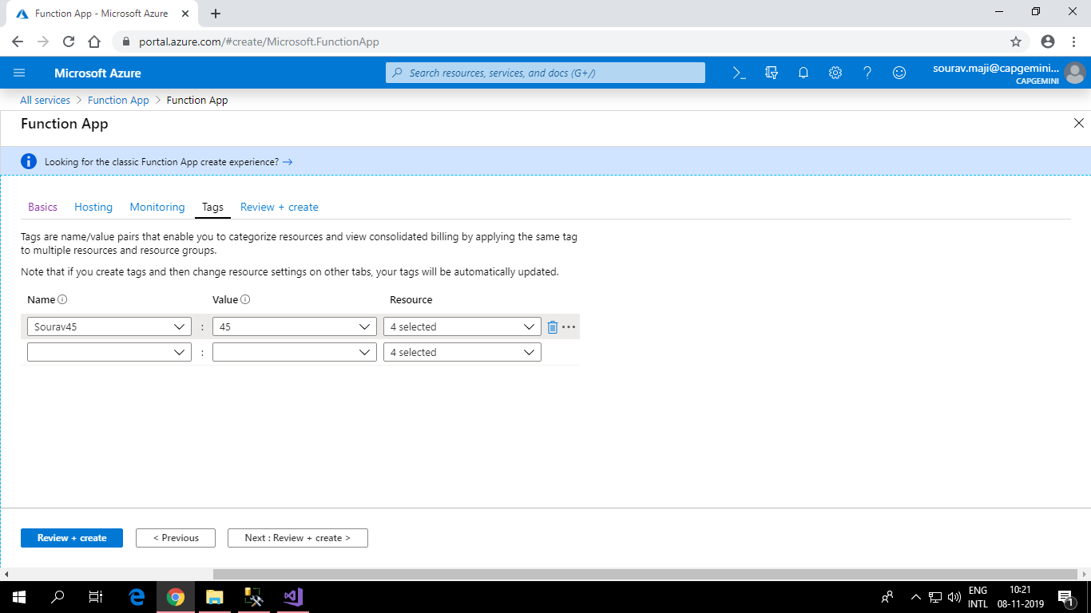

**Step 5:**

Choose In-portal to author functions in the Azure Portal

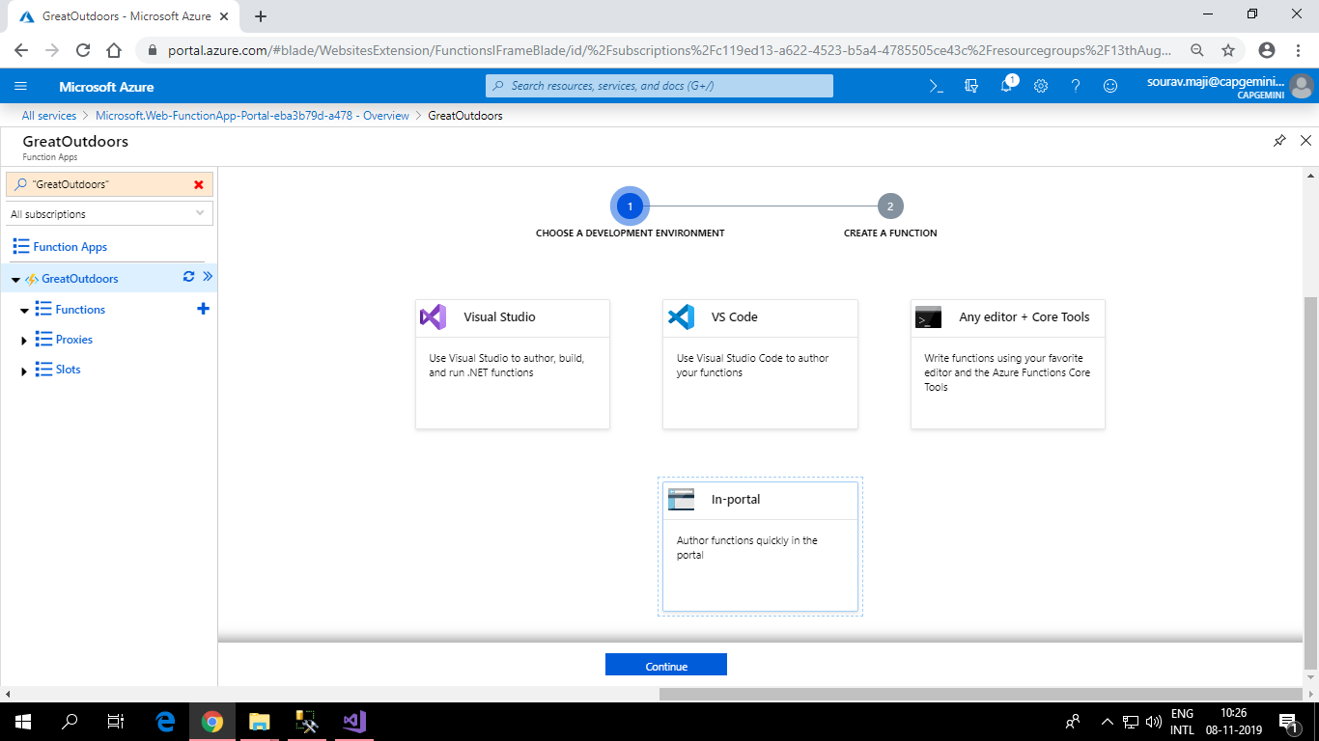

**Step 6:**

Choosing Webhook + API as function to be created.

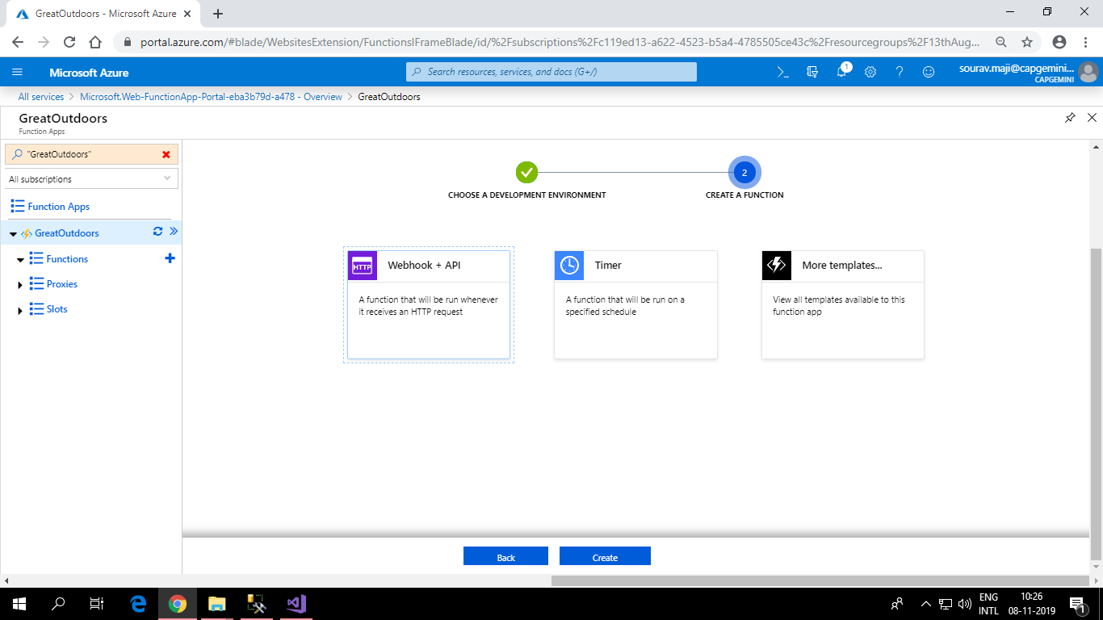

**Step 7:**

Deploying the Function App

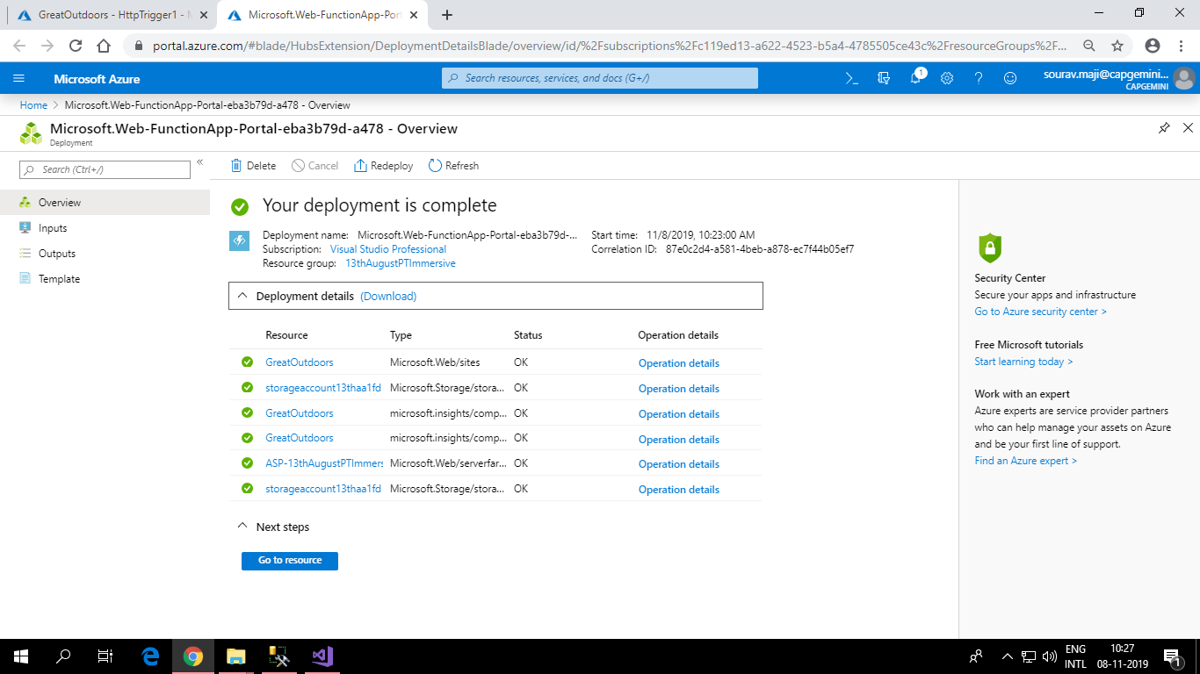

**Step 9:**

Create a Http Trigger function to display the name entered in the url.

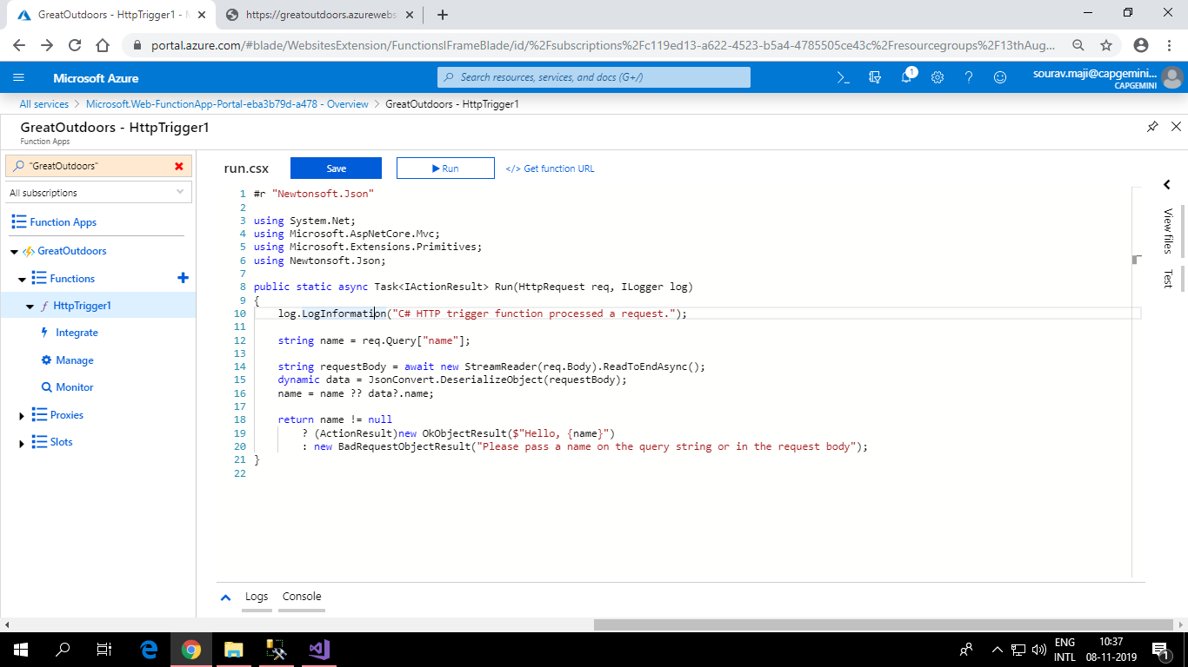

**Step 10:**

Output

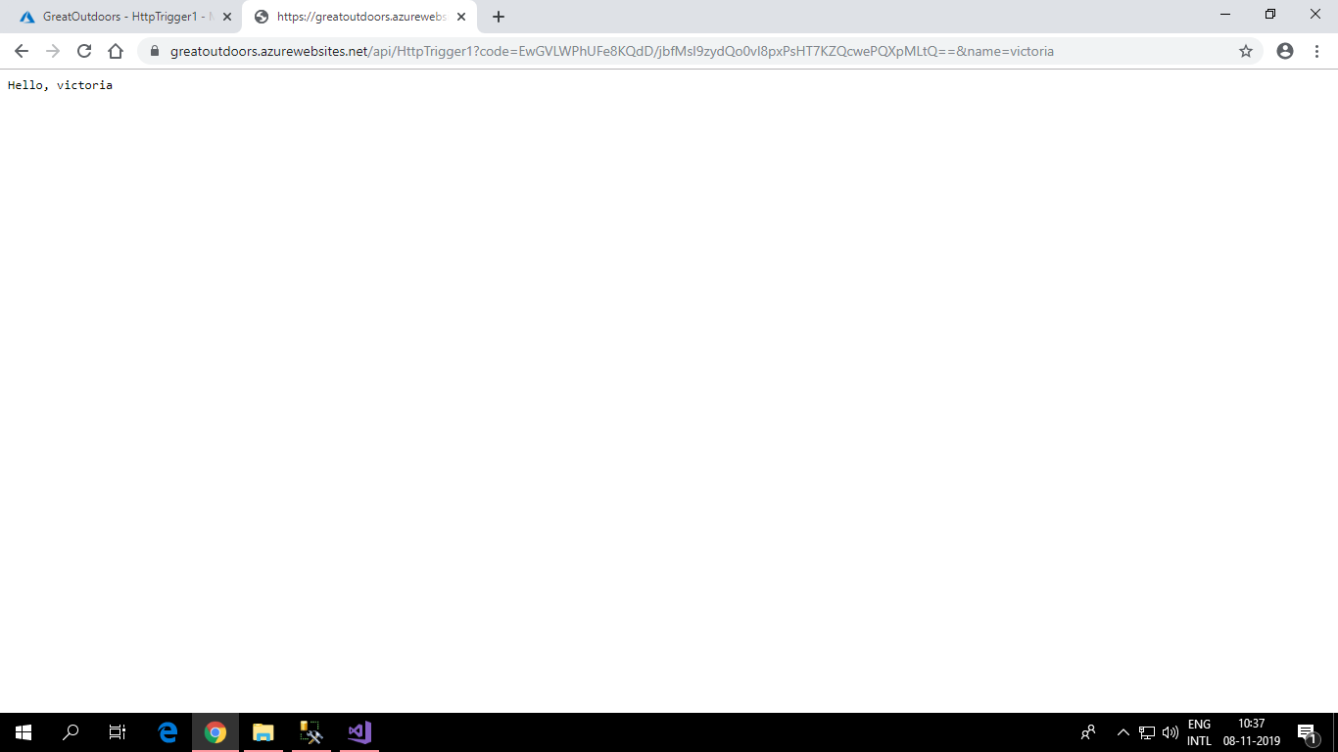

**Creating more Http Trigger Function in Azure and using ADO.NET**

**Step 1:**

Creating table using ADO.NET in function app

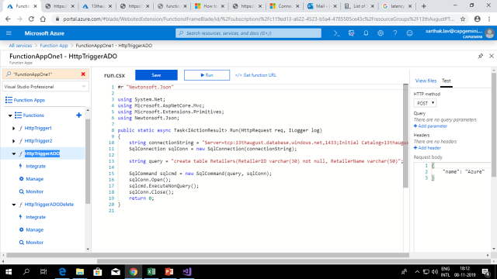

**Step.2**

After inserting some rows, a row was deleted.

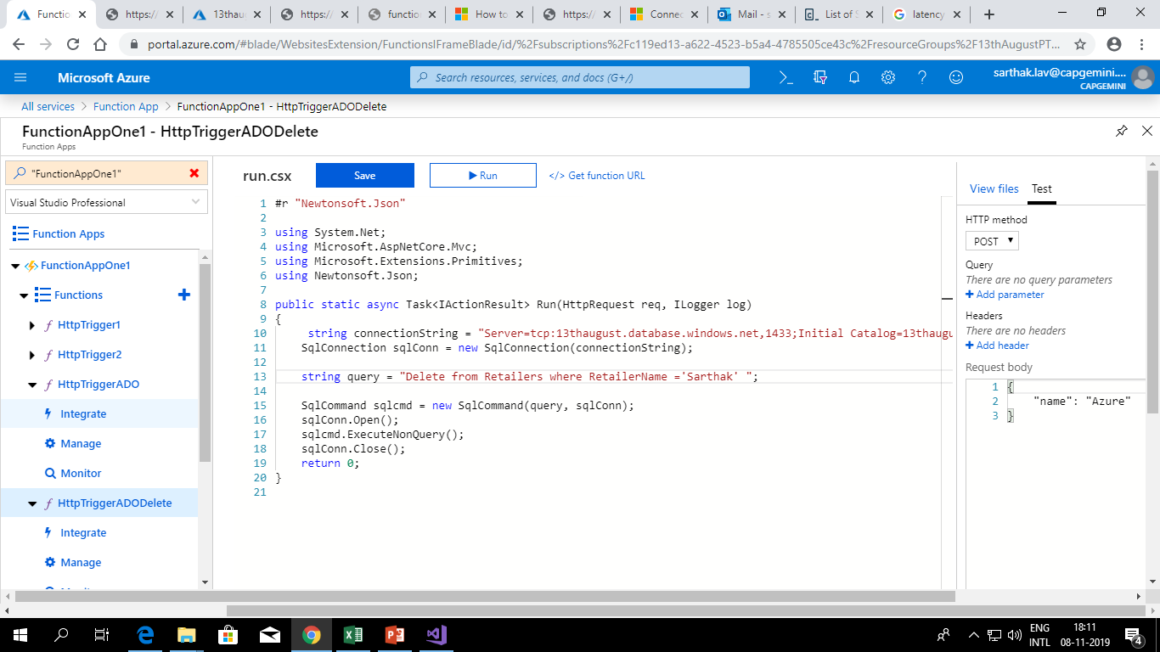

**Cognitive services**

Step 1. Cognitive services were used to show search suggestions.

Step 2. The html page consumes the auto suggest service and the results were shown in JSON format.

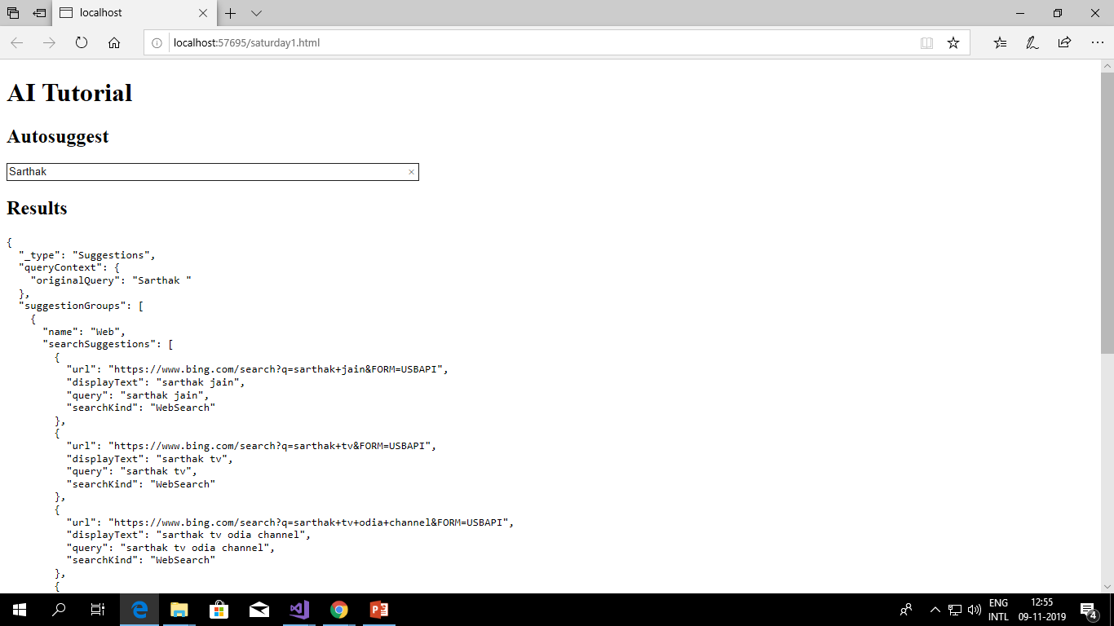

**Using blob storage services**

**Step 1.** Create storage account.

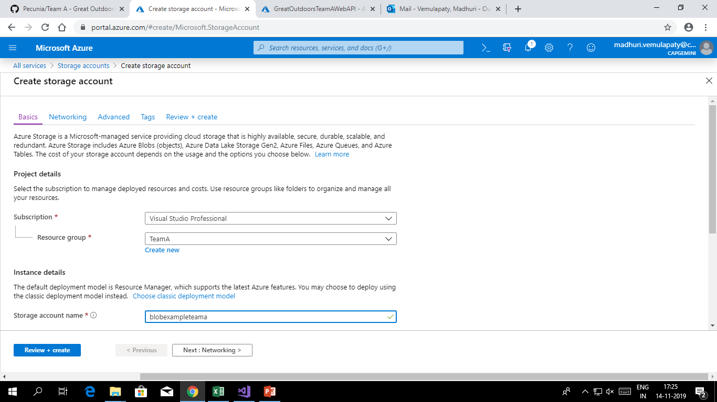

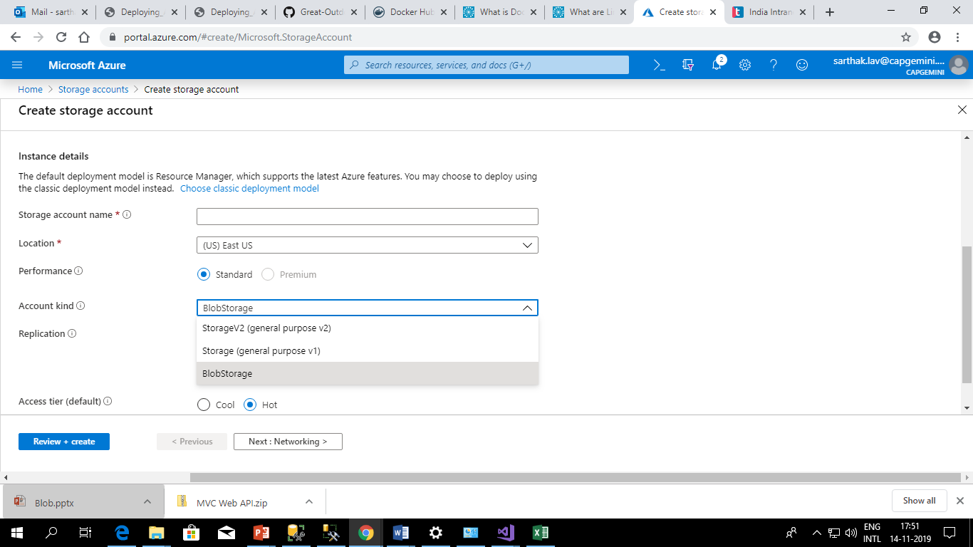

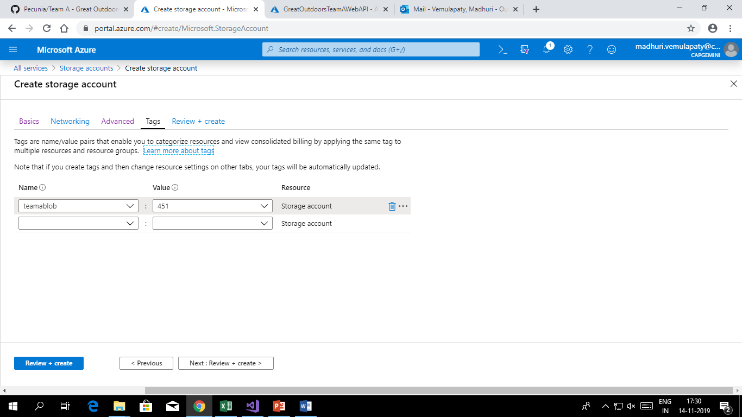

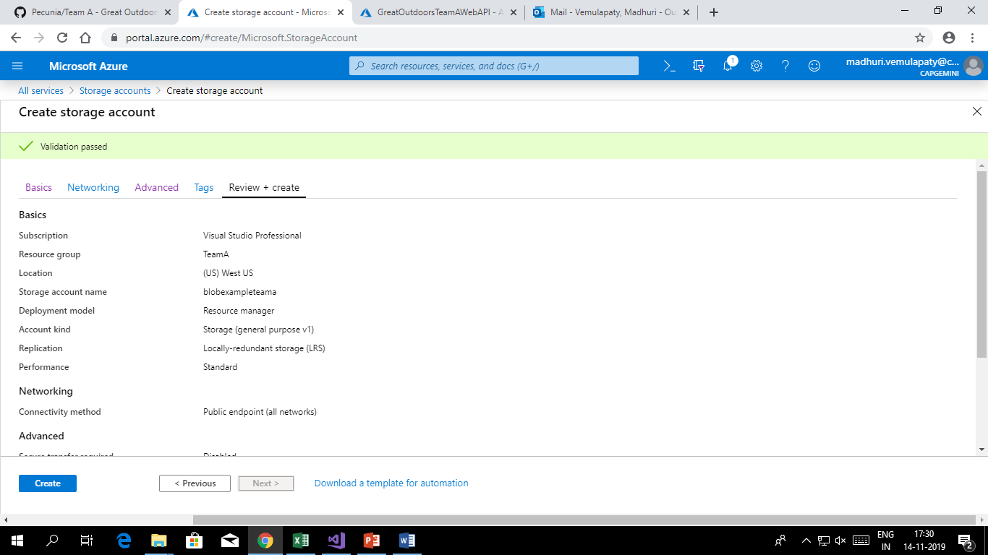

**Step 2.** After creating storage account it will be deployed.

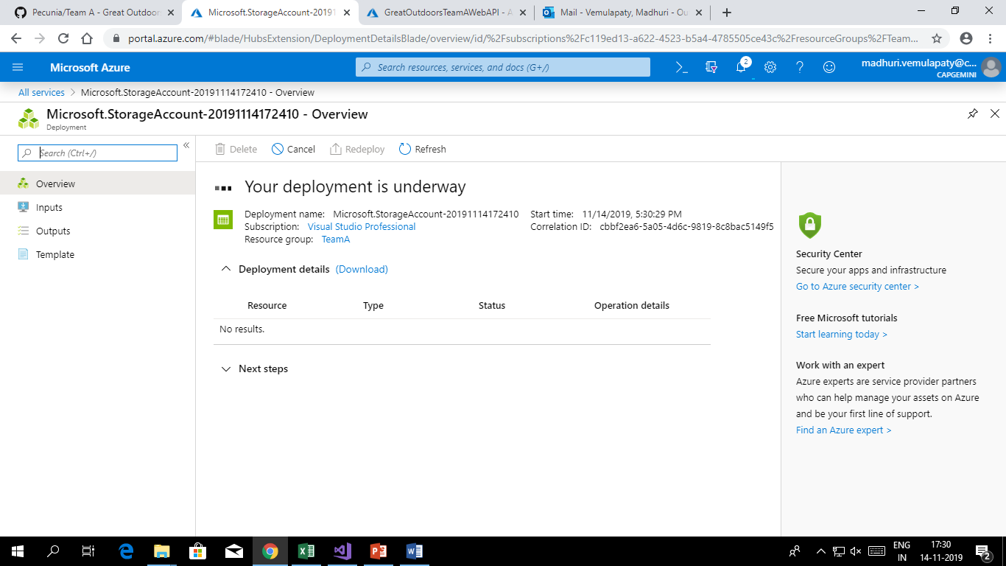

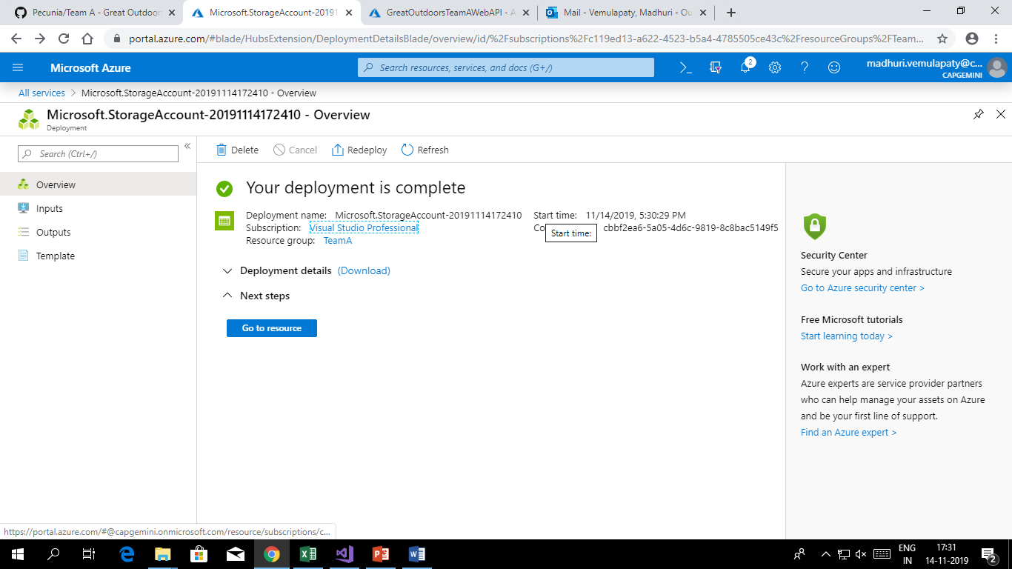

**Step 3.** Go to resource

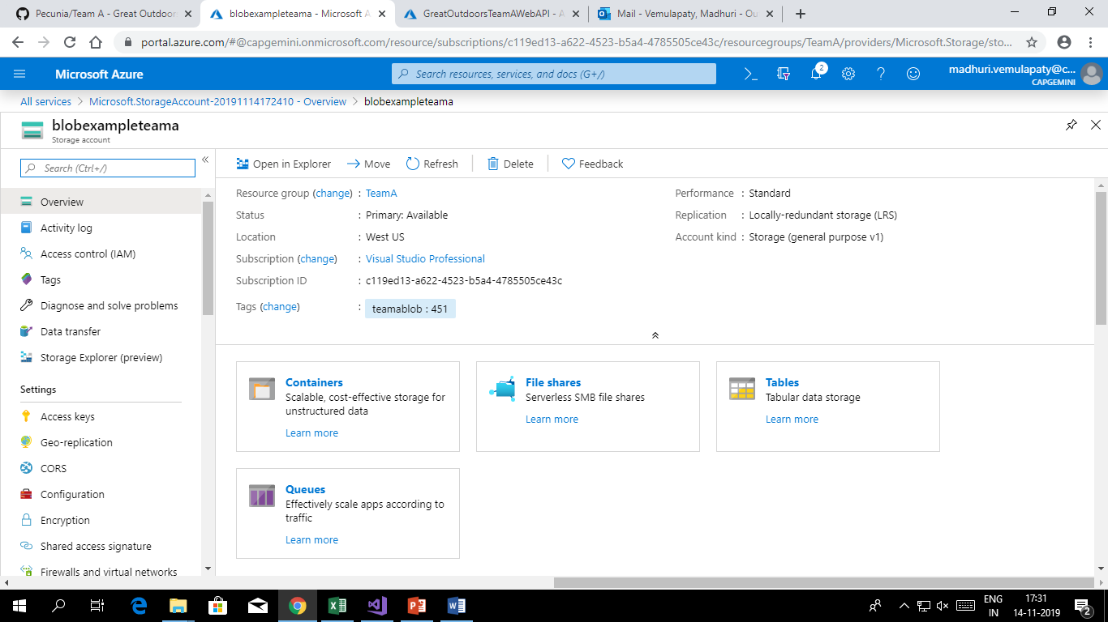

**Step 4.**  Go to container



**Step 5.** Create a container

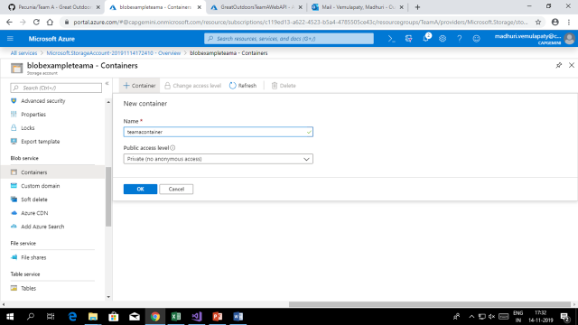

**Step 6.** Go to upload

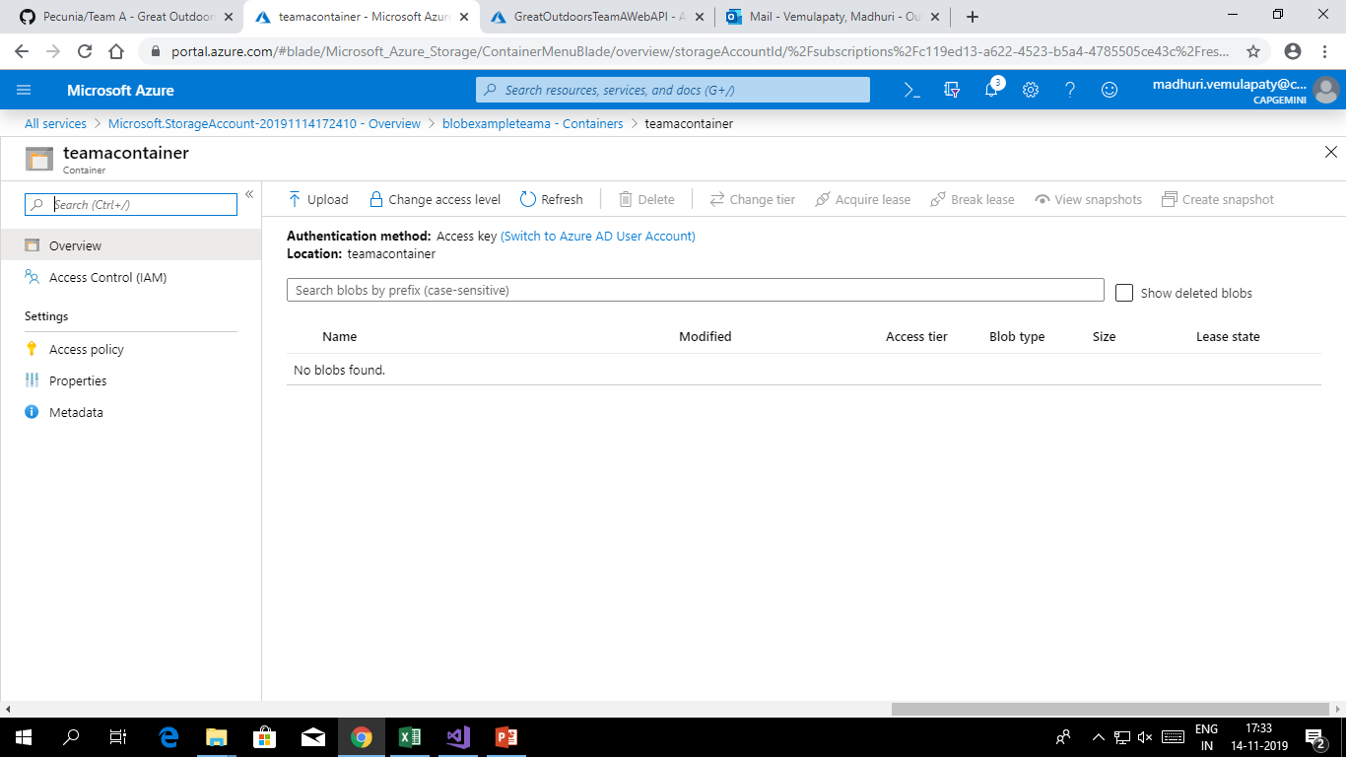

**Step 7.** Upload any file to the blob

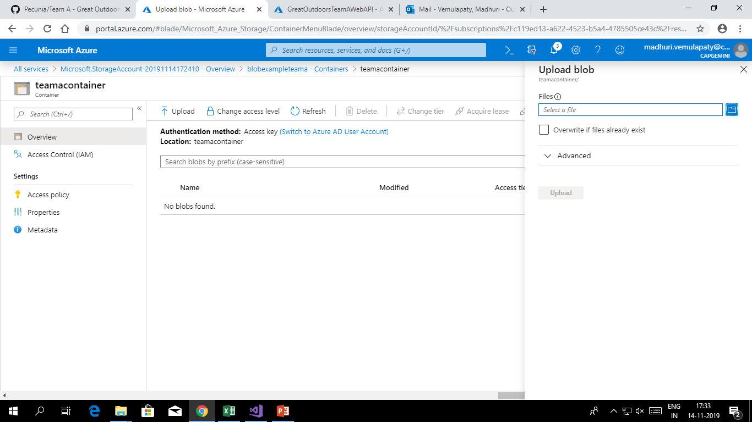

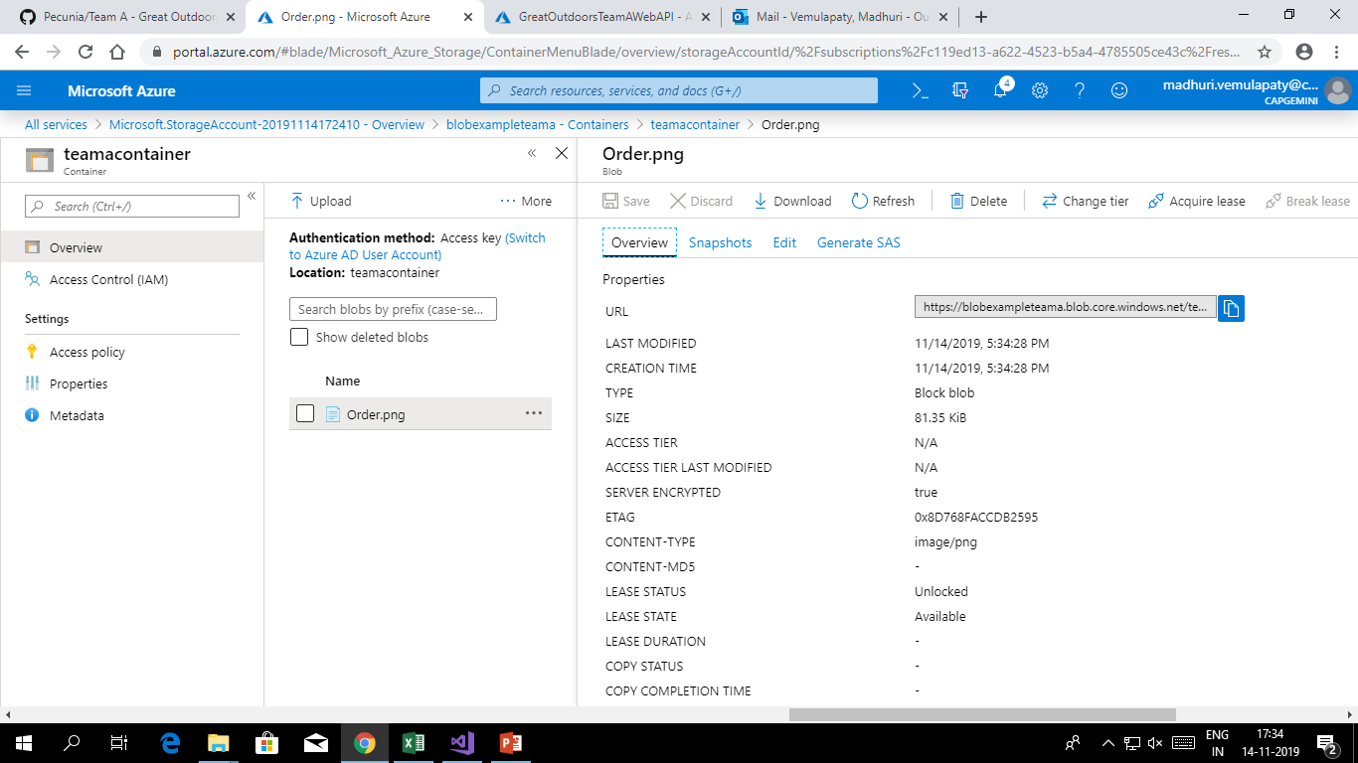

**Creating queue in blob storage**

In the same storage account we can create queue.

**Step 1.** Go to queue after creating storage account.

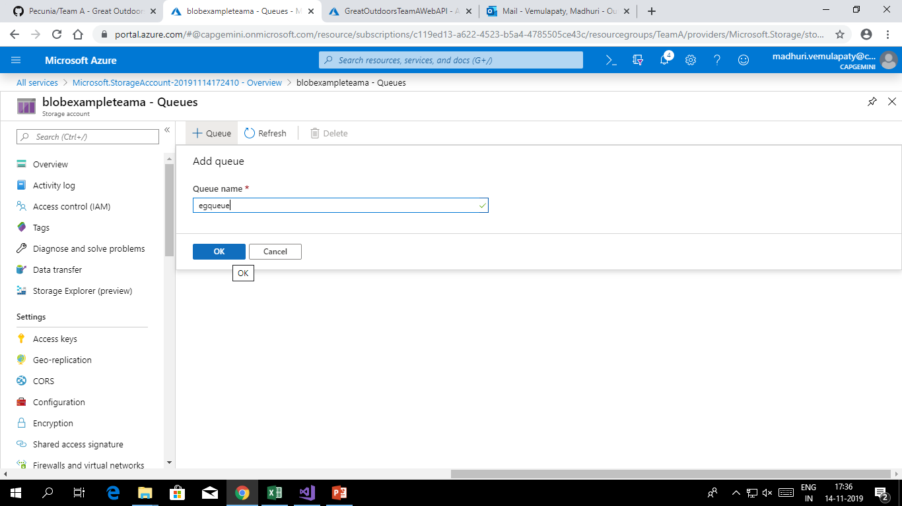

**Step 2.** Add a message

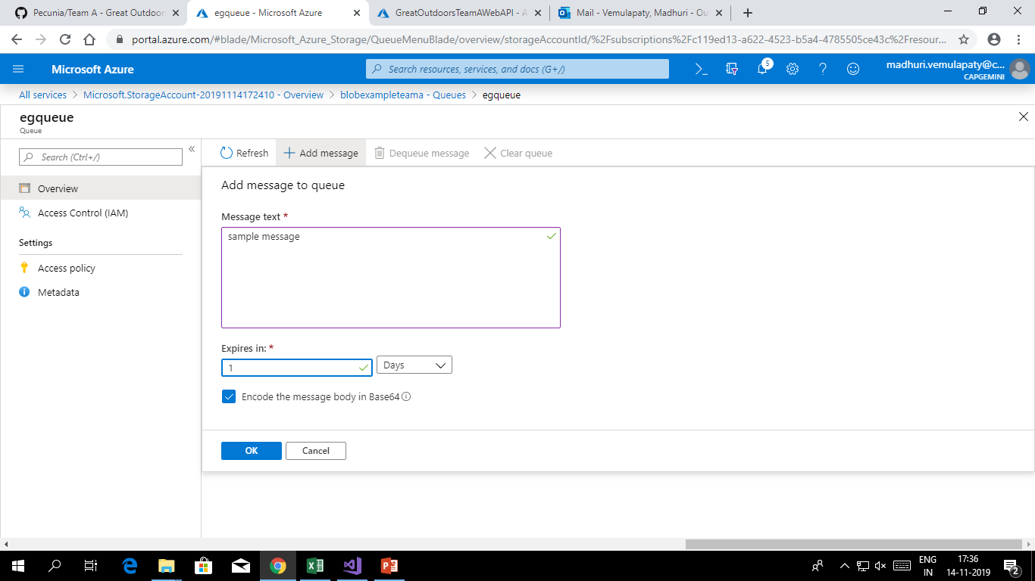

**Step 3**. Message is added in the queue

