Technical Design Document

Great Outdoors

Capgemini Technology Services

Airoli, Navi Mumbai,

India

Date : 05-11-2019

**Table of Contents**

Introduction.……………………………………………………………………………………………………3

Explanation of Use Case Contents………………………………………………………………………4

Admin

retailer

Sales Person

ER Diagram…………………………………………………………………………………………………………………………..7

Modules ….…………………………………………………………………………………………………………………………..8

ADMIN & ADDRESS

RETAILER

SALESPERSON

PRODUCT

ORDER

RETURN & CANCEL

**INTRODUCTION**

Great Outdoors (GO) is an electronic distributor of outdoor products. GO sources the products from various manufacturers and supplies it to Retailers across various countries.

Due to the lack of intermediaries, GO has been able to price its products very competitively offering significant discounts as compared to its “brick and mortar” rivals. This has helped their revenue grow very rapidly. GO’s gross profit is quite healthy. However, they continue to make investments into the business to drive growth as a result of which their net profit margins are very thin and at times become red as well. So, there is a constant pressure to optimize on costs and enhance profitability so that they can fuel further growth. GO is always looking at opportunities for cost optimization in order to enhance profitability

**1. Use Case Diagrams**

1. Admin

A close up of a map

Description generated with high confidence

Description : Great Outdoors admin logs in and can perform various functions.

Actor : Great Outdoors Administrator.

Preconditions : Admin has logged in and is now ready to perform the functions available to him.

Post Conditions : Admin can view, edit and add products and salespersons. Admin has the full control of the oprations being performed.

Flow :

1. Admin can add products.
2. Admin can edit product details.
3. Admin can remove sales persons.
4. Admin can add salesperson.
5. Admin can Edit the profile details.
6. Admin can view various reports.
7. Admin controls bonuses of salespersons.
8. Admin controls product discounts.
9. Retailer

A close up of a map

Description generated with high confidence

Description : Great Outdoors retailer logs in and can perform various functions like buying a product.

Actor : Great Outdoors Retailer.

Preconditions : Retailer has logged in and is now ready to perform the functions available to him.

Post Conditions : Retailer can view, edit and buy products. Retailer has the full control of the addresses available and can even add address specific products.

Flow :

1. Retailer can register himself and then log in.
2. Retailer can see his profile details and even manage his profile details.
3. He/She can buy a product, choose address to which to deliever.
4. Retailer can even add multiple addresses.
5. Retailer can look at his order history.
6. Retailer can even return/cancel products.
7. Retailer can view return details and histories.
8. Salesperson

A close up of a map

Description generated with high confidence

Description : Great Outdoors salesperson logs in and can perform various functions like uploading an order.

Actor : Great Outdoors Salesperson.

Preconditions : Salesperson has logged in and is now ready to perform the functions available to him.

Post Conditions : Salesperson can view, edit profile and upload orders. Salesperson has the full control of the products available and can even add address specific products.

Flow :

1. Salesperson can put up offline Order.
2. Salesperson can see his profile details and even manage his profile details.
3. Salesperson can cancel offline order.
4. Salesperson can cancel offline orders.
5. Sales person can view his sales reports.

**2. ER Diagram**

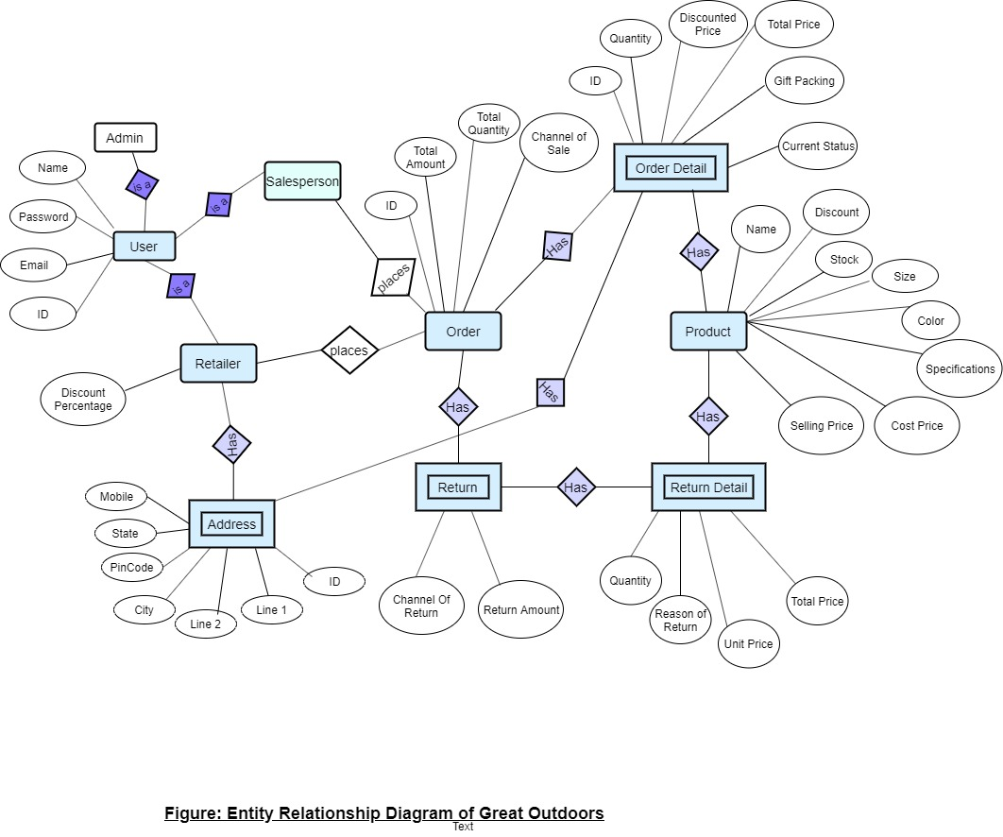

Points to note:

1. 3 type of users: retailer, salesperson and admin.
2. Each user has a name, email ID, password, unique system ID, and a user type.
3. Retailer has specific discount percentages.
4. Retailer has multiple address IDs stored in address table. Address table consists of Address unique ID, Retailer unique ID, Line 1, Line 2, City, State, Pin code and a mobile no.
5. Retailer and salesperson places order.
6. There are products which consists of Product unique ID, Name, Stock, Size, Colour, Specifications, product discount, stock of the product, Cost to Company, Selling Price by the company.
7. Order consists of the unique order ID, total products ordered, total price of the order, retailer ID, salesperson ID and channel of sale.
8. Each Order has multiple Order Details which is stored in the order details table.
9. The order Details has the details of the multiple products constituting a single order.
10. Order Details contains the addresses to which each product is to be delivered and the status of the orders whether under processing, in cart or returned.
11. Return has OrderId of the orders which are returned and aslo has the channel of return and return amount.
12. Return details constitutes of the products which were returned in a particular order.

**3. Modules**

1. Address Module

EPIC: Retailer should add, update and delete addresses

User Stories:

* Retailer should be able to view existing addresses.
* Retailer should be able to update addresses.
* Retailer should be able to delete addresses.

Flow :

* Retailer logs in. If the credentials are valid he is directed to the retailer home page.
* Retailer goes to manage addresses.
* Here he can see the already added addresses.
* He can view, delete or add address.
* After validations on adding, address is added.
* Redirected to addresses page.

**Sequence Diagram to add new address**

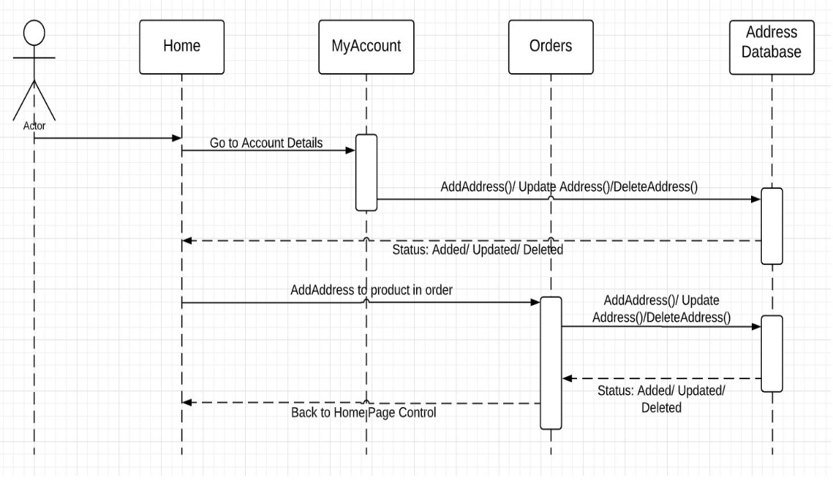

**Activity Diagram to add new address**

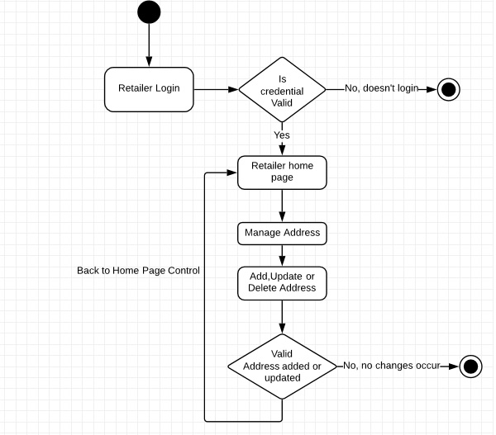

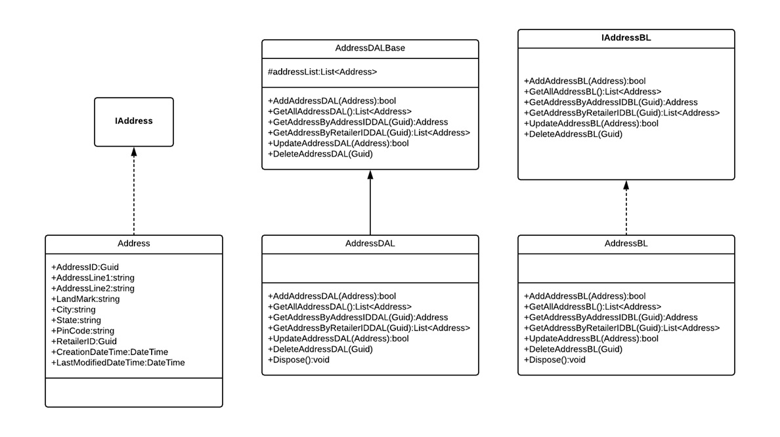

**Class Diagram : Address**

2. Admin Module

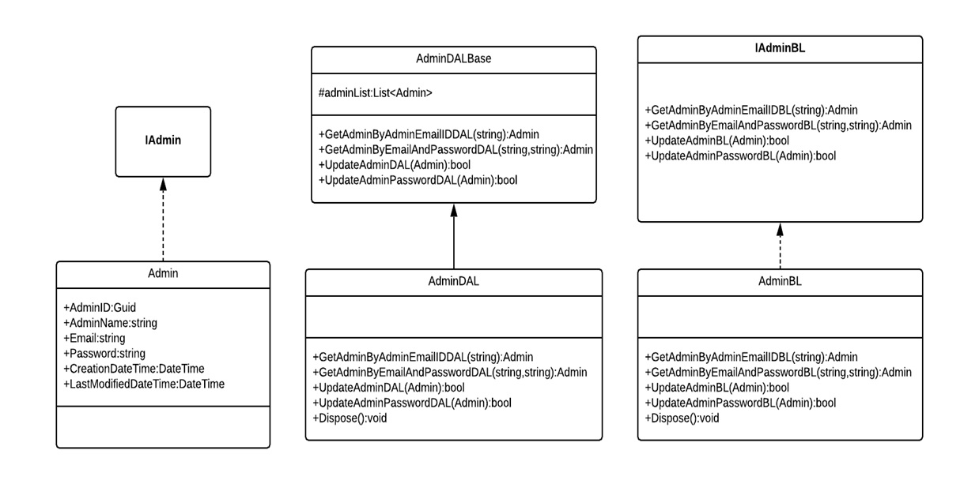

**Class Diagram : Admin**

4. Retailer Module

EPIC: Retailer should be able to update details

User Stories:

* Retailer should be able to register/add his/her details.
* Retailer should be able to view his/her profile
* Retailer should be able to edit his/her details.
* Edited profile should then be displayed.

**Sequence diagram to update retailer**

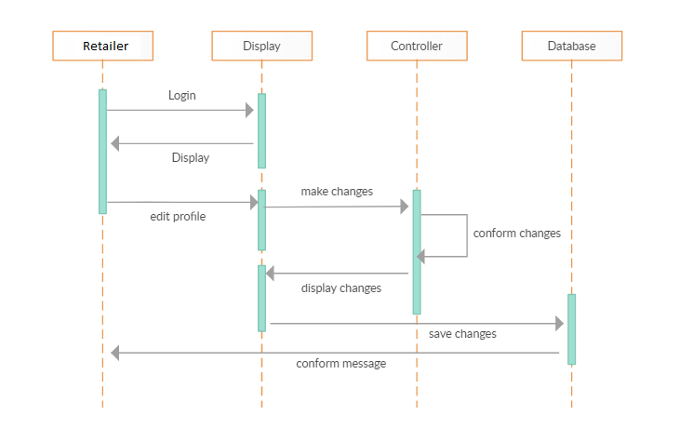

**Activity diagram to update retailer**

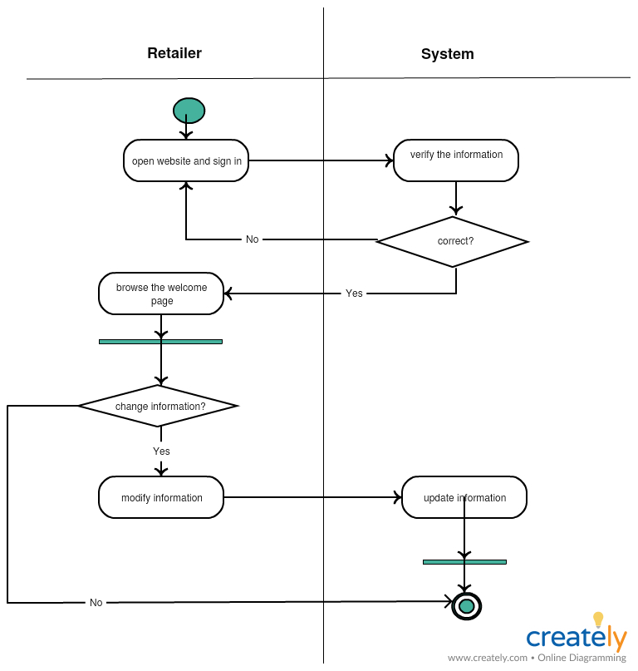

**Class Diagram : Retailer**

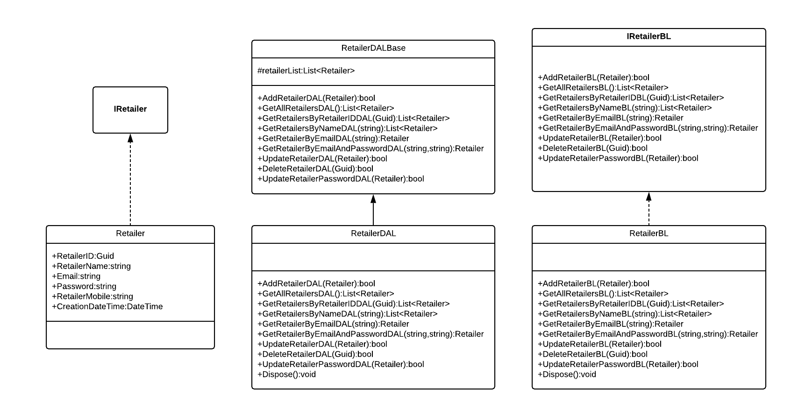

5. Sales Person Module

EPIC: Salesman should upload offline orders

User Stories:

* Salesman should be able to upload order details like product ID, name and quantity along with discount and total price.
* Salesman should be able to view uploaded sales.

**Sequence diagram to upload offline order**

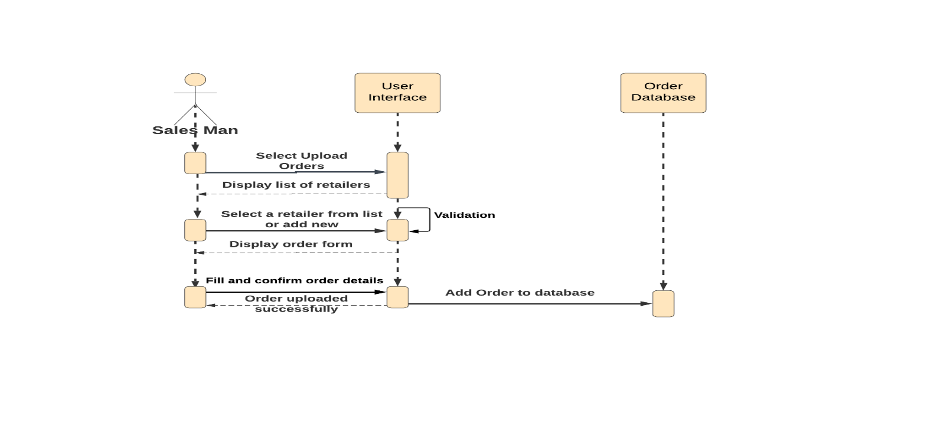

**Activity diagram to upload offline order**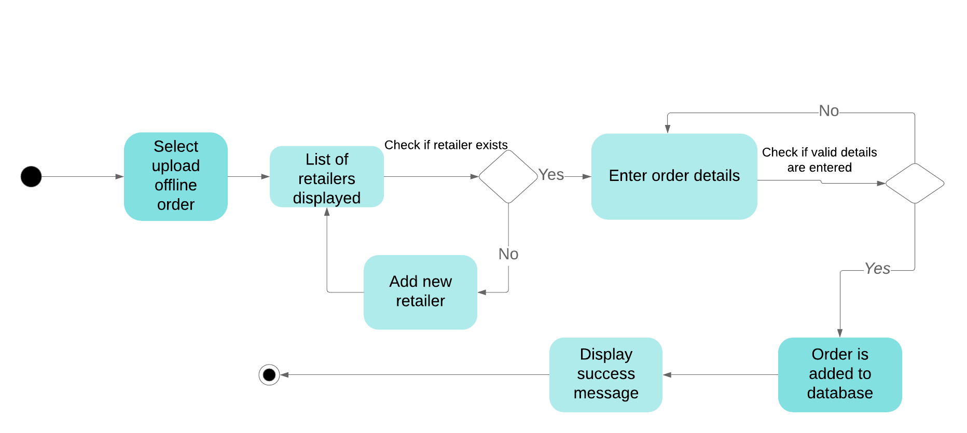

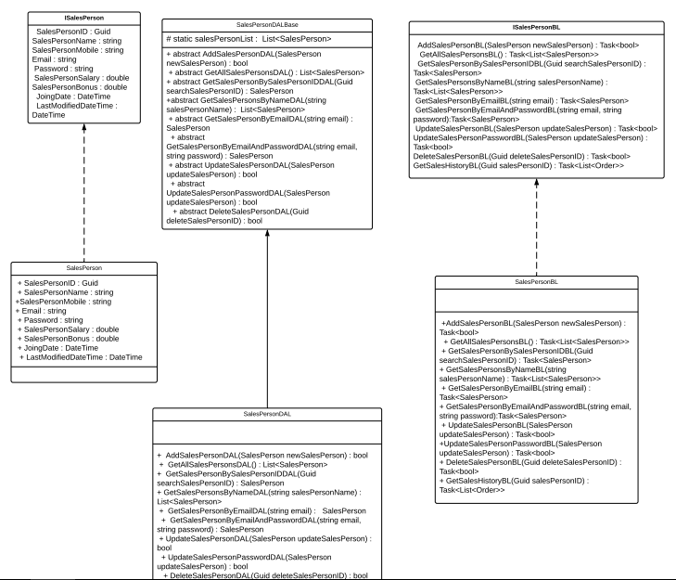

**Class Diagram : SalesPerson**

1. Product Module

EPIC : Admin should add, update and delete products.

User Stories:

* Admin should be able to add products to the database and view the existing products.
* Admin should be able to edit product details like – price, discount etc.
* Admin should be able to delete products from database.

**Sequence diagram to add product**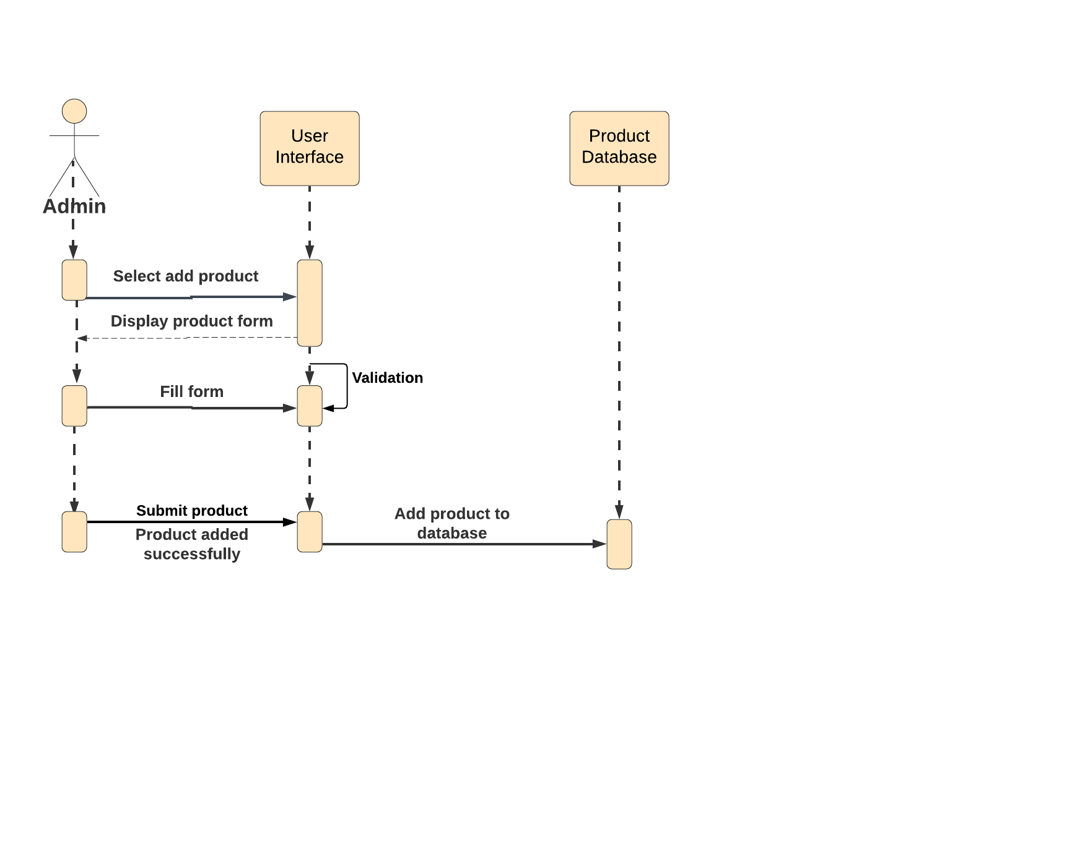 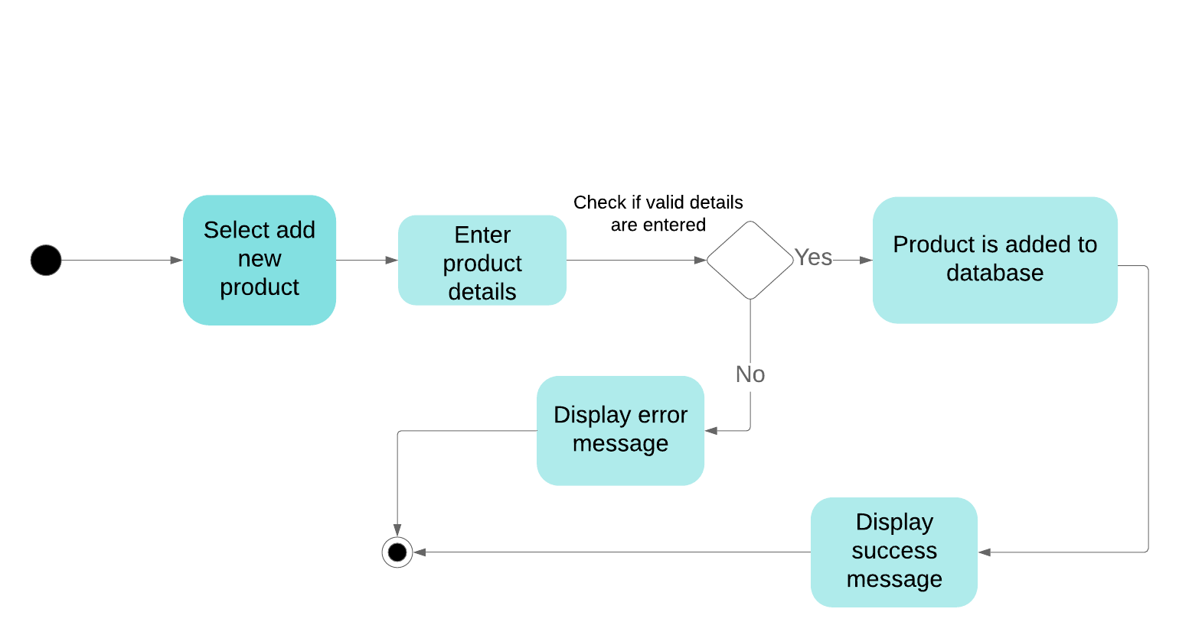

**Activity diagram to add product**

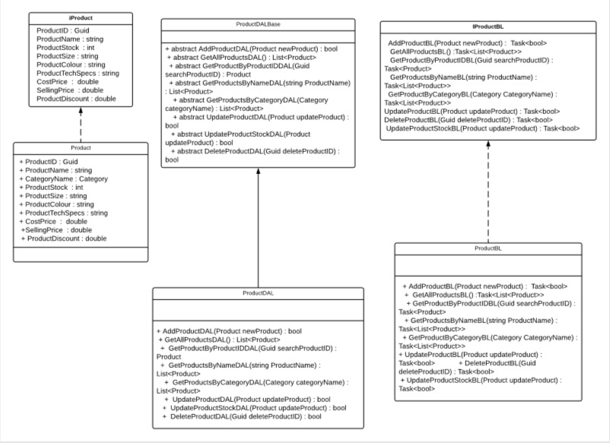

**Class Diagram : Products**

1. Order Module

EPIC: Retailer should be able to place order

User Stories:

* Retailer should be able to view products by category
* Retailer should be able to add product to cart after viewing details and changing quantity.
* Retailer should be able to select address for each product.

**Activity diagram to place order**

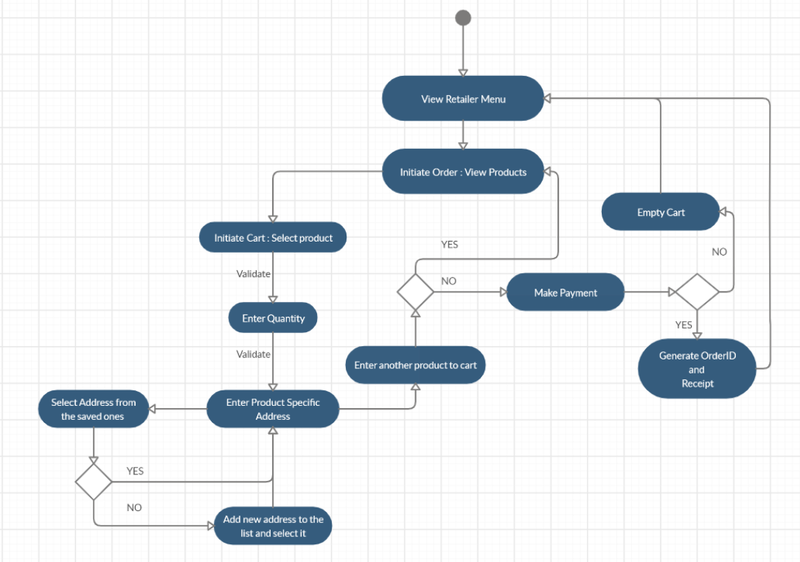

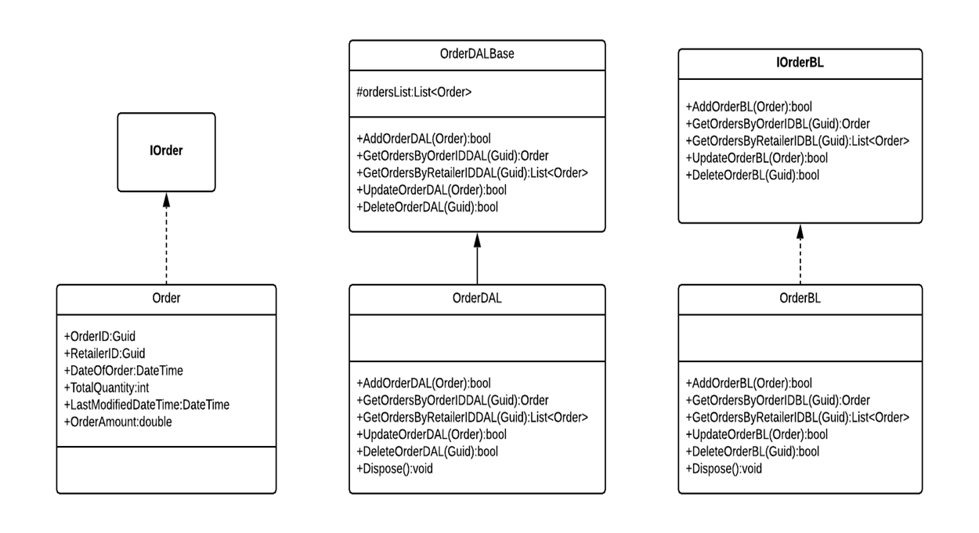

**Class Diagram: Order**

1. Return & Cancel

EPIC: Retailer should be able to return order

User Stories:

* Retailer should be able to view order history.
* Retailer should be able to select a product for return.
* Return status should be displayed after returning.

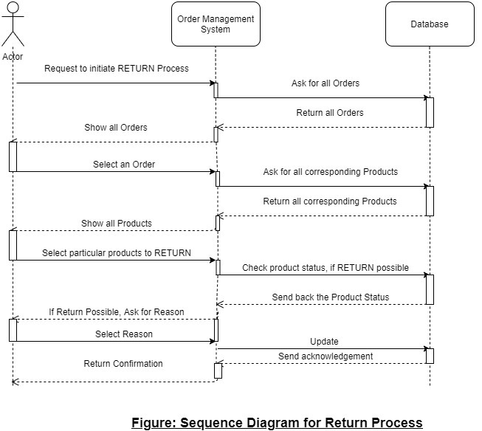

A close up of text on a white background

Description generated with very high confidence

**Class Diagram - Return**

A screenshot of a cell phone

Description generated with very high confidence

1. Cancel Order

EPIC: Retailer should be able to cancel order

User Stories:

* Retailer should be able to view order history.
* Retailer should be able to select a product for cancellation.
* Order status should be displayed after cancellation.

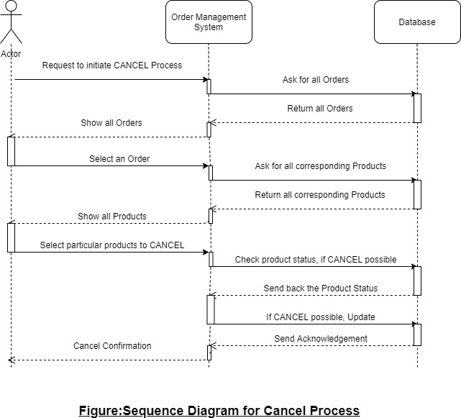

A close up of text on a white background

Description generated with very high confidence