Protractor is a wrapper built over webdriver

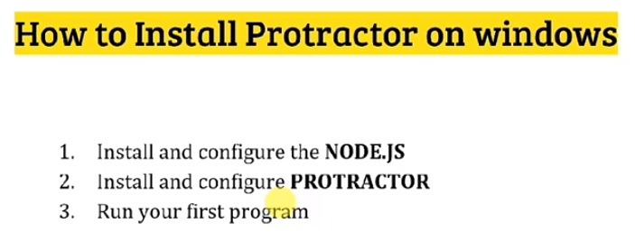

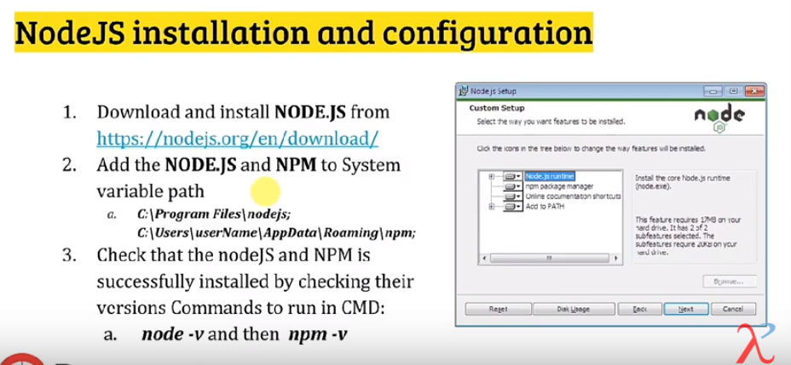

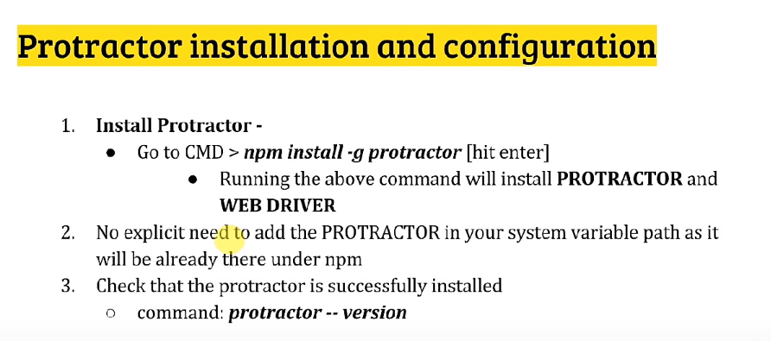

Sample program:

<https://www.youtube.com/watch?v=qhOvmTcCC08>

C:\Users\103343\AppData\Roaming\npm\node_modules\protractor\example

conf.js – this will have the set up

spec.js- have all the test cases for automation