# 8 Updates to Help Migrate and Collaborate between Skype and Teams

Microsoft is in the process of rolling out several major updates to the way businesses will communicate using Office 365. The updates are designed around improving the migration from Skype for Business to Microsoft Teams. While less than a year-old Microsoft made a bold statement that Microsoft Teams will replace Skype for Business. Microsoft Teams is a major game changer across many organizations. The latest updates to Microsoft Office 365 will allow a slower batch or champion style deployment that will give users backward compatibility and allow IT administrators to migrate to the new app out in phases reducing the IT burden.

## Microsoft Teams & Skype for Business Admin Center

|  |  |
| --- | --- |
| Feature ID | 26982 |
| Description | The new Microsoft Teams & Skype for Business Admin Center will provide you a unified experience to manage Microsoft Teams and Skype for Business. We’re delivering additional functionality, end-to-end insights, and the ability to manage Teams settings on a user level. |
| Status | Rolling Out |

While still being rolled out, I haven’t seen a link to the new Microsoft Teams & Skype for Business Admin Center in the Office 365 admin center. I’ve been able to access the new admin center by navigating to <https://admin.teams.microsoft.com> across multiple tenants.

After becoming comfortable in the new Admin center be sure to navigate to **Org-wide settings -> Teams upgrade** and updating your **Coexistence mode** from **Legacy** to **Islands**.

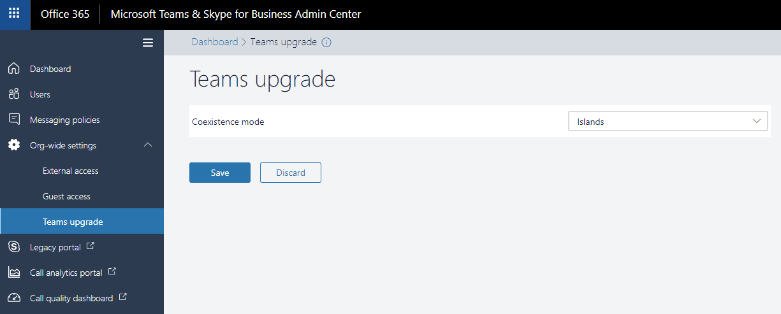

While Microsoft has [documented](https://docs.microsoft.com/en-us/microsoftteams/upgrade-and-coexistence-of-skypeforbusiness-and-teams) more modes that we can expect to see shortly, Islands is the most current configuration.

Microsoft has said the following regarding Islands mode:

Islands mode comes with one-way temporary interoperability that allows chat interoperability from Teams to Skype for Business when the following conditions are met:

The Teams user is homed at, and enabled for, Skype for Business Online.

The Skype for Business user has never used Teams (or isn’t licensed for Teams).

This mode is helpful when you want users who are primarily using Teams to connect with other users in the organization who are still using Skype for Business only.

After the users who previously used only Skype for Business start to use Teams, all their chats from other Teams users will arrive in Teams. This switches these users to islands mode. From that point, they must keep running Teams to ensure they stay connected with the other Teams users in the organization. - [Microsoft](https://docs.microsoft.com/en-us/microsoftteams/upgrade-and-coexistence-of-skypeforbusiness-and-teams)

While some admins are reporting integrated connectivity between Skype for Business and Microsoft Teams for chat while in legacy mode, the setting may be blocking the connectivity within your tenant including calling, meetings, and other collaboration features.

Microsoft does warn admins that coexistence is more complex than a simple cutover migration to Microsoft Teams. Islands mode allows an organization to conduct a proof of concept (PoC) of Teams and slowly migrate users from Skype for Business to Microsoft Teams. Islands mode doesn’t allow a user to go back to Skype for Business and still communicate from Skype for Business to Microsoft Teams users. There is a workaround where an admin can remove Microsoft Teams licensing for the user. This drawback may be cause for concern for some organizations, each organization will need to weigh the value of migrating to Microsoft Teams prior to a more complete collaboration mode that I expect will be coming shortly.

## Microsoft Teams & Skype for Business Integration

|  |  |
| --- | --- |
| Feature ID | 24190 |
| Description | This is one of the SfB messaging capabilities coming to Teams that enables a Teams user to chat with other users who are using Skype for business (online or on-prem). This requires Teams user's account to be hosted online. |
| Status | Launched |

Microsoft has launched a recent update to allow Microsoft Teams users to communicate with Skype for Business users. The new integration between the two apps will make it easier for users to migrate while still collaborating with colleagues that are still using Skype for Business. The new integration functionality will allow organizations to deploy Microsoft Teams to champions or specific departments prior to a full-scale deployment.

Microsoft Teams users will see the Skype icon next to a person’s name in the chat view. This icon indicates the user is still using Microsoft Skype for Business.

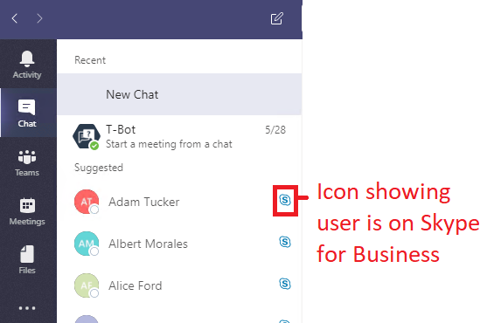

Microsoft Teams will also warn your users in the Messages Header of a chat conversation that some functionality will not be possible between Microsoft Teams and Skype for Business Users. The loss of functionality is to be expected because Skype handles documents and other integrations differently. Since Microsoft is planning to retire Skype for Business I wouldn’t anticipate a future update to make cross-app collaboration perfect.



The Skype icon will also be seen in Windows 10 notifications (that appear in the bottom right hand corner when Microsoft Teams is not your active app).



The below screenshot is showing two separate users communicating across Skype for Business and Microsoft Teams. On the left, Adam Tucker, is using Skype for Business in OWA. On the right, Aaron Wells is using Microsoft Teams. Chat is fast and simple across the apps without any issues.

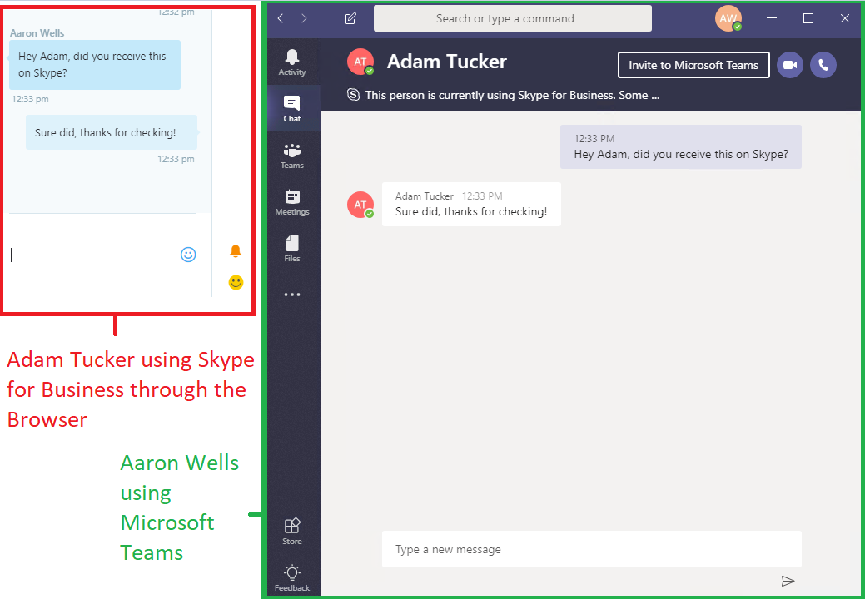

## Microsoft Teams – Unified Presence

|  |  |
| --- | --- |
| Feature ID | 24191 |
| Description | This is one of the SfB messaging capabilities coming to Teams that supports unified presence between Teams and Skype for Business. |
| Status | Rolling Out |

“Presence states for users (i.e. available, busy or in a call) will now be aggregated between Teams and Skype for Business. This ensures that a user has a single presence state regardless of the app and the device they use.  For this functionality, the underlying Skype for Business account that is connected to the Teams user needs to be hosted in Skype for Business online.” – [Microsoft](https://techcommunity.microsoft.com/t5/Microsoft-Teams-Blog/What-s-new-in-Microsoft-Teams-April-update/ba-p/179801)

Users in Microsoft Teams and Skype for Business can now see colleagues free/busy information across apps. The improved functionality will help users seamlessly migrate to Microsoft Teams and continue to work in a coordinated and professional manner.

Upon testing, availability status updated flawlessly from Skype for Business to Microsoft Teams. I had some issues when the availability status did not update in Skype when a user made a change in Microsoft Teams. I’m sure any issues are related to my test tenant or will be resolved shortly through a patch. Be sure to test availability in your tenant and discuss any issues with leadership and users.

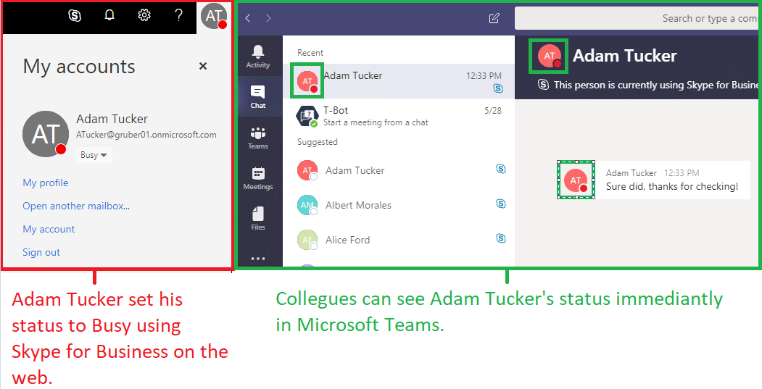

## Microsoft Teams - Out of Office Support

|  |  |
| --- | --- |
| Feature ID | 24167 |
| Description | This is one of the SfB calling capabilities coming to Teams. This feature will allow users to set an Out of Office status and share that with others. This feature is targeted for availability by Q2 CY 2018. |
| Status | In development |

Expected to be deployed shortly, Microsoft Teams will be integrating Out of Office support. The new integration will help users migrate from Skype for Business, as well as, stay up-to-date on a colleague’s status after migrating to Microsoft Teams.

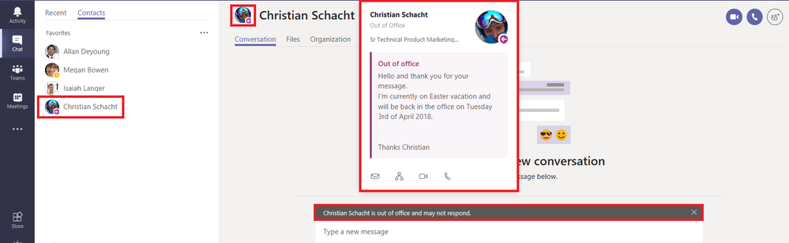

One of the major factors in moving to Microsoft Teams is the one-to-many chat capabilities. IT should have a plan in place for scenarios where a key member of a team or project is out of the office. Two options are available depending on your organization:

1. Make a public team available for each department. If most of the departments in your organization can have their team public, where any employee can join the chat, it’s a straightforward way to make an entire team available for any unplanned out-of-office scenarios. HR & Accounting may need to manage two teams, one public and another private.
2. If an organization would prefer to keep the department teams private and secured from other employees within your organization, a company should create an all company team. All employees can be a member of the team and a channel can be created for each department. If an employee ever wants to contact an entire team they can utilize the appropriate channel. PowerShell is provided at the bottom of this article to help facilitate the creation of an all company team.

## Microsoft Teams - Import Contacts from Skype for Business

|  |  |
| --- | --- |
| Feature ID | 24244 |
| Description | This is one of the SfB messaging capabilities coming to Teams, providing the ability to import contacts from Skype for Business. |
| Status | Launched |

“We’re importing your contact list from Skype for Business Online to Teams. Now, all your contacts and groups that you created in Skype for Business will show up in Teams under your contact list. To access your contacts, simply click on “Chat” in the left navigation and then on “Contacts”. Here, you can also add new contacts or create new contact groups.

In this first step, only contacts from your organization will be imported. Federated contacts from outside your organization will be added at a later point.” - [Microsoft](https://techcommunity.microsoft.com/t5/Microsoft-Teams-Blog/What-s-new-in-Microsoft-Teams-April-update/ba-p/179801)

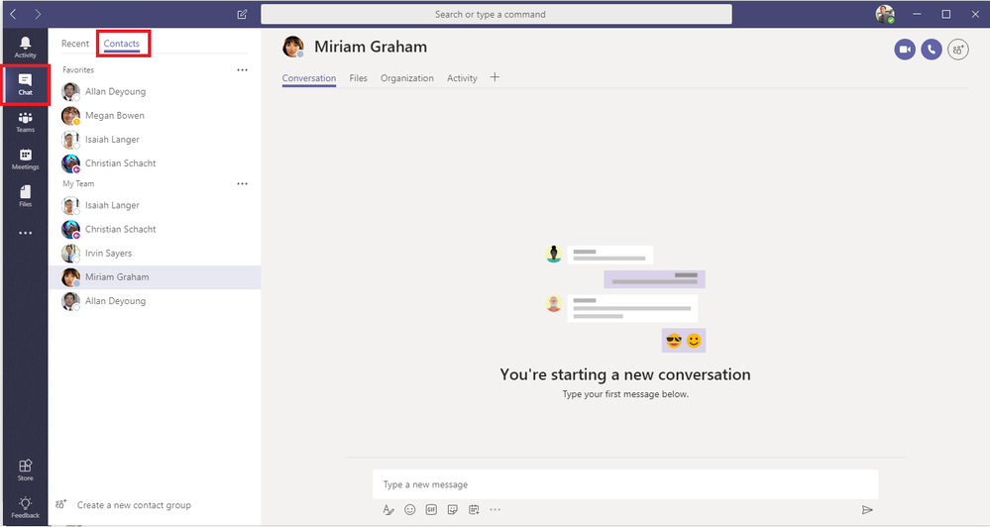

Personally, I haven’t gained access to **Contacts** in Microsoft Teams and haven’t had the opportunity to test the new integration. While contacts may be important to some, I haven’t found a strong need for contacts in Microsoft Teams. In Microsoft Teams you can compose a new chat, begin typing a user’s name and Microsoft Teams will auto-populate a list of all users in your environment.

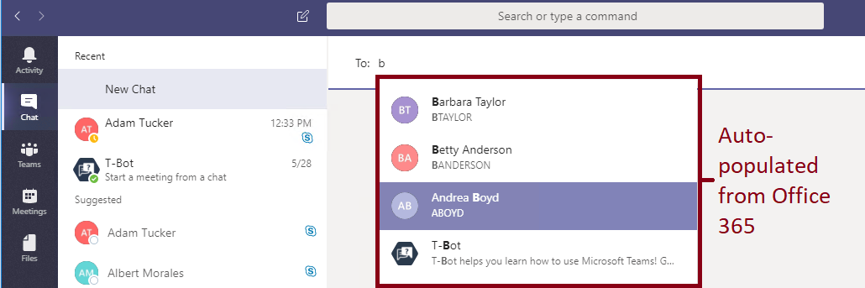

Auto-population plus the Recent contacts list have made it quick and easy to communicate with everyone across the organization. While Teams works great without contacts, the added functionality will be a major benefit to some employees.

## Remote Deployment of Microsoft Teams

Going almost unnoticed, Microsoft has released MSI installers for Microsoft Teams. This enables organizations to leverage System Center Configuration Manager, Group Policy, or any 3rd party distribution mechanisms for broad deployments of Microsoft Teams. Admins can download the installation bits in the following locations:

* [Microsoft Teams 32-bit MSI installer](http://aka.ms/teams32bitmsi)
* [Microsoft Teams 64-bit MSI installer](http://aka.ms/teams64bitmsi)

Target machines will require Windows 7, .NET 4.5, and 3 GB of disk space for the installation. For more information on the deployment view Microsoft’s [documentation](https://docs.microsoft.com/en-us/MicrosoftTeams/msi-deployment).

## Microsoft Teams – All Company team

The following section is designed to assist you with creating an All Company team in Microsoft Teams. The team can then be used to communicate and collaborate with your entire organization. Unfortunately, the max number of members in a team is 2,500. If your organization is larger than 2,500 users, you cannot use a single team to communicate. Due to the one-to-many communication method of Microsoft Teams, I personally wouldn’t recommend having a team larger than 1,000 members. Communication of over 1,000 employees is best implemented using SharePoint and/or Yammer.

Microsoft has documented a similar command shell:

* <https://docs.microsoft.com/en-us/MicrosoftTeams/scripts/powershell-script-sample-create-company-wide-team>
* <https://docs.microsoft.com/en-us/MicrosoftTeams/company-wide-team-creation-powershell>

To run the following commands, you must be able to connect to Azure AD & Microsoft Teams using PowerShell. Connecting to Office 365 PowerShell with a user that has MFA enabled is more difficult. If you haven’t connected to Office 365 PowerShell before and have MFA enabled, it’s recommended to temporarily disable MFA or create a Global Admin without MFA for one-time use.

# Beginning of Script

param(

[Parameter(Mandatory=$true, HelpMessage="Name of team for the All Company Team (Recommended: Company")]

[System.String]$TeamName,

[Parameter(Mandatory=$true, HelpMessage="Username of a global admin account")]

[System.String]$GlobalAdminUsername,

[Parameter(Mandatory=$true, HelpMessage="Password of the global admin account")]

[System.String]$GlobalAdminPassword

)

$encryptedPassword = ConvertTo-SecureString -AsPlainText -Force -String $GlobalAdminPassword

Write-Host "Install NuGet (Used to install Microsoft Teams module)" -ForegroundColor Cyan

Install-PackageProvider -Name NuGet -MinimumVersion 2.8.5.201 -Force

Write-Host "Install Azure AD PowerShell" -ForegroundColor Cyan

Install-Module AzureAD -Force

Write-Host "Install Microsoft Teams PowerShell" -ForegroundColor Cyan

Install-Module MicrosoftTeams -Force

Write-Host "Connect to Azure AD" -ForegroundColor Cyan

$cred = New-Object -typename System.Management.Automation.PSCredential -argumentlist $GlobalAdminUsername, $encryptedPassword

Connect-AzureAD -Credential $cred

Write-Host "Connect to Microsoft Teams" -ForegroundColor Cyan

$cred = New-Object -typename System.Management.Automation.PSCredential -argumentlist $GlobalAdminUsername, $encryptedPassword

Connect-MicrosoftTeams -Credential $cred

Write-Host "Get all Microsoft Office 365 Users" -ForegroundColor Cyan

$Users = Get-AzureADUser -All $true

$Users = $Users | ?{ $_.UserType -eq 'Member' -and $_.AccountEnabled -eq $true -and $_.AssignedLicenses -ne $null }

Write-Host "Verify you don't have over 2,500 users" -ForegroundColor Cyan

if ($Users.Count -gt 2500) {

throw "You have more than 2500 users. A team in Microsoft Teams cannot have over 2,500 users"

}

Write-Host "Create Team" -ForegroundColor Cyan

$Group = New-Team -DisplayName $TeamName -AccessType Public

Write-Host "Adding users to team" -ForegroundColor Cyan

foreach ($User in $Users) {

Write-Host " Adding $($User.UserPrincipalName) to team" -ForegroundColor Cyan

Add-TeamUser -GroupId $Group.GroupId -Role Owner -User $User.UserPrincipalName.ToString()

}

Write-Host "Disconnect from AzureAD" -ForegroundColor Cyan

Disconnect-AzureAD

Write-Host "Disconnect from Microsoft Teams" -ForegroundColor Cyan

Disconnect-MicrosoftTeams

# END OF SCRIPT