# Live Video Broadcasts in Office 365 – In Development

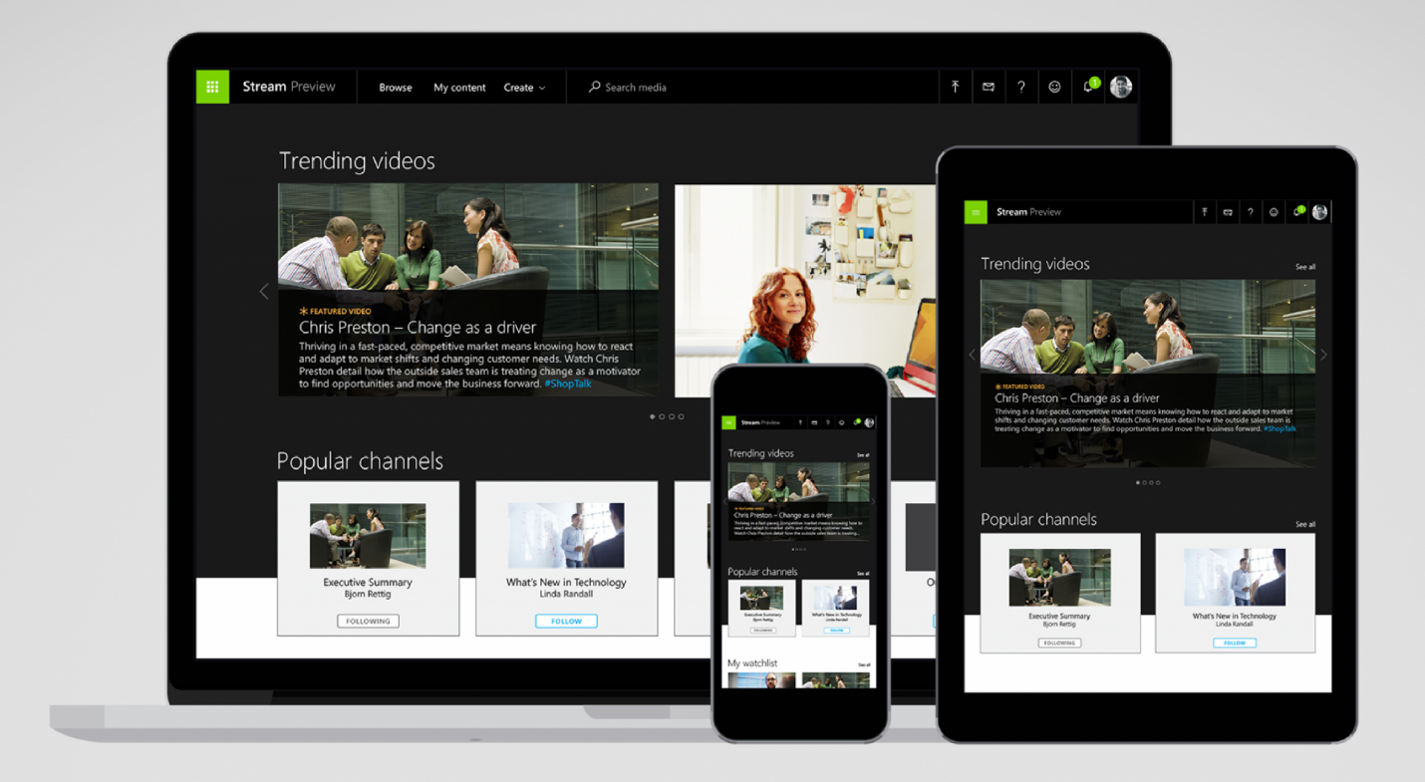

Microsoft has begun development on live video broadcasting for Office 365. Live video broadcasting refers to online streaming media simultaneously recorded and broadcast in real time to the viewer. It’s referred to as streaming. The new feature will be included in [Microsoft Stream](http://gitbit.org/apps/stream), Office 365’s video hosting app.

Microsoft has said the following on the first update:

Live event broadcasting [will be] available in Microsoft Stream. Host and watch live broadcasts in Stream or watch them in Yammer and Teams.

Once released, Office 365 users will have the ability to schedule and host live event broadcasts in Microsoft Stream. Microsoft Stream is expected to be updated in **July 2018**.

## Licensing

Microsoft Stream is currently available to Office 365 users with the following licenses:

* Office 365 Enterprise E1
* Office 365 Enterprise E3
* Office 365 Enterprise E5
* Office 365 A1
* Office 365 A3
* Office 365 A5
* Office 365 F1
* Stream Plan 1
* Stream Plan 2

Microsoft hasn’t announced what plans will include live video broadcasting.

## Azure Media Services

Microsoft Stream is built on Azures Media Services which already has live video. While not announced, we can expect Microsoft stream to have similar features to Azure Media Services:

* Just-in-time AES encryption and PlayReady DRM technology
* Direct integration with Content Delivery Network for automatic provisioning
* Scalability to handle all audience sizes
* Dynamic manifest manipulation for trimming and rendition filtering
* Full cloud DVR workflow capabilities

## History

* **August 2017**: Microsoft announced they were planning the update.
* **December 2017**: Microsoft announced the update was moving off the backlog and beginning development.
* **June 2017**: Microsoft added the update to the Office 365 roadmap with a planned deployment of July 2018.

## Future Updates

After updating Microsoft Stream, live video functionality will be deployed in other Office 365 apps including [Yammer](http://gitbit.org/apps/yammer) and [Teams](http://gitbit.org/apps/microsoft-teams). Microsoft said the following about Yammer:

Allow users to host and drive conversations through live townhall events, broadcasted directly on Yammers feed using Stream.

Microsoft expects to begin rolling out updates to Yammer and Teams in the 4th quarter of 2018.