# Microsoft Rolling Out SharePoint Planner Integration

Microsoft has announced they are rolling out [SharePoint](http://gitbit.org/apps/sharepoint) and [Planner](http://gitbit.org/apps/planner) integration. Office 365 customers will start to see the new integration in their SharePoint sites shortly. The new integration will further integrate the separate Office 365 apps into one streamlined toolset aiding people in management, permissions, and organization.

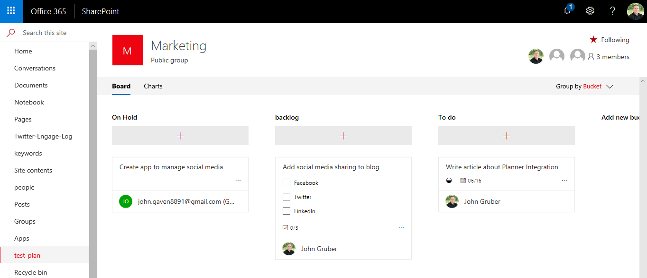

Microsoft said the following about the latest integration:

This is Planner for the team as a full-page app. Simply click New Plan, and start managing team tasks right inside the SharePoint user experience. Add a Planner Plan from within SharePoint in Office 365 (click New Plan).

To learn more about Planner read [Agile Teamwork with Office 365 Planner](http://gitbit.org/articles/agile-teamwork-with-office-365).

## How to Create a Plan in SharePoint

1. From the SharePoint home page click **New > Plan**.
2. Enter a **name** for the plan and click **Create**.

The two screen shots below show how to create a Plan through SharePoint:

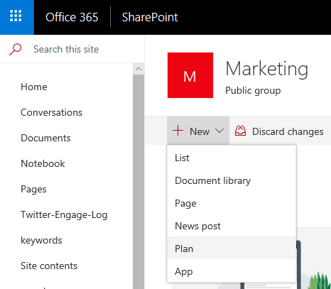

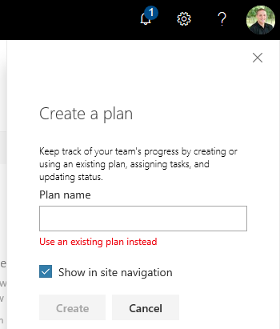

The new plan will automatically be created and accessible through the Office 365 Planner app. The plan will automatically grant people permission who are members of the SharePoint site, including guest users.

**Office 365 will keep the Planner permission in sync with your SharePoint site members. Adding new members to a SharePoint site will automatically give the person access to the plan**.

## How to Integrate an Existing Plan with a SharePoint Site

1. From the SharePoint home page click **New > Plan**.
2. Click **Use an existing plan instead**.
3. Select your Plan from the **Existing plans** drop down menu.
4. Click **Create**.

Currently, I don’t see all my plans. I’m unsure what filtering algorithm is being used to decide which plans to present as options.

## Planner Webpart in SharePoint Pages

You can easily add the Planner chart or boards into any SharePoint page to give project management and team leaders a quick overview of the status of the teams tasks.

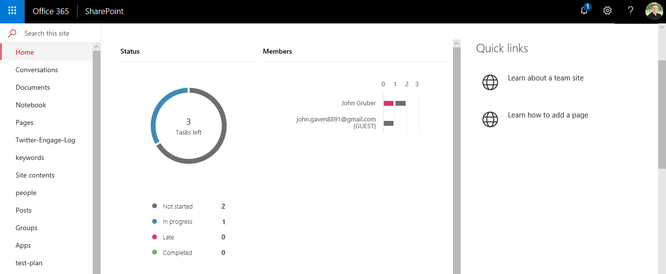

### How to Add Planner Charts to SharePoint Pages

1. While editing a SharePoint page, click the **+** sign to **add a new web part**.
2. Click **Planner** from the web part drop down menu.
3. Select your **plan** and the **tab** you want displayed.

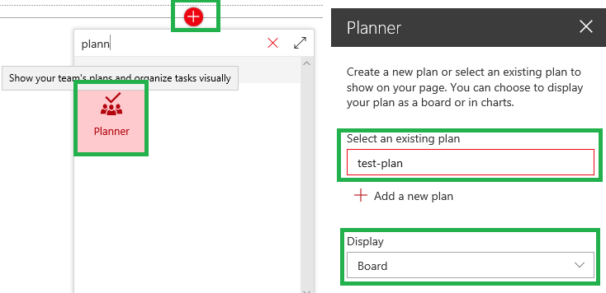

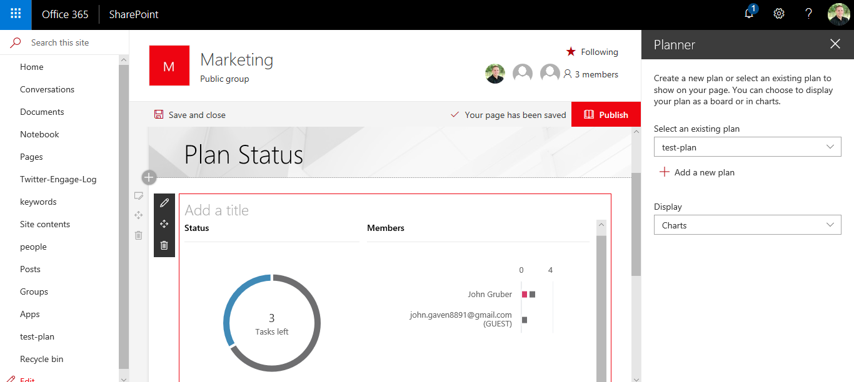

## Navigating from Planner to SharePoint

Plans originally created in SharePoint will have an additional item **Open in SharePoint** to help people quickly navigate from Planner to their SharePoint site.

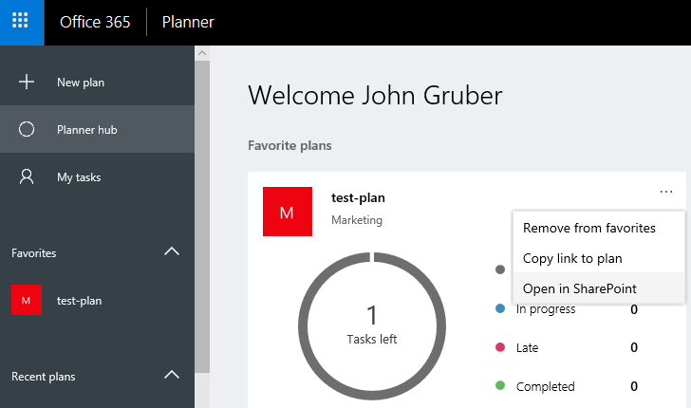

## Frequently Asked Questions

**Can a SharePoint site have multiple Plans?**

Yes, a SharePoint site can have multiple plans. A SharePoint page can have a web part per Plan to deliver quick overviews of the different Plans from one easy page.

**Can guests view the Plans?**

Yes, any guest members on the SharePoint site can view and edit Plans from within SharePoint. Guests can view Planner web parts as well.

**Can you see the new Schedule view of Planner from SharePoint?**

Not currently. Viewing Planner from SharePoint is only showing two tabs: Board and Charts. You can still access the Schedule view by opening your Plan in the Planner app. I expect the Schedule tab will be available in the future.

**Where can I learn more?**

Learn more about [SharePoint](http://gitbit.org/apps/sharepoint).

Learn more about [Planner](http://gitbit.org/apps/planner).

Learn how to [create effective teams with Planner](http://gitbit.org/articles/agile-teamwork-with-office-365).

Learn more about the Planner integration update by viewing the Office 365 [Roadmap](https://products.office.com/en-us/business/office-365-roadmap?filters=%26freeformsearch=30688#abc).