**Introduction to Business Intelligence**

**What is Business Intelligence?**

BI(Business Intelligence) is a set of processes, architectures, and technologies that convert raw data into meaningful information that drives profitable business actions. It is a suite of software and services to transform data into actionable intelligence and knowledge.

BI has a direct impact on organization’s strategic, tactical and operational business decisions. BI supports fact-based decision making using historical data rather than assumptions and gut feeling.

BI tools perform data analysis and create reports, summaries, dashboards, maps, graphs, and charts to provide users with detailed intelligence about the nature of the business.

## Why is BI important?

* Measurement: creating KPI (Key Performance Indicators) based on historic data
* Identify and set benchmarks for varied processes.
* With BI systems organizations can identify market trends and spot business problems that need to be addressed.
* BI helps on data visualization that enhances the data quality and thereby the quality of decision making.
* BI systems can be used not just by enterprises but SME (Small and Medium Enterprises)

## How Business Intelligence systems are implemented?

Here are the steps:

**Step 1**) Raw Data from corporate databases is extracted. The data could be spread across multiple heterogeneous systems.

**Step 2)** The data is cleaned and transformed into the data warehouse. The table can be linked, and data cubes are formed.

**Step 3)** Using BI system the user can ask queries, request ad-hoc reports or conduct any other analysis.

## Examples of Business Intelligence System used in Practice

**Example 1:**

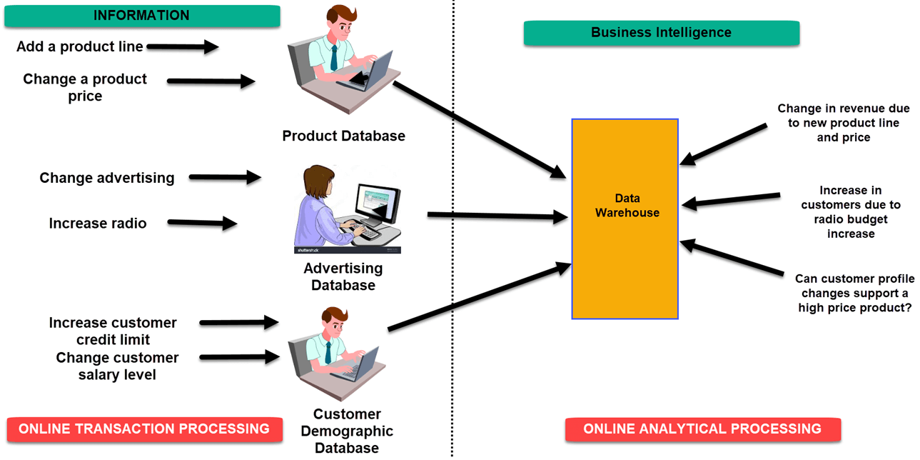

In an Online Transaction Processing ([OLTP](https://www.guru99.com/what-is-oltp.html)) system information that could be fed into product database could be

* add a product line
* change a product price

Correspondingly, in a Business Intelligence system query that would beexecuted for the product subject area could be did the addition of new product line or change in product price increase revenues

In an advertising database of OLTP system query that could be executed

* Changed in advertisement options
* Increase radio budget

Correspondigly, in BI system query that could be executed would be how many new clients added due to change in radio budget

In OLTP system dealing with customer demographic data bases data that could be fed would be

* increase customer credit limit
* change in customer salary level

Correspondingly in the [OLAP](https://www.guru99.com/online-analytical-processing.html) system query that could be executed would be can customer profile changes support support higher product price

**Example 2:**

A hotel owner uses BI analytical applications to gather statistical information regarding average occupancy and room rate. It helps to find aggregate revenue generated per room.

It also collects statistics on market share and data from customer surveys from each hotel to decides its competitive position in various markets.

By analyzing these trends year by year, month by month and day by day helps management to offer discounts on room rentals.

**Example 3:**

A bank gives branch managers access to BI applications. It helps branch manager to determine who are the most profitable customers and which customers they should work on.

The use of BI tools frees information technology staff from the task of generating analytical reports for the departments. It also gives department personnel access to a richer data source.

**Four types of BI users**

Following given are the four key players who are used Business Intelligence System:

**1. The Professional Data Analyst:**

The data analyst is a statistician who always needs to drill deep down into data. BI system helps them to get fresh insights to develop unique business strategies.

**2. The IT users:**

The IT user also plays a dominant role in maintaining the BI infrastructure.

**3. The head of the company:**

CEO or CXO can increase the profit of their business by improving operational efficiency in their business.

**4. The Business Users”**

Business intelligence users can be found from across the organization. There are mainly two types of business users

1. Casual business intelligence user
2. The power user.

The difference between both of them is that a power user has the capability of working with complex data sets, while the casual user need will make him use dashboards to evaluate predefined sets of data.

**Advantages of Business Intelligence**

Here are some of the advantages of using Business Intelligence System:

**1. Boost productivity**

With a BI program, It is possible for businesses to create reports with a single click thus saves lots of time and resources. It also allows employees to be more productive on their tasks.

**2. To improve visibility**

BI also helps to improve the visibility of these processes and make it possible to identify any areas which need attention.

**3. Fix Accountability**

BI system assigns accountability in the organization as there must be someone who should own accountability and ownership for the organization’s performance against its set goals.

**4. It gives a bird’s eye view:**

BI system also helps organizations as decision makers get an overall bird’s eye view through typical BI features like dashboards and scorecards.

**5. It streamlines business processes:**

BI takes out all complexity associated with business processes. It also automates analytics by offering predictive analysis, computer modeling, benchmarking and other methodologies.

**6. It allows for easy analytics.**

BI software has democratized its usage, allowing even nontechnical or non-analysts users to collect and process data quickly. This also allows putting the power of analytics from the hand’s many people.

## BI System Disadvantages

**1. Cost:**

Business intelligence can prove costly for small as well as for medium-sized enterprises. The use of such type of system may be expensive for routine business transactions.

**2. Complexity:**

Another drawback of BI is its complexity in implementation of datawarehouse. It can be so complex that it can make business techniques rigid to deal with.

**3. Limited use**

Like all improved technologies, BI was first established keeping in consideration the buying competence of rich firms. Therefore, BI system is yet not affordable for many small and medium size companies.

**4. Time Consuming Implementation**

It takes almost one and half year for data warehousing system to be completely implemented. Therefore, it is a time-consuming process.

### **Top Business Intelligence Tools**

These are popular BI Tools

1. **Power BI**
2. SAP Business Intelligence
3. **SAP HANA**
4. Microstrategy
5. Sisense
6. **Tableau**
7. SAS Business Intelligence
8. Dundas BI
9. TIBCO Spotfire
10. **QlikSense**

## BI Architecture Framework In Modern Business

There are various components and layers that business intelligence architecture consists of.

A solid BI architecture framework consists of:

1. Collection of data
2. Data integration
3. Storage of data
4. Data analysis
5. Distribution of data
6. Reaction based on insights

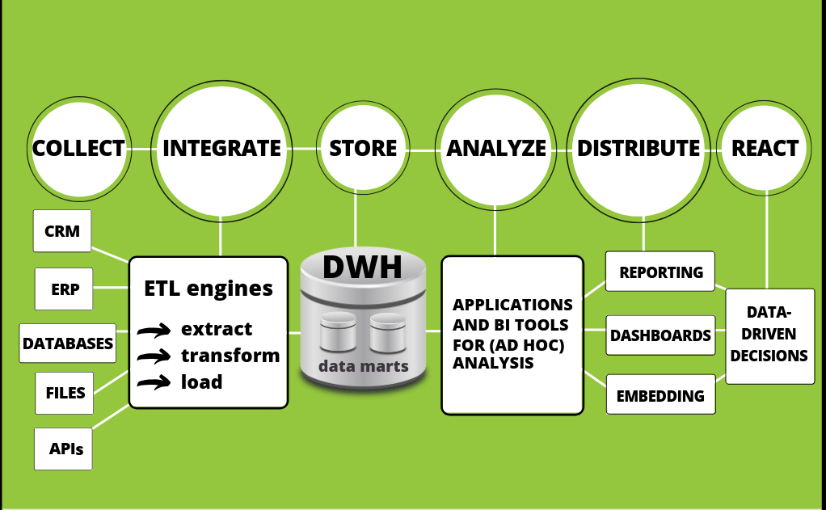

In above BI architecture diagram, we can see how the process flows through various layers, and now we will focus on each.

### 1. Collection of data

The first step in creating a stable architecture starts in gathering data from various data sources such as CRM, ERP, databases, files or APIs, depending on the requirements and resources of a company. Modern BI tools offer a lot of different, fast and easy [data connectors](https://www.datapine.com/data-connectors/) to make this process smooth and easy by using smart ETL engines in the background. They enable communication between scattered departments and systems that would otherwise stay disparate. From a business point of view, this is a crucial element in creating a successful data-driven decision culture that can eliminate errors, increase productivity, and streamline operations. You have to collect data in order to be able to manipulate with it.

### 2. Data integration

When data is collected through scattered systems, the next step continues in extracting data and loading it to a data warehouse. This process is called ETL (Extract-Transform-Load).

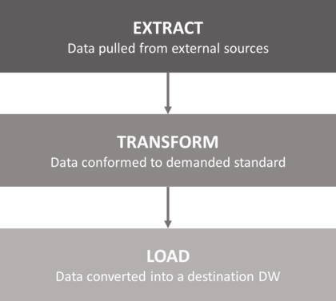

With an increasing amount of data generated today and the overload on IT departments and professionals, [ETL as a service](https://www.datapine.com/etl-as-a-service) comes as a natural answer to solve complex data requests in various industries. The process is simple; data is pulled from external sources (from our step 1) while ensuring that these sources aren’t negatively impacted with the performance or other issues. Secondly, data is conformed to the demanded standard. In other words, this (transform) step ensures data is clean and prepared to the final stage: loading into a data warehouse.

### 3. Data storage

Store data in DWH.

### 4. Analysis of data

In this step of our compact BI architecture, we will focus on the analysis of data after it’s handled, processed, and cleaned in former steps with the help of data warehouse(s). The ubiquitous need for successful analysis for empowering businesses of all sizes to grow and profit is done through BI application tools. Especially when it comes to [ad hoc analysis](https://www.datapine.com/blog/ad-hoc-reporting-analysis-meaning-benefits-examples/) that enables freedom, usability, and flexibility in performing analysis and helping answer critical business questions swiftly and accurately.

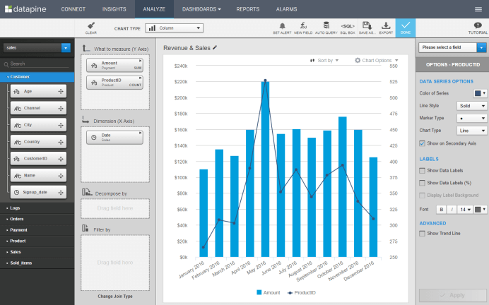

This visual above represents the power of a modern, easy-to-use BI user interface. Modern BI tools empower business users to create queries via drag and drop, and build stunning data visualizations with a few clicks, even without profound technological knowledge. This simplifies the process of creating business dashboards, or an [analytical report](https://www.datapine.com/blog/analytical-report-example-and-template/), and generate actionable insights needed for improving the operational and strategic efficiency of a business. The data warehouse works behind this process and makes the overall architecture possible.

### 5. Data distribution

Data distribution comes as one of the most important processes when it comes to sharing information and providing stakeholders with indispensable insights to obtain sustainable business development. Distribution is usually performed in 3 ways:

**a) Reporting via automated e-mails:** Created reports can be shared with selected recipients on a defined schedule. The dashboards will be automatically updated on a daily, weekly or monthly basis which eliminates manual work and enables up to date information.

**b) Dashboarding**: Another reporting option is to directly share a dashboard in a secure viewer environment. The users you share with cannot make edits or change the content but can use assigned filters to manipulate data and interact with the dashboard. Another option is to share via public URL that enables users to access the dashboards even if they’re outside of your organization, as shown in the picture below:

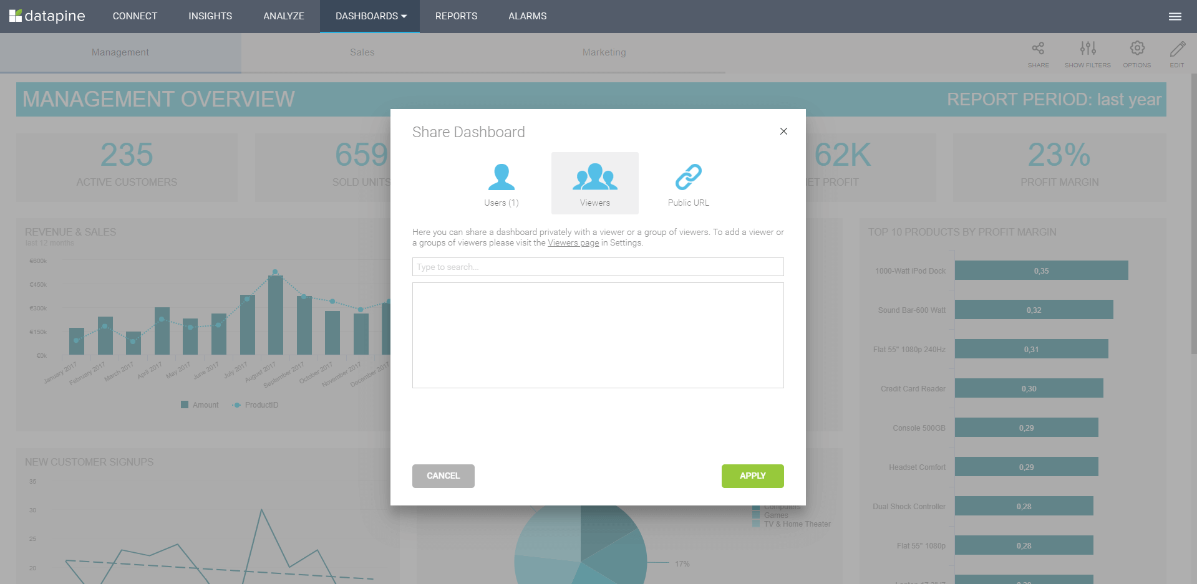

**c) Embedding:** This form of data distribution is enabled through [embedded BI](https://www.datapine.com/blog/embedded-bi-tools-and-business-analytics-software/). Your own application can use dashboards as a mean of analytics and reporting without the need for labelling the BI tool in external applications or intranets.

### 6. Reactions based on generated insights

The final stage where the BI architecture expounds its power is the fundamental part of any business: creating [data-driven decisions](https://www.datapine.com/blog/data-driven-decision-making-in-businesses/). Without the backbones of data warehousing and business intelligence, the final stage wouldn’t be possible and businesses won’t be able to progress. CEOs, managers, professionals, coworkers, and all the interested stakeholders can have the power of data to generate valid, accurate, data-based decisions that will help them move forward. Let’s see this through one of our [dashboard examples](https://www.datapine.com/dashboard-examples-and-templates/): the management KPI dashboard.

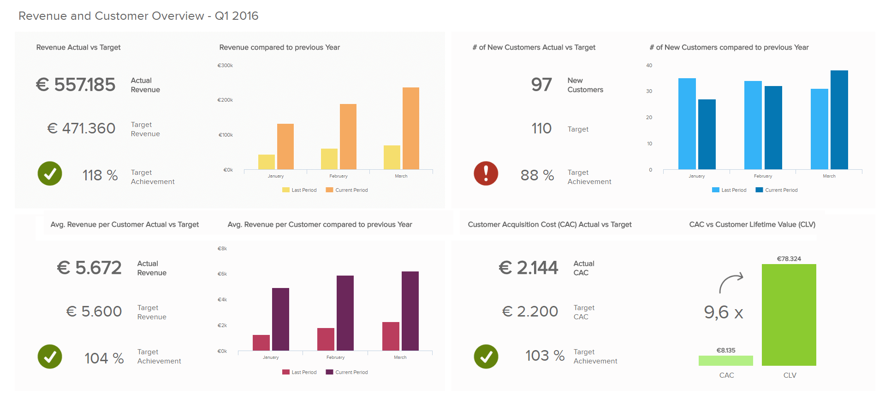

This dashboard is the final product on how data warehouse and business intelligence work together. The processes behind this visualization include the whole architecture which we have described, but it would not be possible to achieve without a firm data warehouse solution. Ultimately, this enables a high-level manager to get a comprehension of the strategic development and potential decisions for creating and maintaining a stable business.

On this particular dashboard, you can see the total revenue, as well as on a customer level, adding also the costs. The targets are also set so that the dashboard immediately calculates if they have been met or additional adjustments are needed from a management point of view. As revenue is one of the most important factors when evaluating if the business is growing, this [management dashboard](https://www.datapine.com/dashboard-examples-and-templates/management) ensures all the essential data is visualized and the user can easily interact with each section, on a continual basis, making the decision processes more cohesive and, ultimately, more profitable.

Decision Support Systems:

1. <https://www.investopedia.com/terms/d/decision-support-system.asp#:~:text=A%20decision%20support%20system%20(DSS)%20is%20a%20computerized%20program%20used,problems%20and%20in%20decision%2Dmaking>.
2. <https://www.tutorialspoint.com/management_information_system/decision_support_system.htm>
3. <https://www.managementstudyguide.com/decision-support-systems.htm>