Name - Gaurang A Raorane Div - D15A Roll no - 49 Batch - C

**Experiment - 1**

**Aim -** To study a Web Analytics Tool.

**Theory -**

Web analytics is the **gathering, synthesizing, and analysis** of website data with the goal of improving the website user experience. It’s a practice that’s useful for managing and optimizing websites, web applications, or other web products. It’s highly data-driven and assists in making high-quality website decisions. You might also get ideas on how to improve your product and drive business growth from web analytics.

Product managers, data scientists, UX designers and others can use web analytics if they’re looking to enhance their website or product experience to meet customer needs. They need to know which website metrics to track while also being mindful of the shortcomings of web analytics.

Web analytics is helpful for understanding which channels users come through to your website. You can also identify popular site content by calculating the average length of stay on your web pages and how users interact with them—including which pages prompt users to leave.

The process of web analytics involves:

* **Setting business goals:** Defining the key metrics that will determine the success of your business and website
* **Collecting data:** Gathering information, statistics, and data on website visitors using analytics tools
* **Processing data:** Converting the raw data you’ve gathered into meaningful ratios, KPIs, and other information that tell a story
* **Reporting data:** Displaying the processed data in an easy-to-read format
* Developing an online strategy: Creating a plan to optimize the website experience to meet business goals
* **Experimenting:** Doing [A/B tests](https://amplitude.com/blog/ab-testing) to determine the best way to optimize website performance.

You can use this information to optimize underperforming pages and further promote higher-performing ones across your website. For example, French news publisher [Le Monde](https://www.lemonde.fr/) used analytics to inform a website redesign that [increased subscriber conversions by 46 percent and grew digital subscriptions by over 20 percent](https://amplitude.com/case-studies/le-monde). Le Monde was able to identify which paid content users engaged with the most, then use that information to highlight top-performing content on the homepage.

**Different Web Analytics Tools:-**

1. [**Google Analytics**](https://www.hotjar.com/web-analytics/tools/#1-google-analytics)
2. [**Mixpanel**](https://www.hotjar.com/web-analytics/tools/#2-mixpanel)
3. [**Kissmetrics**](https://www.hotjar.com/web-analytics/tools/#3-kissmetrics)
4. [**Adobe Analytics**](https://www.hotjar.com/web-analytics/tools/#4-adobe-analytics)
5. [**Matomo (formerly Piwik)**](https://www.hotjar.com/web-analytics/tools/#5-matomo-formerly-piwik)
6. [**Open Web Analytics**](https://www.hotjar.com/web-analytics/tools/#6-open-web-analytics)
7. [**Woopra**](https://www.hotjar.com/web-analytics/tools/#7-woopra)
8. [**Hotjar**](https://www.hotjar.com/web-analytics/tools/#8-hotjar)
9. [**HubSpot**](https://www.hotjar.com/web-analytics/tools/#9-hubspot)
10. [**Chartbeat**](https://www.hotjar.com/web-analytics/tools/#10-chartbeat)
11. [**SimilarWeb**](https://www.hotjar.com/web-analytics/tools/#11-similarweb)
12. [**Ahrefs**](https://www.hotjar.com/web-analytics/tools/#12-ahrefs)

**Link of the project :-**

[**https://worldwise-pranav-raikar.vercel.app/**](https://worldwise-pranav-raikar.vercel.app/)

**Output:-**

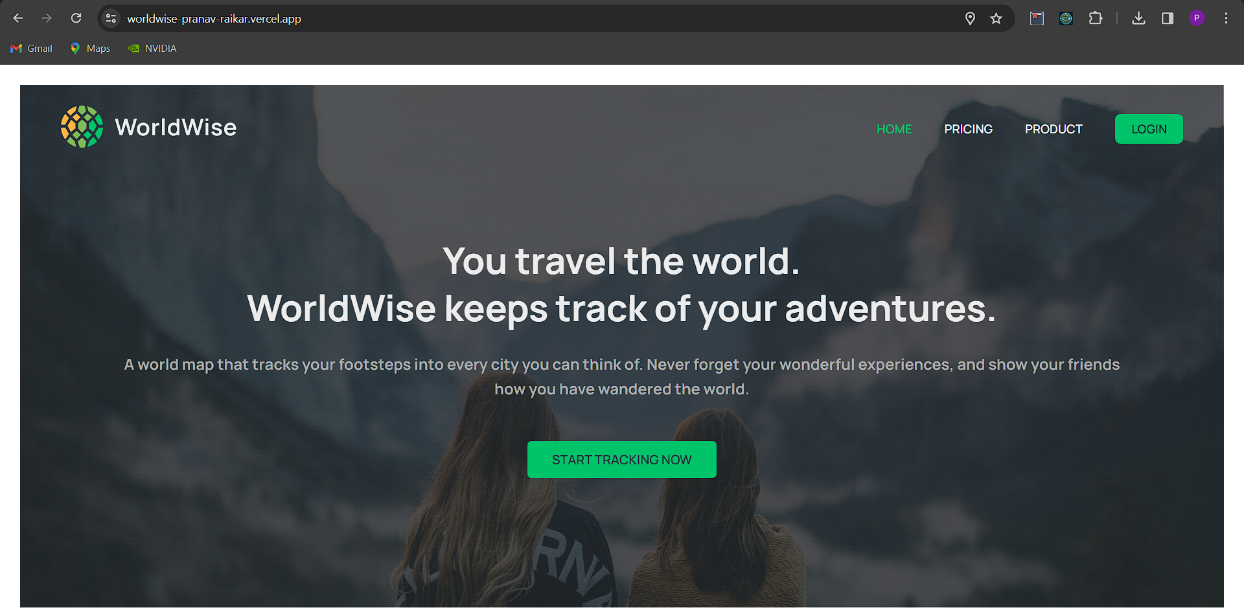

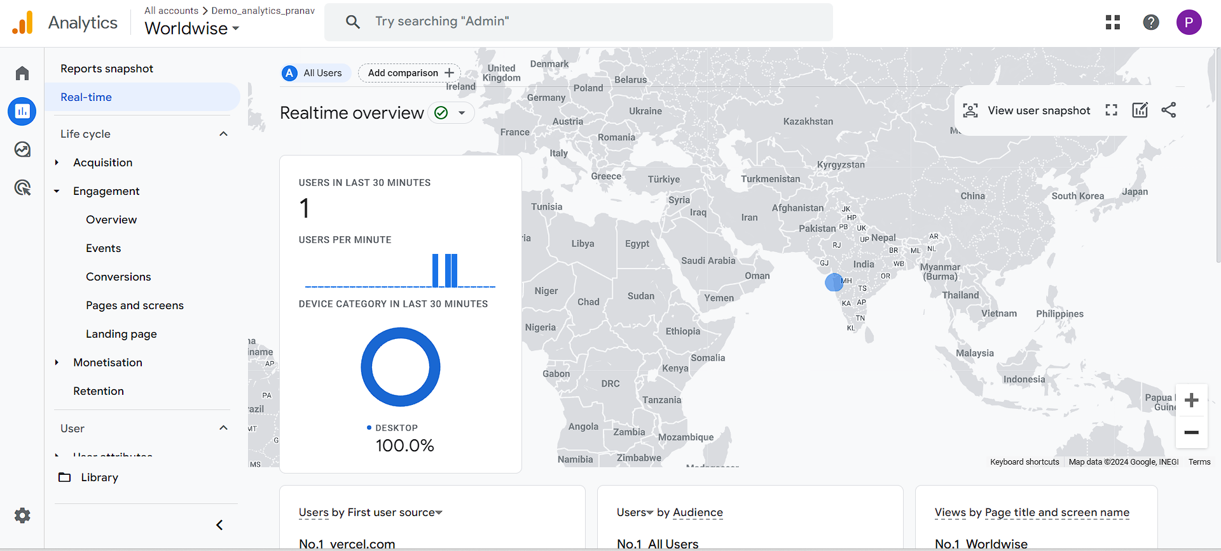

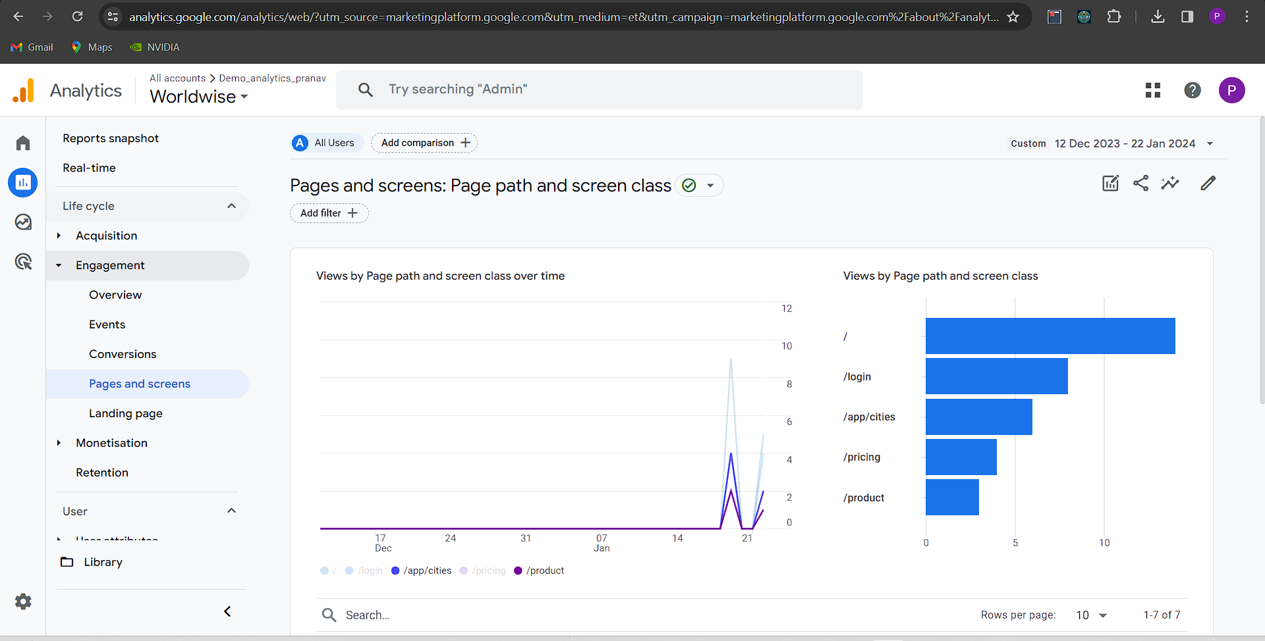

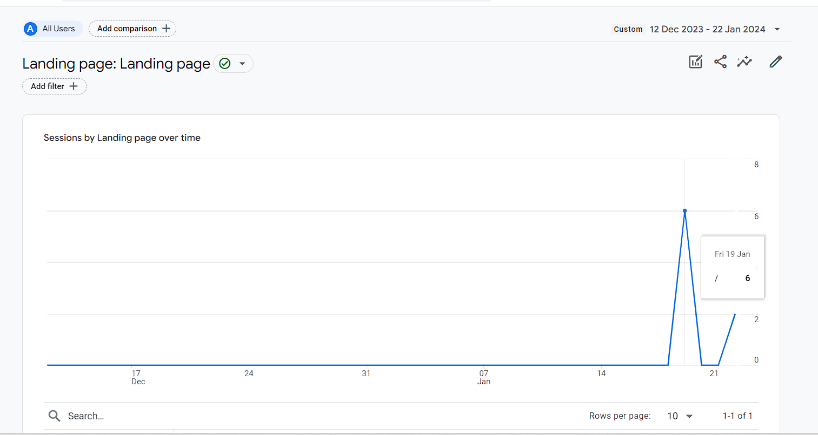

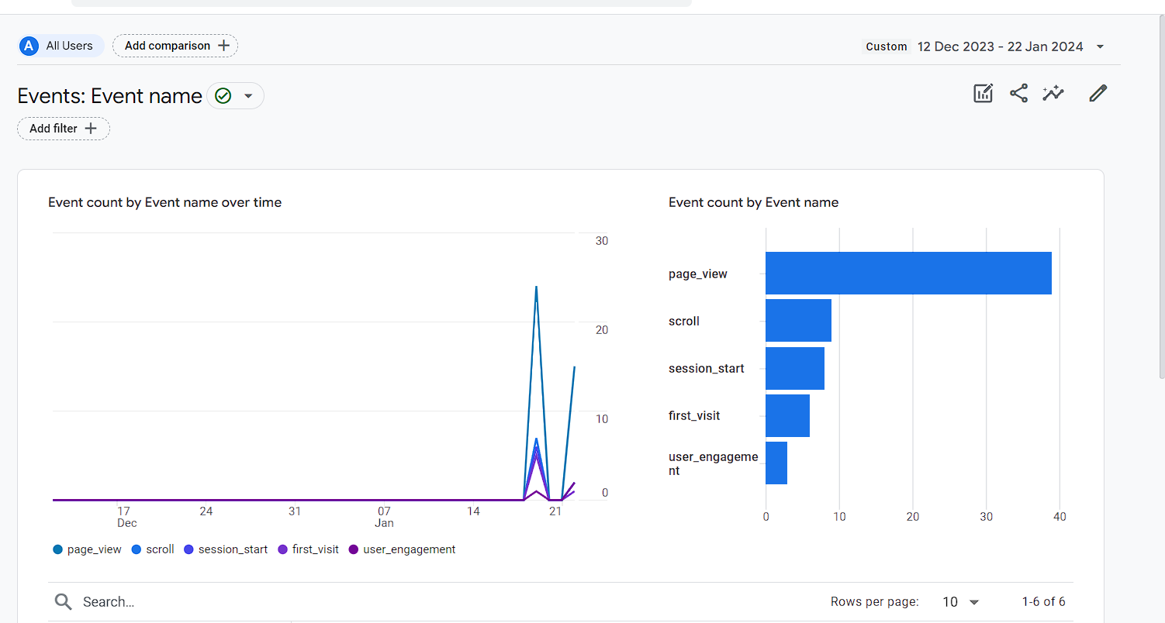

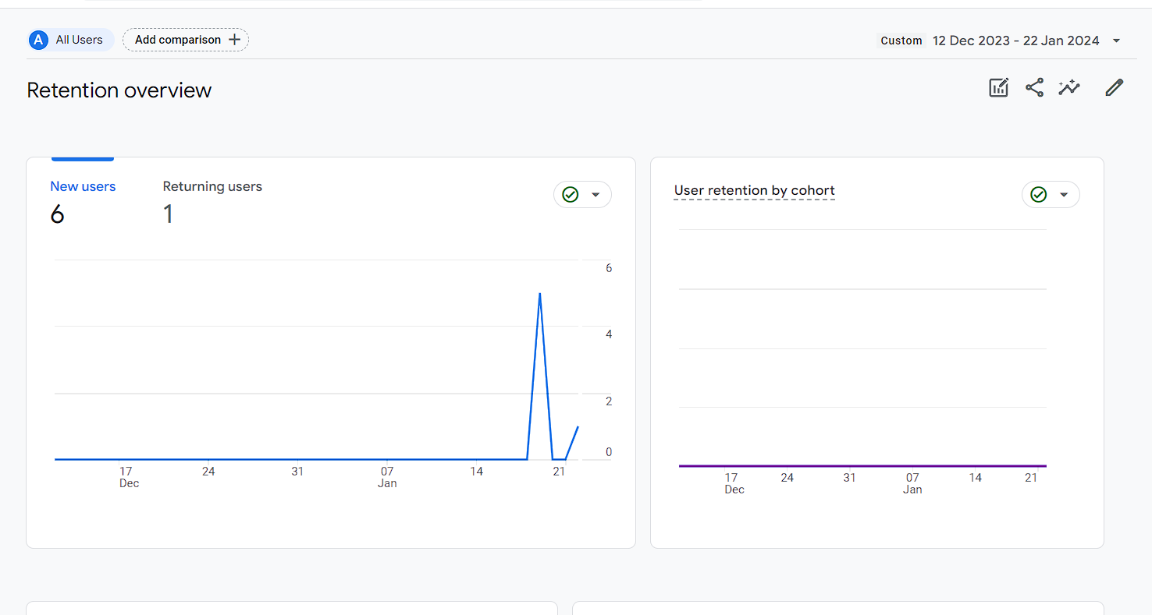

**Conclusion:-** Through this experiment we understood the process of web analytics and how it helps businesses and organizations to take informed decisions and also learnt a business analysis tool i.e. Google Web Analytics.