python -m venv venv

venv\Scripts\activate

pip install fastapi uvicorn python-multipart ultralytics pillow

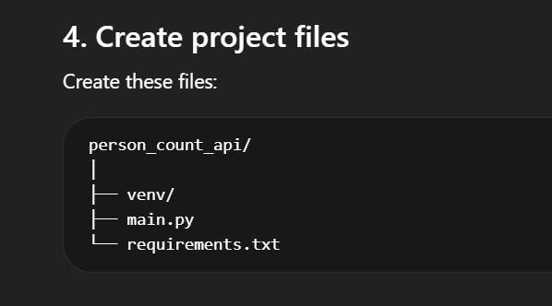

pip freeze > requirements.txt

uvicorn main:app --reload --host 127.0.0.1 --port 5000

Then open http://127.0.0.1:5000/docs

Now quit the env

Create docker file, docker compose and docker ignore

docker compose up --build (this starts the container)

When changes in code, run
docker compose down
docker compose build --no-cache
docker compose up

Working on http://localhost:5000/docs

