Hi Team, (please ignore)

I’m testing redactions for Ticket: RE-903080##, where the redaction shifted…actually more of the text shifting.

This is a sample:

* 43,444 or more, not less.  The latest dat file only contains 36,356 files, so we are 7k short.  The 43,444 are from Sightline so they are all unique and already exported.   Please see the attached file. I will be redacting all CH in the text.
  + CH Can you see the CH
    - CH Can you see the CH
    - CH Can you see the CH
* I worked with CH – Can you see the CH Development and again we briefly stopped the BGP Servers (03-06), which populated the MS-Queue the Indexing in your Project, removed/purged those messages, and restarted the BGP Servers.   This processed allowed your currently ingestion to truly complete.   I also started the Analysis on the remaining ingestion, which completed and is published. The cause is due to a racing condition in Sightline.  Multiple threads picked up your Job and blocked each other from completing, which spawned up additional Jobs.   Development identified the issue and will look to address it in Sightline 6.2 release.  In the meantime, please continue to create tickets for this type of issue and we’ll address them.
* RPMX.BackgroundServices.ContentIndexingTasks.ContentIndexingProcessor :: CH can you see the CH Error while calling Web API method. Status : Conflict. Message : CONFLICT Duplicate background job (store: 'mp__fc2ec4ff-6653-474f-9a21-06e151e17e8b', doc_id: 'MasterCluster-fc2ec4ff-6653-474f-9a21-06e151e17e8b', doc_version: '379'.

[**Provide RMU the ability to "Quick Batch" documents**](https://consilio.atlassian.net/browse/RPMXCON-40698) **[RPMXCON-40698]**

* In Sightline today, CH the user needs to perform several steps to batch out documents for review. Several customers and potential customers complained about the lack of simplicity to quickly batch documents, which is especially important in small matters. In addition, these customers also complained about jumping hoops to start review of the documents as well as confusing behavior around coding options when coding docs in the context of SG vs. coding the docs in the context of assignments.

1. ***Quick Batching:***  
   To simply batching process, provide the ability to quickly batch documents in a single step. Refer to attached PPT for a mockup. The user will be able to select a set of docs from Search Results (Basic and Advanced), Saved Search, Search Term Report, Doc List, Doc Explorer and Tally/SubTally, and be able to perform the "Quick Batch" action, by providing the following information on the "Quick Batch" popup.

# -Assignment Name CH

# Required

# This assignment is automatically created under the Root

# -Coding Form

# Required

# -Sort Order CH

# Values: Optimized OR Chronological - please use these values instead of the ones in the mockup

# Optimized option is selected by default; one of them must be selected

# Chronological option orders the docs by MasterDate Ascending, and Optimized option orders the docs using the current default optimized sort i.e. Email Thread, Family Members, Near Dupes, and then DocID.

# Support for Chronological order requires the below Sort option to be incorporated.

# Add Reviewers

# Optional (please ignore the required * in mockup)

# Be able to add one or more users. These users can be DAUs, PAUs, RMUs and Reviewers.

# The users will be automatically added to the created assignment.

# -Selected Documents

# List the number docs this action is being performed

When the user clicks on Continue, it will show the Like Documents popup similar to Bulk Assign. The user can optionally select the like document options on the Like Documents popup and complete the action. This action is performed in the backend and a notification will be provided after the entire Quick Batch is completed. This is a notification (name is Quick Batch separate from the Bulk Assign. The user remains on the same page after the Quick Batch popup is closed. The Quick batch does the following:

-Creates a new assignment with the default assignment configuration (same as what you see when you navigate to Create New Assignment under Root) with the following applied:

* Specified assignment name
* Selected coding form
* Draw from Pool Enabled with 100 docs max to draw, and the Draw from Pool Family setting enabled with the value set to 1000
* Selected sorting  
  -Adds the documents to this assignment  
  -Adds the selected users to the assignment
* Just like the audit history is maintained for the docs that have been added to an assignment using Bulk Assign, audit history (Added to Assignment and Removed from Assignment) should be maintained for the docs added to the assignment using Quick Batch option.

Note that the Quick Batch option is applicable to new assignments only. If the user wants to add documents to existing assignments, the user will use the Bulk Assign feature.

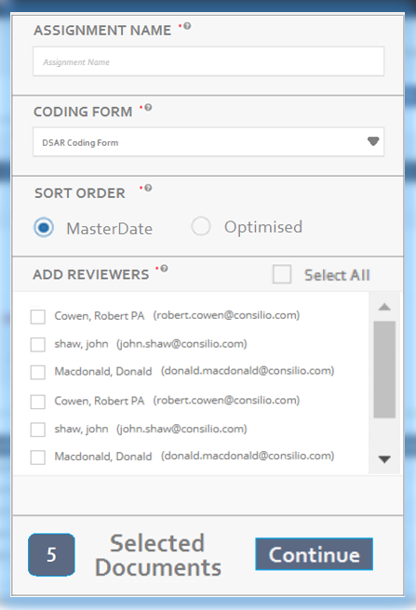

[**Provide the ability to bypass PAU role, and process, review and produce in security group as RMU**](https://consilio.atlassian.net/browse/RPMXCON-40700) **[RPMXCON-40700]**

We received consistent feedback from several self-service clients saying that the construct of Project and Security Groups, the need to move data and workproduct between them, and the different access controls that apply to projects and security groups are confusing and unnecessary. While the project and security groups are more applicable to large projects, they are really not useful in small self-service matters. In order to simplify the user experience, we will allow the users to bypass the PAU role (or projects) and simply allow to process, review and produce (do almost everything) in the construct of a security group as an RMU.

There will be 3 features that the user will not be able to do in a security group: Manage Project Fields, Manage Security Groups, and Ingestions. These are typically not handled by the clients by themselves in the self-service matters. So, Consilio will help the clients if such a need arises.

To support the bypassing of PAU role, the following navigations need to be enhanced:

* In Domain dashboard, clicking on a project will take the user to Default SG in the project as impersonated RMU (as opposed to the project as impersonated PAU).
* Back to Domain Dashboard option needs to be provided in SG (similar to the one available in projects), so the user can click on and navigate back to Domain Dashboard. This option must be available whether the user is in a domain project or non-domain project. When in non-domain project, Back to Dashboard shall take the user to the last accessed domain dashboard. When the user goes into a domain project where the user is not a DAU, but has access as only a PAU or an RMU, Back to Dashboard shall take the user to the last accessed domain dashboard.
* When in an SG, changing the project in Project Dropdown should take the user to the Default SG in the selected project (instead of the project)
* When in SG, the SG dropdown should display all SGs in the project the user has access to. Changing the SG in SG Dropdown should take the user to the corresponding SG in the same project the user is in.

In addition, the following access control needs to be updated, so that RMUs can perform productions in a security group.

* Make Productions accessible to RMUs by default. Note that today the productions already happen in the context of a security group. It's just that PAU runs them.

When a SA or a DA user creates a project, all project fields need to be released to the security group.

Lastly, Change Role for a Reviewer user now allows to impersonate back up to RMU and other roles. See screenshot below.

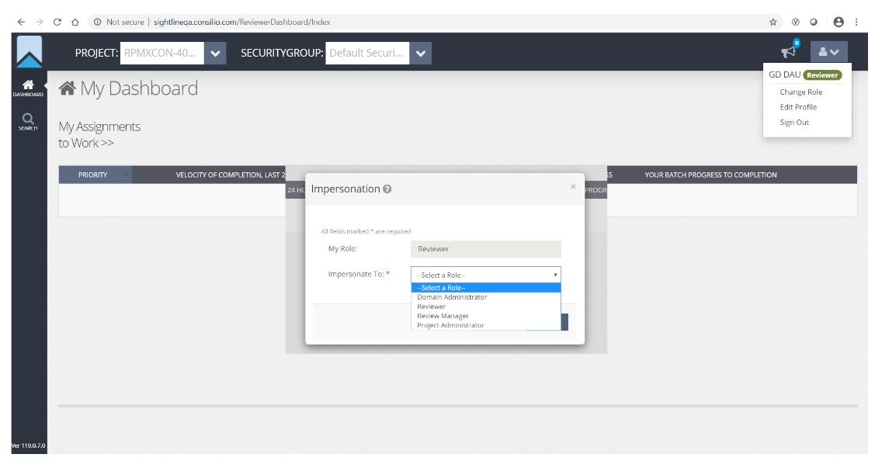

[**Provide the ability to create a new project with configuration from an existing project**](https://consilio.atlassian.net/browse/RPMXCON-40854) **[RPMXCON-40854]**

Provide the ability to create a new project with configuration from an existing project.   
Refer the attached requirements document and the below (updated) mockup. Note that in addition to new section to specify the existing project to copy from, the Project Active check box has been moved to the top corner.

Outlined below is what we is expected from the user interface and the changes to project creation.  
**The User Interface:**

1) When a SAU, DAU invokes project creation, the Create Project UI should now present as depicted in the mockup. The 3 check-boxes to the right should not present initially and should be presented to the user only after he has selected a template project.  
2) When the user clicks on the dropdown for "Project to Copy from", the list should present the projects that are in the "Client" as selected by the user in "Client Name". If the user clicks on this dropdown, without having selected a Client Name, the dropdown list will have no project entries.   
3) The "isActive" flag/attribute should now be renamed to "Project Active" and should present on the top right corner as suggested in the mockup  
4) The user should be able to tick mark the optional check-boxes. If the "users" check-box is checked by the user, then if the user ticks the "Assignments" check-box, the Assigned Reviewers check-box should present below the Assignments check-box, indented to the right. If the user does not tick the Assignments check-box, the Assigned Reviewers check-box should not present at all. If the user does tick the Assignments check-box, but had not ticked the "Users" check-box, then also, the "Assigned Reviewers" check-box should not present at all.

5) The user should be able to click on "Save" and start the project creation. The user should be able to click on save even if he had not chosen any template project in the "Project to Copy From" dropdown.

**The Project Creation:**  
6) If the user did not select a template project, then the project creation should be identical to how it is today.  
If the user did select a template project, then in addition to the project creation that happens today the following will happen:  
7) The list of object types that are marked as mandatory in the attached document will be copied from the source template project to the project that is newly created. These are : Project Fields, Security Groups, Coding Forms, Tags, Folders, Comments, Production Export Templates, Annotation Layers, Redaction Tags and Keywords  
8) In addition to the above mandatory objects, those optional object types for which the user had ticked the check-boxes in the project creation UI should also get copied from the template project.  
9) For each of the object types copied from the template, all the objects of that object type should be copied i.e. if users are checked to be copied, all users should be copied and not only some users.  
10) All custom project fields newly added in the template project in addition to the pre-packaged metadata fields should also get copied/created in the newly created project.  
All modifications to the pre-packaged metadata fields in the template project should also get replicated in the new project being created.  
11) All production/export templates created/saved by the user in the template project should get copied. If no productions/exports had been saved as a template, then no templates will get copied.

12) If users are "checked" to be copied, then all "active" users from the template project should be created in the new project being created. The users copied should have the same role that they have in the template project. The users copied can be of the roles PAU, RMU and Reviewers.  
13) For each user that is copied, the user should be automatically active in the new project - he should not have to activate himself.   
14) The copied user should be able to login to the new project with the user-id password successfully without any further intervention.

15) If Assignments are ticked to be copied, then all assignments from the template project should be copied in the new project along with the configuration. i.e. all the flags/properties of the assignment copied should be the same in the copied project.  
16) If the user had also ticked "Assigned Reviewers", then the reviewers assigned to the assignment in the template project should also be assigned to the assignment in the new project. If the "Assigned Reviewers" was not selected/ticked, the assignment should be copied with the configuration but without the users assigned to the assignment.   
17) When an assignment is copied, no documents should be copied/distributed as part of the assignment copy.   
18) If Saved Searches are "ticked" to be copied, saved searches in the template project should be copied along with the search group structure and hierarchy.  
19) The copied searches will be in a "DRAFT" state and will not have any counts associated with them.  
20) My Searches will be copied only if the "Users" are also ticked to be copied.  
21) If users were not ticked to be copied, yet, all shared search groups and their searches should also be copied.  
22) All security groups and their associated workproduct objects (and project fields) will also be copied from the source template.  
23) No documents or document specific information should be copied into the new project as part of this process.  
24) A user should be able to delete objects in the new project, that were copied from a template project, just like he deletes any objects that were created explicitly in the new project. (Subject to permissions and rules and checks that apply in the new project).

CH – Error on creating a new project from the Ex

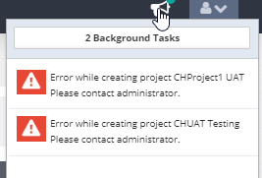

**Errors:**  
25) Any errors occuring during the process of copying/creating objects in the new project, should get captured and reported as an error, with meaningful information on the error and during what step the error occurred.  
26) When an error occurs at any stage of this process, the project creation should fail (be rolled back) and any artefacts that were created during this process should be cleaned up.

[**A user needs to be able to access the application with reasonable speed while uploading data in drag-and-drop**](https://consilio.atlassian.net/browse/RPMXCON-41206) **[RPMXCON-41206]**

A user needs to be able to access the application/project while uploading data in drag-and-drop. This was asked by Activision and others. Today's the workaround is to create another user with a different email address that the client has, which is not always possible and not always acceptable.

The solution is for the user to bring up the application/project in a different tab, so the user can continue to use the application. However, today, the second tab is very slow. Sometimes, it takes a minute to show the page. The speed needs to be improved, so the user can continue to use the application. If there is any other way to achieve the same, we will consider it.

CH – I was able to open another tab while the first one performed the upload. There’s no noticeable slowness.

[**In Domain Dashboard, workspace size should not include the PDFs, archives and duplicates**](https://consilio.atlassian.net/browse/RPMXCON-41189) **[RPMXCON-41189]**

In Domain Dashboard, workspace size should not include the PDFs, archives and duplicates. From Chia's findings (in Mills & Reeve UK domain), the current workspace is including PDFs (which we know), uploaded files/archives and duplicate docs.

Chia’s Note from Emails:

The 3.69 GB is coming from the Published data into Sightline.  As you can see, due to duplication only about 20% of the overall size from the Expanded got published.  \\llnas25\ukslprod\DestinationLocation\MILLSREEVE\Project Earth\8d63718b-bac8-4a70-875a-772bb3a0526d folder, which is reported to the Workspace Size is 32 GB, while the Natives are the Published size in Sightline at 3.69 GB.

The only change I can see is for our Dashboard SP metric to exclude the ‘Exhibit’ subfolder under the \\llnas25\ukslprod\DestinationLocation\MILLSREEVE\Project Earth\8d63718b-bac8-4a70-875a-772bb3a0526d for all Projects when Sightline is collecting the Metrics for the Workspace Size.  We might want to exclude ‘UC’ subfolder as well because that’s the Temp location when the user drag-n-drop data to move into the ‘Exhibit’ when the copying is done.  For example, if the client is uploading a 20 GB Zip and it’s 90% done, 18 GB worth of data will be the UC folder.  If the SP executes to collect the Workspace size during this time, then 18GB of Raw data will be collected.

CH = Need to check after the SP starts and updates on Monday 3/9th.

[**In the login page, after a user has made two consecutive unsuccessful login attempts to login, provide a message to the user about the account being potentially locked out if the next attempt to login is unsuccessful**](https://consilio.atlassian.net/browse/RPMXCON-41164) **[RPMXCON-41164]**

While we are not receiving requests to Reset Password in Sightline anymore, we are still receiving requests from clients to unlock their user accounts. This is because the application is not letting the users know that their accounts will be locked after 3 unsuccessful login attempts. This is creating unnecessary tickets or unnecessary work for administrators. To avoid this unnecessary work, provide the following message to the user after 2 unsuccessful login attempts on the login page.  
"You already had 2 unsuccessful login attempts. Your account will be locked after the 3rd unsuccessful login attempt. If you do not remember your password, you can click on "Forgot Password" and reset your password."

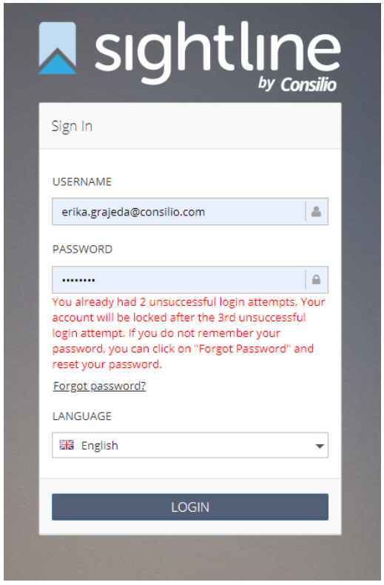

CH – Looks good.

[**In DocView, the two scroll bars presented are very inefficient and frustrating to use when there are several pages in the doc**](https://consilio.atlassian.net/browse/RPMXCON-41163) **[RPMXCON-41163]**

In DocView, the two scroll bars are very inefficient and frustrating to use when there are several pages in the doc. Several clients complained about this..

* Avoid the need to use two scroll bars when reviewing a large doc
* Avoid the need to scroll back up to apply redactions on the later pages of the doc. If I want to redact on page 9, it do not have to scroll back up to access the redaction menu. Same with highlighting and reviewer remarks.
* Avoid the need to scroll back up to apply coding when the user is on the later pages of the doc

The scrollbar changes were done in the following places:

1. Default Doc View tab
2. Text tab
3. Images tab
4. Translations tab

[**‘AllProductionBatesRanges' is currently a searchable field, but searching for this field is not returning all matching documents**](https://consilio.atlassian.net/browse/RPMXCON-41162) **[RPMXCON-41162]**

The user can search for docs using Bates #s in Adv Search page. Based on discussion with engineering the following is the ask for 6.1:

The field "AllProductionsBatesRange" should be changed to be:  
1) Not Searchable  
AND  
2) The "isSearchable" attribute for this field should not be allowed to be modified to make it searchable.

For the scope of this ticket, we need to ensure that:  
1) In all new projects, the field "AllProductionsBatesRange" should be not searchable. And when a user tries to edit the field, he should not be able to make it searchable.   
2) There needs to be a help text on this field which says "This is not a searchable field."  
3) In an existing project, if this field had been left as non-searchable, ie. searchable is false, then the user should not be able to make the field searchable by editing it.  
4) In an existing project, if this field has been edited and is now searchable, then we should leave the field to be searchable.

[**All security group keywords should be added to an assignment, by default, to be considered for highlighting**](https://consilio.atlassian.net/browse/RPMXCON-41161) **[RPMXCON-41161]**

Today, when an assignment is created, the keywords need to be manually added to the assignment for highlighting. This is an additional step. Most of the time, the users forget about this and then call project manager. To avoid this, all the security group keywords should be added by default to the assignment. The user will be able to remove any keywords that are not applicable to the assignment.

* When a new assignment is created all the existing security group keywords are automatically added.
* When a new key word is added to the security group, it is automatically added to all existing assignments.
* When a keyword is deleted from the security group, it is removed from all assignments it is part of.

[**In Productions, producing just the DAT file for 10K docs is taking 4 hours**](https://consilio.atlassian.net/browse/RPMXCON-41159) **[RPMXCON-41159]**

In Productions, producing just the DAT file for 10K docs is taking 4 hours. Based on the info from DEV, 10K messages are created for 10K docs. The production also has throttling of messages and sleeping while handling messages etc.. As a result, instead of finishing the export in minutes, it is taking hours. It is likely that the same inefficiency exists in the full production (DAT, TIFFs, natives, Text) as well. This needs to be looked at and optimized.

Chia:

Dat file with 12k records took: 5mins and 43 secs.

Dat, Native and PDFs – 12k started on 2020-03-10 02:15:06.733

[**In DocView, make the redactions transparent all the time**](https://consilio.atlassian.net/browse/RPMXCON-41157) **[RPMXCON-41157]**

In DocView, make the redactions transparent all the time, so the user need not hover over the redactions to view the content.

[**Increase the DocView viewer file size limit from 10MB to 25MB**](https://consilio.atlassian.net/browse/RPMXCON-41152) **[RPMXCON-41152]**

Increase the DocView viewer file size limit from 10MB to 25MB

Currently, the limit for the file size of a document viewed in DocView is a system-wide setting - which means that whatever value it is set to, will apply to all projects in the SL instance.  
What we want to be able to do is to have a mechanism where we can override/set the value of this parameter at a project level - for a given project.  
When set at a project level, the value at the project level will take precedence over the instance level setting value.  
Currently, we do not want this exposed such that the client user himself can set it. Rather, currently, only a Consilio internal user (support / admin) should be able to set this override value at a project level.

Ideally, we want this to be designed such that:  
1) We can extend this project-level override mechanism for other configuration parameters also easily, when the need arises  
2) If and when we decide to do so, we should be able to easily expose these project-level parameter settings in the SL UI.

[**Infosec Audit: Address the recent finding related to Stored XSS found during Infosec review**](https://consilio.atlassian.net/browse/RPMXCON-41150) **[RPMXCON-41150]**

To avoid this issue, < and > characters are not allowed to be used in the name of the saved search and in the name of the security group.

[**For a document with the hidden property "Contains Comments", present the message to "download native to review" for excel files and do not present it for word docs, ppts where the generated PDF already presents the comments.**](https://consilio.atlassian.net/browse/RPMXCON-41149) **[RPMXCON-41149]**

1) In 6.0, if a document has the hidden property "Contains Comments", we are always asking the reviewer to download the native to review the document.   
This was because for Excel files, we do not generate a PDF and so the user has to download the native to see the comments.  
But for non-excel files like word docs and ppts, the generated PDF contains the comments also. Hence, there is no need for the user to download the native in order to view the comments while reviewing. Hence, in the HiddenProperties message, we should not present the part where we suggest the reviewer to download the native to review.   
We should continue to present that however, for excel files.

Note that the above applies for ICE data and applies only if the PDF file variant exists.

2) Also, if ICE is not able to process a file, it now sends the "ExceptionStatus" of such a file as "Native Review Required" and sends the description of the error in "ErrorDescription". As per confirmation from Prabu, ICE is now sending this status "Native Review Required" only for those files for which ICE is not able to process the file and not for any file for which there are HiddenProperties. Hence, for such a file/document for which ICE sends "ExceptionStatus" as "Native Review Required" (eg the Excel spreadsheet in ticket Done ), Sightline should present the Error Placeholder PDF and ask the user to download the native.

3) Product also noticed an issue where there were several documents in a project, for which the field "HiddenProperties" did not have any value (was blank), but SL is showing a message that says that the document has "HiddenProperties" and asks the reviewer to download the native. We need to fix this to ensure that we are presenting the document as having HiddenProperties and the corresponding message, only when the document actually has HiddenProperties.  
Project Details where the above is seen:   
Domain: Duke Energy Corporation; Project: H52357 2018 Micheal Storm Cost Recovery  
DocIDs: ID00002812, ID00002945, ID00003142, ID4515

When ICE flags a document as "Native Review Required" in ExceptionStatus, Sightline should present the Error Placeholder PDF and ask the user to download the native

If ICE is not able to process a file, it now sends the "ExceptionStatus" of such a file as "Native Review Required" and sends the description of the error in "ErrorDescription". As per confirmation from Prabu, ICE is now sending this status "Native Review Required" only for those files for which ICE is not able to process the file and not for any file for which there are HiddenProperties. Hence, for such a file/document for which ICE sends "ExceptionStatus" as "Native Review Required", Sightline should present the Error Placeholder PDF and ask the user to download the native.

[**In DocView, when redaction is being applied, the redaction popup should automatically select a redaction tag**](https://consilio.atlassian.net/browse/RPMXCON-41148) **[RPMXCON-41148]**

**40857:**  
In DocView, when redaction is being applied, the redaction popup should automatically select the redaction tag that was last applied (not just this document). This is to eliminate the unnecessary clicking needed to apply a redaction. Several customers complained about the same.

If this is the first redaction being applied, then automatically select "Default Redaction Tag". If "Default Redaction Tag" doesn't exist, then select the first redaction in the list.

**41144:**  
Today, for non-audio docs, we allow the user to select only one redaction tag for a given redaction.  
But for audio docs, we are allowing the user to select and associate multiple redaction tags for a single redaction.   
While having a doc redacted for privacy as well as privilege is not impractical, what we want to do going forward, for this, is to have the behaviour consistent across audio and non-audio documents and therefore allow the user to select only one redaction tag for one redaction.

As part of this, the user should be able to select and associate only one redaction tag for a given redaction in a document - audio or non-audio.

[**All coding options should be available when docs are reviewed in the context of a security group**](https://consilio.atlassian.net/browse/RPMXCON-40866) **[RPMXCON-40866]**

When docs are being reviewed in the context of a security group, the coding options (Save, Save and Next, Code Same as Last and Coding Stamps) should be same as those of the ones presented when the docs are being reviewed in the context of an assignment. The only different is that the coding is saved instead of completing.

We need to,

* Make sure that when docs are viewed in DocView in the context of SG, then Save, Save and Next, Code Same as Last and Coding Stamps are presented.
* Make sure that these options are working the same as in the assignment context with the only difference being that the coding for each of these actions (in SG) is Saved instead of Completed.
* Make sure that when docs are viewed in the context of a project, it will be same as it is today.
* Make sure that this enhancement doesn't in anyway change the current coding options and behavior in the context of assignments.

[**Present these three widgets by default for RMU on RMU Dashboard**](https://consilio.atlassian.net/browse/RPMXCON-40865) **[RPMXCON-40865]**

Present 3 of the 6 widgets as default widgets for RMU on RMU Dashboard. The widgets to be shown by default are (in this order) for any newly created project:

* Review Rate Trend widget
* End-to-end widget
* Tagging widget

They information presented in these widgets is same what is shown by default when the RMU manually adds these widgets to the dashboard. These automatically widgets work the same way as those that are manually added.

[**RMU should be able to access batches as well as help content from the RMU dashboard**](https://consilio.atlassian.net/browse/RPMXCON-40864) **[RPMXCON-40864]**

**RMU to review docs without needing to impersonate as Reviewer**  
This is another confusing experience today when a RMU user wants to review docs in an assignment. The RMU needs to impersonate down as Reviewer in order to review docs. In several small matters, the RMU users review the docs. In addition, after the impersonating down to Reviewer, the user cannot impersonate back to RMU. This is a confusing experience, which needs to be remedied.

* In RMU Dashboard, repurpose the "My Assignments" widget in order to show the same information that Reviewer sees on the Reviewer Dashboard page. Meaning, this widget will show the assignments this RMU has been assigned to. The RMU will be able to select an assignment and review documents like he/she can review by impersonating as a reviewer today. RMU will also be able to draw docs (from pool) just he/she can do today as reviewer.
* Change label to "My Assignments to Work"

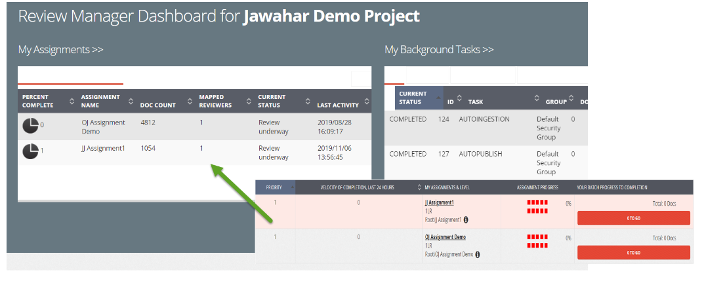

**RMU to be able to access the help content, hosted externally, from the application**

* In addition, change/remove the "My Background Tasks" widget and replace it with the image "GetTheMostFromSightline" which is an image that also contains a link. This link will take the user to an external page (in a new tab) with Sightline documentation.  
  Refer to the attached mockup for the same. (40864_MockupForLinkToDocumentationFromDashboard)

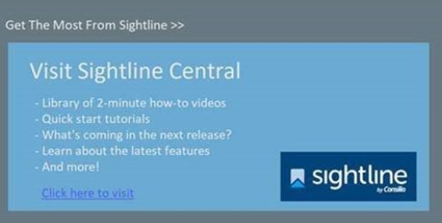

[**Provide the ability to batch documents to pending activation users**](https://consilio.atlassian.net/browse/RPMXCON-40863) **[RPMXCON-40863]**

Batch Docs to Pending Users  
Today, you cannot batch docs to a reviewer until the reviewer activates the account. The administrator needs to wait until each of the reviewers activates his/her user account, which doesn't makes sense. When a RMU wants to batch docs to a set of reviewers, the RMU should be able to create the reviewer users and batch the docs to them, without waiting for the reviewer users to activate their accounts. In other words, RMU should be able to assign docs to a user before the user's account is activated.

To support the above need, present the pending users in Quick Batch, Manage Reviewers (Edit Assignment) and Distribute Documentss (Edit Assignment). The RMU users needs to be able to perform actions (e.g. Redistribute Docs, Remove Docs) on these pending users who have been added to the assignment (on Manage Reviewers tab) just like they can do on the active users who are in the assignment.

[**Manage Project Fields: Re-indexed belly band notification is displayed when adding a 'Is Searchable' field**](https://consilio.atlassian.net/browse/RPMXCON-41420) **[RPMXCON-41420]**

DESCRIPTION:  
The re-index belly band notification should only be displayed when the user edits an existing project field, and not when adding a new project field.

[**Accusoft: Some Emojis in HTML are not presenting in the generated documents for Sightline.**](https://consilio.atlassian.net/browse/RPMXCON-41158)  **[RPMXCON-41158]**

It has been noticed that several emoji’s that are present in the native are not being presented in the document generated for review in Sightline.

We need to investigate to find the root cause and see how we can fix the same.