Set up GOPATH environment variable

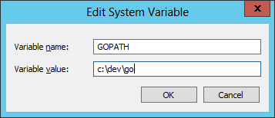

Install Go from

<https://golang.org/dl/>

Install git from

<https://git-scm.com/>

Bring up a cmd prompt and run:

**go get –u github.com/gitdlam/emailer**

go to the local folder containing the source files

**cd \dev\go\src\github.com\gitdlam\emailer**

to compile, run

**go build**

If need to grab the latest copy of the source files from github, run

**go get –u github.com/gitdlam/emailer**