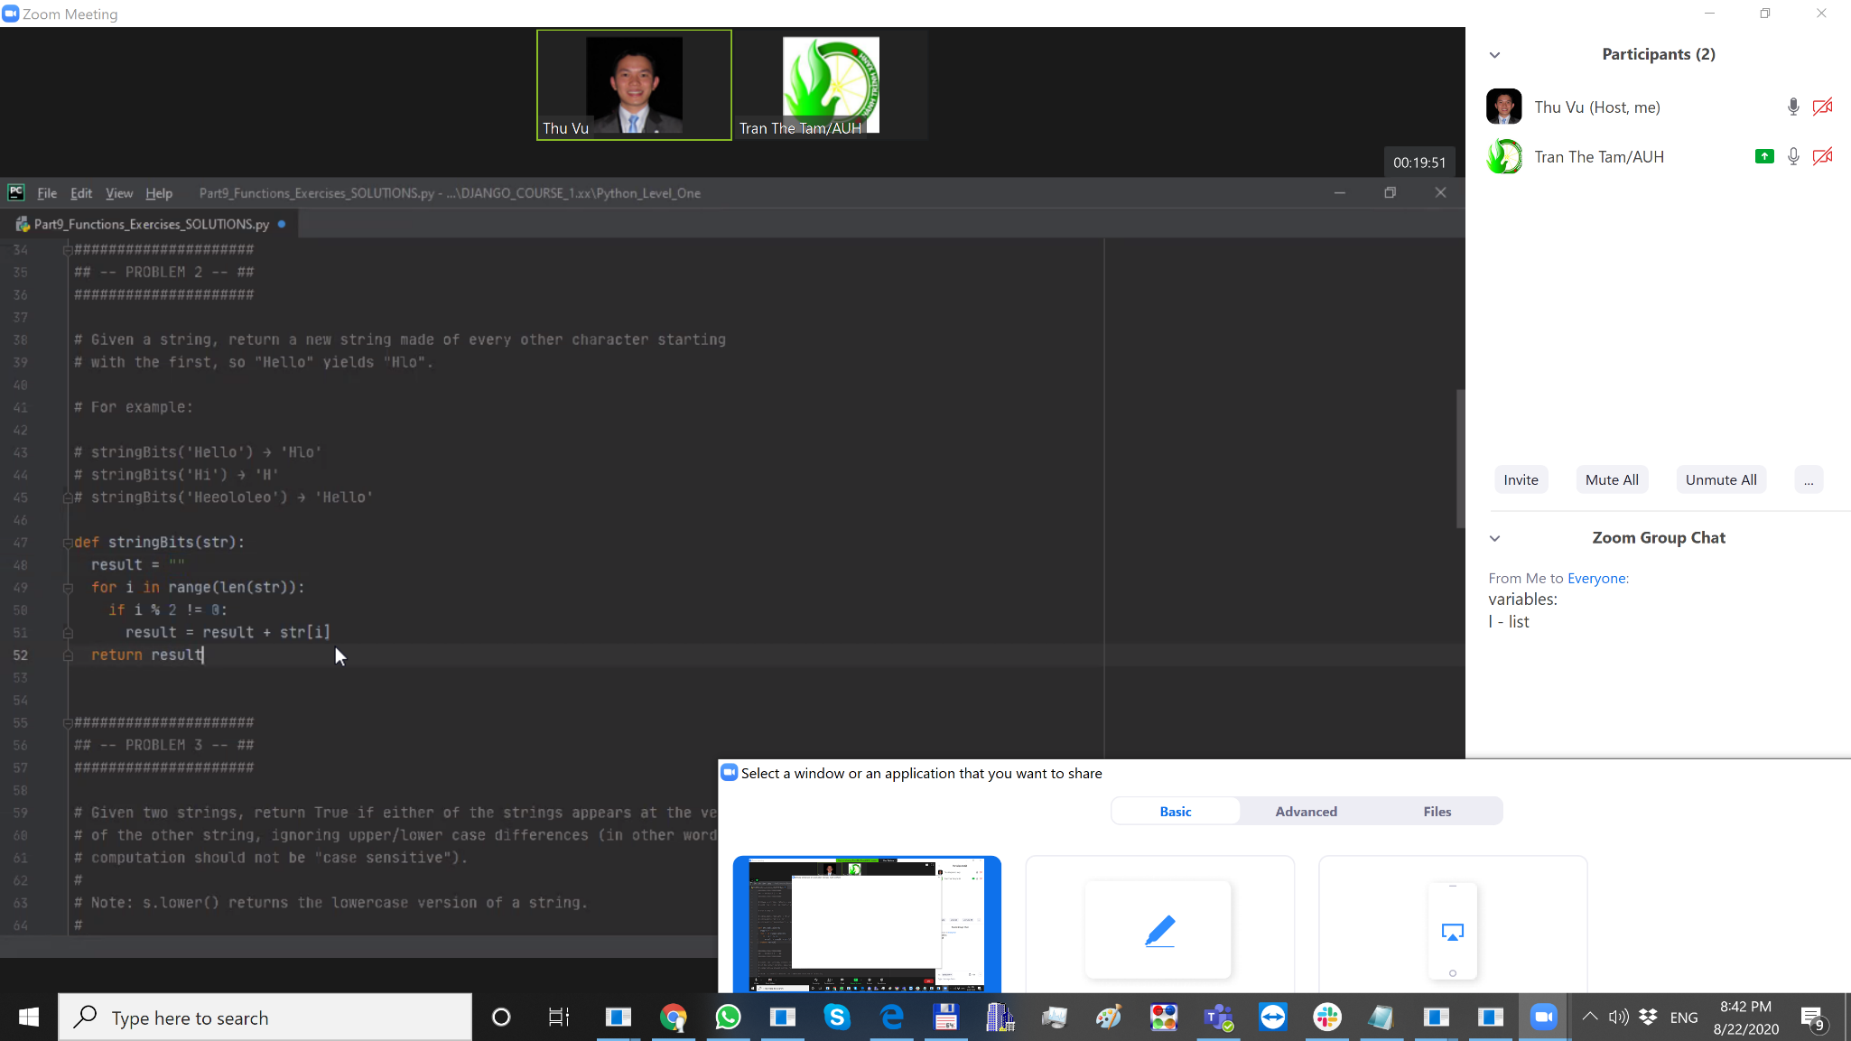

|  |  |  |  |  |  |
| --- | --- | --- | --- | --- | --- |
| Line | str | i | str[i] | result | if in line 50 |
| 47 | ‘Hello’ |  |  |  |  |
| 48 | ‘Hello’ |  |  | “” |  |
| 49 | ‘Hello’ | 0 | “H” | “” |  |
| 50 | ‘Hello’ | 0 | “H” | “” | false |
| 49 | ‘Hello’ | 1 | “e” | “” |  |
| 50 | ‘Hello’ | 1 | “e” | “” | true |
| 51 | ‘Hello’ | 1 | “e” | “e” |  |
| 49 | ‘Hello’ | 2 | “l” | “e” |  |
| 50 | ‘Hello’ | 2 | “l” | “e” | False |
| 49 | ‘Hello’ | 3 | “l” | “e” |  |
| 50 | ‘Hello’ | 3 | “l” | “e” | True |
| 51 | ‘Hello’ | 3 | “l” | “el” |  |
| 49 | ‘Hello’ | 4 | “o” | “el” |  |
| 50 | ‘Hello’ | 4 | “o” | “el” | False |
| 52 | ‘Hello’ | 4 | “o” | “el” |  |
|  |  |  |  |  |  |

len(str)=5

for i in range (5) -> 0,1,2,3,4

range(n) -> 0,1,2...n-1