Git Lab Exercise

Objectives
• Setup Git configuration
• Configure Notepad++ as the default Git editor
• Create a local Git repository
• Add, commit and push a file to a GitLab repository

Procedure

Step 1: Check Git Version
Command:
git --version
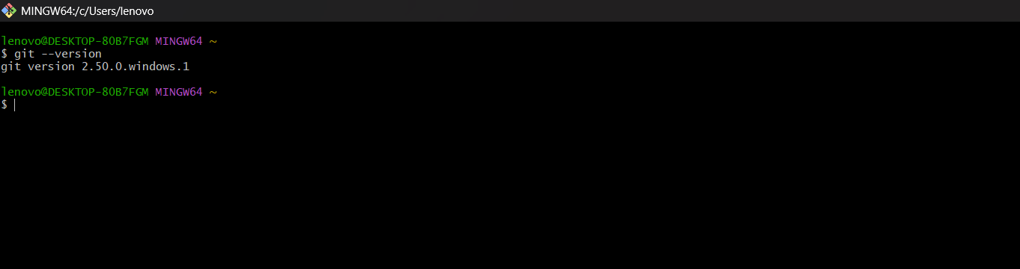

Step 2: Verify Git Configuration
Command:
git config --list
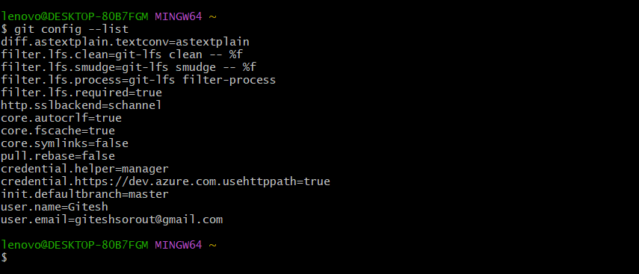

Step 3: Launch Notepad++
Command:
notepad++
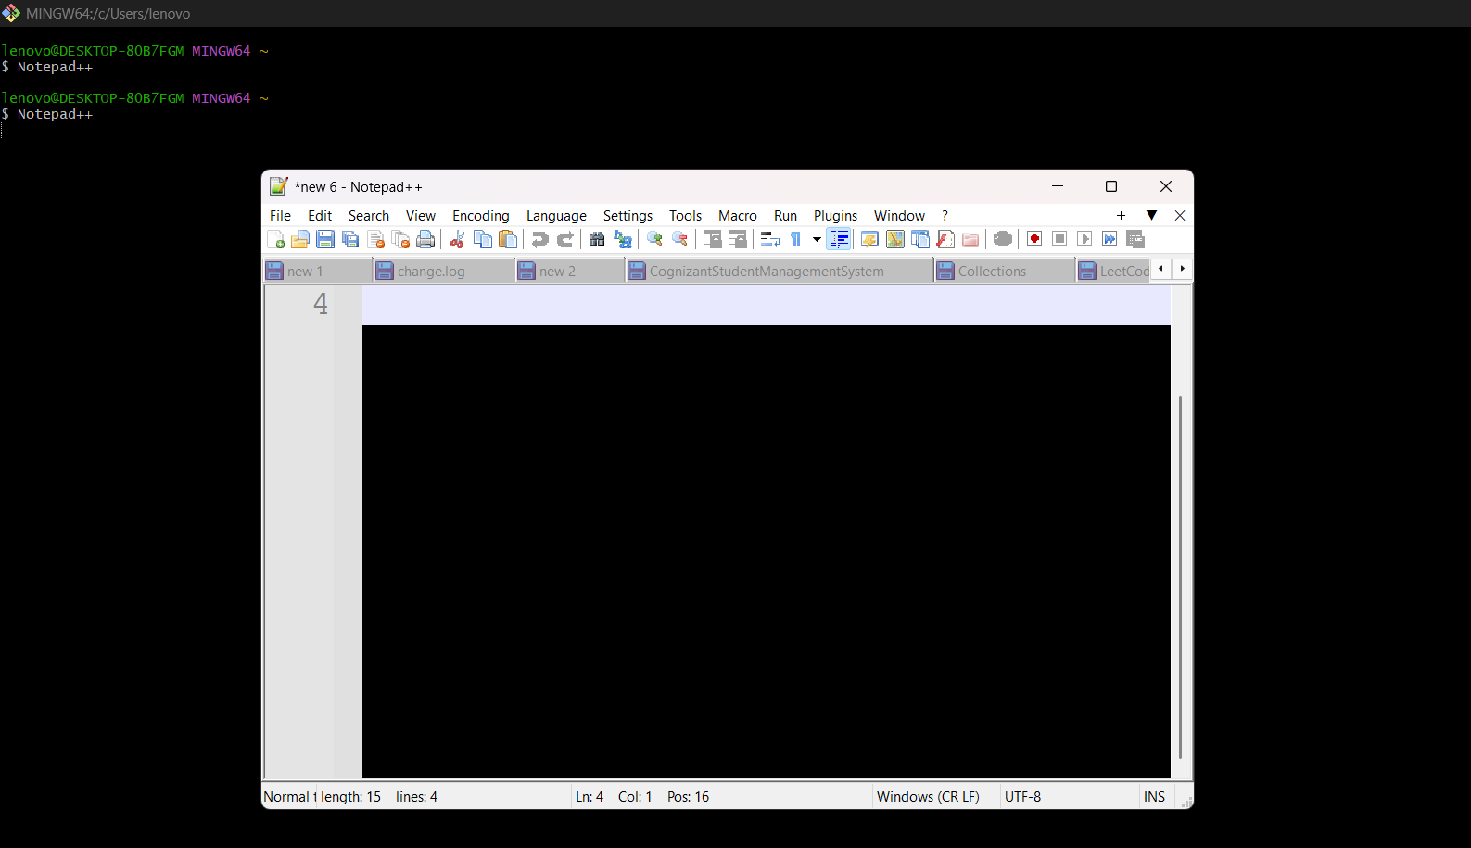

Step 4: Verify Default Editor
Command:
git config --global -e
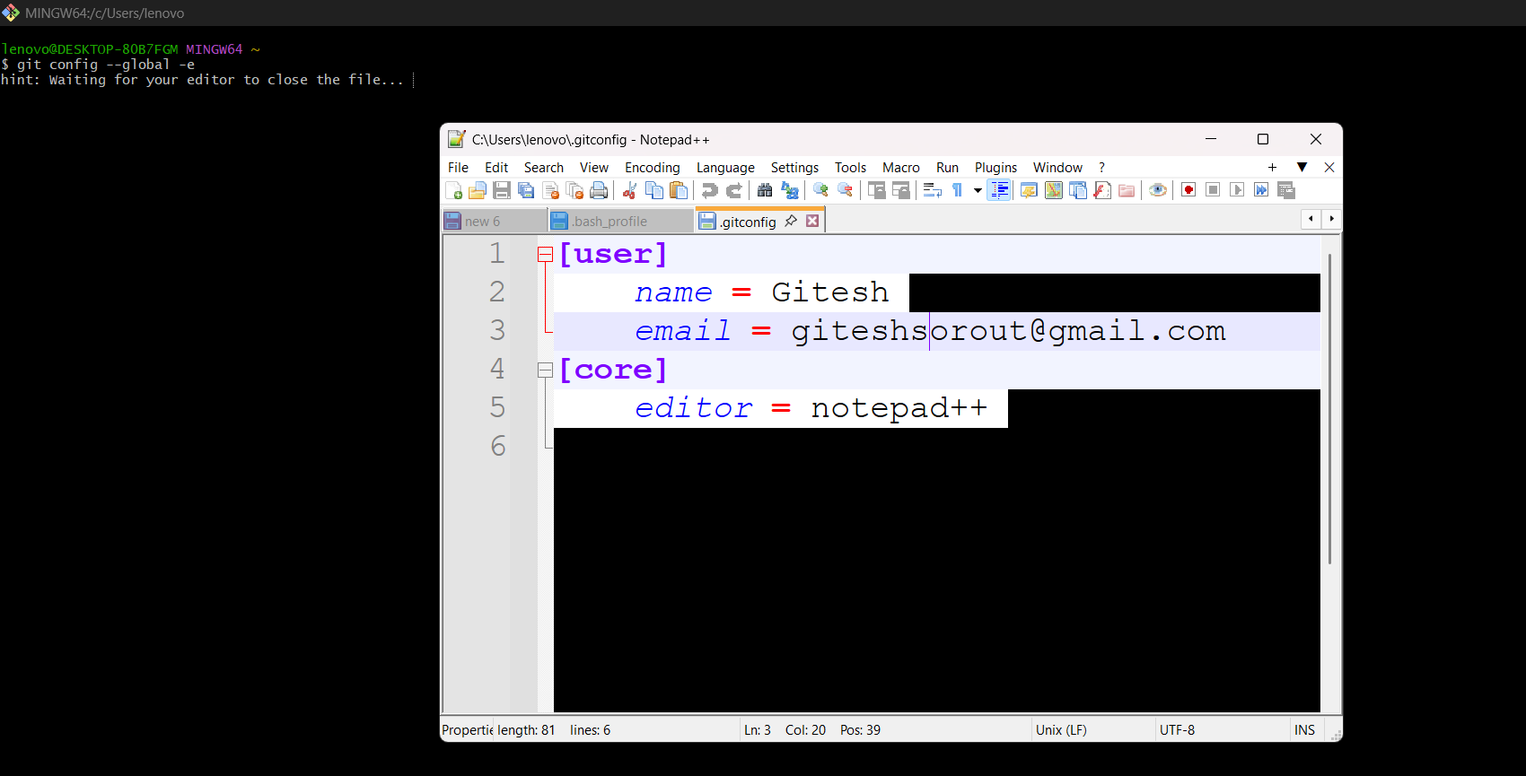

Step 5: Create Project and Initialize Repository
Command:
cd Desktop
mkdir GitDemo
cd GitDemo
git init
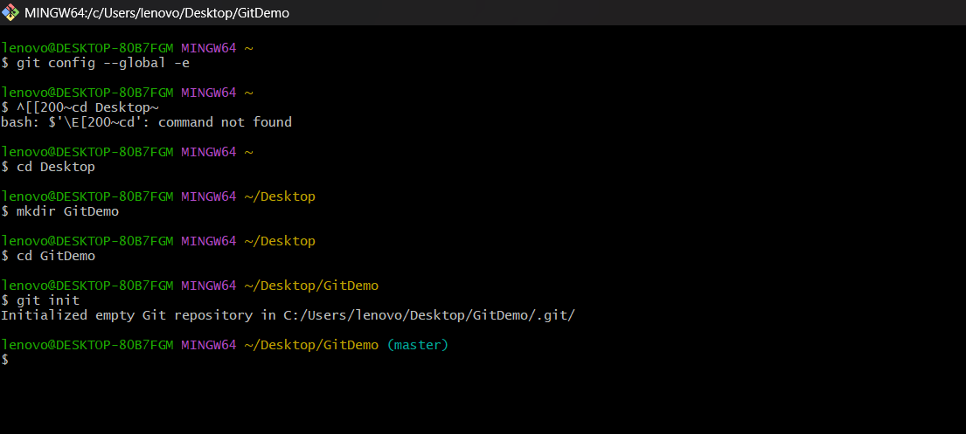

Step 6: View Hidden Files
Command:
ls -la
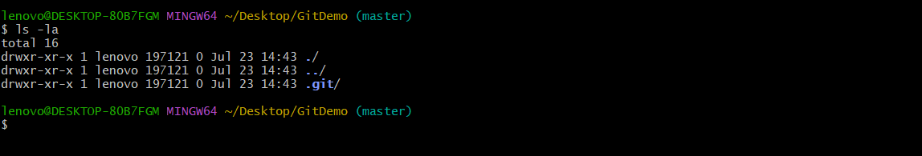

Step 7: Create welcome.txt
Command:
echo "Welcome to Git Lab" > welcome.txt
ls
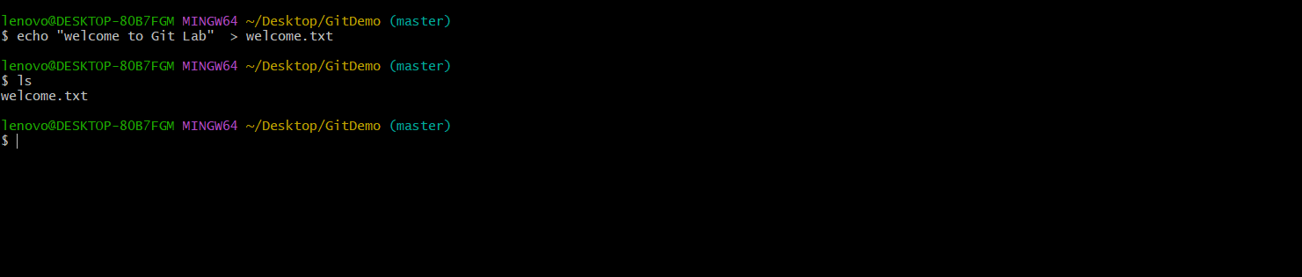

Step 8: View File Content
Command:
cat welcome.txt
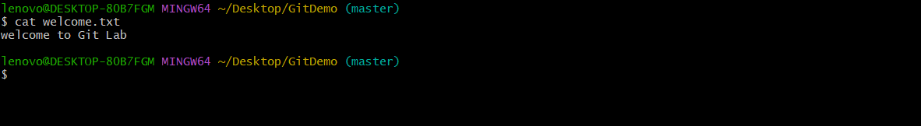

Step 9: Check Repository Status
Command:
git status
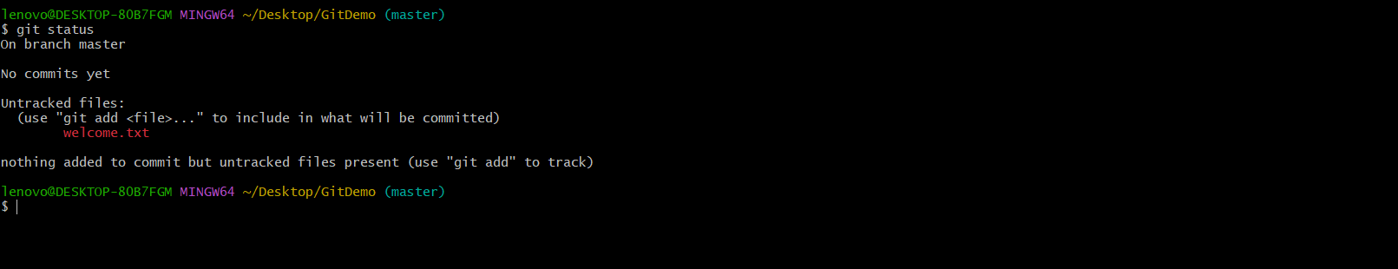

Step 10: Track File
Command:
git add welcome.txt
git status
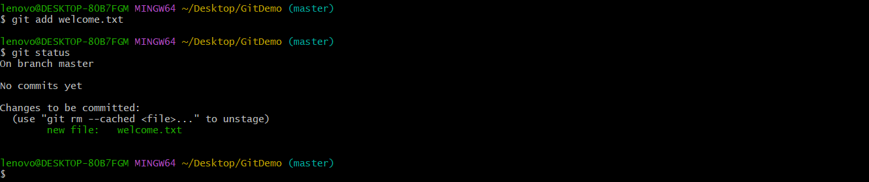

Step 11: Commit Changes
Command:
git commit
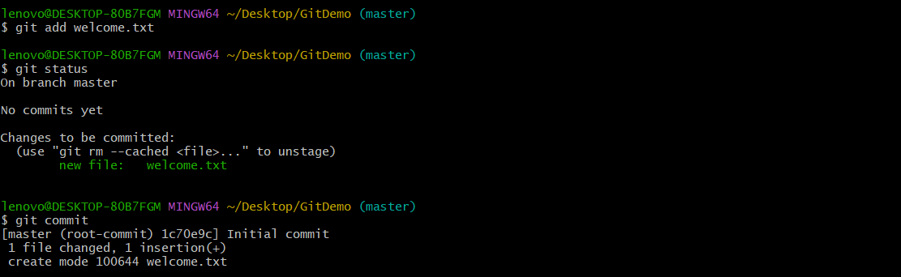

Step 12: Create GitLab Repository

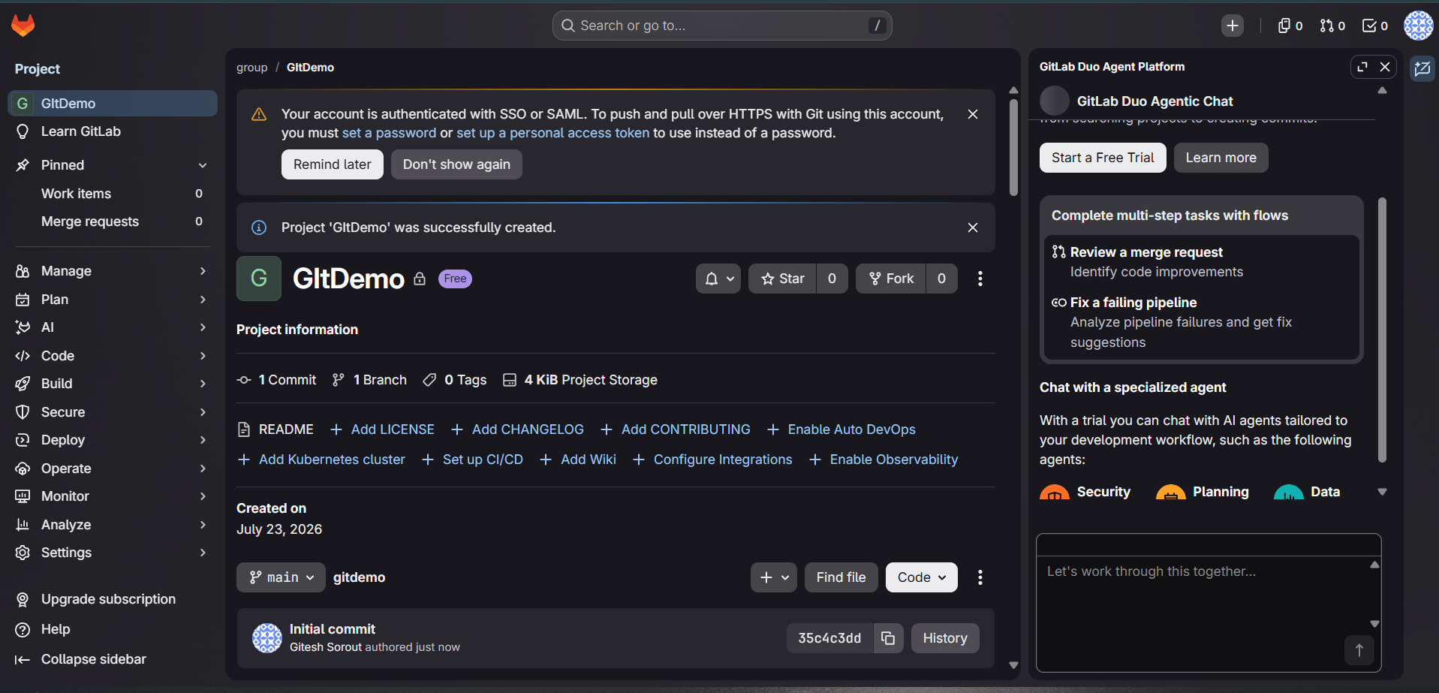

Step 13 : Add and Verify Remote
Command:
git remote add origin https://gitlab.com/group8732430/gitDemo.git
git remote -v
Description: Links the local repository with the GitLab repository.
Screenshot:
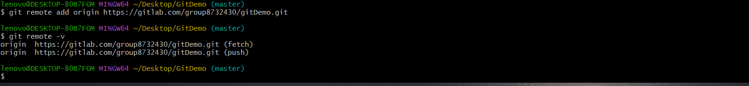

Step 14: Pull and Push Repository
Command:
git pull origin main --allow-unrelated-histories
git push -u origin master
Description: Synchronizes with the remote repository and pushes the local commits.
Screenshot:
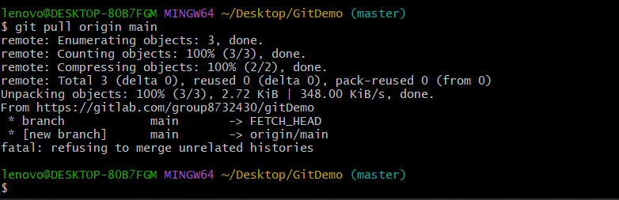

Conclusion
Git was configured successfully. A local repository was created, a text file was committed, and the project was prepared for synchronization with the remote GitLab repository.

Additional Notes
Paste the remaining screenshots in the placeholders provided for the following steps:
• Verify Remote Repository (git remote -v)
• Pull Remote Repository (git pull origin main --allow-unrelated-histories)
• Push Repository (git push -u origin master)

