Git Ignore Lab Exercise - 2

Objective
Explain Git Ignore and implement .gitignore to ignore unwanted files and folders.

Prerequisites
- Git environment configured
- Notepad++ configured as default editor
- Existing local and remote Git repository

Step 1: Open Repository
Command:
cd ~/Desktop/GitDemo
Description: Open the existing Git repository.
Screenshot:
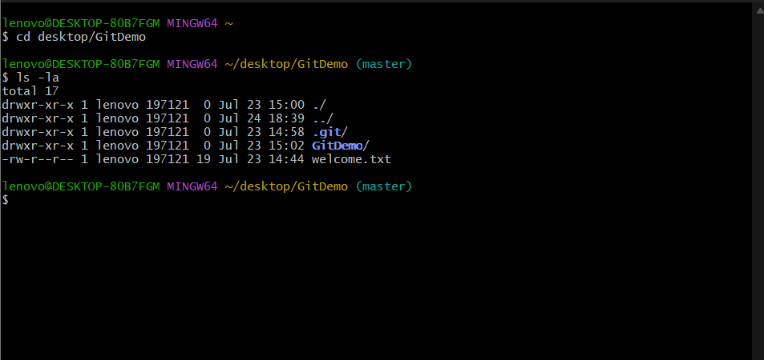

Step 2: Verify Repository
Command:
ls -la
Description: Verify repository files.
Screenshot:


Step 3: Create Log File
Command:
echo "Application started" > app.log
Description: Create a sample log file.
Screenshot:
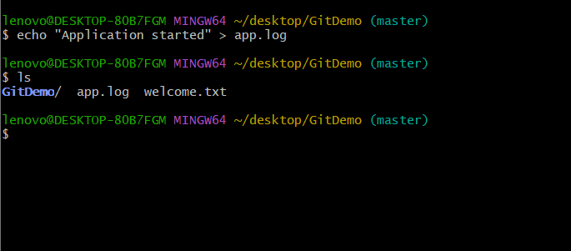

Step 4: Create Log Folder

Command:
mkdir log
echo "Error Log" > log/error.log
Description: Create log folder and file.
Screenshot:
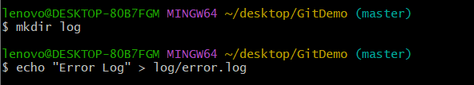

Step 5: Check Status
Command:
git status
Description: Verify app.log and log/ are untracked.
Screenshot:

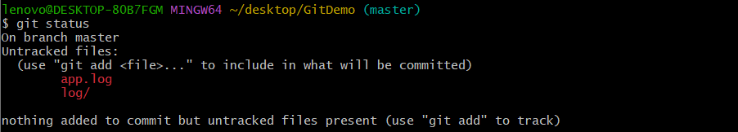

Step 6: Create .gitignore

Command:
notepad++ .gitignore
Description: Create .gitignore file.

Screenshot:

Step 7: Update .gitignore
Command:
*.log
log/
Description: Ignore log files and log folder.
Screenshot:
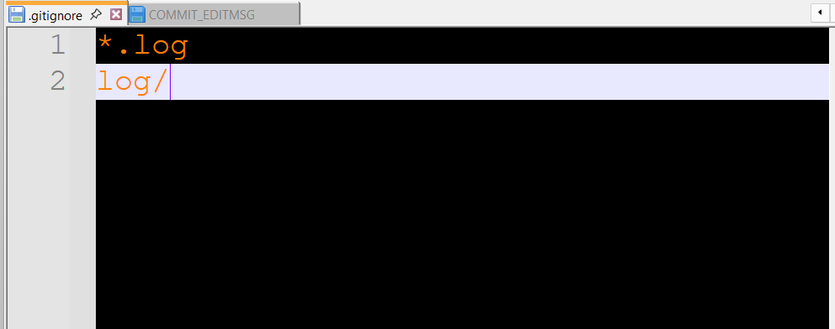

Step 8: Verify .gitignore
Command:
cat .gitignore
Description: Display .gitignore content.
Screenshot:
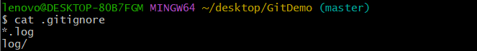
Step 9: Verify Status Again
Command:
git status
Description: Only .gitignore should appear.
Screenshot:
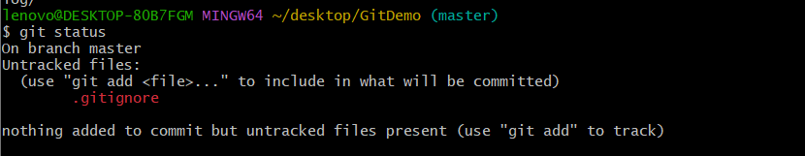

Step 10: Stage File
Command:
git add .gitignore
Description: Stage .gitignore.
Screenshot:

Step 11: Commit
Command:
git commit
Description: Commit changes.
Screenshot:
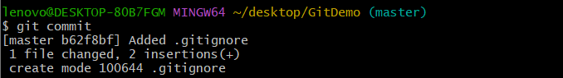

Step 12: Working Tree
Command:
git status
Description: Verify working tree is clean.
Screenshot:
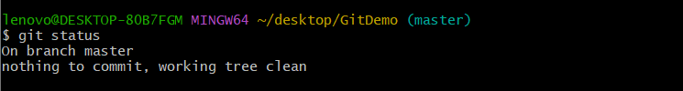

Step 13: Push
Command:
git push -u origin main
Description: Push to GitLab.
Screenshot:
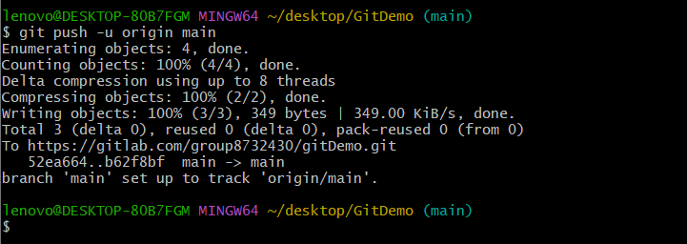

Conclusion
The .gitignore file successfully ignored all .log files and the log folder. The repository status was verified, the changes were committed, and the repository was ready to be pushed to GitLab.

