Git Branching and Merging Lab Report 3

Objectives
Explain branching and merging, create a branch, commit changes, merge into the main branch, and understand branch and merge requests in GitLab.

Prerequisites
- Git configured
- P4Merge configured (optional)
- Existing GitLab repository

Step 1: Open Repository
Command:
cd ~/Desktop/GitDemo
Screenshot:
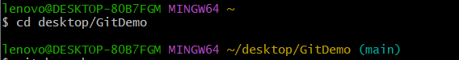

Step 2: Check Status
Command:
git status
Screenshot:
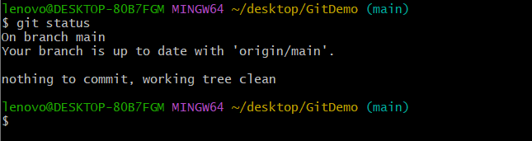

Step 3: Create Branch
Command:
git branch GitNewBranch
Screenshot:
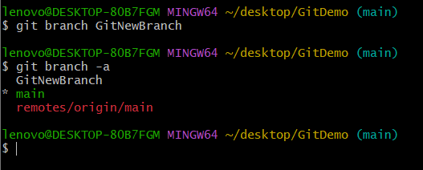

Step 4: List Branches
Command:
git branch -a
Screenshot:



Step 5: Switch Branch
Command:
git checkout GitNewBranch
Screenshot:

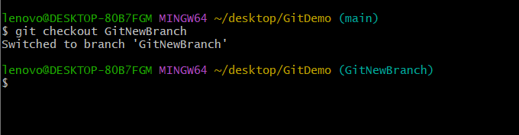

Step 6: Verify Branch
Command:
git branch
Screenshot:
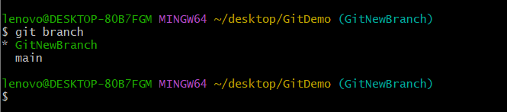

Step 8: List Files
Command:
ls
Screenshot:
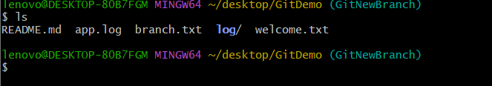

Step 9: View File
Command:
cat branch.txt
Screenshot:
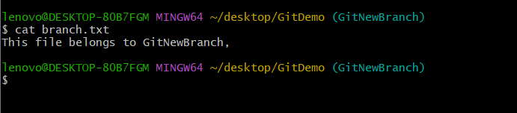

Step 10: Check Status
Command:
git status
Screenshot:
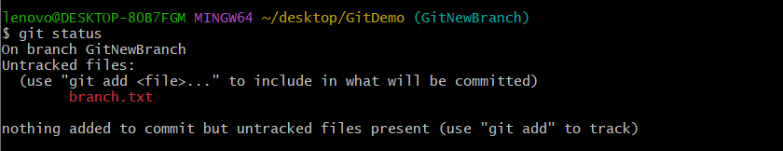

Step 12: Commit
Command:
git commit
Screenshot:
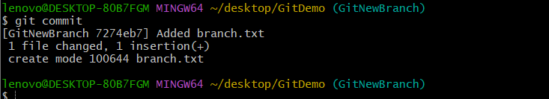

Step 13: Verify Status
Command:
git status
Screenshot:
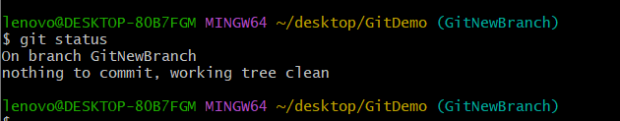

Step 14: Switch to Main
Command:
git checkout main
Screenshot:


Step 15: Compare Branches
Command:
git diff main GitNewBranch
Screenshot:
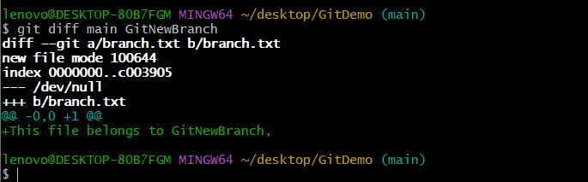

Step 16: Visual Compare
Command:
git difftool main GitNewBranch

Step 17: Merge
Command:
git merge GitNewBranch
Screenshot:
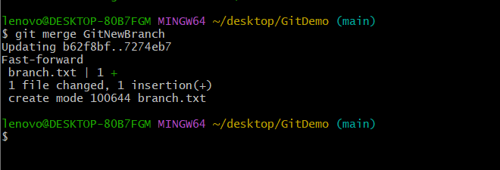

Step 18: View Log
Command:
git log --oneline --graph --decorate
Screenshot:
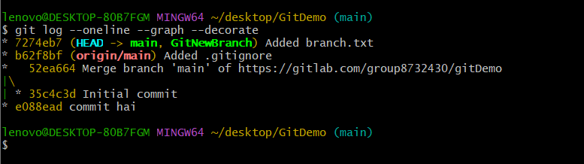

Step 19: Delete Branch
Command:
git branch -d GitNewBranch
Screenshot:
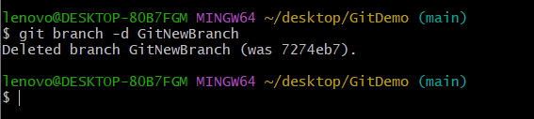

Step 20: Verify Branch
Command:
git branch
Screenshot:
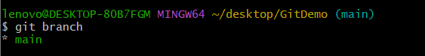

Step 21: Push
Command:
git push origin main
Screenshot:
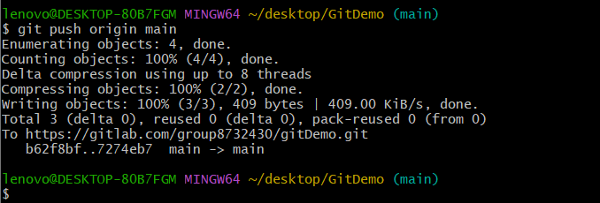

GitLab Branch Request
Repository > Branches > New Branch > Enter branch name > Create Branch

GitLab Merge Request
Merge Requests > New Merge Request > Select source and target branches > Create Merge Request > Merge

Conclusion
The branch was created, changes were committed, merged into the main branch, and the merged branch was deleted successfully.

