Git Merge Conflict Resolution Lab Report - 4

Objectives
Explain merge conflict resolution and implement conflict resolution during branch merging.

Prerequisites
- Git configured
- Previous branching lab completed
- GitLab repository available

Step 1: Verify Main
Command:
git checkout main
git status
Screenshot:
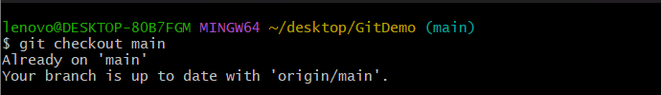
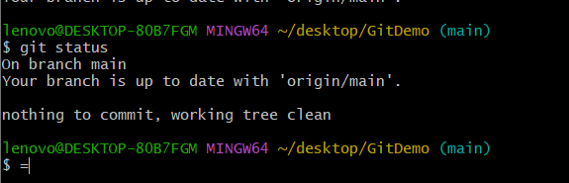

Step 2: Create Branch
Command:
git checkout -b GitWork
Screenshot:
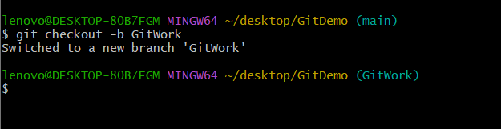

Step 3: Create hello.xml
Command:
echo "<message>Hello from GitWork Branch</message>" > hello.xml
Screenshot:

Step 4: Check Status
Command:
git status
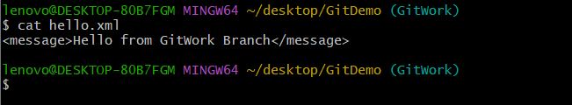

Step 5: Commit Branch Changes
Command:
git add hello.xml
git commit
Screenshot:
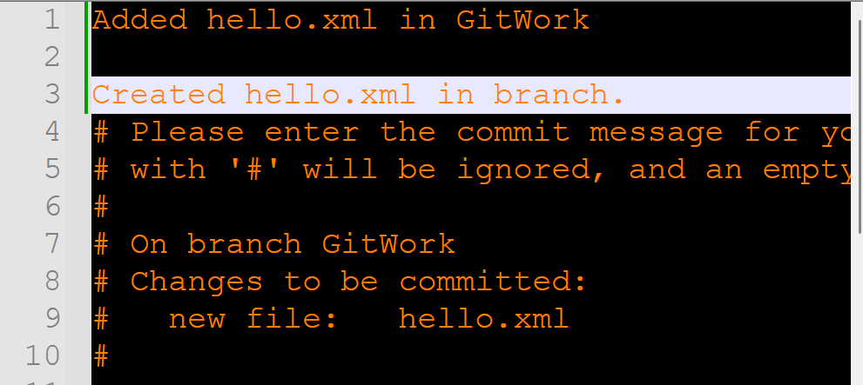

Step 6: Switch to Main
Command:
git checkout main
Screenshot:
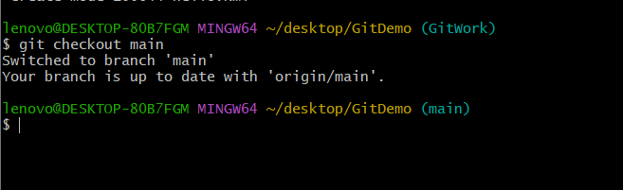

Step 7: Create Different hello.xml
Command:
echo "<message>Hello from Main Branch</message>" > hello.xml
Screenshot:

Step 8: Commit Main Changes
Command:
git add hello.xml
git commit
Screenshot:
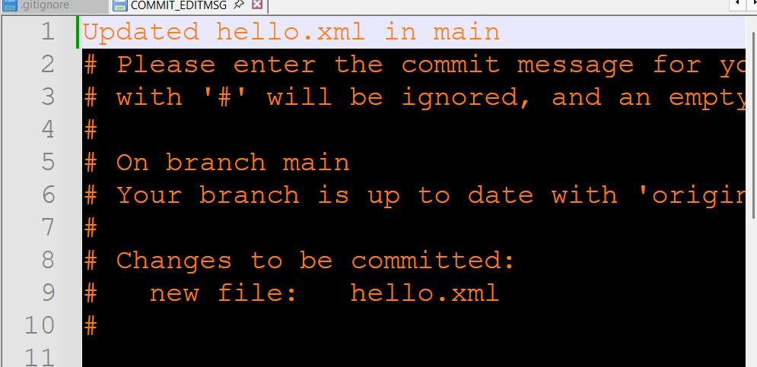

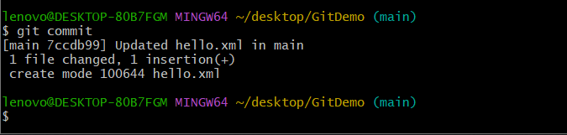

Step 9: View Log
Command:
git log --oneline --graph --decorate --all
Screenshot:
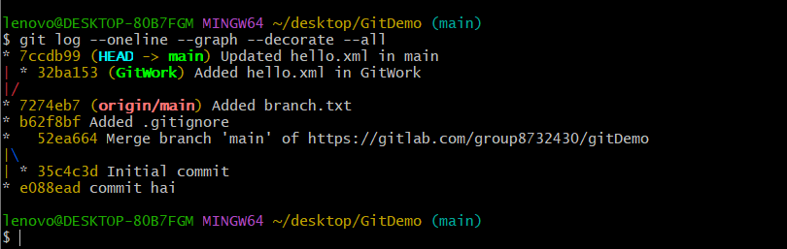

Step 10: Compare Branches
Command:
git diff main GitWork
Screenshot:
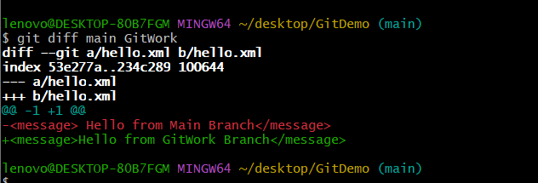

Step 11: Visual Compare

Command:
git difftool main GitWork
Screenshot:


Step 12: Merge Branch
Command:
git merge GitWork
Screenshot:
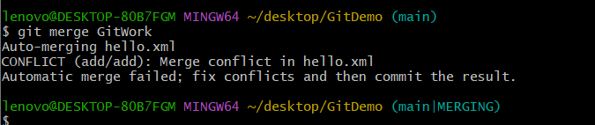

Step 13: Observe Conflict

Command:
cat hello.xml
Screenshot:
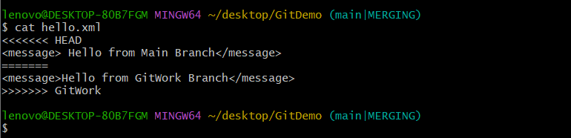

Step 14: Resolve Conflict
Command:
notepad++ hello.xml
Screenshot:
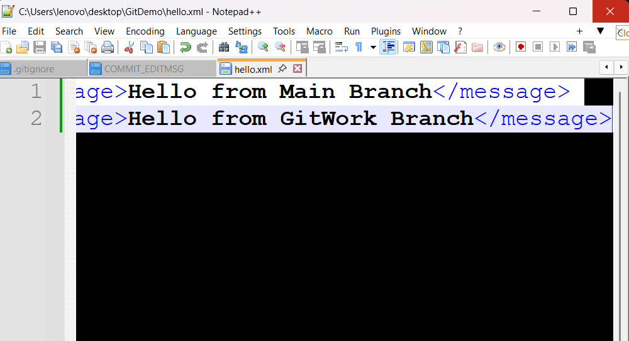

Step 15: Commit Merge
Command:
git add hello.xml
git commit
Screenshot:
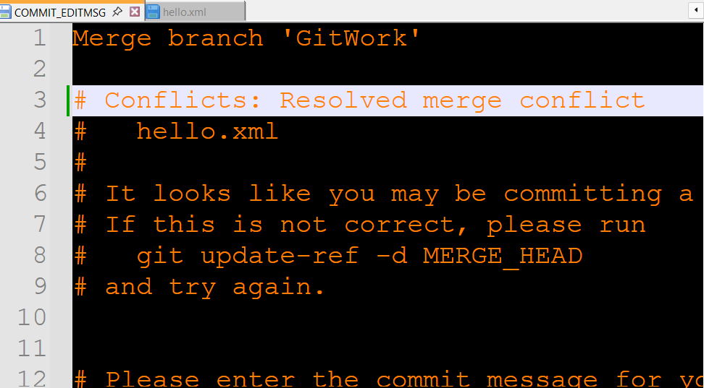

Step 16: Check Status
Command:
git status
Screenshot:
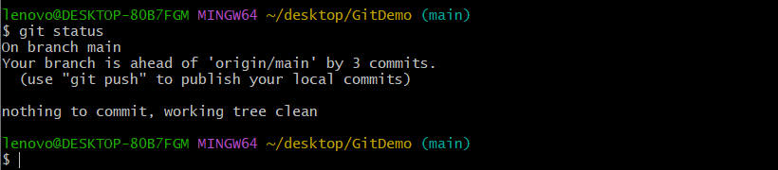

Step 17: Update .gitignore

Command:
notepad++ .gitignore
Screenshot:
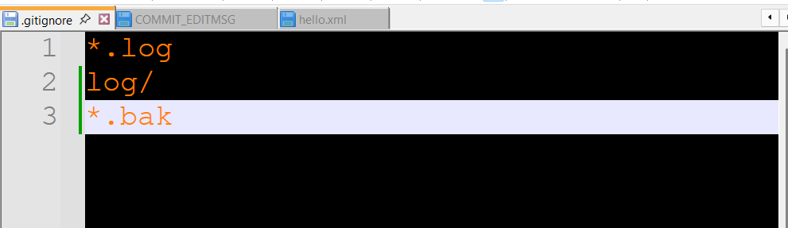

Step 18: Commit .gitignore
Command:
git add .gitignore
git commit
Screenshot:

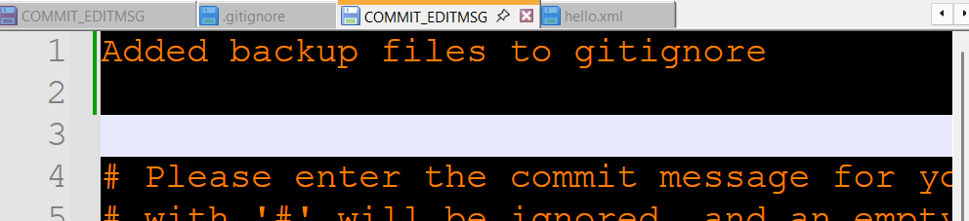

Step 19: List Branches
Command:
git branch
Screenshot:
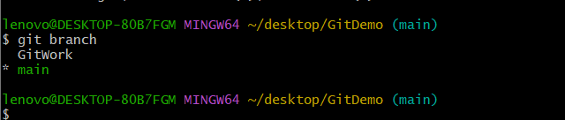

Step 20: Delete Branch
Command:
git branch -d GitWork
Screenshot:
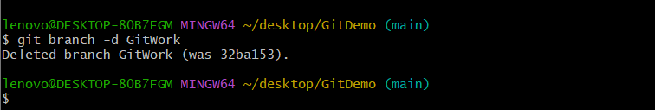

Step 21: Final Log
Command:
git log --oneline --graph --decorate
Screenshot:
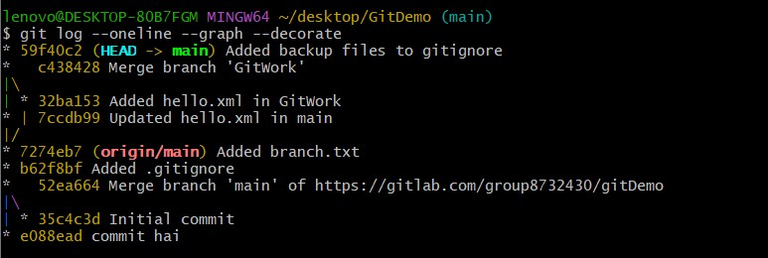

Step 22: Push
Command:
git push origin main
Screenshot:
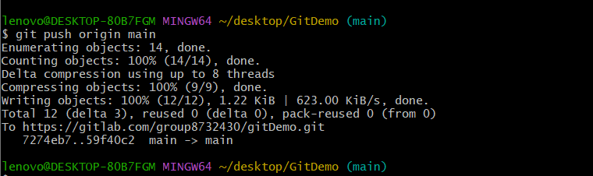

Conclusion
The merge conflict was created, resolved successfully, committed, and the merged branch was deleted.

