Git Cleanup and Push to Remote Repository Lab Report - 5

Objectives
• Explain how to clean up and push changes back to the remote Git repository.
• Execute the steps involved in cleaning up the local repository and synchronizing it with the remote GitLab repository.

Prerequisites
- Previous Git Merge Conflict Resolution lab completed
- Git environment configured
- Existing local Git repository connected to GitLab

Procedure

Step 1: Open Git Repository
Command:
cd ~/Desktop/GitDemo
Description: Navigate to the existing Git repository.
Screenshot:

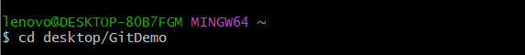

Step 2: Verify Repository Status
Command:
git status
Description: Verify that the working tree is clean.
Screenshot:

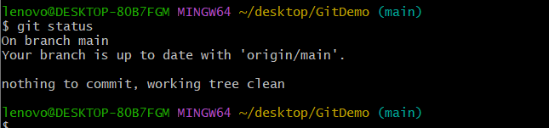

Step 3: List Available Branches
Command:
git branch -a
Description: Display all local and remote branches.
Screenshot:

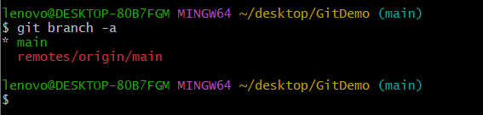

Step 4: Pull Latest Changes from Remote
Command:
git pull origin main
Description: Synchronize the local repository with the remote repository.
Screenshot:

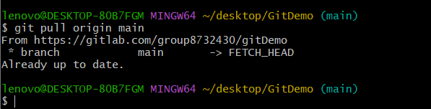

Step 5: Push Local Changes
Command:
git push origin main
Description: Push all pending commits to the remote GitLab repository.
Screenshot:

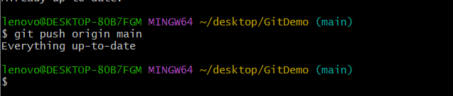

Step 6: Verify Remote Repository
Command:
Open GitLab Repository
Description: Verify that all committed files and changes are available in the remote repository.
Screenshot:
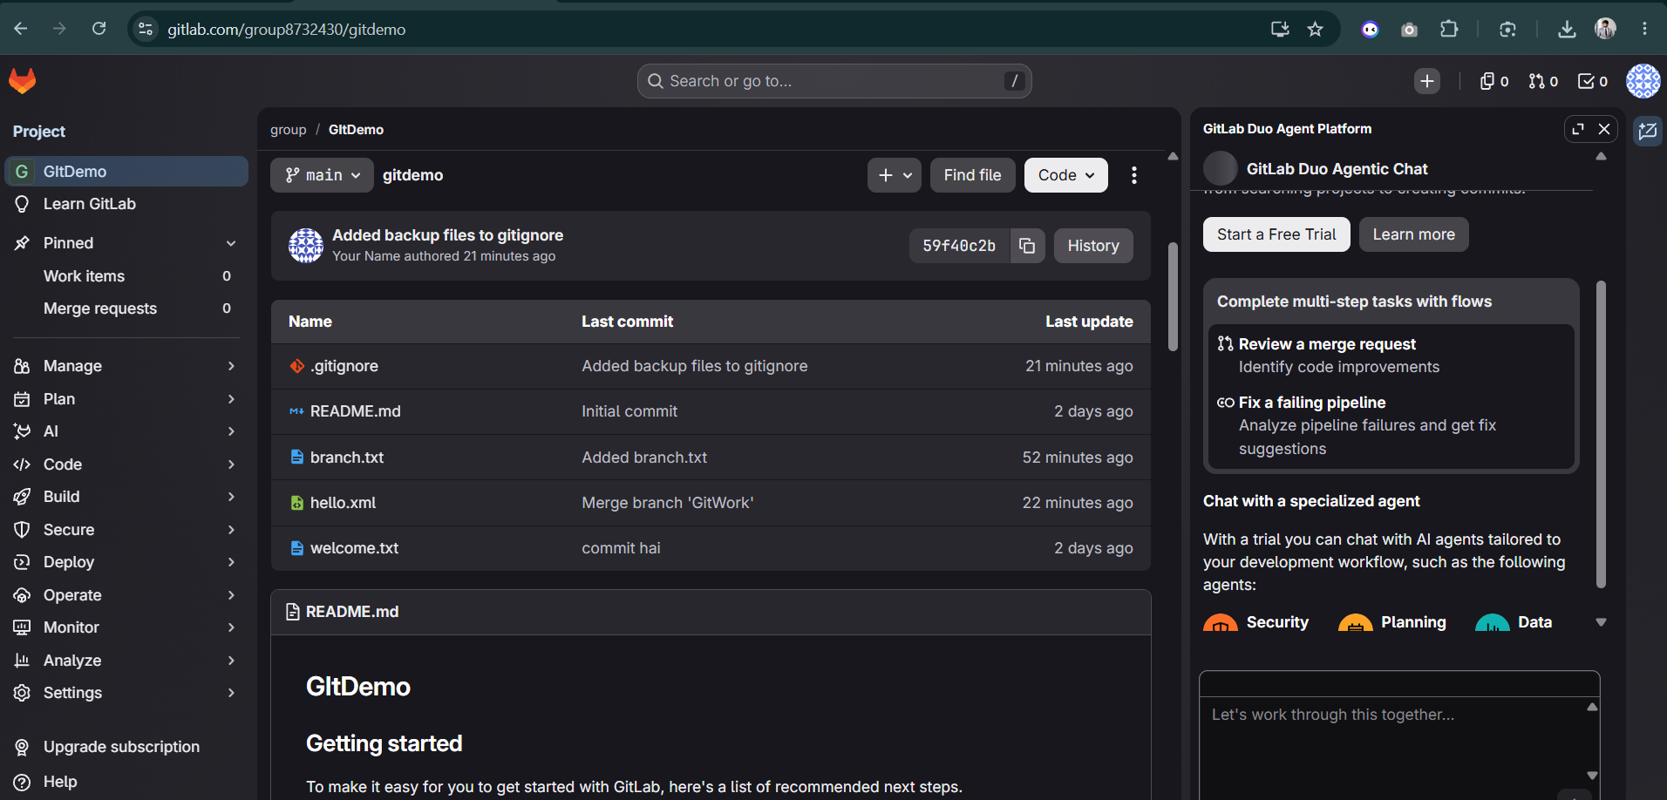

Conclusion
The local repository was verified to be in a clean state. The latest changes were pulled from the remote repository, pending commits were pushed successfully, and the changes were verified in the GitLab remote repository.

