Exercise 1: Implementing the Singleton Pattern
Project Name: SingletonPatternExample

Scenario
The objective of this exercise is to create a logging utility class that has only one instance throughout the application lifecycle. This helps maintain consistent logging across the application.

Exercise Steps Covered
Step | Requirement | Implementation Done
1 | Create a new Java project named SingletonPatternExample. | A project/folder named SingletonPatternExample was created inside WEEK1/DesignPattern.
2 | Create a class named Logger with a private static instance. | Logger.java contains a private static Logger reference to store the single object.
2 | Ensure the constructor of Logger is private. | The Logger constructor is private, so objects cannot be created directly using new Logger().
2 | Provide a public static method to get the instance. | The getInstance() method returns the single Logger object.
3 | Implement the Singleton pattern. | The getInstance() method creates the Logger object only once and returns the same object every time.
4 | Create a test class to verify only one instance. | SingletonTest.java creates two Logger references and compares them using ==.

Implementation Summary
- Logger.java is the Singleton class used for logging messages.
- The Logger constructor is private, which prevents direct object creation from outside the class.
- A private static Logger reference stores the single object of the Logger class.
- The getInstance() method checks whether the object is already created. If not, it creates the object once. If already created, it returns the same object.
- SingletonTest.java verifies the implementation by calling getInstance() two times and checking whether both references point to the same object.

Program Output
The output screenshot below shows that the Logger object is created successfully only once. After that, both log messages are printed using the same Logger instance. The final message confirms that only one Logger instance is used.
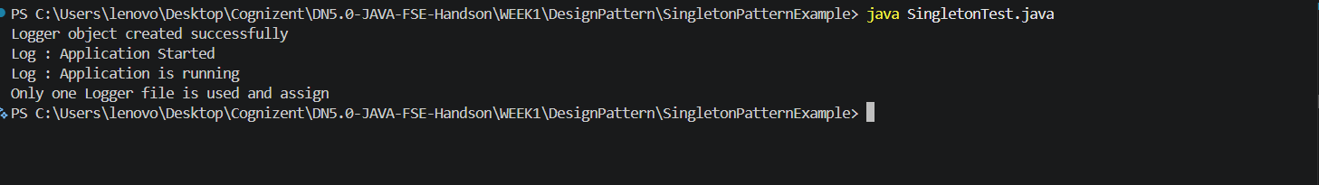
Figure 1: Output of Singleton Pattern Implementation

Output Verification
- Logger object created successfully: This line appears only once, which proves that the Logger object is created only one time.
- Log : Application Started: This is the first log message printed through the Logger instance.
- Log : Application is running: This is the second log message printed through the same Logger instance.
- Only one Logger file is used and assign: This confirms that both Logger references are using the same instance.

Conclusion
The Singleton Pattern has been implemented successfully. The Logger class allows only one object to be created and the same object is reused throughout the application. The test class verifies this by comparing two Logger references and showing that both refer to the same instance.

Exercise 2: Implementing the Factory Method Pattern
Project Name: FactoryMethodPatternExample

Scenario
The objective of this exercise is to create different types of documents such as Word, PDF and Excel using the Factory Method Pattern. This pattern helps create objects without directly exposing the object creation logic to the client class.

Exercise Steps Covered
Step | Requirement | Implementation Done
1 | Create a new Java project named FactoryMethodPatternExample. | A project/folder named FactoryMethodPatternExample was created inside WEEK1/DesignPattern.
2 | Create interfaces or abstract classes for different document types such as WordDocument, PdfDocument and ExcelDocument. | A Document interface is created with the common open() method for all document types.
3 | Implement concrete classes for each document type. | WordDocument, PdfDocument and ExcelDocument classes implement the Document interface and provide their own open() method.
4 | Create an abstract class DocumentFactory with a method createDocument(). | DocumentFactory defines the factory method createDocument(), which returns a Document object.
4 | Create concrete factory classes for each document type. | WordDocumentFactory, PdfDocumentFactory and ExcelDocumentFactory extend DocumentFactory and create the required document object.
5 | Create a test class to demonstrate the creation of different document types using the factory method. | FactoryMethodTest.java creates different factory objects and opens Word, PDF and Excel documents using the Factory Method Pattern.

Implementation Summary
- Document is the common interface used for all document types.
- WordDocument, PdfDocument and ExcelDocument are concrete document classes.
- Each concrete document class implements the open() method in its own way.
- DocumentFactory is the abstract creator class that declares the createDocument() method.
- WordDocumentFactory, PdfDocumentFactory and ExcelDocumentFactory are concrete factories used to create specific document objects.
- FactoryMethodTest.java verifies the implementation by creating and opening different document types using the factory method.

Program Output
The output screenshot below shows that different document objects are created successfully using the Factory Method Pattern. The test class creates Word, PDF and Excel documents through their respective factory classes and opens them successfully.
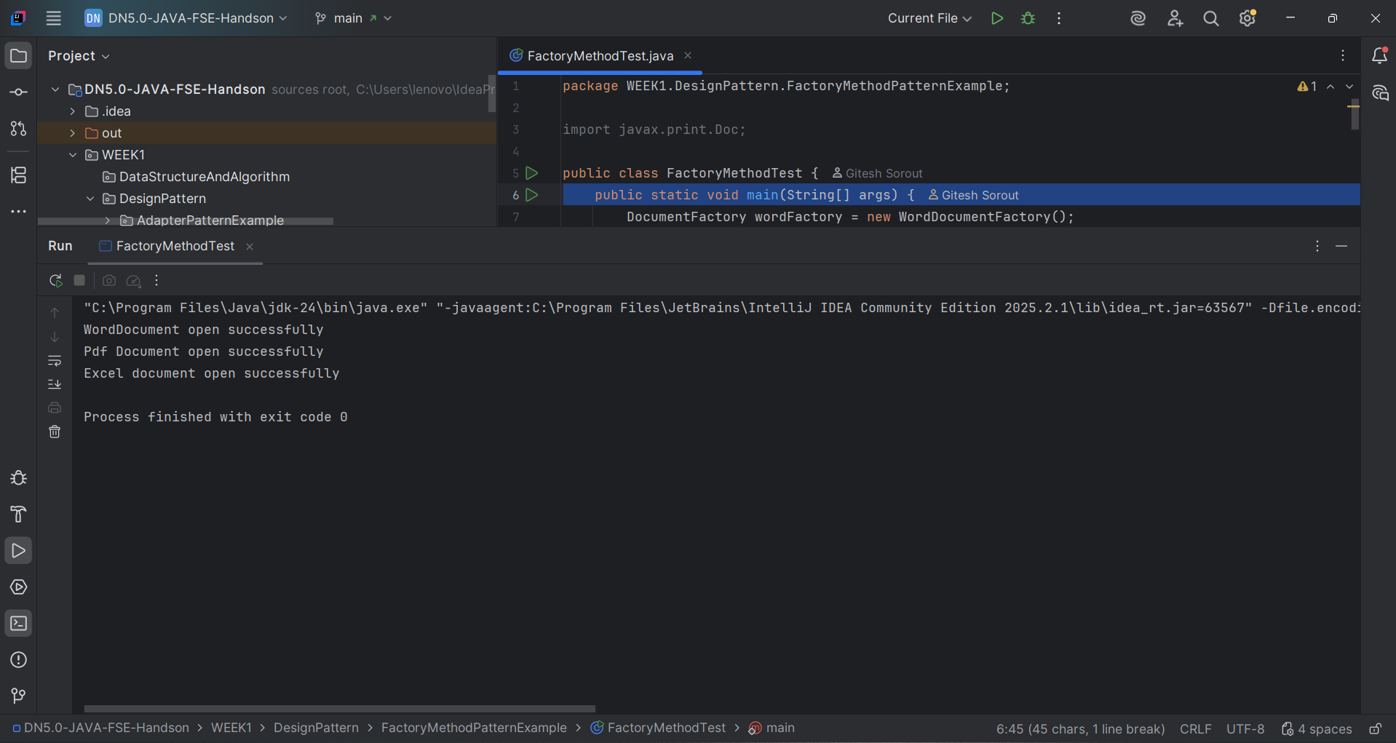
Figure 2: Output of Factory Method Pattern Implementation

Output Verification
- WordDocument open successfully: This line confirms that the Word document object is created and opened successfully.
- Pdf Document open successfully: This line confirms that the PDF document object is created and opened successfully.
- Excel document open successfully: This line confirms that the Excel document object is created and opened successfully.
- Process finished with exit code 0: This confirms that the program executed successfully without any error.

Conclusion
The Factory Method Pattern has been implemented successfully. The DocumentFactory class provides a common factory method, and each concrete factory creates its own document type. The test class verifies the implementation by creating Word, PDF and Excel documents without directly depending on their concrete creation logic.

Exercise 3: Implementing the Builder Pattern
Project Name: BuilderPatternExample

Scenario
The objective of this exercise is to create complex Computer objects with multiple optional parts. The Builder Pattern is used to manage the construction process in a clean and flexible way.

Exercise Steps Covered
Step | Requirement | Implementation Done
1 | Create a new Java project named BuilderPatternExample. | A project/folder named BuilderPatternExample was created inside WEEK1/DesignPattern.
2 | Create a class named Computer with attributes like CPU, RAM, Storage, etc. | Computer.java contains fields such as CPU, RAM and storage to store the computer configuration.
3 | Create a static nested Builder class inside Computer with methods to set each attribute. | The Builder class contains setter methods like setCPU(), setRAM() and setStorage(), and each method returns the Builder object.
3 | Provide a build() method in the Builder class. | The build() method returns a new Computer object after assigning the selected values.
4 | Ensure that the Computer class has a private constructor that takes the Builder as a parameter. | The Computer constructor is private and receives the Builder object to initialize the final Computer object.
5 | Create a test class to demonstrate different Computer configurations. | BuilderPatternTest.java creates gaming, office and basic computer objects using the Builder Pattern.

Implementation Summary
- Computer.java is the product class used to represent a computer configuration.
- The Computer class has attributes such as CPU, RAM and storage.
- A static nested Builder class is created inside the Computer class.
- The Builder class contains methods to set values for each required or optional attribute.
- Each setter method returns the same Builder object, so method chaining can be used.
- The build() method creates and returns the final Computer object.
- BuilderPatternTest.java verifies the implementation by creating different Computer configurations.

Program Output
The output screenshot below shows that different Computer objects are created successfully using the Builder Pattern. Each object has a different configuration, such as a gaming computer, an office computer and a basic computer.
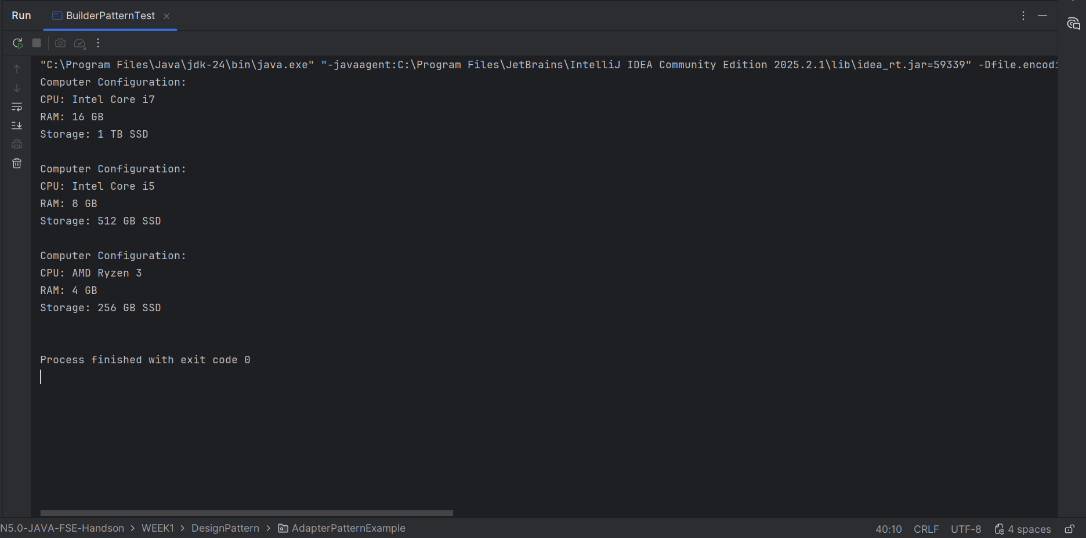
Figure 3: Output of Builder Pattern Implementation

Output Verification
- Computer Configuration: This heading is printed for each Computer object created through the Builder Pattern.
- CPU: The output displays different CPU values such as Intel Core i7, Intel Core i5 and AMD Ryzen 3.
- RAM: The output displays different RAM values such as 16 GB, 8 GB and 4 GB.
- Storage: The output displays different storage values such as 1 TB SSD, 512 GB SSD and 256 GB SSD.
- Process finished with exit code 0: This confirms that the program executed successfully without any error.

Conclusion
The Builder Pattern has been implemented successfully. The Computer class uses a private constructor and a static nested Builder class to create objects step by step. The test class verifies the implementation by creating different Computer configurations using method chaining.

Exercise 4: Implementing the Adapter Pattern
Project Name: AdapterPatternExample

Scenario
The objective of this exercise is to create a payment processing system that can work with multiple third-party payment gateways. Since each gateway has a different interface, the Adapter Pattern is used to convert gateway-specific methods into one common PaymentProcessor interface.

Exercise Steps Covered
Step | Requirement | Implementation Done
1 | Create a new Java project named AdapterPatternExample. | A project/folder named AdapterPatternExample was created inside WEEK1/DesignPattern.
2 | Create an interface PaymentProcessor with a method like processPayment(). | PaymentProcessor.java defines the common processPayment(double amount) method used by the application.
3 | Create classes for different payment gateways with their own methods. | PayPalGateway.java, StripeGateway.java and RazorpayGateway.java are created with different gateway-specific payment methods.
4 | Create an adapter class for each payment gateway that implements PaymentProcessor. | PayPalAdapter.java, StripeAdapter.java and RazorpayAdapter.java implement PaymentProcessor and translate the request to the correct gateway method.
5 | Create a test class to demonstrate the use of different payment gateways through the adapter. | AdapterPatternTest.java uses the same PaymentProcessor reference to process payments through different gateways.

Implementation Summary
- PaymentProcessor.java is the target interface used by the client code.
- Different gateway classes are created with their own payment method names.
- Each adapter class implements the PaymentProcessor interface.
- The adapter classes convert the common processPayment() call into gateway-specific method calls.
- The test class demonstrates that different payment gateways can be used through the same interface.
- This reduces dependency on third-party gateway classes and makes the system flexible.

Program Output
The output below shows that different third-party payment gateways are used successfully through the common PaymentProcessor interface.
Processing payment using PayPal Adapter
PayPal payment successful. Amount: Rs.2500.0
Processing payment using Stripe Adapter
Stripe payment successful. Amount: Rs.4200.0
Processing payment using Razorpay Adapter
Razorpay payment successful. Amount: Rs.1500.0
Figure 4: Output of Adapter Pattern Implementation

Output Verification
- Processing payment using PayPal Adapter: This line shows that the PayPal adapter is used to process the payment.
- PayPal payment successful: This confirms that the PayPal gateway-specific method was called through the adapter.
- Processing payment using Stripe Adapter: This line shows that the Stripe adapter is used through the same PaymentProcessor interface.
- Stripe payment successful: This confirms that the Stripe gateway-specific method was called correctly.
- Processing payment using Razorpay Adapter: This line shows that the Razorpay adapter is also working with the common interface.

Conclusion
The Adapter Pattern has been implemented successfully. The PaymentProcessor interface provides a common way to process payments, while each adapter class connects this interface to a different third-party payment gateway. The test class verifies the implementation by processing payments through PayPal, Stripe and Razorpay using the same common interface.

Exercise 5: Implementing the Decorator Pattern
Project Name: DecoratorPatternExample

Scenario
The objective of this exercise is to create a notification system where notifications can be sent through multiple channels such as Email, SMS and Slack. The Decorator Pattern is used to add new notification features dynamically without changing the original notifier class.

Exercise Steps Covered
Step | Requirement | Implementation Done
1 | Create a new Java project named DecoratorPatternExample. | A project/folder named DecoratorPatternExample was created inside WEEK1/DesignPattern.
2 | Create an interface Notifier with a method send(). | Notifier.java defines the common send() method used by all notification classes.
3 | Create a class EmailNotifier that implements Notifier. | EmailNotifier.java is the concrete component that sends basic email notifications.
4 | Create an abstract decorator class NotifierDecorator that implements Notifier and holds a Notifier reference. | NotifierDecorator.java stores a Notifier object and forwards the send() call to it.
4 | Create concrete decorator classes like SMSNotifierDecorator and SlackNotifierDecorator. | SMSNotifierDecorator.java and SlackNotifierDecorator.java add SMS and Slack notification functionality dynamically.
5 | Create a test class to demonstrate sending notifications through multiple channels. | DecoratorPatternTest.java creates different notifier combinations and tests Email, SMS and Slack notifications.

Implementation Summary
- Notifier.java is the component interface used for all notification types.
- EmailNotifier.java is the concrete component that sends the basic email notification.
- NotifierDecorator.java is an abstract decorator class that contains a reference of Notifier.
- SMSNotifierDecorator.java extends NotifierDecorator and adds SMS notification functionality.
- SlackNotifierDecorator.java extends NotifierDecorator and adds Slack notification functionality.
- DecoratorPatternTest.java verifies the implementation by combining decorators with the EmailNotifier object.
- The decorators allow extra notification channels to be added without modifying the EmailNotifier class.

Program Output
The output screenshot below shows that notifications are sent successfully through Email, SMS and Slack using the Decorator Pattern. The test class first sends only an Email notification, then Email with SMS, and finally Email with SMS and Slack.
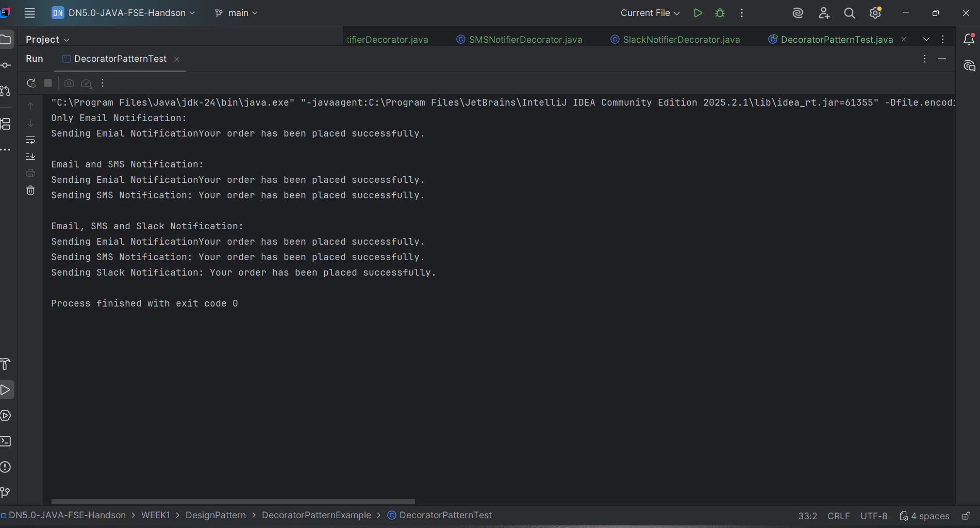
Figure 5: Output of Decorator Pattern Implementation

Output Verification
- Only Email Notification: This output section confirms that the basic EmailNotifier sends an email notification.
- Email and SMS Notification: This confirms that SMSNotifierDecorator adds SMS notification along with Email notification.
- Email, SMS and Slack Notification: This confirms that both SMS and Slack decorators are combined with EmailNotifier successfully.
- Sending SMS Notification: This line shows that the SMS decorator adds extra behavior dynamically.
- Sending Slack Notification: This line shows that the Slack decorator adds another notification channel dynamically.
- Process finished with exit code 0: This confirms that the program executed successfully without any error.

Conclusion
The Decorator Pattern has been implemented successfully. The Notifier interface provides a common method for sending notifications, while EmailNotifier works as the base component. SMSNotifierDecorator and SlackNotifierDecorator add extra notification features dynamically without changing the original EmailNotifier class. The test output confirms that multiple notification channels can be combined successfully using decorators.

Exercise 6: Implementing the Proxy Pattern
Project Name: ProxyPatternExample

Scenario
The objective of this exercise is to create an image viewer application that loads images from a remote server. The Proxy Pattern is used to provide lazy initialization and caching, so the real image object is created only when it is required.

Exercise Steps Covered
Step | Requirement | Implementation Done
1 | Create a new Java project named ProxyPatternExample. | A project/folder named ProxyPatternExample was created inside WEEK1/DesignPattern.
2 | Create an interface Image with a method display(). | Image.java contains the display() method used by both the real object and proxy object.
3 | Create a class RealImage that implements Image and loads an image from a remote server. | RealImage.java implements Image and loads the image when the RealImage object is created.
4 | Create a class ProxyImage that implements Image and holds a reference to RealImage. | ProxyImage.java stores a RealImage reference and controls access to the real image object.
4 | Implement lazy initialization and caching in ProxyImage. | The RealImage object is created only during the first display() call. Later calls reuse the same object from cache.
5 | Create a test class to demonstrate the use of ProxyImage. | ProxyPatternTest.java displays the image two times to show loading and cache behavior.

Implementation Summary
- Image.java is the subject interface that declares the display() method.
- RealImage.java is the real subject class that loads and displays the image.
- ProxyImage.java acts as the proxy class and keeps a reference to RealImage.
- The first display() call creates the RealImage object and loads the image from the remote server.
- The second display() call uses the already loaded image from cache instead of loading it again.
- ProxyPatternTest.java verifies lazy loading and caching by calling display() two times.

Program Output
The output screenshot below shows that the image is loaded from the remote server only during the first display call. During the second display call, the image is loaded from cache and displayed again.
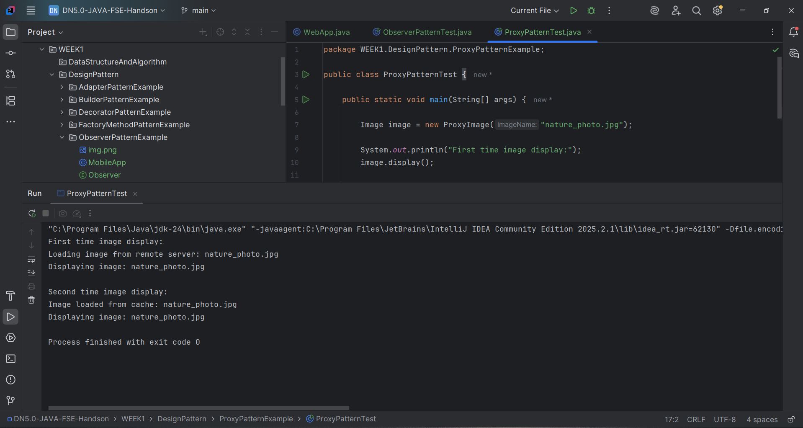
Figure 6: Output of Proxy Pattern Implementation

Output Verification
- First time image display: This section shows the first call to the display() method.
- Loading image from remote server: This confirms that RealImage is created and the image is loaded only when needed.
- Displaying image: This confirms that the image is displayed successfully.
- Second time image display: This section shows the second call to the display() method.
- Image loaded from cache: This confirms that ProxyImage reused the existing RealImage object instead of loading it again.
- Process finished with exit code 0: This confirms that the program executed successfully without any error.

Conclusion
The Proxy Pattern has been implemented successfully. ProxyImage controls the creation of RealImage and provides lazy initialization and caching. The test output confirms that the image is loaded from the remote server only once and reused from cache during the second display call.

Exercise 7: Implementing the Observer Pattern
Project Name: ObserverPatternExample

Scenario
The objective of this exercise is to create a stock market monitoring application where multiple clients need to be notified whenever stock prices change. The Observer Pattern is used so that registered observers receive updates automatically.

Exercise Steps Covered
Step | Requirement | Implementation Done
1 | Create a new Java project named ObserverPatternExample. | A project/folder named ObserverPatternExample was created inside WEEK1/DesignPattern.
2 | Create an interface Stock with methods to register, deregister and notify observers. | Stock.java contains registerObserver(), deregisterObserver() and notifyObservers() methods.
3 | Create a class StockMarket that implements Stock and maintains a list of observers. | StockMarket.java uses an ArrayList to store observer objects and notify them when stock details change.
4 | Create an interface Observer with a method update(). | Observer.java contains the update() method used by all observer classes.
5 | Create classes MobileApp and WebApp that implement Observer. | MobileApp.java and WebApp.java implement update() and print stock price notifications.
6 | Create a test class to demonstrate registration and notification of observers. | ObserverPatternTest.java registers observers, updates stock prices and removes one observer to test deregistration.

Implementation Summary
- Stock.java is the subject interface used to manage observers.
- Observer.java is the observer interface that defines the update() method.
- StockMarket.java is the concrete subject that stores observers and notifies them when stock price changes.
- MobileApp.java and WebApp.java are concrete observer classes that receive stock update notifications.
- The observer list allows multiple clients to receive updates from the same StockMarket object.
- ObserverPatternTest.java verifies registration, notification and deregistration of observers.

Program Output
The output screenshot below shows that both Mobile App and Web App observers receive stock price updates. After removing the Web App observer, only the Mobile App receives the next update.
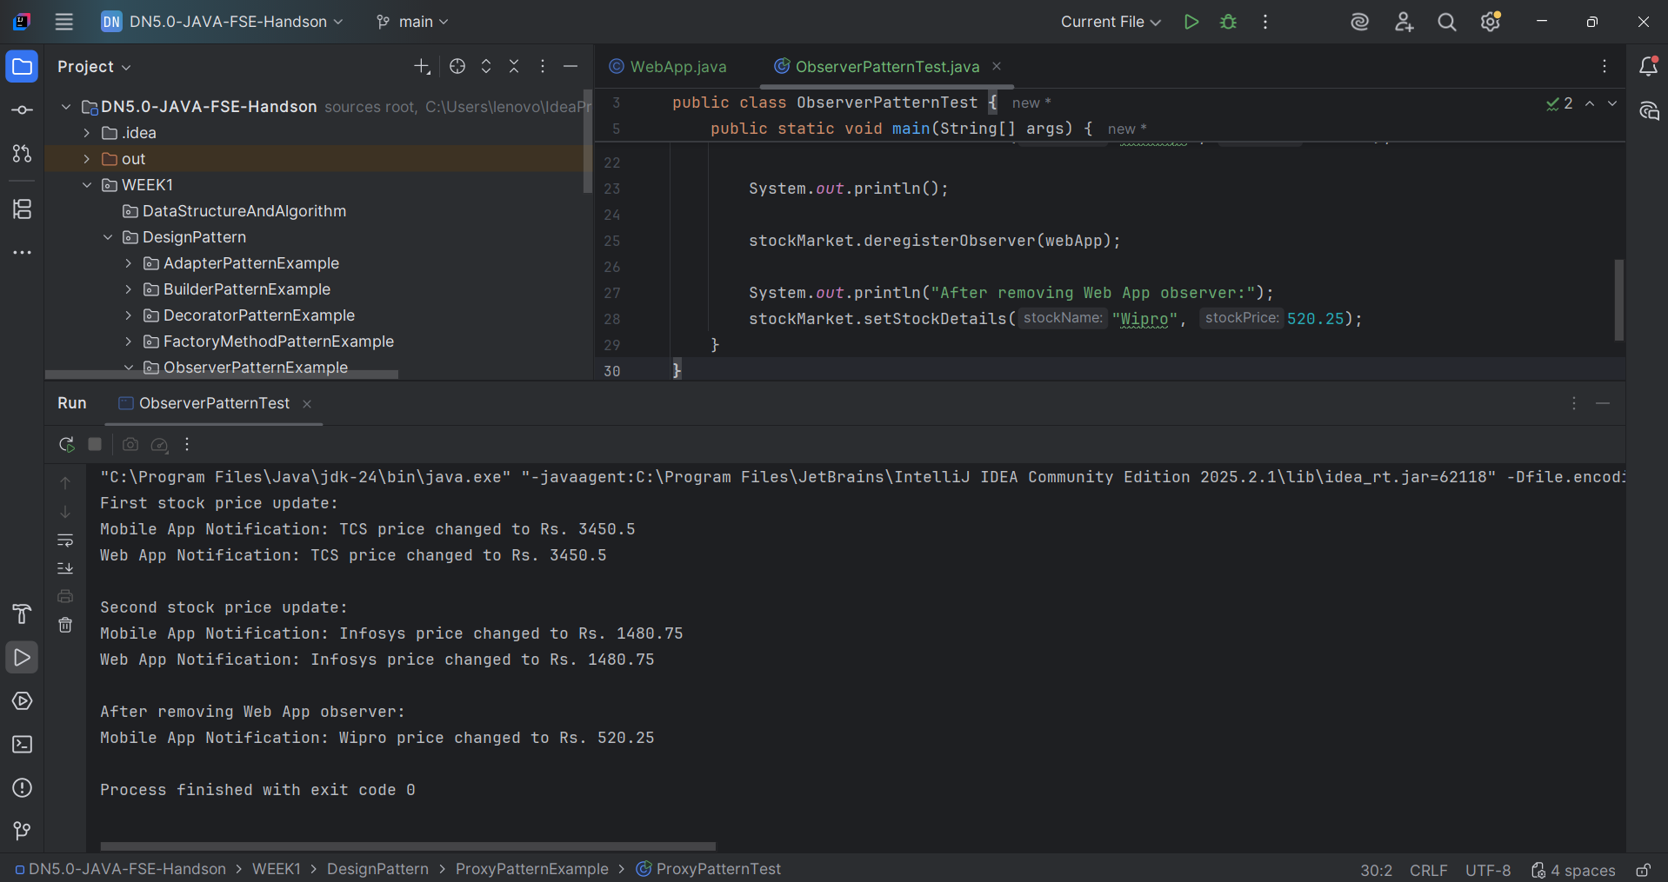
Figure 7: Output of Observer Pattern Implementation

Output Verification
- First stock price update: This section confirms that the first stock update is sent to all registered observers.
- Mobile App Notification: This confirms that the MobileApp observer received the update.
- Web App Notification: This confirms that the WebApp observer also received the update.
- Second stock price update: This section shows that observers continue to receive new updates.
- After removing Web App observer: This confirms that the WebApp observer was deregistered successfully.
- Only Mobile App Notification appears after removal, which proves that deregistration is working correctly.
- Process finished with exit code 0: This confirms that the program executed successfully without any error.

Conclusion
The Observer Pattern has been implemented successfully. StockMarket works as the subject and maintains a list of observers. MobileApp and WebApp receive notifications whenever stock prices change. The test output also confirms that an observer can be removed and will no longer receive updates.

Exercise 8: Implementing the Strategy Pattern
Project Name: StrategyPatternExample

Scenario
The objective of this exercise is to create a payment system where different payment methods can be selected at runtime. The Strategy Pattern is used to separate payment algorithms and allow the client to choose the required payment strategy dynamically.

Exercise Steps Covered
Step | Requirement | Implementation Done
1 | Create a new Java project named StrategyPatternExample. | A project/folder named StrategyPatternExample was created inside WEEK1/DesignPattern.
2 | Create an interface PaymentStrategy with a method pay(). | PaymentStrategy.java contains the common pay() method used by all payment strategies.
3 | Create classes CreditCardPayment and PayPalPayment that implement PaymentStrategy. | CreditCardPayment.java and PayPalPayment.java implement their own payment logic.
4 | Create a class PaymentContext that holds a reference to PaymentStrategy. | PaymentContext.java stores a PaymentStrategy object and uses it to execute the selected payment method.
5 | Create a test class to demonstrate selecting and using different payment strategies. | StrategyPatternTest.java changes the payment strategy at runtime and processes payments using Credit Card and PayPal.

Implementation Summary
- PaymentStrategy.java is the strategy interface that defines the pay() method.
- CreditCardPayment.java is a concrete strategy for credit card payment.
- PayPalPayment.java is a concrete strategy for PayPal payment.
- PaymentContext.java works as the context class and holds the selected PaymentStrategy object.
- The payment method can be changed at runtime by assigning a different strategy object.
- StrategyPatternTest.java verifies that different payment strategies work through the same context class.

Program Output
The output screenshot below shows that the payment system successfully uses different strategies at runtime. First, payment is done using Credit Card, and then another payment is done using PayPal.
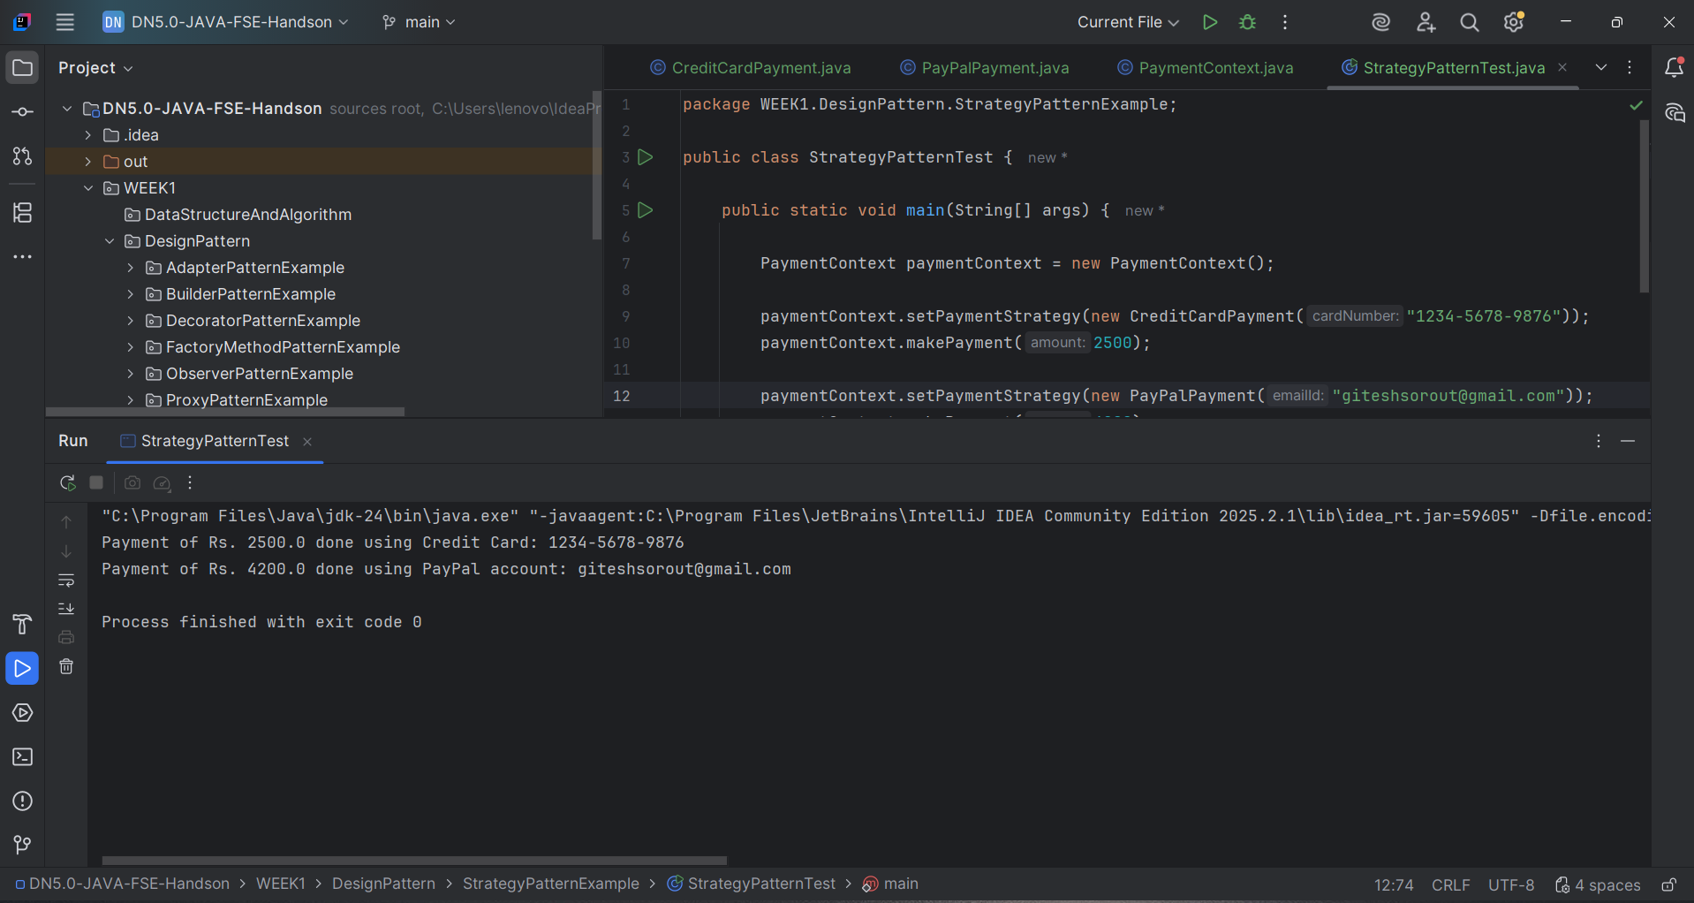
Figure 8: Output of Strategy Pattern Implementation

Output Verification
- Payment of Rs. 2500.0 done using Credit Card: This confirms that CreditCardPayment strategy was selected and executed.
- Payment of Rs. 4200.0 done using PayPal account: This confirms that PayPalPayment strategy was selected and executed.
- The same PaymentContext object is used with different payment strategies.
- The output proves that payment behavior can be changed at runtime without changing the context class.
- Process finished with exit code 0: This confirms that the program executed successfully without any error.

Conclusion
The Strategy Pattern has been implemented successfully. PaymentStrategy provides a common interface for different payment methods, while CreditCardPayment and PayPalPayment provide separate implementations. PaymentContext selects and executes the required strategy at runtime, making the payment system flexible and easy to extend.

Exercise 9: Implementing the Command Pattern
Project Name: CommandPatternExample

Scenario
The objective of this exercise is to create a home automation system where commands can be issued to turn devices on or off. The Command Pattern is used to wrap each request as an object and execute it through a remote control.

Exercise Steps Covered
Step | Requirement | Implementation Done
1 | Create a new Java project named CommandPatternExample. | A project/folder named CommandPatternExample was created inside WEEK1/DesignPattern.
2 | Create an interface Command with a method execute(). | Command.java contains the execute() method used by all command classes.
3 | Create classes LightOnCommand and LightOffCommand that implement Command. | LightOnCommand.java and LightOffCommand.java call the required methods on the Light object.
4 | Create a class RemoteControl that holds a reference to a Command. | RemoteControl.java stores a Command object and executes it when pressButton() is called.
5 | Create a class Light with methods to turn on and off. | Light.java works as the receiver class and contains turnOn() and turnOff() methods.
6 | Create a test class to demonstrate issuing commands using the RemoteControl. | CommandPatternTest.java sets the ON and OFF commands in RemoteControl and executes them.

Implementation Summary
- Command.java is the command interface that declares the execute() method.
- Light.java is the receiver class that contains the actual device operations.
- LightOnCommand.java and LightOffCommand.java are concrete command classes.
- RemoteControl.java is the invoker class that executes the command assigned to it.
- The command object separates the request sender from the receiver object.
- CommandPatternTest.java verifies the implementation by turning the light ON and OFF through RemoteControl.

Program Output
The output screenshot below shows that the RemoteControl successfully executes the ON and OFF commands. The Light receiver performs the actual action when each command is executed.
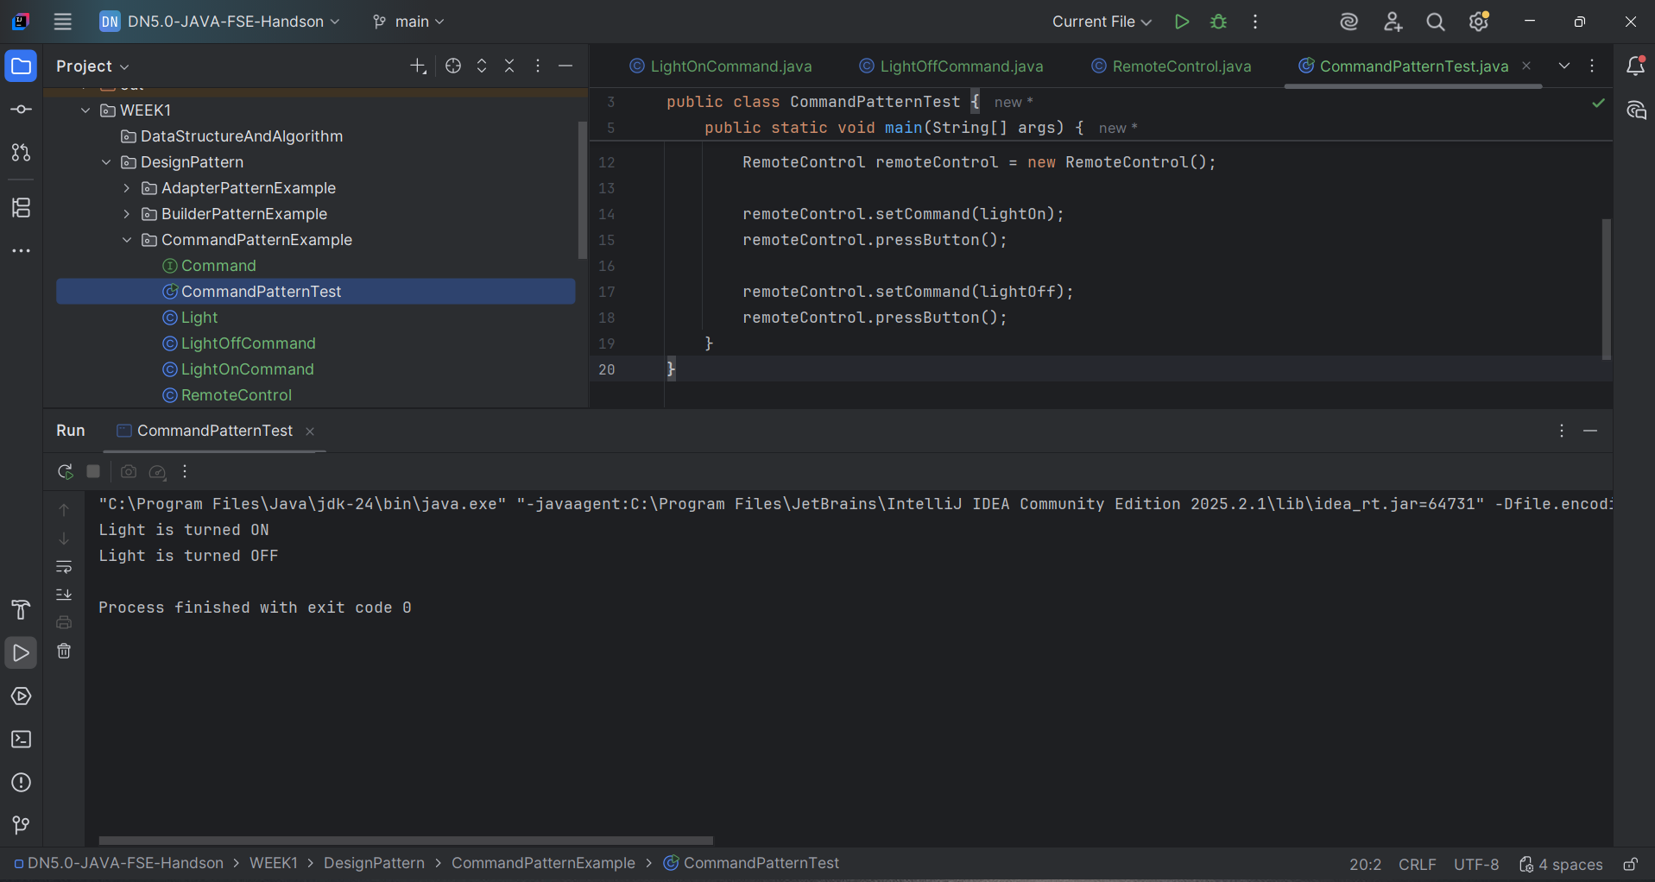
Figure 9: Output of Command Pattern Implementation

Output Verification
- Light is turned ON: This confirms that LightOnCommand executed successfully and called the turnOn() method of Light.
- Light is turned OFF: This confirms that LightOffCommand executed successfully and called the turnOff() method of Light.
- RemoteControl executes commands without directly knowing the internal methods of the Light class.
- The output confirms that command objects are used to perform different actions.
- Process finished with exit code 0: This confirms that the program executed successfully without any error.

Conclusion
The Command Pattern has been implemented successfully. Light works as the receiver, LightOnCommand and LightOffCommand work as command objects, and RemoteControl works as the invoker. The test output confirms that commands can be assigned and executed to control the light.

Exercise 10: Implementing the MVC Pattern
Project Name: MVCPatternExample

Scenario
The objective of this exercise is to create a simple application for managing student records using the MVC Pattern. The Model stores student data, the View displays the data, and the Controller updates the Model and refreshes the View.

Exercise Steps Covered
Step | Requirement | Implementation Done
1 | Create a new Java project named MVCPatternExample. | A project/folder named MVCPatternExample was created inside WEEK1/DesignPattern.
2 | Create a class Student with attributes like name, id and grade. | Student.java works as the model class and contains student fields with getter and setter methods.
3 | Create a class StudentView with a method displayStudentDetails(). | StudentView.java works as the view class and prints student details on the console.
4 | Create a class StudentController that handles communication between model and view. | StudentController.java updates Student data and calls StudentView to display the current details.
5 | Create a main class to demonstrate creating, updating and displaying student records. | MVCPatternTest.java creates a Student object, displays initial details, updates values and displays updated details.

Implementation Summary
- Student.java is the model class that stores student information such as id, name and grade.
- StudentView.java is the view class that displays student details.
- StudentController.java is the controller class that manages communication between Student and StudentView.
- The controller updates the model and refreshes the view using updateView().
- MVCPatternTest.java verifies the MVC flow by displaying initial and updated student details.
- The MVC Pattern separates data, display logic and control logic into different classes.

Program Output
The output screenshot below shows that the initial student details are displayed first. After updating the student name and grade through the controller, the updated details are displayed successfully.
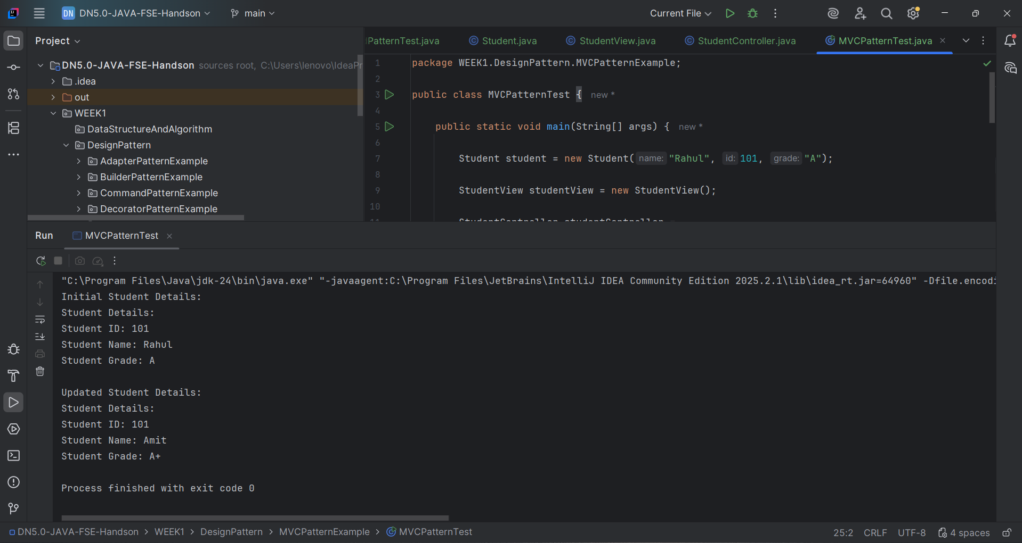
Figure 10: Output of MVC Pattern Implementation

Output Verification
- Initial Student Details: This section shows the original values stored in the Student model.
- Student ID: 101, Student Name: Rahul and Student Grade: A are displayed through StudentView.
- Updated Student Details: This section confirms that the controller updated the model values.
- Student Name changes from Rahul to Amit and Student Grade changes from A to A+.
- The output proves that the controller successfully updates the model and refreshes the view.
- Process finished with exit code 0: This confirms that the program executed successfully without any error.

Conclusion
The MVC Pattern has been implemented successfully. Student works as the model, StudentView displays the details, and StudentController handles updates between the model and the view. The test output confirms that student details can be displayed and updated correctly using MVC structure.
--- End of Report ---

