Exercise 1: Implementing the Singleton Pattern
Project Name: SingletonPatternExample

Scenario
The objective of this exercise is to create a logging utility class that has only one instance throughout the application lifecycle. This helps maintain consistent logging across the application.

Exercise Steps Covered
Step | Requirement | Implementation Done
1 | Create a new Java project named SingletonPatternExample. | A project/folder named SingletonPatternExample was created inside WEEK1/DesignPattern.
2 | Create a class named Logger with a private static instance. | Logger.java contains a private static Logger reference to store the single object.
2 | Ensure the constructor of Logger is private. | The Logger constructor is private, so objects cannot be created directly using new Logger().
2 | Provide a public static method to get the instance. | The getInstance() method returns the single Logger object.
3 | Implement the Singleton pattern. | The getInstance() method creates the Logger object only once and returns the same object every time.
4 | Create a test class to verify only one instance. | SingletonTest.java creates two Logger references and compares them using ==.

Implementation Summary
- Logger.java is the Singleton class used for logging messages.
- The Logger constructor is private, which prevents direct object creation from outside the class.
- A private static Logger reference stores the single object of the Logger class.
- The getInstance() method checks whether the object is already created. If not, it creates the object once. If already created, it returns the same object.
- SingletonTest.java verifies the implementation by calling getInstance() two times and checking whether both references point to the same object.

Program Output
The output screenshot below shows that the Logger object is created successfully only once. After that, both log messages are printed using the same Logger instance. The final message confirms that only one Logger instance is used.
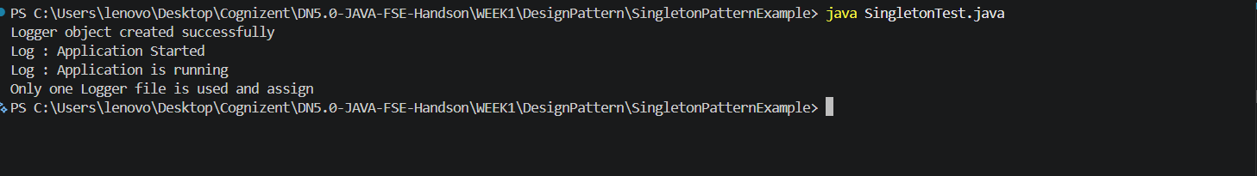
Figure 1: Output of Singleton Pattern Implementation

Output Verification
- Logger object created successfully: This line appears only once, which proves that the Logger object is created only one time.
- Log : Application Started: This is the first log message printed through the Logger instance.
- Log : Application is running: This is the second log message printed through the same Logger instance.
- Only one Logger file is used and assign: This confirms that both Logger references are using the same instance.

Conclusion
The Singleton Pattern has been implemented successfully. The Logger class allows only one object to be created and the same object is reused throughout the application. The test class verifies this by comparing two Logger references and showing that both refer to the same instance.
--- End of Report ---

