ASSIGNMENT 1

Question 1:
Explain the difference between frontend, backend, and full-stack development with
suitable real-world examples.
Answer:
Frontend Development: Builds the user interface of a website using HTML, CSS, and JavaScript.
Example: Product pages on Amazon.
Backend Development: Handles server, database, and logic of the website using Node.js, Python, or Java.
Example: Logging in to Netflix and fetching account data.
Full-Stack Development: Works on both frontend and backend, creating a complete web application.
Example: A food delivery app with UI and order management.
Question2:
Create a simple diagram showing how the client-server model works in web architecture.
Answer:
+-------------------+
| CLIENT |
| (Web Browser)
+-------------------+
|
| 1. Request (HTTP)
↓
+-------------------+
| SERVER
| (Web Server +
| Backend Logic)
+-------------------+
|
| 2. Query/Response
↓
+-------------------+
| DATABASE
| (Data Storage)
+-------------------+
↑
| 3. Data Sent Back
|
+-------------------+
| SERVER
+-------------------+
↑
| 4. Response (HTML, JSON)
|
+-------------------+
| CLIENT
+-------------------+

Question 3:
When a user enters a web address (URL) in the browser, the following steps occur:
- DNS Lookup:
The browser contacts the Domain Name System (DNS) to find the IP address of the web server hosting the website.
- Request Sent:
The browser sends an HTTP or HTTPS request to the web server for the required web page.
- Server Processing:
The web server receives the request, processes it (with help from backend logic if needed), and retrieves the requested files such as HTML, CSS, JavaScript, or images.
- Response Sent:
The server sends these files back to the browser in the form of an HTTP response.
- Rendering the Page:
The browser interprets the HTML, applies the CSS for styling, runs JavaScript for interactivity, and finally displays the complete web page to the user.
Question 4:
Identify and list the tools required to set up a web development environment. Explain the purpose of each.
answer:
A complete web development setup includes a code editor, browser, server, database, version control, and debugging tools — all working together to build and test web applications.
Question5:
Explain what a web server is and give examples of commonly used servers.
Answer:
A web server is a system that stores and delivers web pages to users over the internet using the HTTP/HTTPS protocol. When a user requests a website, the server processes the request and sends back the required files like HTML, CSS, or images for the browser to display.
Examples: Apache, Nginx, Microsoft IIS, Node.js.
Question 6:Define the roles of a frontend developer, backend developer, and database administrator in a project.
Frontend Developer: Designs and builds the website’s user interface using HTML, CSS, and JavaScript. Backend Developer: Handles the server-side logic and ensures communication between the frontend and database. Database Administrator (DBA): Manages and maintains the database, ensuring data is stored, secure, and retrievable.
Question 7:
Install VS Code and configure it for HTML, CSS, and JavaScript development. Take a screenshot of the setup.
Answer:
Download and install VS Code from code.visualstudio.com.
Open VS Code and install extensions: HTML CSS Support, Live Server, JavaScript (ES6) snippets.
Create a folder, add files index.html, style.css, script.js.
Right-click index.html → Open with Live Server to run the webpage.
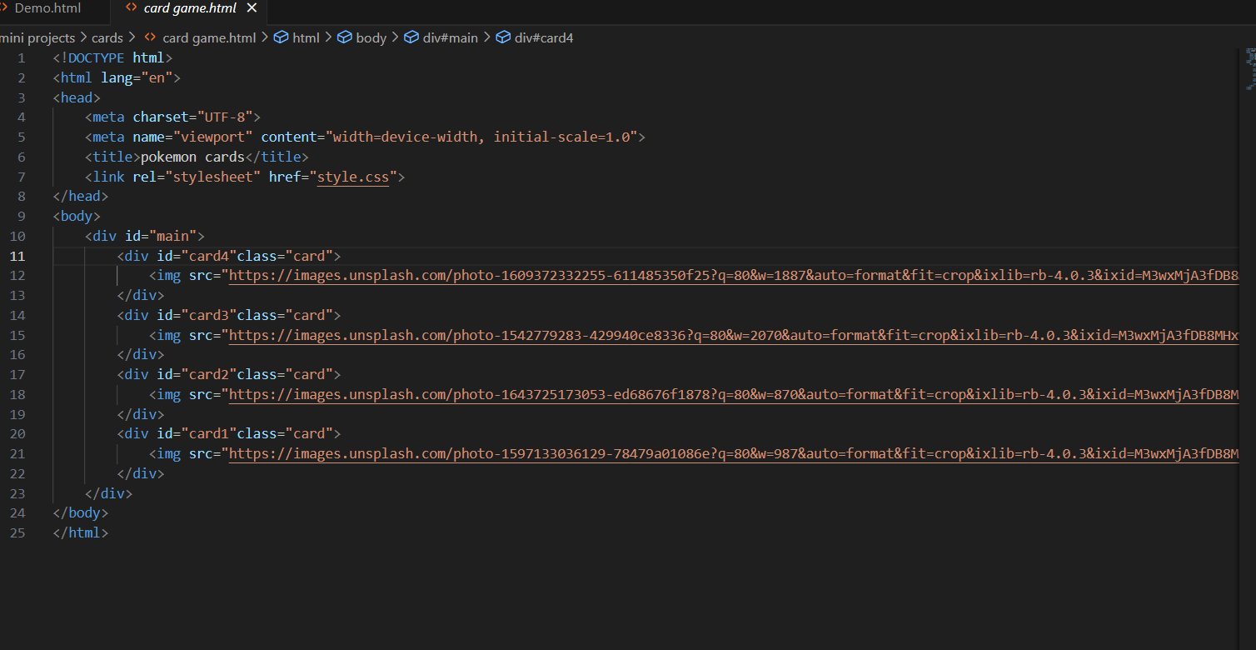

Question 8:
Explain the difference between static and dynamic websites. Provide an example of each.
Answer:
Static Website:
Shows fixed content that does not change unless manually updated. Example: A personal portfolio website.
Dynamic Website:
Shows changing content based on user interaction or database.
Example: Facebook or Amazon.
Question 9:
Research and list five web browsers. Explain how rendering engines differ between them.
Answer:
Five Web Browsers: Chrome, Firefox, Edge, Safari, Opera.
Rendering Engines:
Chrome & Edge: Blink
Firefox: Gecko
Safari: WebKit
Opera: Blink
Difference: Rendering engines control how browsers display web pages, so different engines may render the same page slightly differently.
Question 10:
Draw a labeled diagram showing the basic web architecture flow — client, server, database, and APIs.
Answer:
+-------------------+
| CLIENT |
| (Browser/App)
+-------------------+
|
| 1. HTTP Request
↓
+-------------------+
| SERVER |
| (Web Server + |
| Backend Logic) |
+-------------------+
|
| 2. API Call / Query
↓
+-------------------+
| DATABASE |
| (Stores Data) |
+-------------------+
↑
| 3. Response via API
|
+-------------------+
| SERVER |
+-------------------+
|
| 4. HTTP Response
↓
+-------------------+
| CLIENT |
+-------------------+

