AICTE | IBM SkillsBuild
Data Analytics with AI Internship 2026 | BharatCares
E-Commerce Sales and Customer Behavior Analysis using Python
Data Analytics Project Report
Prepared by: Gitesh Ubhad
Date: 06 October 2026

1. Abstract
This project performs exploratory and descriptive analysis on an e-commerce sales dataset using Python. The analysis converts raw transaction records into key business measures and visual insights covering revenue, profit, product performance, regional performance, customer segments, monthly sales trends, and the relationship between discounts and profit. The submitted dataset contains 300 orders and 14 columns.

2. Problem Statement
E-commerce businesses generate large volumes of transaction data. Without structured analysis, it is difficult to identify profitable products, high-value customers, strong-performing regions, and sales trends. This project provides a simple analytics workflow to transform transaction data into useful business insights for decision-making.

3. Objectives
- Analyze e-commerce transaction data.
- Calculate sales, profit, order and quantity KPIs.
- Find top-performing products and categories.
- Compare regional and customer-segment performance.
- Study monthly sales trends.
- Identify top customers based on sales.
- Visualize the relationship between discounts and profit.
- Present findings in a clear and reproducible Python notebook.

4. Tools and Technologies
Tool / Library | Purpose
Python | Core programming and analysis
Pandas | Data loading, cleaning, grouping and aggregation
NumPy | Numerical operations
Matplotlib | Charts and trend visualisation
Seaborn | Statistical visualisation, including scatter plot
Jupyter Notebook | Executable project code and documentation
CSV | Dataset storage format

5. Dataset Description
The supplied dataset contains 300 e-commerce orders and 14 columns. It includes order details, customer details, product and category information, region, customer segment, quantity, unit price, discount, sales, cost, profit, and payment method.
Field | Description
Order_ID | Unique order identifier
Order_Date | Date of order
Customer_ID | Customer identifier
Category | Product category
Product | Product name
Region | Sales region
Customer_Segment | Consumer, Home Office or Corporate
Quantity | Units ordered
Unit_Price | Price per unit
Discount_Percent | Applied discount percentage
Sales | Transaction sales value
Cost | Transaction cost
Profit | Transaction profit
Payment_Method | Payment mode used for the order

Dataset validation results:
Validation Check | Result
Rows | 300
Columns | 14
Missing values | 0
Duplicate rows | 0
Invalid parsed dates | 0

6. Methodology / Workflow
- Load the CSV dataset with Pandas.
- Convert Order_Date to datetime format for time-based analysis.
- Inspect dataset shape, data types, missing values and duplicate rows.
- Create KPI measures for sales, profit, orders, quantity, average order value and profit margin.
- Use group-by aggregation for product, category, region, customer segment and customer analysis.
- Create a monthly sales series for trend analysis.
- Use charts to visualise major comparisons and the discount-profit relationship.
- Summarise the findings and possible future extensions.

7. Key Performance Indicators
KPI | Value
Total Sales | ₹8,285,755.55
Total Profit | ₹2,305,833.95
Total Orders | 300
Total Quantity | 759
Average Order Value | ₹27,619.19
Profit Margin | 27.83%
The KPI values are calculated directly from the supplied dataset. The notebook reproduces these calculations programmatically.

8. Analysis and Visual Results

8.1 Product Analysis
The highest-sales product is Laptop, with total sales of ₹3,375,591.04. The chart below shows the top 10 products by sales.
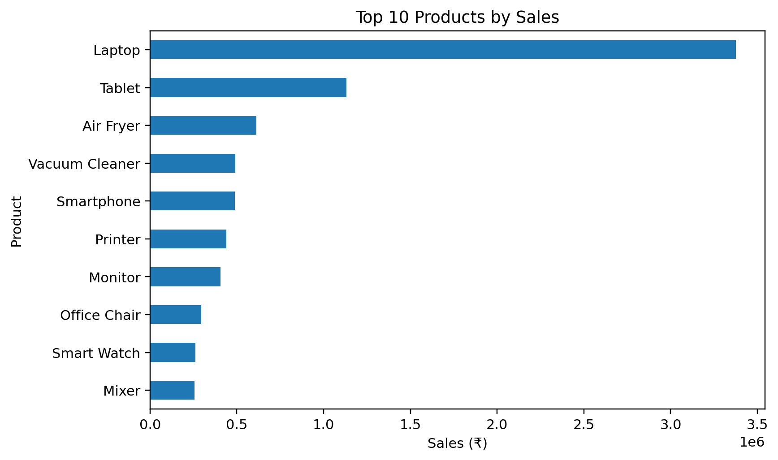

8.2 Category Analysis
Electronics has the highest total sales and the highest total profit among the four categories in the supplied dataset.
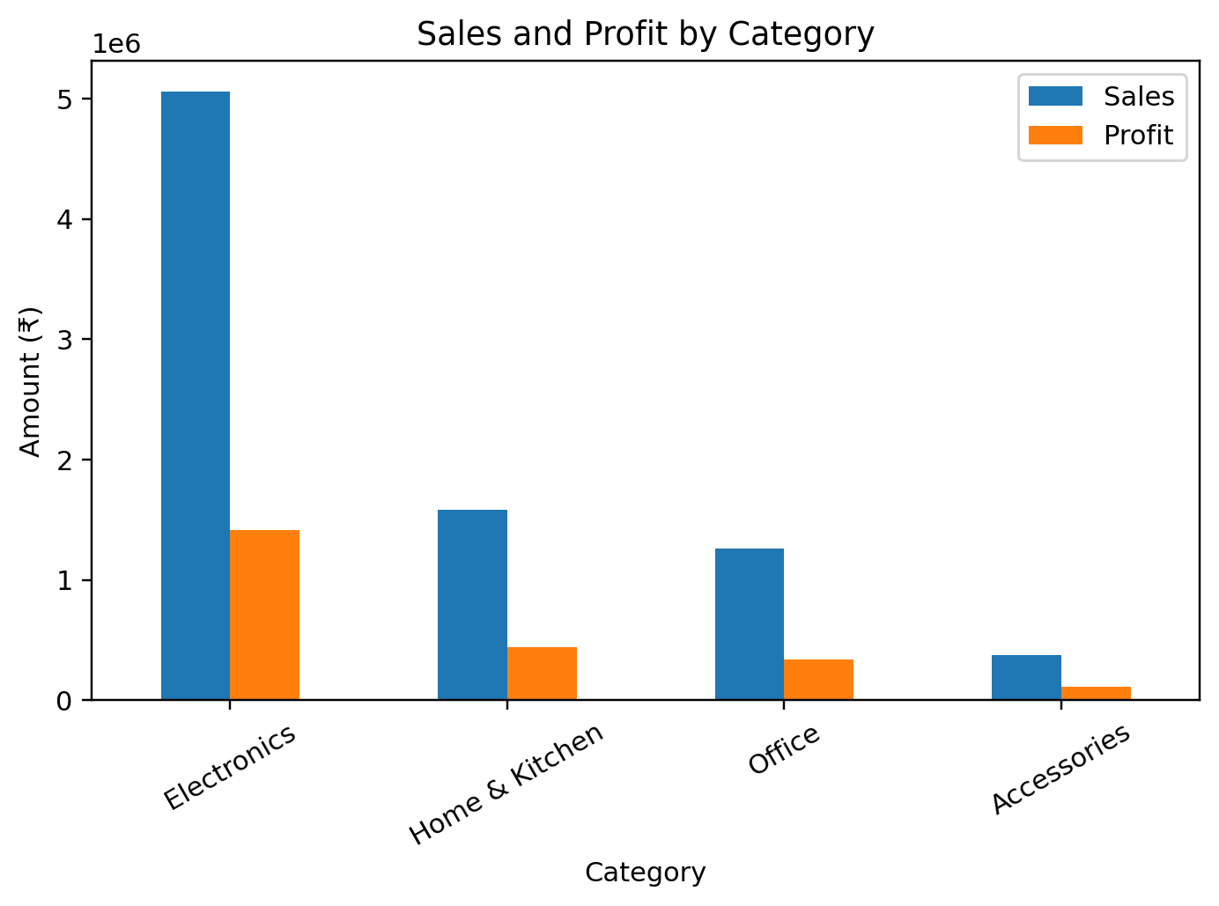
Category | Sales (₹) | Profit (₹)
Electronics | 5,061,342.77 | 1,414,337.98
Home & Kitchen | 1,581,655.11 | 440,885.59
Office | 1,264,076.77 | 339,907.25
Accessories | 378,680.90 | 110,703.13

8.3 Region Analysis
Nagpur is the highest-sales region, with total sales of ₹2,467,532.33.
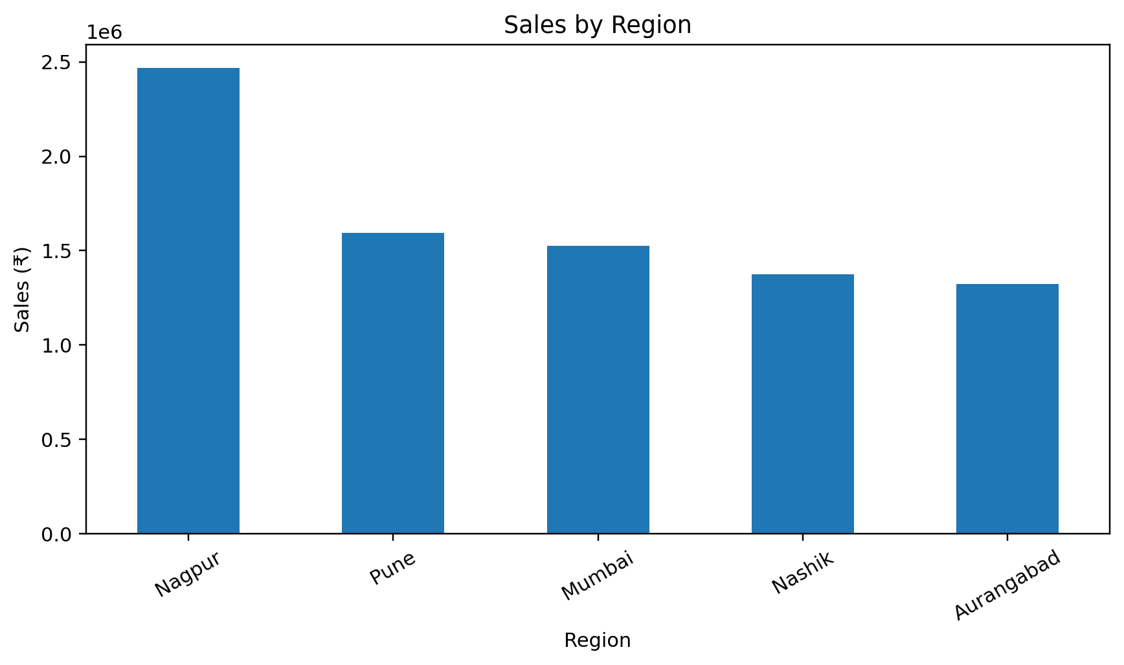
Region | Sales (₹) | Profit (₹)
Nagpur | 2,467,532.33 | 730,396.56
Pune | 1,594,085.57 | 415,155.75
Mumbai | 1,524,799.92 | 422,203.12
Nashik | 1,375,905.56 | 363,752.87
Aurangabad | 1,323,432.17 | 374,325.65

8.4 Customer Segment Analysis
Customer Segment | Sales (₹) | Profit (₹)
Consumer | 3,050,774.52 | 850,994.32
Home Office | 3,033,971.56 | 845,385.52
Corporate | 2,201,009.47 | 609,454.11

8.5 Monthly Sales Trend
The strongest sales month in this dataset is 2025-10, with sales of ₹1,322,354.68.
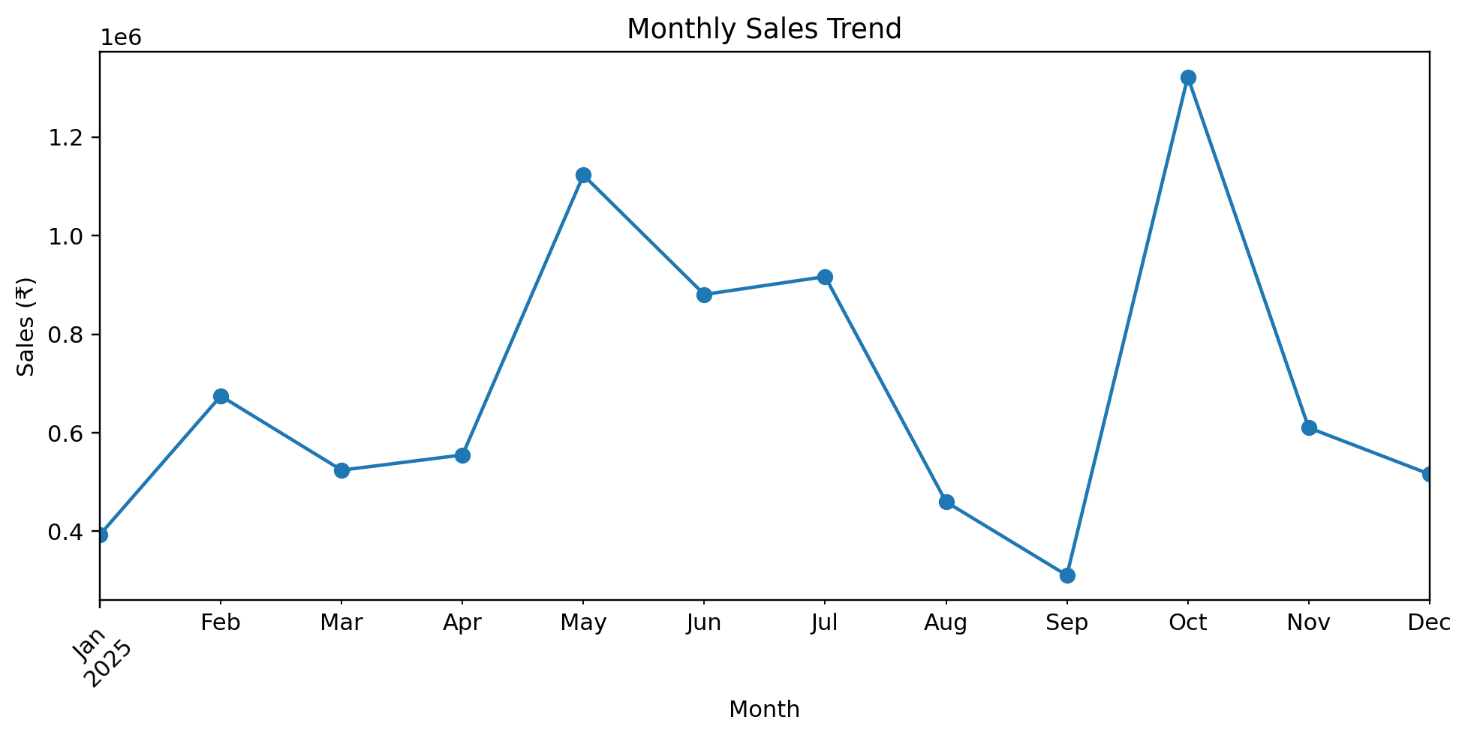

8.6 Top Customers
The notebook identifies the top 10 customers by total sales using Customer_ID aggregation.
Rank | Customer ID | Sales (₹)
1 | CUST037 | 508,763.61
2 | CUST025 | 434,710.62
3 | CUST062 | 335,890.58
4 | CUST035 | 291,568.72
5 | CUST067 | 280,429.85
6 | CUST052 | 273,354.41
7 | CUST075 | 269,123.37
8 | CUST032 | 268,123.51
9 | CUST012 | 255,721.88
10 | CUST066 | 236,645.20

8.7 Discount versus Profit
The Pearson correlation between Discount_Percent and Profit is -0.0218. This is a very weak linear relationship in the supplied dataset, so discount percentage alone does not strongly explain profit.
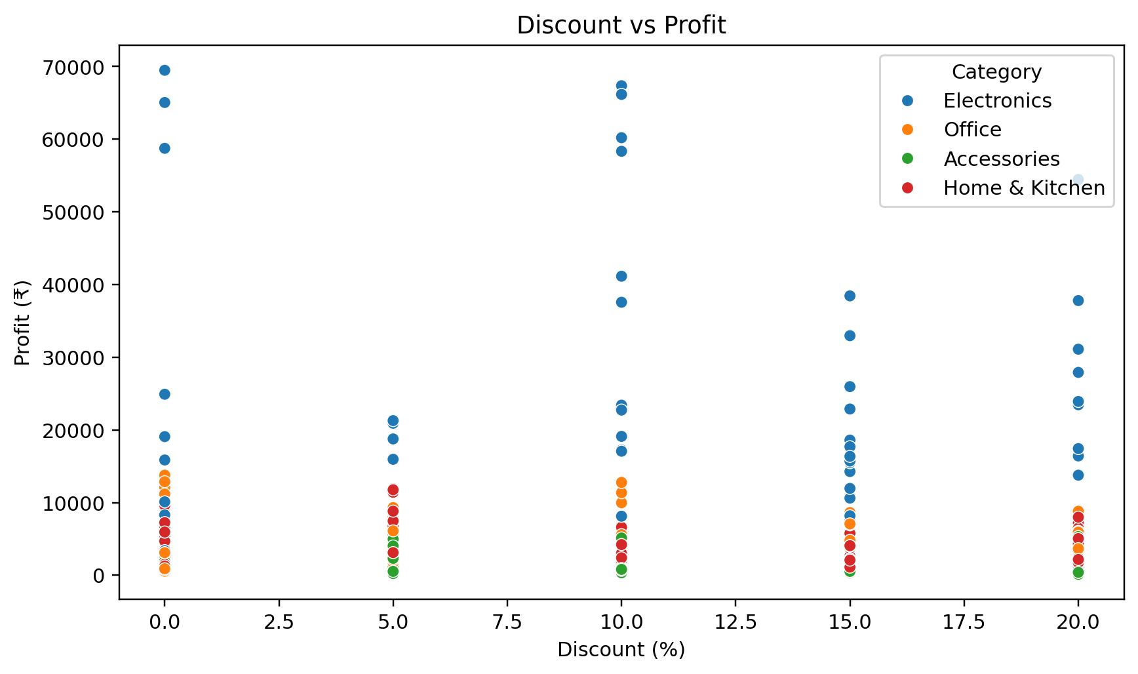

9. Key Findings
- Laptop is the highest-sales product with ₹3,375,591.04 in sales.
- Nagpur is the highest-sales region with ₹2,467,532.33 in sales.
- Electronics is the highest-profit category with ₹1,414,337.98 in profit.
- Consumer is the highest-sales customer segment with ₹3,050,774.52 in sales.
- 2025-10 is the highest-sales month with ₹1,322,354.68 in sales.
- The discount-profit correlation is -0.0218, indicating only a weak linear relationship in this dataset.

10. Conclusion
The project demonstrates a complete beginner-friendly data analytics workflow. Raw e-commerce transactions are converted into meaningful KPIs, grouped comparisons, time-based trends, customer rankings, and visual insights. The submitted Jupyter Notebook contains the full executable analysis, while this report documents the project method and results.

11. Future Scope
- Interactive Power BI dashboard for management reporting.
- SQL database integration for scalable data storage and querying.
- Customer segmentation using behavioural and monetary features.
- Demand forecasting and sales prediction.
- Machine learning applications such as customer churn prediction.
- Automated business reports and scheduled analytics.

12. Internship Submission Deliverables
This project has been updated to match the four-file submission structure shown in the internship instructions:
Required File | Prepared File
Code File (.ipynb) | Gitesh_ECommerce_Project.ipynb
Requirements File (.txt) | requirements.txt
Project Report (.docx) | Gitesh_ECommerce_ProjectReport.docx
README File (.md) | README.md
Supporting dataset: ecommerce_sales_data.csv. Keep the dataset with the notebook when running the project locally or upload it to the notebook environment when using Google Colab.

