“WASTE ANALYSIS & SORTING TECHNOLOGY ENGINE (W.A.S.T.E)”
Patil Rajnandini, 199
Patil Giteshwari, 185
R. C. Patel Educational Trust's Institute of Management Research and Development, Shirpur.

Abstract:
Effective waste management is one of the most pressing challenges in modern society, particularly in rural and semi-urban regions where expert staff and advanced infrastructure are often lacking. This project proposes a machine learning–based system for automatic classification of waste into three critical categories: recyclable, organic, and hazardous. The model leverages multiple sensor-driven features, including weight, moisture, pH, conductivity, chemical signature, odor intensity, and physical properties such as color, texture, and combustibility. These inputs are preprocessed through normalization and categorical encoding before being applied to four classification algorithms: K-Nearest Neighbors, Support Vector Machine, Decision Tree, and Naïve Bayes. Each model is evaluated using accuracy, precision, recall, F1-score, and confusion matrices to identify the most effective approach. The resulting system aims to reduce manual labor, enable safer handling of hazardous materials, and promote efficient recycling practices. Ultimately, this work demonstrates how intelligent waste sorting can support sustainable and safer waste management.
Keywords: Waste segregation, Classifier algorithms,
Introduction:
One of the most critical stages in waste management is classification—the process of identifying whether a material is recyclable, organic, or hazardous^{[1]}. Proper classification ensures that recyclable items are reused, organic waste is composted or treated naturally, and hazardous waste is carefully handled to prevent contamination or accidents. Unfortunately, in many rural and semi-urban areas, waste classification is still done manually, often by workers with limited training or resources. This manual approach not only slows down the process but also exposes workers to health risks and leads to errors that reduce the effectiveness of recycling and safe disposal^{[1]}.
In recent years, the rise of smart technologies has opened the door for automation in waste management. Sensors can now measure physical and chemical features of waste—such as weight, moisture content, pH level, odor intensity, texture, combustibility, and chemical signatures. These measurable signals contain enough information to distinguish between different types of waste, but analyzing them efficiently requires advanced computational techniques. This is where machine learning (ML) becomes highly relevant^{[2]} .
Waste generation is an unavoidable outcome of human activity, ranging from household garbage to industrial byproducts. With rapid urbanization, population growth, and changes in consumption patterns, the quantity and complexity of waste are steadily increasing. According to global estimates, billions of tons of solid waste are generated each year, and a significant portion of it is either mismanaged or disposed of improperly. This has direct consequences on human health, soil and water quality, and the overall balance of the ecosystem^{[3]} .
Machine learning provides tools and algorithms that can learn from data patterns and make predictions without being explicitly programmed. By training models on datasets of waste samples with labeled categories (recyclable, organic, hazardous), an ML system can automatically classify new waste items in real time. Such an approach reduces human error, increases efficiency, and creates a more systematic waste management process^{[4]}.
This work aims to develop and test a machine learning–based classification system for waste using sensor data. The study compares different classification algorithms—including K-Nearest Neighbors (KNN), Support Vector Machine (SVM), Decision Tree, and Naïve Bayes—to determine which model delivers the best accuracy and reliability. The system is designed with practical application in mind, especially for rural recycling centers, where access to expert staff and advanced infrastructure is limited^{[4]} .
By addressing the challenge of automated waste classification, this work contributes to safer handling of hazardous waste, improved recycling rates, and overall sustainability. The findings are expected to provide a foundation for building affordable, real-world waste management solutions powered by artificial intelligence^{[5]}.

Problem Definition:
The improper classification of waste often leads to health hazards, environmental pollution, and reduced recycling efficiency. Manual methods are time-consuming, error-prone, and not scalable for growing populations.
Objectives:
- To build a system that can separate different types of waste automatically .
- To help recycling plants work faster and smarter by correctly spotting items that can be recycled.
- To collect and study waste data using cloud tools to make better plans for waste management.
- To reduce the money and effort spent on sorting and collecting waste by using automated systems.
- To create a flexible system that can be used in villages, small towns, or big cities.
- To support a clean, green future by reducing waste, reusing materials, and promoting eco-friendly practices.
Challenges:
- Gathering enough real and accurate waste data for training machine learning models can be difficult.
- Sensors used to detect moisture, pH, and chemical levels may give errors if not calibrated well.
- Machine learning models may need a lot of data and computing power to work correctly.
- Installing sensors, robotics, and IoT devices can be expensive, especially for small towns and villages.
- The system will need regular maintenance and updates to stay accurate and efficient.
- Workers and local staff will need basic training to operate and monitor the system.

Methodology:
This research paper examines the dataset of 500 images that are processed using CNN algorithm regarding waste segregation. Using machine learning classifier algorithms, preferring prediction of waste as recyclable or organic one.
Experiment:
KNN: (K-Nearest Neighbors) is a supervised learning algorithm that classifies data based on the majority class of its nearest K neighbors using distance measures.
Table 1: KNN PREDICTION TABLE:
This table includes the dataset trained on KNN classifier algorithm along with tunning parameters.
No of features | K Value | Train% | Test% | Accuracy%
8 | 3 | 0.8 | 0.2 | 85.00
 |  | 0.7 | 0.3 | 85.33
 |  | 0.6 | 0.4 | 87.25
 | 5 | 0.8 | 0.2 | 86.50
 |  | 0.7 | 0.3 | 85.33
 |  | 0.6 | 0.4 | 86.67
This table showing the model accuracy for different settings of K value, train-test split, and number of features, accuracy ranges 85.00% to 87.25%. Best accuracy: 87.25% (K=3, Train/Test=0.6/0.4, 8 features).
SVM: Support Vector Machine (SVM) is a supervised learning algorithm that finds the best boundary (hyperplane) to separate classes by maximizing the margin between data points.
Table 2: SVC PREDICTION TABLE:
This table includes the dataset trained on SVC classifier algorithm along with tunning parameters.
No of features | Kernel Value | Train % | Test % | Accuracy%
8 | linear | 0.8 | 0.2 | 88.00
 |  | 0.7 | 0.3 | 89.00
 |  | 0.6 | 0.4 | 88.75
 | rbf | 0.8 | 0.2 | 90.00
 |  | 0.7 | 0.3 | 88.67
 |  | 0.6 | 0.4 | 93.00
 | poly | 0.8 | 0.2 | 89.00
 |  | 0.7 | 0.3 | 88.00
 |  | 0.6 | 0.4 | 92.00
This table shows the Support Vector Machine (SVM) model performance with different kernel types (linear, polynomial, RBF), train-test splits, and 8 selected features. Accuracy ranges 88.00% to 93.00%. Best accuracy: 93.00% (RBF kernel, train/test=0.6/0.4, 8 features).

Naive Bayes: Naive Bayes is a classification algorithm based on Bayes' theorem that assumes feature independence and predicts the class with the highest probability.
Table 3: NAIVE BAYES PREDICTION TABLE:
This table includes the dataset trained on Naïve Bayes regressor algorithm along with tunning parameters.
No of features | NB | Alpha | Binarize | Accuracy%
8 | Gaussian NB | - | - | 71.00
 | Bernoulli NB | 1.0 | 0.5 | 69.00
 | Complement Naive Bayes | 1.0 | - | 69.00
This table shows the Naïve Bayes model performance with three variants (Gaussian NB, Bernoulli NB, Complement NB) using 8 features.Best accuracy: 71.00% (Gaussian NB). Other model (Bernoulli NB, Complement) achieved about 69% accuracy.
Decision Tree: Decision Tree is a machine learning algorithm that splits data into branches based on feature decisions to predict outcomes. It creates a tree where each node represents a condition and leaves represent final predictions.
Table 4: DECISION TREE PREDICTION TABLE:
This table includes the dataset trained on Decision Tree classifier algorithm along with tunning parameters.
No of features | Tune Parameters | max_depth | Accuracy%
8 | criterion="gini" | None | 79.50
 | criterion="entropy" | None | 78.50
 | criterion="gini" | 5 | 84.00
 | criterion="entropy" | 5 | 81.00
 | min_samples_split=2 | None | 79.50
 | min_samples_split=2 | 5 | 84.00
This table shows the Decision Tree model performance with different splitting criteria (gini, entropy) and max_depth settings. Accuracy range: 78.50% to 84.00%. Best accuracy 84.00% (criterion=gini, max_depth=5,8 features).

Result:
Sr no | Classifiers | Accuracy%
1 | KNN | 87.25%
2 | SVM | 93.00%
 | Naïve Bayes | 71.00%
4 | Decision tree | 84%

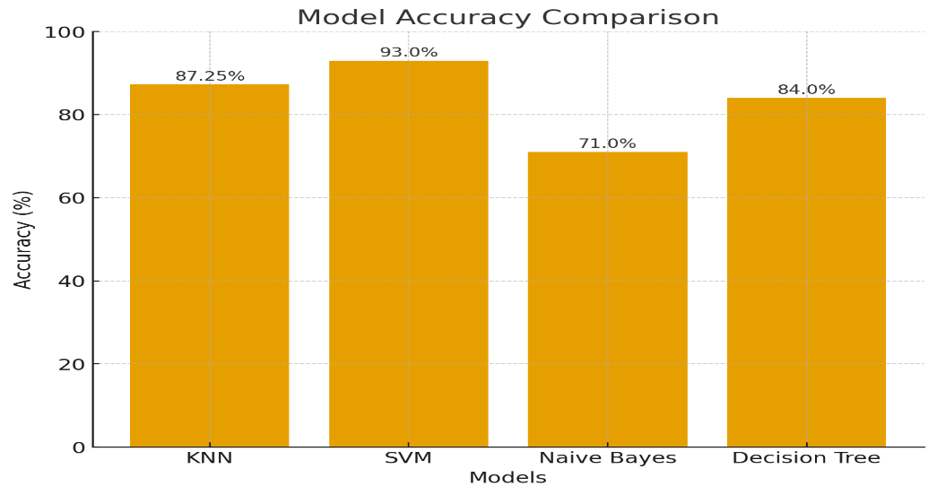
SVM gives highest accuracy to classify waste as organic or recyclable upto 93.00%.

Conclusion:
This project shows that machine learning can be used to sort waste into recyclable or organic, categories with good accuracy. By using features like weight, moisture, pH, odor, and chemical signals, the system makes classification more reliable than manual guessing. The models tested (KNN, SVM, Decision Tree, and Naïve Bayes) give different strengths, but overall they prove that waste sorting can be automated in a simple and effective way. SVM gives highest accuracy to classify waste up to 93.00%. This system can help rural areas and small recycling centers handle waste safely, recycle more, and reduce risks from hazardous materials.

References:
- Abdullah Alourani, M. U. (2025). Smart waste management and classification system using advanced IoT and AI technologies. PeerJ Computer Science, 24.
- Bingbing Fang, J. Y.-S. (2023, April 24). Artificial intelligence for waste management in smart cities: a review. Environmental Chemistry Letters.
- Siedlecka, J. S. (2025, September 4). From Waste to Resource: Circular Ewa Economy Approaches to Valorize Fine Glass, Ceramic, and Plastic Residues in a Glass Recycling Plant. Sutainability, p. 20.
- Pieters, Luntungan Stephen. (2025). DEVELOPMENT OF AUTOMATIC WASTE CLASSIFICATION SYSTEM USING CNN BASED DEEP LEARNING TO SUPPORT SMART WASTE MANAGEMENT. JURNAL INOVTEK POLBENG - SERI INFORMATIKA,, 2527-9866.
- Mohammed A. Al Doghan, V. P. (2023). AI-ENABLED REVERSE LOGISTICS AND BIG DATA FOR ENHANCED WASTE AND RESOURCE MANAGEMENT. Operational Research in Engineering Sciences: Theory and Applications, 15-335.
- Mona Jabor Al-Thani, M. H. (2025). Smart food supply chain management: A bibliometric and systematic review. Food and Humanity, 100736.
- Muhammad Aminullah Abd Rahim, S. A. (2025). Evaluating 3R Waste Management Practice for Construction and Demolition Waste among Contractors in Malaysia. Journal of Sustainable Civil Engineering and Technology, 78-89.
- Sameh Fuqaha, N. N. (2025, June 4). Artificial Intelligence and IoT for Smart Waste Management: Challenges, Opportunities, and Future Directions. Future techno Science, pp. 3048-3719.
- Zhou, Y. (2025). AI-driven digital circular economy with material and energy sustainability for industry 4.0. Energy and AI 20, 13.

