manipulator-x_all

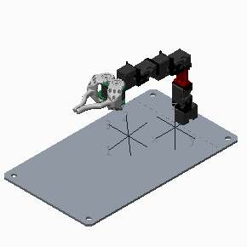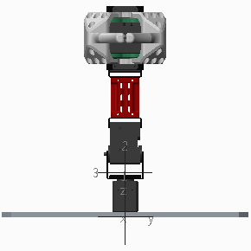

MASS = 2.9379703e+03 GRAM

CENTER OF GRAVITY with respect to X-0 coordinate frame:

X Y Z 1.4611973e+02 7.5916388e-02 4.9617725e+01 MM

INERTIA at CENTER OF GRAVITY with respect to X-0 coordinate frame: (GRAM * MM^2)

INERTIA TENSOR:

Ixx Ixy Ixz 3.1630705e+07 -3.8877478e+04 4.1142669e+06

Iyx Iyy Iyz -3.8877478e+04 6.9407198e+07 -4.0562593e+04

Izx Izy Izz 4.1142669e+06 -4.0562593e+04 6.3758089e+07

X-base

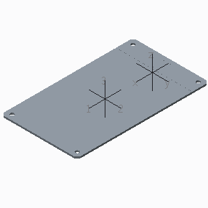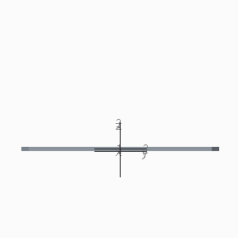

MASS = 2.0764186e+03 GRAM

CENTER OF GRAVITY with respect to X-0 coordinate frame:

X Y Z 1.6982208e+02 0.0000000e+00 2.9978478e+00 MM

INERTIA at CENTER OF GRAVITY with respect to X-0 coordinate frame: (GRAM * MM^2)

INERTIA TENSOR:

Ixx Ixy Ixz 1.2810211e+07 2.9593477e+00 -7.2394445e+02

Iyx Iyy Iyz 2.9593477e+00 3.8303401e+07 0.0000000e+00

Izx Izy Izz -7.2394445e+02 0.0000000e+00 5.1101174e+07

X-1

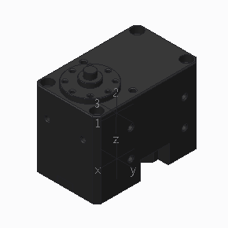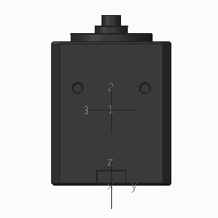

MASS = 8.5809212e+01 GRAM

CENTER OF GRAVITY with respect to X_1 coordinate frame:

X Y Z 2.7237100e-01 0.0000000e+00 1.7786005e+01 MM

INERTIA at CENTER OF GRAVITY with respect to X_1 coordinate frame: (GRAM * MM^2)

INERTIA TENSOR:

Ixx Ixy Ixz 1.3599316e+04 0.0000000e+00 -2.1585266e+02

Iyx Iyy Iyz 0.0000000e+00 2.3517991e+04 0.0000000e+00

Izx Izy Izz -2.1585266e+02 0.0000000e+00 2.0801772e+04

X-2

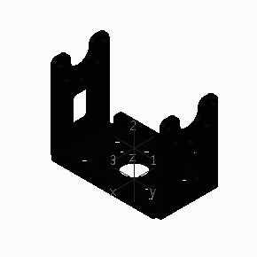 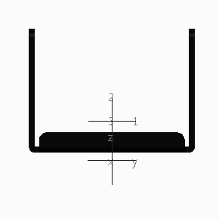

MASS = 7.9508877e+00 GRAM

CENTER OF GRAVITY with respect to X-2 coordinate frame:

X Y Z 0.0000000e+00 0.0000000e+00 9.7458641e+00 MM

INERTIA at CENTER OF GRAVITY with respect to X-2 coordinate frame: (GRAM * MM^2)

INERTIA TENSOR:

Ixx Ixy Ixz 2.6531739e+03 0.0000000e+00 0.0000000e+00

Iyx Iyy Iyz 0.0000000e+00 1.0512515e+03 0.0000000e+00

Izx Izy Izz 0.0000000e+00 0.0000000e+00 2.4601443e+03

X-3

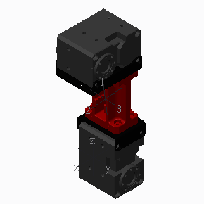 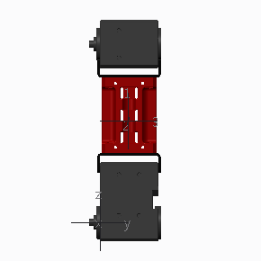

MASS = 2.1940858e+02 GRAM

CENTER OF GRAVITY with respect to X-3 coordinate frame:

X Y Z 5.3495553e+00 1.6520648e+01 5.9367390e+01 MM

INERTIA at CENTER OF GRAVITY with respect to X-3 coordinate frame: (GRAM * MM^2)

INERTIA TENSOR:

Ixx Ixy Ixz 4.3395152e+05 1.2766226e+02 -5.1294039e+04

Iyx Iyy Iyz 1.2766226e+02 4.4404073e+05 -1.7756255e+02

Izx Izy Izz -5.1294039e+04 -1.7756255e+02 5.4150859e+04

X-4

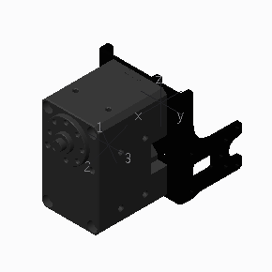 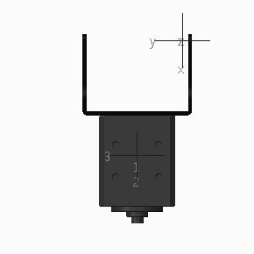

MASS = 9.7458692e+01 GRAM

CENTER OF GRAVITY with respect to X-4 coordinate frame:

X Y Z 4.2975851e+01 1.7000002e+01 1.1881107e+01 MM

INERTIA at CENTER OF GRAVITY with respect to X-4 coordinate frame: (GRAM * MM^2)

INERTIA TENSOR:

Ixx Ixy Ixz 2.5802457e+04 0.0000000e+00 -1.4380091e+03

Iyx Iyy Iyz 0.0000000e+00 3.2033814e+04 0.0000000e+00

Izx Izy Izz -1.4380091e+03 0.0000000e+00 2.2905623e+04

X-5

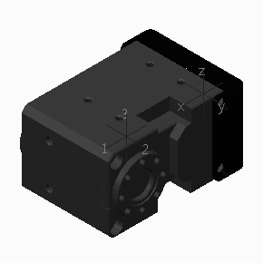 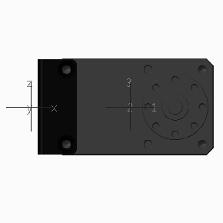

MASS = 9.2256914e+01 GRAM

CENTER OF GRAVITY with respect to X-5 coordinate frame:

X Y Z 2.9294840e+01 -5.6909045e-01 0.0000000e+00 MM

INERTIA at CENTER OF GRAVITY with respect to X-5 coordinate frame: (GRAM * MM^2)

INERTIA TENSOR:

Ixx Ixy Ixz 1.5354294e+04 1.2410399e+02 0.0000000e+00

Iyx Iyy Iyz 1.2410399e+02 2.4978515e+04 0.0000000e+00

Izx Izy Izz 0.0000000e+00 0.0000000e+00 2.8652179e+04

X-6

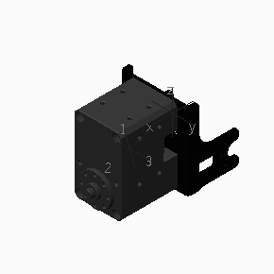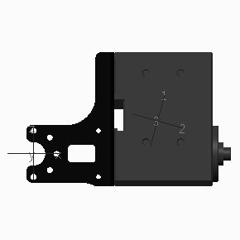

MASS = 9.7458692e+01 GRAM

CENTER OF GRAVITY with respect to X-6 coordinate frame:

X Y Z 4.2975851e+01 1.7000001e+01 1.1401479e+01 MM

INERTIA at CENTER OF GRAVITY with respect to X-6 coordinate frame: (GRAM * MM^2)

INERTIA TENSOR:

Ixx Ixy Ixz 2.5768922e+04 0.0000000e+00 -8.7494630e+02

Iyx Iyy Iyz 0.0000000e+00 3.2000279e+04 0.0000000e+00

Izx Izy Izz -8.7494630e+02 0.0000000e+00 2.2905623e+04

X-789

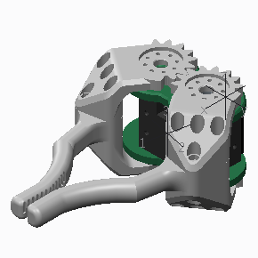 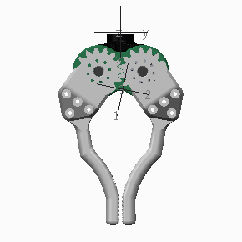

MASS = 2.6120875e+02 GRAM

CENTER OF GRAVITY with respect to X-7 coordinate frame:

X Y Z 4.1969024e+01 1.4575120e+00 -2.0824691e-01 MM

INERTIA at CENTER OF GRAVITY with respect to X-7 coordinate frame: (GRAM * MM^2)

INERTIA TENSOR:

Ixx Ixy Ixz 1.9173299e+05 5.4822011e+03 -7.3148779e+02

Iyx Iyy Iyz 5.4822011e+03 2.1748011e+05 1.2950472e+01

Izx Izy Izz -7.3148779e+02 1.2950472e+01 2.8673887e+05

X-7

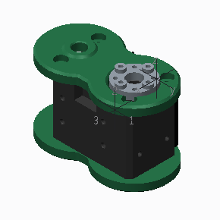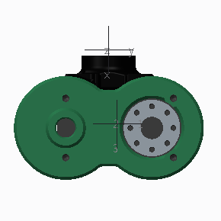

MASS = 1.2679580e+02 GRAM

CENTER OF GRAVITY with respect to X-7 coordinate frame:

X Y Z 2.7451299e+01 3.0025828e+00 -4.2900408e-01 MM

INERTIA at CENTER OF GRAVITY with respect to X-7 coordinate frame: (GRAM * MM^2)

INERTIA TENSOR:

Ixx Ixy Ixz 4.8969467e+04 -4.4913106e+01 5.8217173e+01

Iyx Iyy Iyz -4.4913106e+01 3.2610497e+04 1.0267086e+02

Izx Izy Izz 5.8217173e+01 1.0267086e+02 4.0076286e+04

X-8

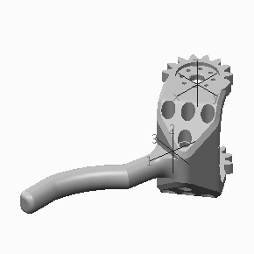 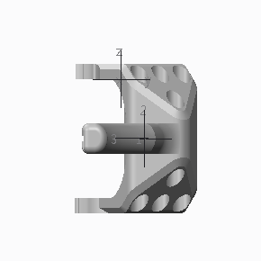

MASS = 6.7206474e+01 GRAM

CENTER OF GRAVITY with respect to X-8 coordinate frame:

X Y Z 2.6664034e+01 9.0981881e+00 -2.2999842e+01 MM

INERTIA at CENTER OF GRAVITY with respect to X-8 coordinate frame: (GRAM * MM^2)

INERTIA TENSOR:

Ixx Ixy Ixz 2.8747006e+04 5.9284508e+03 5.9731532e+01

Iyx Iyy Iyz 5.9284508e+03 6.6461991e+04 -8.6616279e+01

Izx Izy Izz 5.9731532e+01 -8.6616279e+01 5.4735725e+04

X-9

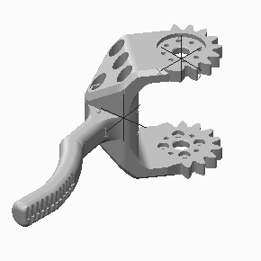 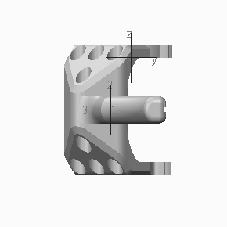

MASS = 6.7206474e+01 GRAM

CENTER OF GRAVITY with respect to X-9 coordinate frame:

X Y Z 2.6664034e+01 -9.0981881e+00 -2.3000158e+01 MM

INERTIA at CENTER OF GRAVITY with respect to X-9 coordinate frame: (GRAM * MM^2)

INERTIA TENSOR:

Ixx Ixy Ixz 2.8747006e+04 -5.9284508e+03 -5.9731532e+01

Iyx Iyy Iyz -5.9284508e+03 6.6461991e+04 -8.6616279e+01

Izx Izy Izz -5.9731532e+01 -8.6616279e+01 5.4735725e+04

|  |  |  |  |
| --- | --- | --- | --- |
| L_L | x | y | z |
| X-base-X1 | 0 | 0 | 0 |
| X1-X2 | 12 | 0 | 34 |
| X2-X3 | 0 | -17 | 30 |
| X3-X4 | 24 | 0 | 104.5 |
| X4-X5 | 62 | 17 | 24 |
| X5-X6 | 42.5 | -17 | 0 |
| X6-X7 | 62 | 17 | 0 |
| X7-X8 | 29 | 16 | 23 |
| X8-X9 | 0 | -32 | 0 |