Domain-Driven Design (DDD)
Architectural Bounded Contexts & Aggregate Models

1. Strategic Design & Bounded Contexts
The system architecture is structured into three primary Bounded Contexts:
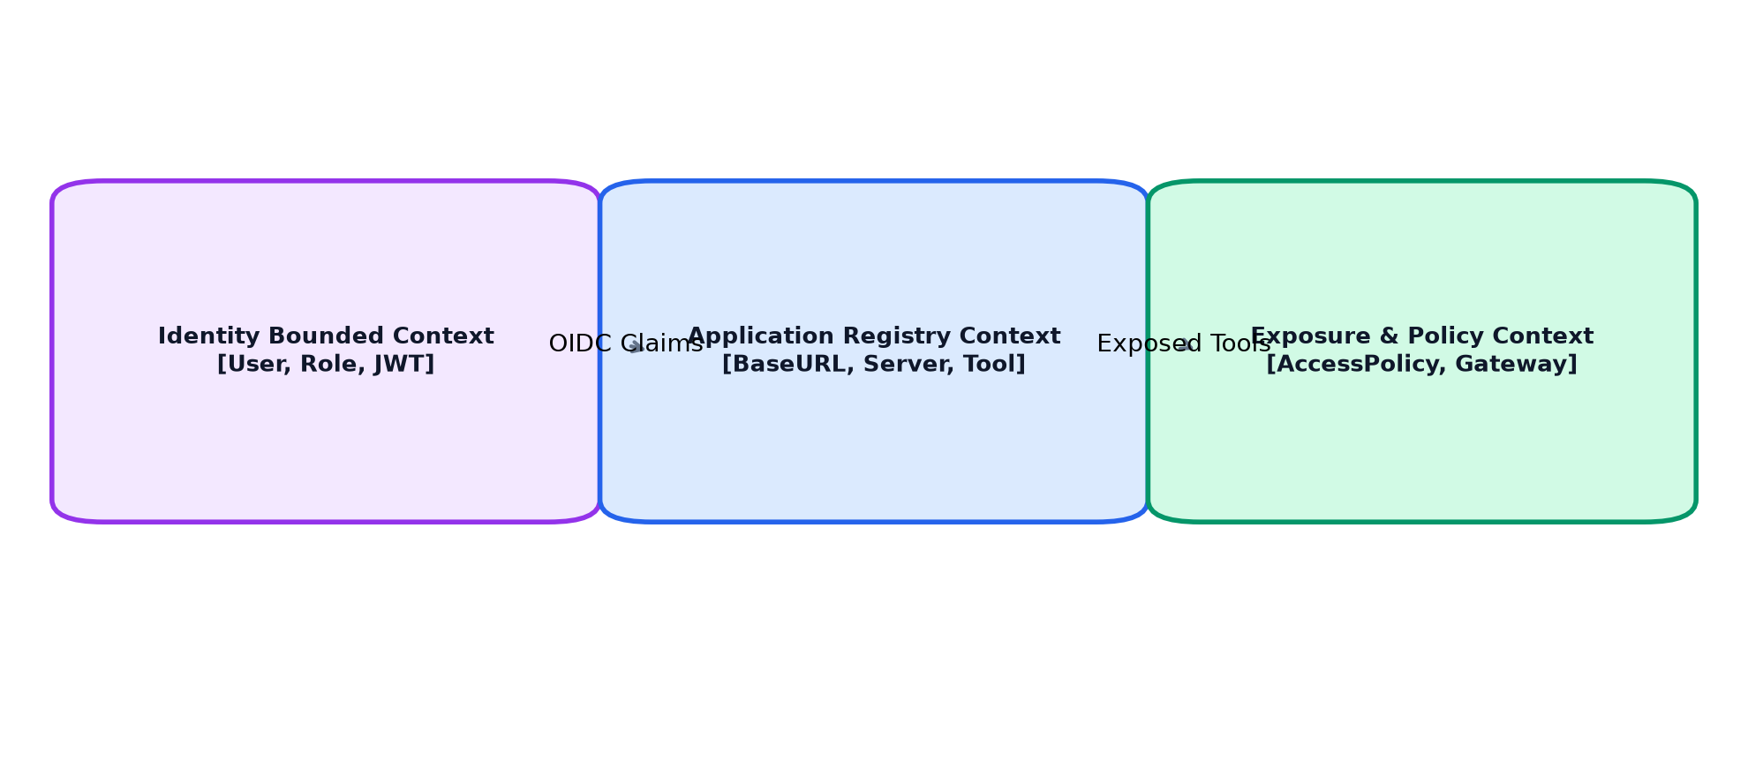
Figure: Bounded Context Map and Relationships

2. Domain Aggregates & Repositories
- Application Aggregate: Root: BaseURLModel. Encapsulates registered base URLs, openapi path, and selected endpoints.
- MCP Server Aggregate: Root: ServerModel. Encapsulates MCP server metadata, health status, and tool selections.
- Exposure Aggregate: Root: AccessPolicyModel. Defines effective access modes (allow, approval, deny) per tool.

