Software Deployment Plan
MCP Server Manager v2.0 Production Release

1. System Overview & Deployment Topology
The MCP Server Manager is deployed as a multi-container microservice suite using Docker Compose. The architecture comprises a Next.js 16 frontend gateway, FastAPI core backend engine, PostgreSQL 16 database, Redis caching layer, Keycloak OIDC identity server, and connected target API applications.
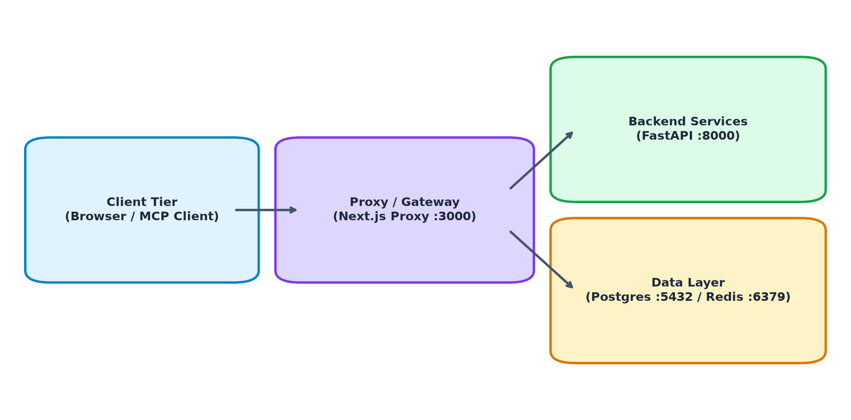
Figure: MCP Server Manager Microservice Container Topology

2. Pre-Deployment Prerequisites
- Docker Engine: Version 24.0+ with Docker Compose v2.20+
- Network Interfaces: Host networking or bridged overlay ports (3000, 8000, 5432, 6379)
- Environment Variables: Verified HMAC_SECRET_KEY, DB credentials, and Keycloak realm URLs

3. Deployment Execution Steps
Step | Command / Action | Target Component | Validation Criterion
1 | docker compose up -d --build backend frontend | Core Gateway | Containers state = Started
2 | Automatic Startup Diagnostics (main.py) | DB & Redis | [PASS] Core Dependencies
3 | ensure_dynamic_schema_migrations() | Postgres DB | Tables & Columns Auto-Synced
4 | curl -i http://localhost:3000/api/proxy/health | Next.js Proxy | HTTP/1.1 200 OK

4. Rollback & Recovery Procedures
[IMPORTANT] In the event of deployment failure, execute `docker compose down` followed by restoring the database from the previous tag snapshot using `pg_restore`.

