Software Requirements Specification
SRS Document for MCP Server Manager

1. Executive Summary & Purpose
This document specifies the functional, non-functional, and interface requirements for the MCP Server Manager. The platform acts as a centralized gateway for exposing OpenAPI microservices and native MCP tools to AI assistants and external clients with strict role-based access control (RBAC).
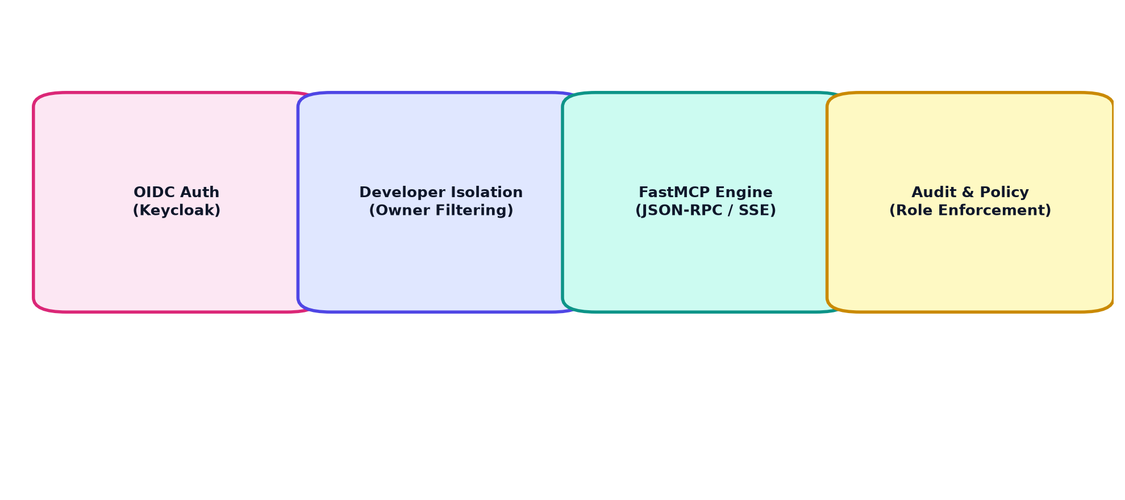
Figure: Core System Functional Modules

2. Key Functional Requirements
- FR-01: Multi-Tenant Data Isolation: Developers must strictly view and modify only applications, servers, tools, and endpoints registered by their own user ID.
- FR-02: Role-Based Access Control: Admins maintain full system oversight. Audit logs and global tenant settings are strictly restricted to admin roles.
- FR-03: Combined FastMCP Server: Expose unified OpenAPI operations and MCP tools under `/mcp/apps` via Streamable HTTP & SSE transport with JSON-RPC 2.0 protocol.
- FR-04: Dynamic Database Schema Sync: On startup, inspect all model schemas and automatically issue `ALTER TABLE ... ADD COLUMN IF NOT EXISTS` for altered models.

3. Non-Functional Requirements
Category | Requirement Specification | Target Metric
Security | JWT validation via Bearer Header, Cookie, or Token Query Param | 0 Unauthenticated Data Leaks
Performance | Cached catalog responses & Redis namespaced key lookups | < 50ms Catalog Response Time
Reliability | Automatic DB reconnect & startup health diagnostics | 99.9% Uptime

