MCP Server Manager
System Architecture, Component Breakdown & Workflow Presentation Guide

[EXECUTIVE] This guide is designed for technical presentation to engineering leadership and management. It details the end-to-end operational architecture, exact file locations, primary function signatures, security enforcement, and workflow flowcharts.

1. Executive System Architecture & Operating Principles
The MCP Server Manager (MCP-Server-Manager) is an enterprise control plane that centralizes microservice OpenAPI registrations and native Model Context Protocol (MCP) servers into a unified, security-hardened gateway (`/mcp/apps`).
- Unified Tool Gateway: Exposes REST microservices and MCP servers as standard MCP tools via FastMCP 3.4.4 streamable HTTP and SSE transports.
- Strict Multi-Tenant Isolation: Developers can only view, manage, and execute tools registered under their own user ID (`created_by_user_id`), preventing cross-tenant data leakage.
- Role-Based Access Control (RBAC): Integrated with Keycloak OIDC identity provider. Audit logs, global tenant policies, and user management are strictly restricted to Admin roles.
- Dynamic Startup Schema Auto-Sync: On application boot, `ensure_dynamic_schema_migrations()` automatically inspects all SQLAlchemy model declarations against live database tables and executes `ALTER TABLE ... ADD COLUMN IF NOT EXISTS` seamlessly.
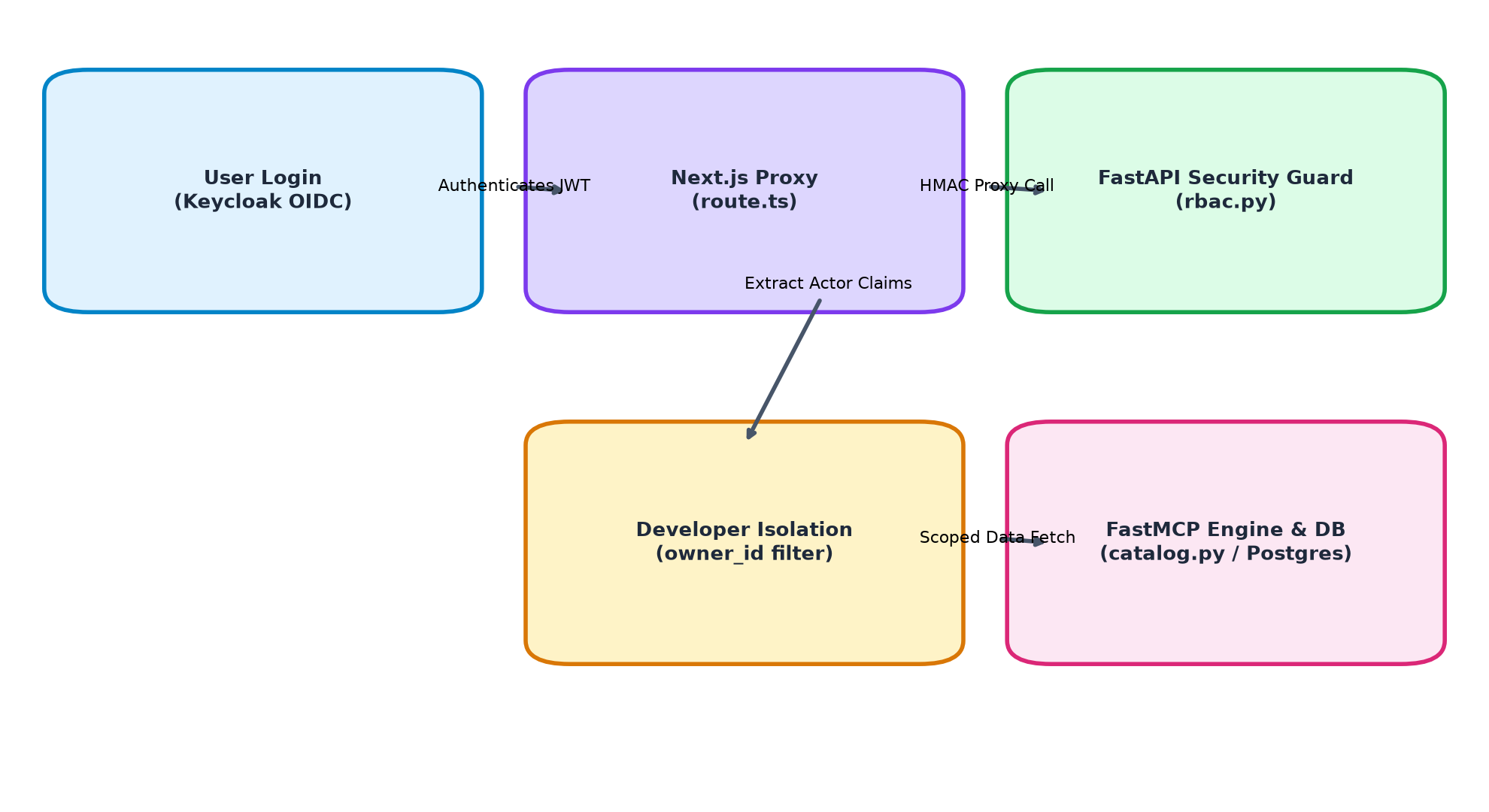
Figure: End-to-End User Authentication & Tenant Isolation Request Flowchart

2. Frontend Architecture & Component Matrix
The frontend layer is built with Next.js 16 (App Router), TailwindCSS, and TypeScript. All client requests route through a serverless proxy layer to enforce HMAC signature validation and credentials management.
File Path | Primary Functions & Components | Operational Responsibility
frontend/app/api/proxy/[...path]/route.ts | handleProxy(req, { params }) | Next.js API proxy handler. Signs outgoing requests with HMAC headers (X-Signature, X-Timestamp), forwards HttpOnly auth cookies, and manages failover routing across target origins.
frontend/services/http.ts | authenticatedFetch(input, init)  http<T>(path, options) | Centralized HTTP utility layer. Manages credentials inclusion (`credentials: 'include'`), handles 401 session expiration redirects, and formats standard JSON responses.
frontend/components/Navigation.tsx | Navigation({ pageTitle }) | Main layout navigation bar. Dynamically fetches current user role from `/api/me` and renders navigation tabs (Admin tab rendered for both Admin and Developer roles).
frontend/app/admin/page.tsx | loadCurrentUser()  fetchAll()  TABS | Admin Panel. Displays dashboard statistics, registered applications, MCP servers, tools, and API endpoints. Developers view only their owned resources; Audit tab is restricted to Admins.
frontend/app/playground/page.tsx | PlaygroundPage()  fetchData()  handleAppSelect() | Interactive AI Tool Testing Playground. Loads application tool catalog via `/mcp/openapi/catalog` and sends prompt test queries to `/agent/playground/query`.
frontend/app/mcp-endpoints/page.tsx | McpEndpointsPage()  fetchData()  copyUrl() | Combined MCP Endpoints Hero page. Displays the absolute server URL (`/api/proxy/mcp/apps`), combined tool count, health summary, and fallback text copy utilities.

3. Backend Engine Architecture & Function Reference
The backend is implemented in FastAPI (Python 3.11) with SQLAlchemy ORM, Redis caching, Keycloak OIDC validation, and FastMCP runtime execution.
File Path | Key Function / Class Signatures | Operational Responsibility
backend/app/main.py | init_db()  ensure_dynamic_schema_migrations()  JWTAuthASGIMiddleware  CombinedAppsOpenAPIMCP | Backend entrypoint. Initializes database schema auto-migrations on boot, mounts `/mcp/apps` FastMCP ASGI application, and validates Bearer/Cookie/Query JWT auth.
backend/app/core/rbac.py | get_request_actor(request)  require_role(allowed_roles)  verify_resource_ownership() | RBAC & Security core module. Decodes Keycloak JWT tokens, extracts primary role (`admin`, `developer`), and enforces tenant resource ownership validation.
backend/app/core/cache.py | cache_get_json(key)  cache_set_json(key, value)  cache_delete_prefix(prefix) | Redis cache layer. Caches status responses using user-namespaced keys (`status:servers:...:{sub}`) to prevent cross-tenant cache contamination.
backend/app/routers/catalog.py | create_catalog_router()  get_openapi_tool_catalog() | Unified Catalog Router. Serves `/mcp/openapi/catalog`. Filters active apps and tools by `created_by_user_id` for developers and returns aligned `summary` stats.
backend/app/routers/base_urls.py | create_base_urls_router()  list_base_urls()  register_base_url() | Application Registry Router. Handles `/base-urls` CRUD operations. Enforces regex URL validation, duplicate URL checks, and developer tenant isolation.
backend/app/routers/servers.py | create_servers_router()  list_servers()  register_server() | MCP Server Router. Manages `/servers` registrations, performs connectivity probing (`discover_server_tools`), and isolates server queries by developer ID.
backend/app/routers/tools.py | create_tools_router()  list_tools() | Tool Registry Router. Manages `/tools` query listings and status updates. Filters tools based on active parent server/app ownership.
backend/app/routers/endpoints.py | create_endpoints_router()  list_endpoints() | API Endpoint Router. Manages `/endpoints` registry with owner ID prefixes (`app:{name}` and `mcp:{name}`) and MCP exposure toggle states.
backend/app/routers/audit.py | create_audit_router()  get_audit_logs() | Audit Log Router. Strictly guarded by `Depends(require_role(['admin']))`. Returns system activity logs for compliance.
backend/app/routers/agent.py | create_agent_router()  agent_query()  playground_query() | AI Agent Execution Router. Interfaces with Ollama LLM (`/agent/query`) and restricts available tools strictly to the developer's owned applications.
backend/app/services/registry/exposure_service.py | resolve_exposable_tools() | Exposure Calculation Engine. Computes effective tool access modes (`allow`, `approval`, `deny`) against `access_policies` and DB registry tables.

4. Combined MCP Endpoint & Client Protocol Compatibility
External AI assistants and MCP clients (e.g. Claude Desktop, Cursor, AGY CLI) connect to the combined endpoint (`/mcp/apps`) using standard JSON-RPC 2.0 over FastMCP Streamable HTTP / SSE transport.
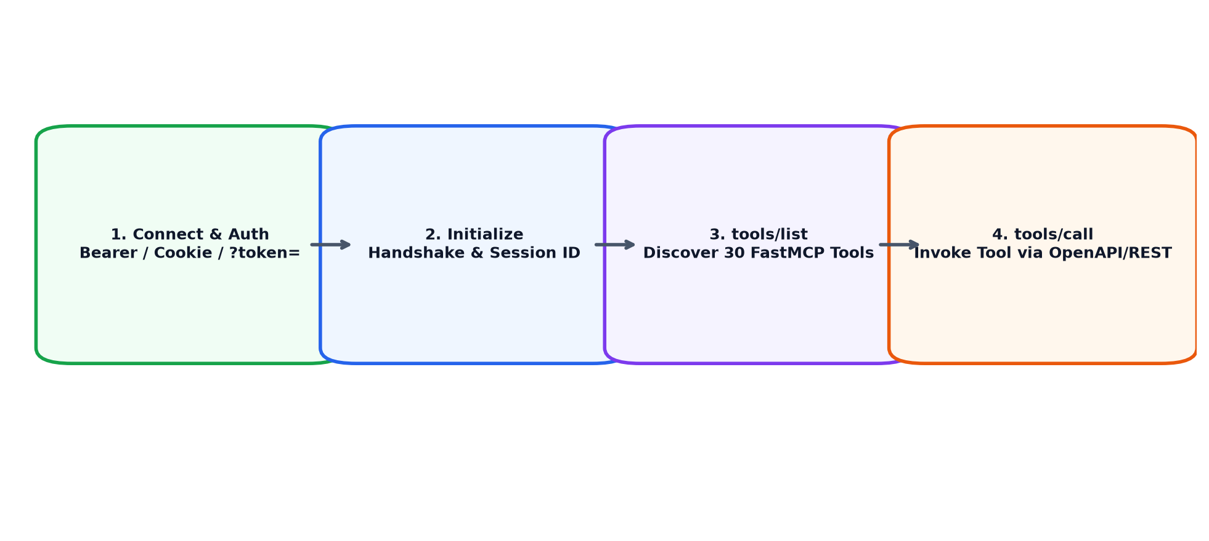
Figure: MCP Client Interaction Sequence (Handshake, Discovery & Tool Invocation)

MCP Protocol Step-by-Step Execution Sequence
- 1. Authentication Handshake: The MCP client connects to `/mcp/apps/` providing authentication via `Authorization: Bearer <token>`, `access_token` cookie, or URL parameter `?token=<token>`.
- 2. Protocol Initialization: Client sends `initialize` JSON-RPC 2.0 request (`Accept: application/json, text/event-stream`). Server responds with `200 OK`, returning server capabilities and `Mcp-Session-Id` header.
- 3. Tool Discovery (tools/list): Client calls `tools/list` with `Mcp-Session-Id` header. Server returns full JSON schema for all 30 exposed tools.
- 4. Tool Invocation (tools/call): Client executes a tool (e.g. `mcp_client_secure__health_health_get`). Server verifies access policy, executes upstream HTTP call, and returns `structuredContent` result.
[SUCCESS] All 6 approval documents (.docx) and architecture guides have been compiled and verified in the documents/ directory.

