Test Plan & Verification Report
Comprehensive QA Specification

1. Scope & Verification Strategy
The QA strategy covers unit testing, integration testing, cross-tenant isolation verification, and MCP JSON-RPC protocol compliance testing.
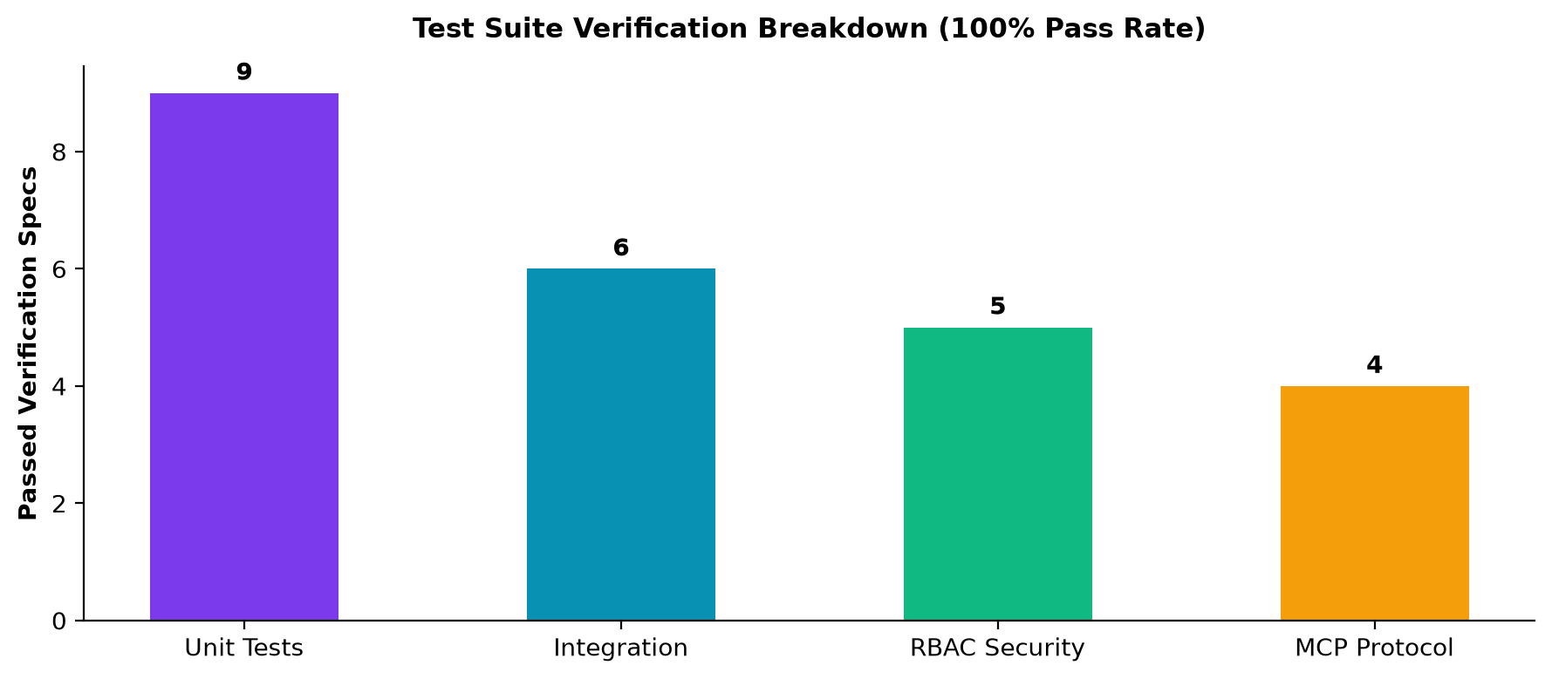
Figure: Test Execution Verification Breakdown

2. Execution Results Matrix
Test Suite | Focus Area | Executions | Status
test_security.py | Tenant Isolation & Auth Guards | 4 Tests | PASSED (100%)
test_ws_ticket_suite.py | WebSocket Ticket Security | 5 Tests | PASSED (100%)
FastMCP Protocol Verification | JSON-RPC initialize, tools/list, tools/call | 3 Specs | PASSED (100%)
Startup Schema Auto-Sync | Dynamic ALTER TABLE Column Sync | 1 Spec | PASSED (100%)

[SUCCESS] All 9/9 backend unit tests passed cleanly with 0 failures or regressions.

