

DMN Modeler Report
DMCommunity Challenge - March 2017

Published: 5/28/2017
By: Edson Tirelli
Table of Contents
Introduction 3
DMCommunity Challenge - Match 2017 4
Decision Requirement Diagram 4
Elements 4
Data Types 8

Introduction
This is the proposed solution for the DMCommunity challenge from March 2017: Online Dating Decision services.
In this document, you will find the explanation and documentation of the solution. The source code of this model is available here:
- DMN model
This is a standard DMN level 3 solution, and as so, you should beable to execute it using any DMN level 3 compatible engine. In particular, I used Trisotech’s DMN Modeler to edit and create the model and Red Hat’s Drools to execute it.
Here is a sample code to execute the model in Drools:
- Drools runner for the model
The runner above, produces the following results:
Matches for Bob:
1. Eleonore - Score = 3
2. Isis - Score = 2
3. Alice - Score = -1
4. Grace - Score = -3

DMCommunity Challenge - Match 2017

Decision Requirement Diagram
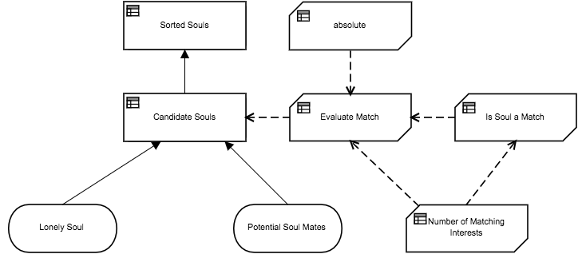

Elements
Sorted Souls (Decision)
Description
Sorts and returns the the list of matching souls in decreasing score order.
Output Data Type
Type | tCandidates

Decision Logic (Literal Expression)
Sorted Souls
sort( Candidate Souls, function( c1, c2 ) c1.Score >= c2.Score )

absolute (Business Knowledge Model)
Description
Given a number, this BKM returns the absolute value of that number. I.e., if the number is greater or equal to zero, it returns the number itself. If the number is negative, it returns the number multiplied by -1.
This BKM could easily be implemented with a simple "if" statement, but it is here demonstrating how the model can easily integrate with Java functions to provide functionality not available out of the box in FEEL.
Output Data Type
Type | Number

Decision Logic (Function - Expression)
absolute
J | ( value Number )
class |  | "java.lang.Math"
method signature |  | "abs(double)"

Candidate Souls (Decision)
Description
Iterates the list of Potential Soul Mates checking for matches with the Lonely Soul. Returns a list containing only the matching souls with their corresponding scores.
Output Data Type
Type | tCandidates

Decision Logic (Context)
Candidate Souls
Candidates  tCandidates |  | for Soul Mate in Potential Soul Mates return Evaluate Match( Lonely Soul, Soul Mate )
Candidates[ Is Match = true ]

Evaluate Match (Business Knowledge Model)
Description
Evaluates the match between the Lonely Soul and a Candidate, setting the Is Match attribute as true if it is a match of false otherwise. It also calculates the Score for the match.
Requirements are not clear on how to calculate the score, so this decision assumes 1 point for each matching interest and -1 for each year of difference in the ages of the loving birds.
Output Data Type
Type | tCandidate

Decision Logic (Function - Context)
Evaluate Match
( | Lonely Soul  tProfile | , | Candidate  tProfile | )

Profile1  tProfile |  | Lonely Soul
Profile2  tProfile |  | Candidate
Is Match  Boolean |  | Is Soul a Match(Lonely Soul, Candidate) and Is Soul a Match(Candidate, Lonely Soul)
Score  Number |  | Number of Matching Interests(Lonely Soul, Candidate) - absolute( Lonely Soul.Age - Candidate.Age )

Is Soul a Match (Business Knowledge Model)
Description
Returns true if the candidate is a match for the given lonely soul. According to the requirements, a candidate is a match if and only if:
- Gender of the other person must be one of the acceptable genders
- Age of the other person must be within the acceptable range
- City must match exactly
- Matching interests of the other person must match at least the number specified

Output Data Type
Type | Boolean

Decision Logic (Function - Expression)
Is Soul a Match
F | ( Lonely Soul tProfile , Candidate tProfile )
list contains(Lonely Soul.Acceptable Genders, Candidate.Gender)
and
Candidate.Age between
Lonely Soul.Minimum Acceptable Age and
Lonely Soul.Maximum Acceptable Age
and
Candidate.City = Lonely Soul.City
and
Number of Matching Interests(Lonely Soul, Candidate) >= Lonely Soul.Minimum Matching Interests

Potential Soul Mates (Input Data)
Description
A list of profiles of the potential soul mates.
Input Data Type
Type | tProfiles

Lonely Soul (Input Data)
Description
The profile of the user for which potential soul mates are being looked for.
Input Data Type
Type | tProfile

Number of Matching Interests (Business Knowledge Model)
Description
Returns the number of matching interests between the Lonely Soul and the Candidate Soul Mate.
Output Data Type
Type | Number

Decision Logic (Function - Context)
Number of Matching Interests
( | Lonely Soul  tProfile | , | Candidate Soul Mate  tProfile | )

Matching Interests  tBooleans | for Interest in Lonely Soul.List of Interests return  list contains(Candidate Soul Mate.List of Interests, Interest)
count( Matching Interests[item = true] )

Data Types
tProfile
Name | Text
Gender | tGender  "Male", "Female"
City | Text
Age | Number
List of Interests | tInterests
Minimum Acceptable Age | Number
Maximum Acceptable Age | Number
Acceptable Genders | tGenders
Minimum Matching Interests | Number
tGender
Text
"Male", "Female"
tGenders
tGender
"Male", "Female"
tInterests
Text
tProfiles
tProfile

tCandidate
Profile1 | tProfile
Profile2 | tProfile
Is Match | Boolean
Score | Number
tCandidates
tCandidate
tBooleans
Boolean

